|  |  |
| --- | --- |
| raspberrypilogo.jpg | Raspberry Pi Internet Radio |

Constructors Manual

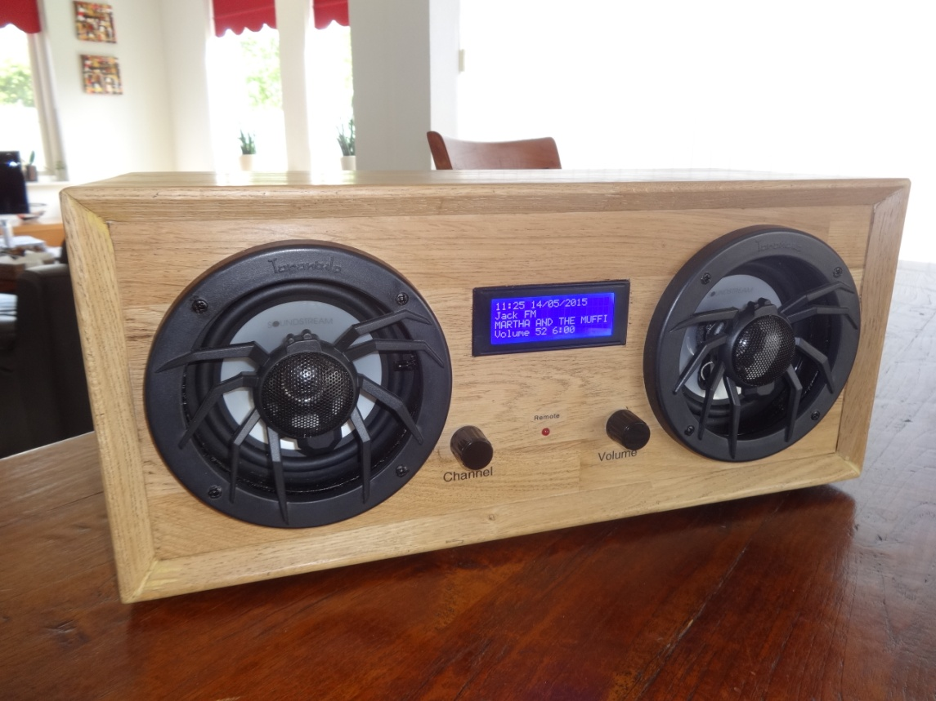

A comprehensive guide to building Internet radios using the Raspberry Pi

Bob Rathbone Computer Consultancy

www.bobrathbone.com

15th of December 2018

Version 6.9

Contents

[Chapter 1 - Introduction 1](#_Toc532457353)

[Document Overview 3](#_Toc532457354)

[Quick links 3](#_Toc532457355)

[Examples 4](#_Toc532457356)

[Vintage Radio Conversion 9](#_Toc532457357)

[Chapter 2 - Hardware overview 10](#_Toc532457358)

[Raspberry Pi computer 10](#_Toc532457359)

[Raspberry Pi Zero and Pi Zero W 11](#_Toc532457360)

[The HD44870 LCD display 11](#_Toc532457361)

[Touch-screens 12](#_Toc532457362)

[Raspberry Pi 7-inch touch screen 12](#_Toc532457363)

[Adafruit 3.5-inch TFT 12](#_Toc532457364)

[Using other touch screens 13](#_Toc532457365)

[Olimex OLED 128x64 pixel screen 14](#_Toc532457366)

[Pimoroni Pirate Radio 14](#_Toc532457367)

[Radio variants 15](#_Toc532457368)

[Connecting the LCD display 16](#_Toc532457369)

[Housing the radio 16](#_Toc532457370)

[Building in a IR sensor and remote control 17](#_Toc532457371)

[Chapter 3 - Wiring 18](#_Toc532457372)

[Version 1 boards (early boards) 21](#_Toc532457373)

[Version 2, 3 or model B+ boards 21](#_Toc532457374)

[Rotary encoder wiring 22](#_Toc532457375)

[LCD Module Wiring 23](#_Toc532457376)

[Power supply considerations 25](#_Toc532457377)

[Selecting an audio amplifier 26](#_Toc532457378)

[GPIO Hardware Notes 27](#_Toc532457379)

[Parts List 28](#_Toc532457380)

[Chapter 4 - Construction details 29](#_Toc532457381)

[Construction using an interface board 29](#_Toc532457382)

[Construction using breakout boards 31](#_Toc532457383)

[Construction using an Adafruit LCD plate 32](#_Toc532457384)

[Introduction 32](#_Toc532457385)

[Using other switches 33](#_Toc532457386)

[Using the Adafruit LCD plate with the model B+, 2B and 3B 33](#_Toc532457387)

[Using alternatives to the Adafruit display 33](#_Toc532457388)

[Construction using an I2C LCD backpack 34](#_Toc532457389)

[Adafruit I2C Backpack 34](#_Toc532457390)

[Arduino PCF8574 I2C backpacks 35](#_Toc532457391)

[Creating the interface board for the I2C back pack 35](#_Toc532457392)

[Construction using the Adafruit 3.5 inch TFT 36](#_Toc532457393)

[Fitting a wake-up button 37](#_Toc532457394)

[Installing an IR sensor and remote control 38](#_Toc532457395)

[IR Sensor 38](#_Toc532457396)

[Remote control 38](#_Toc532457397)

[Remote Control Activity LED 39](#_Toc532457398)

[Construction using an IQaudIO Cosmic Controller 40](#_Toc532457399)

[Construction using the Pimoroni Pirate radio 41](#_Toc532457400)

[Construction using the PiFace CAD 41](#_Toc532457401)

[Installing the FLIRC USB remote control 42](#_Toc532457402)

[FLIRC USB Remote Control dongle 42](#_Toc532457403)

[Using DAC Sound Cards 42](#_Toc532457404)

[HiFiBerry DAC 42](#_Toc532457405)

[IQaudIO DAC sound products 45](#_Toc532457406)

[JustBoom DAC products 46](#_Toc532457407)

[Pimoroni pHat DAC 47](#_Toc532457408)

[Construction Tips and Tricks 47](#_Toc532457409)

[Wiring up rotary encoders and switches 48](#_Toc532457410)

[Preventing electrical interference 50](#_Toc532457411)

[Fit a mains filter 50](#_Toc532457412)

[Connecting up a USB power adapter 51](#_Toc532457413)

[Cooling the Raspberry Pi 51](#_Toc532457414)

[Miscellaneous 52](#_Toc532457415)

[Simple tone regulator 52](#_Toc532457416)

[Using the Adafruit backlit RGB LCD display 53](#_Toc532457417)

[Chapter 5 – System Software Installation 54](#_Toc532457418)

[Conventions used in this tutorial 54](#_Toc532457419)

[Entering system commands 55](#_Toc532457420)

[Editing configuration files 56](#_Toc532457421)

[Using the Vi editor 56](#_Toc532457422)

[Using Nano 56](#_Toc532457423)

[System Software installation 58](#_Toc532457424)

[SD card creation 58](#_Toc532457425)

[Upgrading from Raspbian Jessie to Stretch 58](#_Toc532457426)

[Log into the system 58](#_Toc532457427)

[Using SSH to log into the Raspberry PI 58](#_Toc532457428)

[Enabling ssh in raspi-config 59](#_Toc532457429)

[Preparing the Operating System for software installation 60](#_Toc532457430)

[Update to the latest the packages 60](#_Toc532457431)

[Disable booting to the desktop environment 61](#_Toc532457432)

[Setting the time zone 62](#_Toc532457433)

[Changing the system hostname and password 63](#_Toc532457434)

[Configuring the Wi-fi Connection 64](#_Toc532457435)

[Setting up the locale 65](#_Toc532457436)

[Install other required packages 67](#_Toc532457437)

[Chapter 6 - Installing the radio Software 68](#_Toc532457438)

[Music Player Daemon Installation 68](#_Toc532457439)

[Installing pulseaudio 68](#_Toc532457440)

[Install the Radio Daemon 69](#_Toc532457441)

[Configuring the radio 69](#_Toc532457442)

[Configure SPI Kernel Module 73](#_Toc532457443)

[Configure the I2C interface 74](#_Toc532457444)

[Select the type of LCD display 76](#_Toc532457445)

[Installing the HDMI or touch screen software 77](#_Toc532457446)

[Configuring the audio output 78](#_Toc532457447)

[Installing the Python I2C libraries 79](#_Toc532457448)

[Installation log 81](#_Toc532457449)

[Reboot to enable the software 81](#_Toc532457450)

[Installing PiFace CAD software 81](#_Toc532457451)

[Installing Pimoroni Pirate Radio (pHat BEAT) 82](#_Toc532457452)

[Install Pimoroni software 82](#_Toc532457453)

[Disable Pimoroni software 83](#_Toc532457454)

[Install the Rathbone Internet radio software 83](#_Toc532457455)

[Configuring HDMI or Touchscreen 83](#_Toc532457456)

[Apply patches to the radio software 83](#_Toc532457457)

[Setting the mixer volume 84](#_Toc532457458)

[Configuring other sound devices 85](#_Toc532457459)

[Configuring a USB sound device 85](#_Toc532457460)

[Configuring a Sound Card 86](#_Toc532457461)

[Testing the Music Player Daemon MPD 88](#_Toc532457462)

[Manually configuring sound cards 89](#_Toc532457463)

[Configuring MPD to use pulseaudio 90](#_Toc532457464)

[Installing the Infra Red sensor software 90](#_Toc532457465)

[Testing the remote control 94](#_Toc532457466)

[Disabling the repeat on the volume control 95](#_Toc532457467)

[Configuring a wireless adaptor 95](#_Toc532457468)

[Install the wireless adapter 95](#_Toc532457469)

[Configure the adaptor 95](#_Toc532457470)

[Explanation of the network fields 96](#_Toc532457471)

[Operating the wireless interface 97](#_Toc532457472)

[Troubleshooting the wireless adapter 97](#_Toc532457473)

[Configuring a static IP address 98](#_Toc532457474)

[Configuring DHCP in a router 98](#_Toc532457475)

[Ethernet static IP configuration 99](#_Toc532457476)

[Installing the Web interface 99](#_Toc532457477)

[Install Apache 99](#_Toc532457478)

[Install the Web Browser server pages 100](#_Toc532457479)

[Start the radio web interface 101](#_Toc532457480)

[Changing the Web Interface Radio photo 103](#_Toc532457481)

[Installing the speech facility 103](#_Toc532457482)

[The /var/lib/radiod/voice file 103](#_Toc532457483)

[Testing espeak 104](#_Toc532457484)

[Speech Operation 105](#_Toc532457485)

[Suppressing an individual message 105](#_Toc532457486)

[Keeping the radio software up-to-date 106](#_Toc532457487)

[Backing up the SD card 106](#_Toc532457488)

[Chapter 7 – Configuration 107](#_Toc532457489)

[Configuring the HDMI or Touch Screen 107](#_Toc532457490)

[Configuring GPIO outputs 108](#_Toc532457491)

[Switches and rotary encoders GPIO assignments 108](#_Toc532457492)

[Disabling button or rotary encoder GPIOs 108](#_Toc532457493)

[LCD display GPIO assignments 109](#_Toc532457494)

[Configuring button interface with pull up resistors 109](#_Toc532457495)

[Configuring the remote control activity LED 109](#_Toc532457496)

[Testing the remote control activity LED 109](#_Toc532457497)

[Changing the date format 110](#_Toc532457498)

[Configuring the IQaudIO Cosmic controller and OLED 110](#_Toc532457499)

[Configuring the Adafruit LCD backlight colours 111](#_Toc532457500)

[Configuring startup mode for Radio or Media player 111](#_Toc532457501)

[Configuring the volume display 112](#_Toc532457502)

[Configuring the volume range 112](#_Toc532457503)

[Changing the display language 113](#_Toc532457504)

[Creating a new language file 113](#_Toc532457505)

[Configuring an RSS feed 114](#_Toc532457506)

[Configuring the Alsa Equaliser 115](#_Toc532457507)

[Disabling the Alsa equalizer 116](#_Toc532457508)

[Configuration of the FLIRC USB dongle 117](#_Toc532457509)

[Configuring FLIRC from the command line 118](#_Toc532457510)

[Chapter 8 - Operation 121](#_Toc532457511)

[Operation of LCD versions 121](#_Toc532457512)

[Starting the program 121](#_Toc532457513)

[Radios with push buttons operation 123](#_Toc532457514)

[Radios with rotary encoders operation 124](#_Toc532457515)

[Mute function 125](#_Toc532457516)

[Operation of HDMI and touch screen displays 126](#_Toc532457517)

[The graphical screen 126](#_Toc532457518)

[The display window 127](#_Toc532457519)

[The search window 127](#_Toc532457520)

[Smaller TFT screens 129](#_Toc532457521)

[Artwork display 129](#_Toc532457522)

[Volume and Mute controls 130](#_Toc532457523)

[Source selection 130](#_Toc532457524)

[Other graphic window controls 130](#_Toc532457525)

[Python pygame colour constants 132](#_Toc532457526)

[Graphic screen keyboard controls 132](#_Toc532457527)

[The Vintage Graphic Radio 132](#_Toc532457528)

[Switching between graphics programs 134](#_Toc532457529)

[Configuring a screen saver 134](#_Toc532457530)

[Playing Media 135](#_Toc532457531)

[Playing MP3 and WMA files 135](#_Toc532457532)

[Playing music from a USB stick 135](#_Toc532457533)

[Playing music from the SD card 135](#_Toc532457534)

[Playing music from a Network Attached Storage (NAS) 135](#_Toc532457535)

[Organising the music files 135](#_Toc532457536)

[MPD Logging 136](#_Toc532457537)

[Radio program logging 136](#_Toc532457538)

[Configuration and status files 136](#_Toc532457539)

[Using the Timer and Alarm functions 137](#_Toc532457540)

[Setting the Timer (Snooze) 137](#_Toc532457541)

[Setting the Alarm 137](#_Toc532457542)

[Using the Alarm and Timer functions together 138](#_Toc532457543)

[Music Player Clients 138](#_Toc532457544)

[Using the MPC client 138](#_Toc532457545)

[Adafruit RGB Plate changing colours 139](#_Toc532457546)

[Shutting down the radio 139](#_Toc532457547)

[Creating and Maintaining Playlist files 140](#_Toc532457548)

[Creating new playlists 140](#_Toc532457549)

[Creating Media playlists 142](#_Toc532457550)

[Accessing Shoutcast 145](#_Toc532457551)

[Using the get\_shoutcast.py program 145](#_Toc532457552)

[Using the Shoutcast Web Interface 146](#_Toc532457553)

[Using old 5.x Radio playlists 148](#_Toc532457554)

[Radio stream resources on the Internet 148](#_Toc532457555)

[Getting a radio stream from a web browser 148](#_Toc532457556)

[Overview of media stream URLs 149](#_Toc532457557)

[M3U Files 149](#_Toc532457558)

[PLS file format 149](#_Toc532457559)

[ASX file 150](#_Toc532457560)

[Direct stream URLs 150](#_Toc532457561)

[Listening to live Air Traffic Control (ATC) 151](#_Toc532457562)

[Mounting a network drive 154](#_Toc532457563)

[Finding the IP address of the network drive 154](#_Toc532457564)

[The CIFS mount command 154](#_Toc532457565)

[Older NAS drives sec security option 155](#_Toc532457566)

[The NFS mount command 155](#_Toc532457567)

[Display the share directory 155](#_Toc532457568)

[Un-mounting the /share directory 156](#_Toc532457569)

[Copy the mount command to the configuration 156](#_Toc532457570)

[Load the music library 156](#_Toc532457571)

[Update the playlists for the new share 156](#_Toc532457572)

[Disabling the share 156](#_Toc532457573)

[Further information 157](#_Toc532457574)

[Troubleshooting mount problems 157](#_Toc532457575)

[Controlling the Music Player daemon from Mobile devices 157](#_Toc532457576)

[Android devices 157](#_Toc532457577)

[Apple devices 158](#_Toc532457578)

[Chapter 9 -Troubleshooting 159](#_Toc532457579)

[Installation problems 159](#_Toc532457580)

[The Raspberry Pi will not boot 159](#_Toc532457581)

[Missing package dependency problems 160](#_Toc532457582)

[Confused or unsure of wiring 160](#_Toc532457583)

[Unexpected message during an upgrade 160](#_Toc532457584)

[HDMI/Touchscreen problems 161](#_Toc532457585)

[HDMI/Touchscreen does not start 161](#_Toc532457586)

[HDMI/Touchscreen is displaying upside-down 161](#_Toc532457587)

[The touch screen displays a lightning symbol 161](#_Toc532457588)

[The touch screen displays a thermometer symbol 161](#_Toc532457589)

[Sound is heard but the graphical radio program will not start 161](#_Toc532457590)

[Trouble shooting problems with MPD 161](#_Toc532457591)

[MPD fails to install 162](#_Toc532457592)

[Music Player Daemon won’t start 162](#_Toc532457593)

[The MPD program may display a socket error 162](#_Toc532457594)

[The MPD daemon complains about the avahi daemon 162](#_Toc532457595)

[LCD Problems 163](#_Toc532457596)

[LCD screen not showing anything 163](#_Toc532457597)

[The LCD only displays hieroglyphics 163](#_Toc532457598)

[The LCD displays hieroglyphics or goes blank occasionally 163](#_Toc532457599)

[LCD backlight not working 163](#_Toc532457600)

[LCD only displays dark blocks on the first line 163](#_Toc532457601)

[The LCD displays the message “No playlists” 163](#_Toc532457602)

[Constant alternate display of Station Name and Volume 164](#_Toc532457603)

[Adafruit LCD backlight problems 164](#_Toc532457604)

[I2C and SMBUS problems 164](#_Toc532457605)

[Import errors 164](#_Toc532457606)

[PiFace CAD and SPI problems 165](#_Toc532457607)

[PiFace CAD not detected 165](#_Toc532457608)

[Olimex OLED problems 165](#_Toc532457609)

[Radio does not start with Olimex screen 165](#_Toc532457610)

[OLED Screen is displaying upside down 165](#_Toc532457611)

[Rotary encoder problems 165](#_Toc532457612)

[Button problems 165](#_Toc532457613)

[Buttons seem to be pressing themselves 165](#_Toc532457614)

[Stream decode problems 166](#_Toc532457615)

[Cannot mount remote network drive 166](#_Toc532457616)

[Sound problems 167](#_Toc532457617)

[Noisy interference on the radio 167](#_Toc532457618)

[Humming sound on the radio 167](#_Toc532457619)

[Music is first heard at boot time then stops and restarts 167](#_Toc532457620)

[USB sound device won’t play 167](#_Toc532457621)

[HiFBerry or other types of DAC no sound 168](#_Toc532457622)

[Cannot change volume when running Airplay 169](#_Toc532457623)

[Volume control errors 169](#_Toc532457624)

[Operational problems 169](#_Toc532457625)

[Radio daemon doesn’t start or hangs 169](#_Toc532457626)

[Volume control not working with DAC or USB speakers 170](#_Toc532457627)

[The radio keeps skipping radio stations 170](#_Toc532457628)

[IR remote control problems 170](#_Toc532457629)

[The irrecord program complains that lircd.conf already exists 170](#_Toc532457630)

[The irrecord cannot open /dev/lirc0 170](#_Toc532457631)

[Remote control software does not start up 171](#_Toc532457632)

[Using the diagnostic programs 172](#_Toc532457633)

[Running the radio program in diagnostic mode 172](#_Toc532457634)

[Using the LCD test code 172](#_Toc532457635)

[Testing push buttons program 173](#_Toc532457636)

[Testing rotary encoders 173](#_Toc532457637)

[The remote\_control program 173](#_Toc532457638)

[The display\_model program 173](#_Toc532457639)

[The display\_current program 174](#_Toc532457640)

[The wiring program 174](#_Toc532457641)

[Running the radio program in nodaemon mode 176](#_Toc532457642)

[Creating a log file in DEBUG mode 176](#_Toc532457643)

[Displaying information about the Raspberry Pi 177](#_Toc532457644)

[Displaying information about the Operating system 177](#_Toc532457645)

[Display the kernel details 177](#_Toc532457646)

[Displaying the GPIO information 177](#_Toc532457647)

[Chapter 10 - Streaming to other devices using Icecast2 179](#_Toc532457648)

[Inbuilt MPD HTTP streamer 179](#_Toc532457649)

[Introduction to Icecast 179](#_Toc532457650)

[Installing Icecast 179](#_Toc532457651)

[Overclocking older Raspberry PI’s 180](#_Toc532457652)

[Icecast2 Operation 181](#_Toc532457653)

[Switching on streaming 181](#_Toc532457654)

[Playing the Icecast stream on Windows 182](#_Toc532457655)

[Running the Icecast Adminstration web pages 183](#_Toc532457656)

[Playing the Icecast2 stream on an Apple IPad 184](#_Toc532457657)

[Playing the Icecast2 stream on an Android device 184](#_Toc532457658)

[Visual streaming indicator 184](#_Toc532457659)

[Troubleshooting Icecast2 184](#_Toc532457660)

[Problem - Icecast streaming page says it can’t be displayed. 185](#_Toc532457661)

[Problem – No Mount Point displayed 185](#_Toc532457662)

[Problem - Cannot play the stream on my Android device 185](#_Toc532457663)

[Problem – Music keeps stopping or is intermittent 185](#_Toc532457664)

[Chapter 11 - Setting up Spotify 186](#_Toc532457665)

[Spotify installation 186](#_Toc532457666)

[Spotify operation 187](#_Toc532457667)

[Exiting Spotify 189](#_Toc532457668)

[Troubleshooting Raspotify 189](#_Toc532457669)

[Installation problems 189](#_Toc532457670)

[Raspotify exits with a 101 error code 189](#_Toc532457671)

[Chapter 12 - Setting up Airplay 190](#_Toc532457672)

[Installation script 190](#_Toc532457673)

[Manual procedure 190](#_Toc532457674)

[Build and install shairport-sync: 191](#_Toc532457675)

[Install the shairport metadata reader 192](#_Toc532457676)

[Configuring the Airplay feature 192](#_Toc532457677)

[Airplay service check 193](#_Toc532457678)

[Using Airplay on the radio 194](#_Toc532457679)

[Chapter 13 - Internet Security 196](#_Toc532457680)

[Some golden Internet Security rules 196](#_Toc532457681)

[SSH keys installation 197](#_Toc532457682)

[Raspberry Pi ssh keys 197](#_Toc532457683)

[Generate a client key 198](#_Toc532457684)

[Add client public key to Raspberry Pi authorised keys 198](#_Toc532457685)

[Firewall set-up 198](#_Toc532457686)

[Chapter 14 - Frequently asked questions (FAQs) 200](#_Toc532457687)

[What is the login name and password? 200](#_Toc532457688)

[Why are the radio stations not in the order that they were defined? 200](#_Toc532457689)

[Why are some station names not being displayed in the web interface? 200](#_Toc532457690)

[Why doesn’t the web interface display URLs until a station is selected? 201](#_Toc532457691)

[Why are music tracks played randomly when loaded? 201](#_Toc532457692)

[Can the volume be displayed as blocks instead of Volume nn? 201](#_Toc532457693)

[Why do I see a station number on LCD line 3? 201](#_Toc532457694)

[Is it possible to change the date format? 201](#_Toc532457695)

[Is there a pause & resume function? 201](#_Toc532457696)

[Is there a reboot or shutdown option? 202](#_Toc532457697)

[Why do I see a different station name from the one in the playlist? 202](#_Toc532457698)

[What Rotary Encoder can I use for this project? 202](#_Toc532457699)

[Can this code or documentation be re-used in other projects? 202](#_Toc532457700)

[Can I use an Electronic Ink display? 202](#_Toc532457701)

[Chapter 15 - Source files 203](#_Toc532457702)

[The Radio program 203](#_Toc532457703)

[The Radio Daemon 203](#_Toc532457704)

[The Display Class 203](#_Toc532457705)

[The Graphical Screen radio programs 203](#_Toc532457706)

[The Graphics display class 204](#_Toc532457707)

[The Graphics controls class 204](#_Toc532457708)

[The OLED class 204](#_Toc532457709)

[The button class 204](#_Toc532457710)

[The rotary class 204](#_Toc532457711)

[The Cosmic controller Class 204](#_Toc532457712)

[The Event class 204](#_Toc532457713)

[The Menu class 204](#_Toc532457714)

[The Message class 204](#_Toc532457715)

[The language class 205](#_Toc532457716)

[The Log class 205](#_Toc532457717)

[The Volume class 205](#_Toc532457718)

[The Configuration Class 205](#_Toc532457719)

[The RSS class 205](#_Toc532457720)

[The Translate class 205](#_Toc532457721)

[The create\_stations program 205](#_Toc532457722)

[The display\_current program 205](#_Toc532457723)

[The display\_model script 205](#_Toc532457724)

[The configure\_radio.sh script 205](#_Toc532457725)

[The configure\_audio.sh script 206](#_Toc532457726)

[The set mixer id script 206](#_Toc532457727)

[The remote control daemon 206](#_Toc532457728)

[The UDP network communications class 206](#_Toc532457729)

[The Status LED class 206](#_Toc532457730)

[The Airplay Class 206](#_Toc532457731)

[The Menu Switch class 206](#_Toc532457732)

[The init file 206](#_Toc532457733)

[Downloading the source from github 207](#_Toc532457734)

[Licences, acknowledgements and support 208](#_Toc532457735)

[Licences 208](#_Toc532457736)

[Intellectual Property, Copyright, and Streaming Media 208](#_Toc532457737)

[Disclaimer 209](#_Toc532457738)

[Technical support 209](#_Toc532457739)

[Acknowledgements 210](#_Toc532457740)

[Glossary 212](#_Toc532457741)

[Appendix A - System Files used by the Radio Program 215](#_Toc532457742)

[A.1 Files added to the system 215](#_Toc532457743)

[/etc/radiod.conf 215](#_Toc532457744)

[/etc/logrotate.d/radiod 218](#_Toc532457745)

[/etc/init.d/radiod 218](#_Toc532457746)

[/lib/systemd/system/radiod.service 218](#_Toc532457747)

[/etc/init.d/asound.conf 218](#_Toc532457748)

[/etc/init.d/irradiod 219](#_Toc532457749)

[/etc/lirc/lircrc 219](#_Toc532457750)

[The Desktop file gradio.desktop 220](#_Toc532457751)

[The Desktop file vgradio.desktop 220](#_Toc532457752)

[A.2 System files modified by the installation 222](#_Toc532457753)

[/etc/modules 222](#_Toc532457754)

[/boot/config.txt 222](#_Toc532457755)

[The lxsession autostart file for desktop radio 222](#_Toc532457756)

[Appendix B – Cheat sheets 223](#_Toc532457757)

[B.1 Operating system and configuration 223](#_Toc532457758)

[B.2 Music Player Daemon and Radio software 223](#_Toc532457759)

[B.3 Installing the Pimoroni Pirate Radio software 224](#_Toc532457760)

[B.4 Installing Web Interface 224](#_Toc532457761)

[B.5 Installing remote IR software 224](#_Toc532457762)

[B.6 Enabling speech facility 225](#_Toc532457763)

[B.7 Installing Spotify 225](#_Toc532457764)

[Appendix C – Technical specification and other notes 226](#_Toc532457765)

[C.1 – Technical specification 226](#_Toc532457766)

[C.2 -Elecrow 7-inch touch-screen notes 227](#_Toc532457767)

[C.3 Sound card DT Overlays 228](#_Toc532457768)

[Configuring other audio devices 228](#_Toc532457769)

[C.4 UDP messages 229](#_Toc532457770)

[Appendix D – Wiring diagrams and lists 230](#_Toc532457771)

[D1 Push Button and Rotary Encoder 40-pin wiring 230](#_Toc532457772)

[D.2 Push Button and Rotary Encoder 26-pin wiring 230](#_Toc532457773)

[D.3 IQaudIO Cosmic Controller wiring 230](#_Toc532457774)

[D.4 Pimoroni Pirate Radio wiring 231](#_Toc532457775)

[D.5 Vintage Radio Push-button/Rotary Encoder 40-pin wiring 231](#_Toc532457776)

[D.6 Raspberry Pi Rotary Encoder version with backlight dimmer 232](#_Toc532457777)

[Index 232](#_Toc532457778)

**Figures**

[Figure 1 Raspberry pi 7-inch touchscreen radio 4](#_Toc532457779)

[Figure 2 HDMI Television running the radio 4](#_Toc532457780)

[Figure 3 Vintage tuning touch-screen radio 4](#_Toc532457781)

[Figure 4 Adafruit 3.5 inch TFT 5](#_Toc532457782)

[Figure 5 Radio using the Adafruit LCD plate 5](#_Toc532457783)

[Figure 6 Lego Internet Radio 5](#_Toc532457784)

[Figure 7 Pi radio using rotary encoders 5](#_Toc532457785)

[Figure 8 Old Zenith radio using rotary encoders 6](#_Toc532457786)

[Figure 9 Transparent Perspex Radio 6](#_Toc532457787)

[Figure 10 Perspex radio rear view 6](#_Toc532457788)

[Figure 11 The Radio running on a Pi Zero 6](#_Toc532457789)

[Figure 12 Boom Box radio front view 7](#_Toc532457790)

[Figure 13 Boom Box Radio rear view 7](#_Toc532457791)

[Figure 14 Raspberry Pi Wine Box radio 7](#_Toc532457792)

[Figure 15 Wine box internet radio internal view 7](#_Toc532457793)

[Figure 16 Very small radio using the Cosmic Controller 7](#_Toc532457794)

[Figure 17 RPI radio with two-stage valve amplifier 8](#_Toc532457795)

[Figure 18 The RPi valve radio chassis view 8](#_Toc532457796)

[Figure 19 Pimoroni Pirate Radio 8](#_Toc532457797)

[Figure 20 PiFace CAD Radio with IR Remote Control 8](#_Toc532457798)

[Figure 21 Philips BX490A (1949) Vintage Internet Radio 9](#_Toc532457799)

[Figure 22 Raspberry PI Model 3B Computer 10](#_Toc532457800)

[Figure 23 Raspberry PI B+ AV cable 10](#_Toc532457801)

[Figure 24 Raspberry Pi Zero 11](#_Toc532457802)

[Figure 25 USB Ethernet adapter 11](#_Toc532457803)

[Figure 26 The HD44870 LCD display 11](#_Toc532457804)

[Figure 27 OLED 4 x20 LCD display 11](#_Toc532457805)

[Figure 28 Raspberry Pi 3 with 7-inch touch screen 12](#_Toc532457806)

[Figure 29 Adafruit 3.5 inch TFT touchscreen 12](#_Toc532457807)

[Figure 30 Pimoroni Pirate Radio - Rear view 14](#_Toc532457808)

[Figure 31 Some examples of radio cases 16](#_Toc532457809)

[Figure 32 IR Sensor and Remote control 17](#_Toc532457810)

[Figure 33 Adafruit and IR sensor and activity LED 17](#_Toc532457811)

[Figure 34 Push-button Wiring version 1 boards 21](#_Toc532457812)

[Figure 35 Push-button wiring version 2 onwards boards 21](#_Toc532457813)

[Figure 36 Rotary Encoder Diagram 22](#_Toc532457814)

[Figure 37 Rotary encoder with push switch 22](#_Toc532457815)

[Figure 38 Rotary encoder pin-outs 22](#_Toc532457816)

[Figure 39 HD44870 LCD electrical circuit 24](#_Toc532457817)

[Figure 40 Wire LCD pin 1 (GND) and 5 (RW) together 24](#_Toc532457818)

[Figure 41 PC speakers 26](#_Toc532457819)

[Figure 42 Velleman 30W stereo amplifier 26](#_Toc532457820)

[Figure 43 IQaudIO DAC and 20W Amplifier 26](#_Toc532457821)

[Figure 44 Vintage radio PA input 26](#_Toc532457822)

[Figure 45 GPIO Numbers 27](#_Toc532457823)

[Figure 46 26 pin header extender 27](#_Toc532457824)

[Figure 47 40-pin Interface board with ribbon cable 29](#_Toc532457825)

[Figure 48 Interface board with LCD screen attached 29](#_Toc532457826)

[Figure 49 Radio controls connections 30](#_Toc532457827)

[Figure 50 Interface board overview 30](#_Toc532457828)

[Figure 51 GPIO header breakout board 31](#_Toc532457829)

[Figure 52 Adafruit LCD plate 32](#_Toc532457830)

[Figure 53 Adafruit LCD plate with ribbon cable adapter 32](#_Toc532457831)

[Figure 54 Chinese 1602 I2C LCD 33](#_Toc532457832)

[Figure 55 Enabling the backlight. 33](#_Toc532457833)

[Figure 56 Adafruit I2C Backpack 34](#_Toc532457834)

[Figure 57 LCD connected to an Adafruit I2C backpack 35](#_Toc532457835)

[Figure 58 Arduino I2C backpack 35](#_Toc532457836)

[Figure 59 Ciseco Humble PI I2C interface board 36](#_Toc532457837)

[Figure 60 The I2C backpack interface board 36](#_Toc532457838)

[Figure 61 Wake-up button 37](#_Toc532457839)

[Figure 62 TSOP38238 IR sensor 38](#_Toc532457840)

[Figure 63 Soldering precautions 38](#_Toc532457841)

[Figure 64 LED polarity 39](#_Toc532457842)

[Figure 65 Adafruit plate with IR sensor and activity LED. 39](#_Toc532457843)

[Figure 66 IQaudIO Cosmic controller and OLED display 40](#_Toc532457844)

[Figure 67 Lego radio with IQaudIO Cosmic controller and OLED 40](#_Toc532457845)

[Figure 68 PiFace CAD and Rasberry PI 41](#_Toc532457846)

[Figure 69 PiFace CAD in a case 41](#_Toc532457847)

[Figure 70 Raspberry PI P5 connector 43](#_Toc532457848)

[Figure 71 HiFiBerry DAC plus Connector 43](#_Toc532457849)

[Figure 72 Pi Radio with HiFiBerry DAC 43](#_Toc532457850)

[Figure 73 HiFiBerry DAC Plus 43](#_Toc532457851)

[Figure 74 HiFiBerry mounted on the Rasberry Pi 44](#_Toc532457852)

[Figure 75 IQaudIO DAC plus 45](#_Toc532457853)

[Figure 76 JustBoom Amp HAT 46](#_Toc532457854)

[Figure 77 JustBoom Amp Zero pHAT 46](#_Toc532457855)

[Figure 78 JustBoom Zero stacker requirements 46](#_Toc532457856)

[Figure 79 Using the 40-pin stacker 46](#_Toc532457857)

[Figure 80 Pimoroni pHat DAC 47](#_Toc532457858)

[Figure 81 Rotary encoder wiring components 48](#_Toc532457859)

[Figure 82 Using wire strippers 48](#_Toc532457860)

[Figure 83 Tinning the wires with solder 48](#_Toc532457861)

[Figure 84 Soldering up the switch 49](#_Toc532457862)

[Figure 85 Shrink shrink-wrap with a hair dryer 49](#_Toc532457863)

[Figure 86 Connecting the rotary encoder an interface board 49](#_Toc532457864)

[Figure 87 Clip on ferrite core 50](#_Toc532457865)

[Figure 88 Loop +5V supply around the core 50](#_Toc532457866)

[Figure 89 Various mains filters 50](#_Toc532457867)

[Figure 90 Integrated mains socket and filter 50](#_Toc532457868)

[Figure 91 3.5mm Jack Ground Loop Isolator 51](#_Toc532457869)

[Figure 92 Connecting up a USB power adapter 51](#_Toc532457870)

[Figure 93 Heat sink kit 52](#_Toc532457871)

[Figure 94 Cooling fans 52](#_Toc532457872)

[Figure 95 Simple tone control circuit 52](#_Toc532457873)

[Figure 96 Tone control board 52](#_Toc532457874)

[Figure 97 IN4148 diode 53](#_Toc532457875)

[Figure 98 The nano file editor 57](#_Toc532457876)

[Figure 99 The nano editor help screen 57](#_Toc532457877)

[Figure 100 Enabling SSH on the boot sector 59](#_Toc532457878)

[Figure 101 Enabling SSH 59](#_Toc532457879)

[Figure 102 Disabling the graphical desktop 61](#_Toc532457880)

[Figure 103 Desktop enable/disable selection 61](#_Toc532457881)

[Figure 104 Console login selection 61](#_Toc532457882)

[Figure 105 Setting the time zone 62](#_Toc532457883)

[Figure 106 Selecting the time zone 62](#_Toc532457884)

[Figure 107 Saving the timezone 62](#_Toc532457885)

[Figure 108 Time zone country selection 63](#_Toc532457886)

[Figure 109 Changing the Raspberry PI password 63](#_Toc532457887)

[Figure 110 Changing the hostname 64](#_Toc532457888)

[Figure 111 Setting up the Wi-Fi in raspi-config 64](#_Toc532457889)

[Figure 112 Entering Wi-Fi credentials 64](#_Toc532457890)

[Figure 113 Setting up the Wi-fi country 65](#_Toc532457891)

[Figure 114 Selecting change locale 65](#_Toc532457892)

[Figure 115 Generating the locale. 66](#_Toc532457893)

[Figure 116 Selecting the locale 66](#_Toc532457894)

[Figure 117 Configure radio – Upgrade 70](#_Toc532457895)

[Figure 118 Replace configuration file 70](#_Toc532457896)

[Figure 119 Configure radio - User interface selection 70](#_Toc532457897)

[Figure 120 Configure radio - Confirmation screen 71](#_Toc532457898)

[Figure 121 Push-button voltage selection 71](#_Toc532457899)

[Figure 122 Configure radio - wiring selection 71](#_Toc532457900)

[Figure 123 Configure radio - Display interface selection 72](#_Toc532457901)

[Figure 124 Olimex OLED flip display 72](#_Toc532457902)

[Figure 125 Enable SPI Kernel Module 73](#_Toc532457903)

[Figure 126 Enable SPI kernel module option 73](#_Toc532457904)

[Figure 127 Configure radio - I2C interface hex address 74](#_Toc532457905)

[Figure 128 Configure radio - Enable I2C libraries 75](#_Toc532457906)

[Figure 129 Selecting interfacing options in raspi-config 75](#_Toc532457907)

[Figure 130 Select I2C libraries in raspi-config 75](#_Toc532457908)

[Figure 131 Configure radio - Display type selection 76](#_Toc532457909)

[Figure 132 Configure radio audio output option 76](#_Toc532457910)

[Figure 133 Touchscreen selection 77](#_Toc532457911)

[Figure 134 Selecting the type of radio display 77](#_Toc532457912)

[Figure 135 Configuring the HDMI or touch screen display startup 77](#_Toc532457913)

[Figure 136 Configuring the graphical radio full screen 78](#_Toc532457914)

[Figure 137 Selecting the audio output device 79](#_Toc532457915)

[Figure 138 The I2C bus display using the i2cdetect program 80](#_Toc532457916)

[Figure 139 Basic Alsa sound mixer 84](#_Toc532457917)

[Figure 140 Configure USB DAC 86](#_Toc532457918)

[Figure 141 The USB PnP Alsa Mixer 86](#_Toc532457919)

[Figure 142 Configuring add-on DAC sound cards 87](#_Toc532457920)

[Figure 143 Set mixer analogue volume 88](#_Toc532457921)

[Figure 144 Set mixer digital volume 88](#_Toc532457922)

[Figure 145 Radio web interface 101](#_Toc532457923)

[Figure 146 Snoopy web interface 102](#_Toc532457924)

[Figure 147 The Alsa Equalizer 116](#_Toc532457925)

[Figure 148 FLIRC setup program 118](#_Toc532457926)

[Figure 149 FLIRC keyboard controller 118](#_Toc532457927)

[Figure 150 HDMI and Touch Screen Display 126](#_Toc532457928)

[Figure 151 Graphical scree information display 127](#_Toc532457929)

[Figure 152 Graphical radio search window 127](#_Toc532457930)

[Figure 153 Graphical radio search functions 127](#_Toc532457931)

[Figure 154 Display playlists 128](#_Toc532457932)

[Figure 155 Display of media tracks 128](#_Toc532457933)

[Figure 156 Displaying artists 128](#_Toc532457934)

[Figure 157 Track artwork display 129](#_Toc532457935)

[Figure 158 Airplay running on a Graphical screen 130](#_Toc532457936)

[Figure 159 Changing the graphical screen theme 131](#_Toc532457937)

[Figure 160 The vintage graphic radio on a touch-screen 133](#_Toc532457938)

[Figure 161 Shoutcast playlist web page 147](#_Toc532457939)

[Figure 162 Shoutcast playlist summary 147](#_Toc532457940)

[Figure 163 Live ATC web page 151](#_Toc532457941)

[Figure 164 WinAmp playing ATC live feed 152](#_Toc532457942)

[Figure 165 WinAmp station information 152](#_Toc532457943)

[Figure 166 MPDdroid set-up screen 158](#_Toc532457944)

[Figure 167 MPDdroid play screen 158](#_Toc532457945)

[Figure 168 MPDdroid play queue 158](#_Toc532457946)

[Figure 169 Configuring Icecast2 179](#_Toc532457947)

[Figure 170 Over-clocking the Raspberry PI 180](#_Toc532457948)

[Figure 171 Windows media player 182](#_Toc532457949)

[Figure 172 Firefox embedded media player 182](#_Toc532457950)

[Figure 173 Icecast2 Status 183](#_Toc532457951)

[Figure 174 Starting the Spotify Receiver 187](#_Toc532457952)

[Figure 175 The radio in Spotify mode 187](#_Toc532457953)

[Figure 176 Spotify connecting to the radio 188](#_Toc532457954)

[Figure 177 Listening to Spotify on the radio 188](#_Toc532457955)

[Figure 178 Spotify playing a music track 189](#_Toc532457956)

[Figure 179 Airplay source selection 194](#_Toc532457957)

[Figure 180 Running an Airplay device on the radio with Cloudbreak 194](#_Toc532457958)

[Figure 181 Wiring Raspberry Pi Radio Rotary Encoder version 232](#_Toc532457959)

**Tables**

[Table 1 Display Type options 15](#_Toc532457960)

[Table 2 User interface options 15](#_Toc532457961)

[Table 3 Radio wiring conflicts 18](#_Toc532457962)

[Table 4 Controls and LCD wiring 26 pin version 19](#_Toc532457963)

[Table 5 Radio and DAC devices 40 pin wiring 20](#_Toc532457964)

[Table 6 LCD module wiring for 26 and 40 pin Raspberry Pi's 23](#_Toc532457965)

[Table 7 Parts list (LCD versions) 28](#_Toc532457966)

[Table 8 Remote Control Activity LED 39](#_Toc532457967)

[Table 9 Adafruit backlit RGB display wiring 53](#_Toc532457968)

[Table 10 PulseAudio installation options 68](#_Toc532457969)

[Table 11 IR Sensor Pin outs 91](#_Toc532457970)

[Table 12 Remote Control Key names and functions 93](#_Toc532457971)

[Table 13 WiFi network configuration 96](#_Toc532457972)

[Table 14 Push Button Operation 123](#_Toc532457973)

[Table 15 Rotary Encoder Knob Operation 124](#_Toc532457974)

[Table 16 Graphic screen keyboard command 132](#_Toc532457975)

[Table 17 Example playlists 140](#_Toc532457976)

[Table 18 Playlist files and directories 140](#_Toc532457977)

[Table 19 Display classes 203](#_Toc532457978)

[Table 20 Sound card Device Tree overlays 228](#_Toc532457979)

[Table 21 UDP messages 229](#_Toc532457980)

[Table 22 40-PinPush-buttons/Rotary encoder Wiring 230](#_Toc532457981)

[Table 23 26-PinPush-buttons/Rotary encoder Wiring 230](#_Toc532457982)

[Table 24 IQaudIO Cosmic Controller Wiring 230](#_Toc532457983)

[Table 25 Pimoroni Pirate radio (pHat BEAT) Wiring 231](#_Toc532457984)

[Table 26 40-PinPush-buttons/Rotary encoder Wiring 231](#_Toc532457985)

# Chapter 1 - Introduction

|  |  |
| --- | --- |
| raspberrypilogo.jpg | This manual describes how to create one of the most popular Internet Radios using the Raspberry PI educational computer. This manual provides a detailed overview of construction and software installation.  The source and basic construction details are available from the following web site: <https://bobrathbone.com/raspberrypi/pi_internet_radio.html> |

The features of the Raspberry PI internet radio are:

|  |  |  |
| --- | --- | --- |
|  |  | Raspberry Pi Internet Radio  Turn your Raspberry Pi into an Internet Radio using a variety of designs as shown in this manual. |
|  |  |  |
|  |  | Media Player  Play your favourite MP3 tracks from a USB stick, SD card or from a NAS (Network Attached Storage). |
|  |  |  |
|  |  | Airplay Receiver  This design allows the Raspberry Pi to act as an Airplay receiver. Music tracks can be played from your Apple or Android mobile phone or tablet. |
|  |  |  |
|  |  | Spotify Receiver  Turn your Raspberry Pi into a Spotify Receiver. This requires a Spotify Premium account. |
|  |  |  |
|  |  | RSS Feed Reader  This software also allows you to read any configured RSS feed. For example, your favourite news feed. |

Continued on next page.

|  |  |  |
| --- | --- | --- |
| https://www.jqueryscript.net/images/Animated-Digital-Clock-Plugin-with-jQuery-CSS3.jpg |  | Digital Clock  The Internet Radio software displays as standard a digital clock and date with alarm and snooze functions. |
|  |  |  |
| https://www.alloperator.com/wp-content/uploads/2018/10/shoutcast-1.png |  | Shoutcast  Shoutcast radio is a streaming audio which is used by some 50,000 Internet Radio stations across the internet. This radio software allows multiple playlist creation from Shoutcast radio stations by genre or country which can selected through the radio menus. |
|  |  |  |
| [Related image](https://www.google.com/url?sa=i&rct=j&q=&esrc=s&source=images&cd=&cad=rja&uact=8&ved=2ahUKEwj1tN77s8neAhXO66QKHWLwAssQjRx6BAgBEAU&url=https://fr.wikipedia.org/wiki/Icecast&psig=AOvVaw0Ptbkg7vcJR2JFzFL7i_p_&ust=1541924884978318) |  | Icecast  Icecast is free streaming software which supports a variety of streams such as MP3 and OGG. Icecast can optionally be installed on the Raspberry Pi and allows the currently playing station or track to be streamed around the local network or out to the Internet. |
|  |  |  |
| [Related image](https://www.google.com/url?sa=i&rct=j&q=&esrc=s&source=images&cd=&cad=rja&uact=8&ved=2ahUKEwilvpeJwMneAhWusaQKHR41BgAQjRx6BAgBEAU&url=https://www.appbajar.com/en/app/mumu.canyoutapthenumber?id%3D2477&psig=AOvVaw27c5pulkQcCKEM_8qgioN4&ust=1541928114740832) |  | User Interface and displays  This design caters for a number of user interfaces such as push-buttons, rotary encoders or touch screens. Also, a number of displays such as 2 and 4-line LCDs, OLED displays, PiFace CAD or full graphical displays such as HDMI and touch-screen are supported. Examples are shown later on in this manual. |
|  |  |  |
| [C:\Users\bob_r\AppData\Local\Microsoft\Windows\INetCache\Content.MSO\A752233.tmp](https://www.google.com/url?sa=i&rct=j&q=&esrc=s&source=images&cd=&cad=rja&uact=8&ved=2ahUKEwjY8sW9tcneAhUL36QKHVk5B-kQjRx6BAgBEAU&url=http://chittagongit.com/icon/web-server-icon-9.html&psig=AOvVaw0lZj9QR18T-f8xupWZo3lP&ust=1541925285906336) |  | Web interface  The radio software includes an optional web interface powered by Apache. This allows stations and playlists to be selected via web pages on your PC, mobile telephone or tablet. |

A full specification can be found in *Appendix C – Technical specification* on page 226.

## Document Overview

This document is organised into the following sections.

|  |  |  |
| --- | --- | --- |
| Section | Topic | Page |
| Chapter 1 | Introduction and examples | 1 |
| Chapter 2 | Hardware overview | 10 |
| Chapter 3 | Wiring information | 18 |
| Chapter 4 | Construction details | 29 |
| Chapter 5 | System software installation | 54 |
| Chapter 6 | Radio software installation | 68 |
| Chapter 7 | Configuring the radio | 107 |
| Chapter 8 | Operation | 121 |
| Chapter 9 | Troubleshooting | 159 |
| Chapter 10 | Icecast streaming installation | 179 |
| Chapter 11 | Spotify Installation | 186 |
| Chapter 12 | Airplay Installation | 190 |
| Chapter 13 | Internet Security | 196 |
| Chapter 14 | Frequently Asked Questions FAQs | 200 |
| Chapter 15 | Source files | 203 |
| Licences | Licence, acknowledgments and support | 208 |
| Glossary | List of abbreviations used | 212 |
| Appendix A | Radio program files | 215 |
| Appendix B | Installation cheat sheet | 223 |
| Appendix C | Technical specification | 226 |
| Appendix D | Wiring diagrams | 230 |
| Index | Document index | 232 |

## Quick links

|  |  |  |  |  |
| --- | --- | --- | --- | --- |
| Topic | Page(s) |  | Topic | Page(s) |
| Adafruit | 32 |  | PiFace CAD | 41,73 |
| Airplay | 190 |  | Playlists creation | 140 |
| Buttons (Switches) | 108 |  | Radio software installation | 68, 107 |
| DAC sound cards | 42 |  | Radio software operation | 121 |
| Glossary | 212 |  | RSS feed |  |
| GPIO configuration | 108 |  | Rotary encoders | 108 |
| HDMI TV or screens | 107 |  | Shoutcast | 145 |
| I2C backpacks | 34 |  | Spotify | 186 |
| IQaudIO Cosmic Controller | 40 |  | Speech facility (espeak) | 103 |
| Interface boards | 29 |  | Switches (Buttons) | 108 |
| Icecast streaming | 179 |  | Touch screens | 12,107 |
| IR sensors | 38,42,117 |  | USB Sound card | 85 |
| LCD displays | 16,23 |  | Vintage radios | 9 |
| Media | 135 |  | Web interface | 99 |
| Network drives (NAS) | 154 |  | WiFi | 95 |
| OLED displays | 14,165 |  | Wiring | 18 |
| Pimoroni pHat BEAT | 14,41,82,231 |  |  |  |

Please note that there is also a full document index on page 232 at the end of this document.

## Examples

This design caters for both the complete novice and more advanced constructors. Do not be put off by the size of this manual as it shows a lot of different designs. Simply read through the following examples and decide which one is the best for you. Some examples are shown in the following pages. Various examples of the Raspberry PI internet radio can be built using this design.

|  |  |
| --- | --- |
| Figure 1 Raspberry pi 7-inch touchscreen radio | The latest design supports the Raspberry Pi 7-inch touch screen. Using the graphic version of this software, the radio can be operated using the touch screen or a mouse and HDMI screen or TV with HDMI. A keyboard can also be attached and used to operate the radio. The touch screen version supports the same functionality as the LCD versions of the radio except for timer and alarm functions. The touch screen can also be configured to use either rotary encoders or buttons. |
| Figure 2 HDMI Television running the radio | The HDMI/Touch screen version of the radio can also be configured to run in a window on the Raspberry Pi desktop. Here it is running on the HDMI input of a typical flat-screen television. It can also be configured to use an IR remote control using a FLIRC USB IR detector. |
| Figure 3 Vintage tuning touch-screen radio | As an alternative to the above design this touch-screen radio is made to look like a vintage radio with a tuning dial. The green slider marks the currently playing station. When a station name is touched on the screen then the slider jumps to that position and plays the selected radio station. The design supports multiple pages of radio stations which can be scrolled left or right.  The volume control slider is at the bottom of the screen. This version currently only plays radio stations and not media or Airplay. The touchscreen can also be configured to use either rotary encoders or buttons. |
| Adafruit_TFT_touch_screen  Figure 4 Adafruit 3.5 inch TFT | This example shows an Adafruit 3.5 inch TFT (Thin Film Transistor) touch-screen running the graphical version of the software (Version 6.7 onwards). This is the smallest screen that is currently supported.  Installation of the Adafruit TFT touchscreen is found in the section called *Construction using the Adafruit 3.5 inch TFT* on page 36. |
| IMG_3675.JPG  Figure 5 Radio using the Adafruit LCD plate | Example of the PI internet radio using an Adafruit RGB-backlit LCD plate for Raspberry PI from AdaFruit industries. It has five push buttons and is one of the easiest options to construct. If you want to build this into a case then don’t use the buttons supplied with the kit but use external buttons. |
| Figure 6 Lego Internet Radio | Example of a fun radio built using this design and Lego from Alan Broad (United Kingdom). This really puts the fun back into computing. |
| Img_3881.jpg  Figure 7 Pi radio using rotary encoders | The rotary encoder switch version of the radio consists of a Raspberry PI connected to an Adafruit 20-character x 4-line RGB LCD display housed. It is all housed in a LogiLink PC speaker set with two rotary encoders.  The rotary encoders also have push buttons (Push the knob in). The left one is the *Mute* switch and the right one is the *Menu* switch. The blue glow in the sub-woofer opening comes from a bright blue LED. |
| F:\Raspberry PI\Raspberry PI project photos\Third party\James Rydell\DSCF0867.JPG  Figure 8 Old Zenith radio using rotary encoders | Example of the PI radio from Jon Jenkins built into an old Zenith valve radio case. The pictures below show the inside and top view respectively. The two original controls have been replaced by two rotary encoders. The old valve radio inside has been completely removed and replaced with the Raspberry PI and radio components. The LCD display has been built into the top so as not to spoil the original face of the radio. This is a fine example of what can be done with this project. |
| C:\Users\Bob\AppData\Local\Microsoft\Windows\INetCache\Content.Word\IMG_0027.jpg  Figure 9 Transparent Perspex Radio | C:\Users\Bob\AppData\Local\Microsoft\Windows\INetCache\Content.Word\IMG_0029.jpg  Figure 10 Perspex radio rear view |
| The above example built by the author has a transparent perspex front and back panel. It uses a Raspberry Pi with a HiFiBerry sound card and a Velleman 30 watt amplifier. | |
| Pi Zero 1 (2).JPG  Figure 11 The Radio running on a Pi Zero | This is an example of the radio running on a Raspberry Pi Zero. In this example it uses a micro to standard USB adaptor to connect a simple USB hub. A USB sound dongle and Tenda wireless adapter are plugged into the USB hub. A USB to Ethernet adapter can also be used in place of the wireless adapter. The display used is the Adafruit LCD plate. Also note that the Pi Zero comes with an unpopulated 40 pin GPIO interface. You need to either directly solder wires to the GPIO interface (Not advised) or solder either a 26 or 40 pin male header (Advised). |

This beautiful radio is a fine example of the latest version of the design built by the author. It is using a Raspberry PI model 2B and rotary encoders with inbuilt push button. The display is a 4 x 20 LCD. The sound system is a Velleman 30-Watt amplifier (bottom right) and two 5 ¼ inch 50-watt speakers. It has an IR sensor (Left speaker on the right side) and an activity LED (between the two knobs).

|  |  |
| --- | --- |
|  |  |
| DSC00504.JPG  Figure 12 Boom Box radio front view | DSC00508.JPG  Figure 13 Boom Box Radio rear view |
|  |  |
| Below is a Raspberry Pi radio built into a old wine box. It uses a 2x8 character LCD and rotary encoders. The amplifier and loud speakers are from a set of old PC speakers.   |  |  | | --- | --- | | C:\Users\Bob\AppData\Local\Microsoft\Windows\INetCache\Content.Word\IMG_0148.jpg  Figure 14 Raspberry Pi Wine Box radio | C:\Users\Bob\AppData\Local\Microsoft\Windows\INetCache\Content.Word\IMG_0150.jpg  Figure 15 Wine box internet radio internal view | | |

|  |  |
| --- | --- |
| Figure 16 Very small radio using the Cosmic Controller | Here is a really cute radio made using the IQaudIO Cosmic Controller and Olimex 128x64 pixel OLED display. The Cosmic Controller provides an excellent solution where space is limited or you simply want a very small radio.  The audio output is on the rear of the case.  The lenses over the three LEDs and IR sensor apertures are simply stick-on transparent furniture protectors available from most hardware stores. |

Below is a fascinating use of both modern and bygone era technology. The radio shown below was created by Broesel from Villach in Austria. In this design a Raspberry Pi has been used with the software described in this manual. However, the audio amplifier has been constructed with an ECL84 vacuum valve. The ECL84 valve provides a two-stage mono audio amplifier driving an elliptical wide frequency response loud speaker. Broesel has very kindly provided the full construction details at the Radio Board Forum. See: <http://theradioboard.com/rb/viewtopic.php?t=6314>

|  |  |  |
| --- | --- | --- |
| Image  Figure 17 RPI radio with two-stage valve amplifier |  | Image  Figure 18 The RPi valve radio chassis view |

|  |  |  |
| --- | --- | --- |
| Figure 19 Pimoroni Pirate Radio |  | From version 6.9 onwards the software supports the Pimoroni Pirate radio with pHat BEAT.  The pHAT BEAT gives high-quality, digital, amplified, stereo or mono audio and 16 RGB LEDs, in two rows of 8, which are ideal as a VU (Volume Unit) indicator, and 6 buttons to control the radio (Five on the left and one at the top). See: <https://shop.pimoroni.com/products/pirate-radio-pi-zero-w-project-kit> |

|  |  |
| --- | --- |
| C:\Users\Piface photos\DSC00446.JPG  Figure 20 PiFace CAD Radio with IR Remote Control | The radio supports the PiFace Control and Display (CAD) board. This is a good choice for complete beginners but is quite slow. See: <http://www.piface.org.uk/products/piface_control_and_display/>  The PiFace CAD has 5 push buttons, a reset button (not currently used) and an Infra Red (IR) sensor. It also has inbuilt support for a remote control. It has one drawback in that the push buttons are on the bottom of the unit. The PiFace CAD uses the Serial Peripheral Bus interface (SPI) on the Raspberry Pi. |

## Vintage Radio Conversion

This version of the software allows for the program to be configured without a screen for use with a vintage radio as shown below:

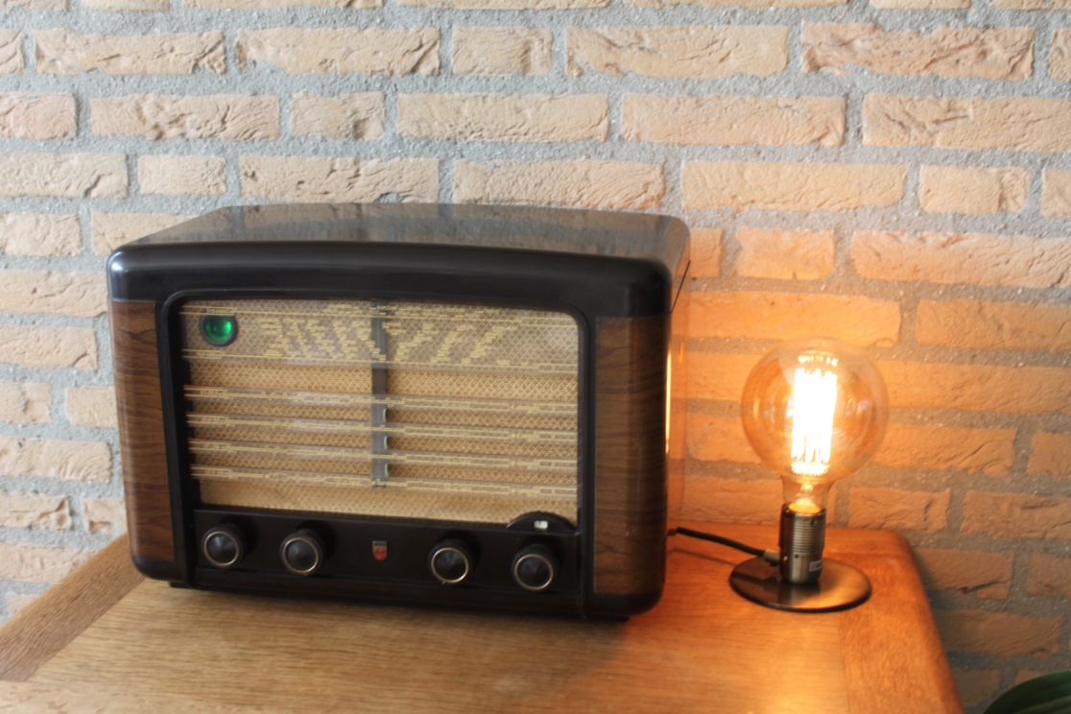

Figure 21 Philips BX490A (1949) Vintage Internet Radio

The radio is a Philips BX490A manufactured in the Netherlands in 1949. The purpose of this design is retain as much of the original look and feel of a vintage radio which has been converted to run as an Internet radio. It does not have any LCD display. In the above example the following controls are used:

* Far left switch - Simple tone control
* Middle left switch - Volume and mute switch
* Middle right switch – Radio channel (Tuner) or media track selection
* Far right switch – Menu switch (8 positions)
* Push button on right side (Not shown) - Standard menu switch

At the top left the so-called magic eye tuning indicator has been replaced with a Red,Green,Blue status LED. In the above picture the LED is glowing green (Normal operation). This window also contains the IR sensor and activity LED for a remote control. If the radio is busy (loading stations for example) it glows blue. For an error or shutdown the LED glows RED. The IR remote control also flashes red to indicate IR remote control activity.

The software allows espeak to be configured to ‘speak’ station and search information etc.

The details on how to construct a similar project is contained in the following documents:

<http://www.bobrathbone.com/raspberrypi/documents/Raspberry%20PI%20Vintage%20Radio.pdf>

<http://www.bobrathbone.com/raspberrypi/documents/Raspberry%20PI%20Vintage%20Radio%20Operating%20Instructions.pdf>

# Chapter 2 - Hardware overview

The principal hardware required to build the radio consists of the following components:

* Current versions of the Raspberry PI computer (Version 1 boards no longer supported)
* Push buttons or rotary encoders for the user interface
* A display such as a HD44870 LCD, OLED or a Raspberry PI touch-screen display

## Raspberry Pi computer

The **Raspberry Pi** is a credit-card-sized single-board computer developed in the United Kingdom by the [Raspberry Pi Foundation](http://en.wikipedia.org/wiki/Raspberry_Pi_Foundation) with the intention of promoting the teaching of basic computer science in schools.

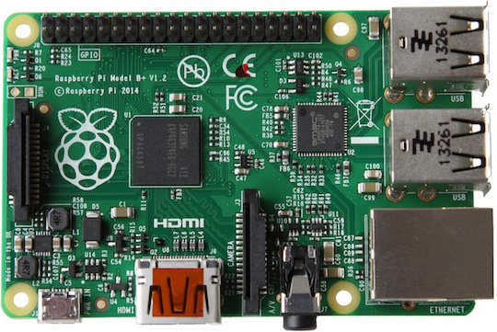

Figure 22 Raspberry PI Model 3B Computer

More information on the Raspberry PI computer may be found here: <http://en.wikipedia.org/wiki/Raspberry_Pi>

If you are new to the Raspberry PI try the following beginners guide. <http://elinux.org/RPi_Beginners>

|  |  |
| --- | --- |
|  |  |

Earlier versions of the Raspberry Pi have a separate audio output jack and composite video output.

Later versions of the Raspberry Pi have a new AV (Audio/Video) port which combines the audio and video signals in a single jack. Instead of using a standard composite cable, this new connector requires a 4 pole 3.55mm AV cable. To complicate matters: not all of these cables are the same! However existing audio jack plugs are compatible with the new AV connector.

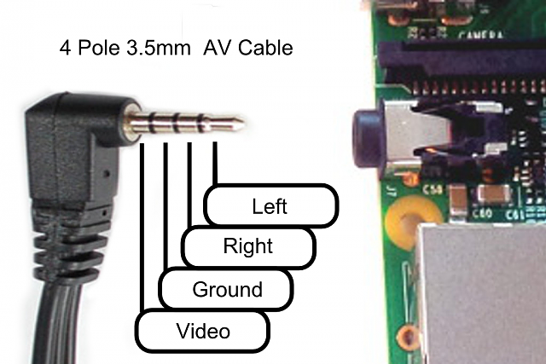

Figure 23 Raspberry PI B+ AV cable

When choosing a cable, seek an **iPod 4 pole AV** cable. This will however result in the left and right audio channels being reversed but otherwise provides the proper connections. Using other cables, such as a camcorder cable will be hit or miss. Typically, camcorder cables have the wrong pin connections for Video and Ground. This change also can cause some issues with shared grounding with audio speakers. If separate audio and composite AV connector is required, these can be split apart using the same jack inputs as for the model A and B.

## Raspberry Pi Zero and Pi Zero W

|  |  |  |
| --- | --- | --- |
| Pi Zero.jpg  Figure 24 Raspberry Pi Zero | On the original Pi Zero network connection is only possible with either a USB to Ethernet adapter or a Wi-Fi Dongle. Note that the USB is a Micro USB and will need an micro USB to standard USB adapter. The PiJack Ethernet adapter board is not currently supported. The Pi Zero W has onboard Wifi and Bluetooth and is a better choice for the radio. | USB Ethernet.jpg  Figure 25 USB Ethernet adapter |

Note: The Raspberry PI Zero does not have an onboard audio output jack. Sound must be played through either the HDMI port or a USB sound dongle (See Figure 11) or one of the Pi Zero DAC boards available from manufacturers such as **IQaudIO**, **HiFiBerry**, or **JustBoom**.

## The HD44870 LCD display

|  |  |
| --- | --- |
| Figure 26 The HD44870 LCD display    Figure 27 OLED 4 x20 LCD display | The HD44870 LCD interface is an industry standard interface for a variety of LCD displays. These can come in various sizes but the two lines by 2x16 or 4x20 character displays are the most popular. The software for this Internet radio supports either display. Most of these modules compatible with the Hitachi HD44870 LCD controller so there is a wide choice of these displays.  The latest displays use OLED displays (Organic Light Emitting Diode) and give very good results.  See <https://en.wikipedia.org/wiki/OLED>  For pin-out details see LCD pin outs on page 22. |

## Touch-screens

### Raspberry Pi 7-inch touch screen

As an alternative to building a radio using limited LCD screens it is possible to build a radio using the Raspberry Pi 7-inch or 3.5-inch touch screen or any other HDMI screen (touch-screen or otherwise). If the screen does not have touch capability then it is possible to use it with a mouse or keyboard or both. Also, the touch screen can be used in conjunction with rotary encoders or push buttons.

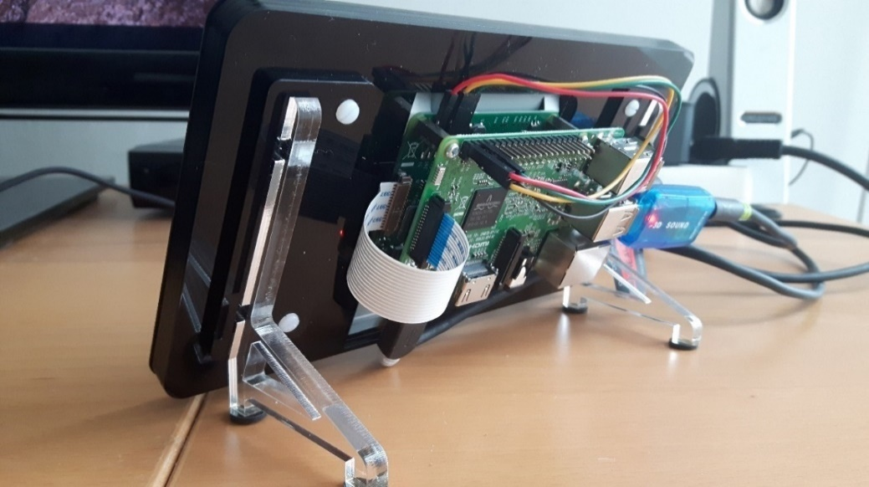

Figure 28 Raspberry Pi 3 with 7-inch touch screen

There is a very good setup guide for the Raspberry Pi touch-screen at:

<https://www.modmypi.com/blog/raspberry-pi-7-touch-screen-assembly-guide>

### Adafruit 3.5-inch TFT

From version 6.7 onwards the radio software supports the Adafruit 3.5-inch TFT touch screen (720 x 480 pixels). The small size can make the controls difficult to use but will still work.

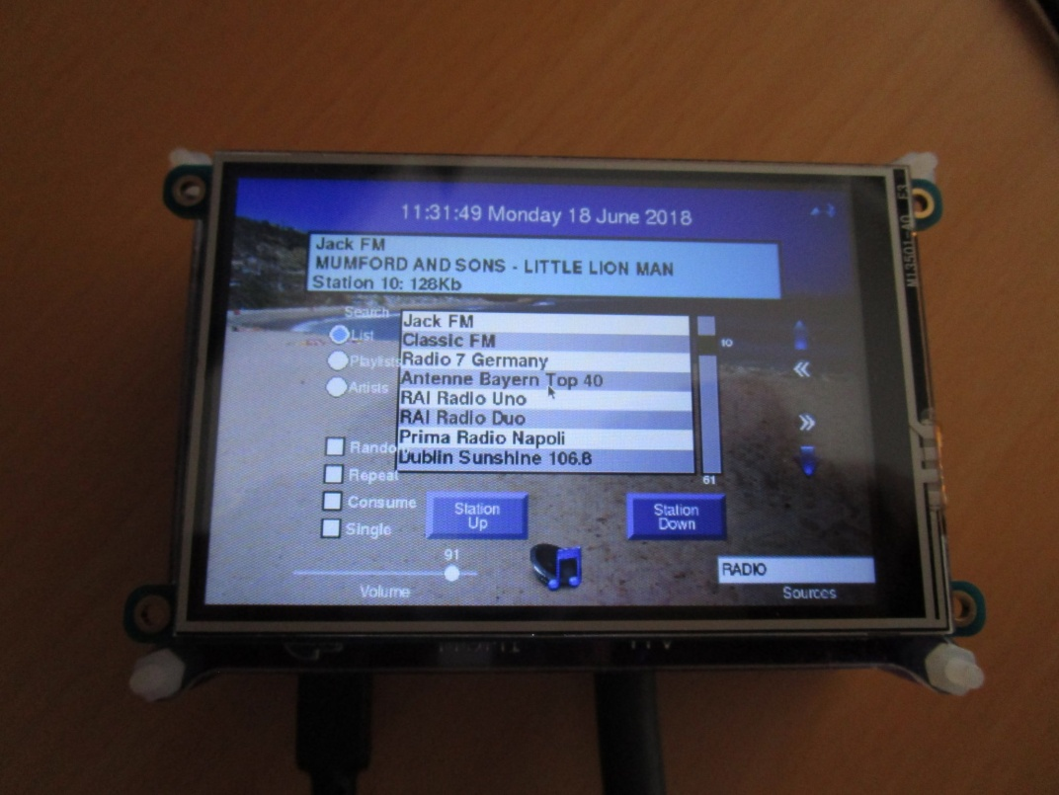

Figure 29 Adafruit 3.5 inch TFT touchscreen

Note: This software has only been tested with the Raspberry Pi 7-inch touch screen and the Adafruit 3.5-inch TFT touch-screen . Smaller than 7-inch screens may prove difficult to operate. The following resolutions are supported: 800x480, 720x320, 480x320 or 1024x600 pixels.

Please also note that touch screen functionality has nothing to do with the radio software. Touch screens emulate mouse functions such as click, drag and hover using standard mouse routines. Should you use another touch-screen other than the one recommended and this does not work then you need to solve this first (or use a mouse/keyboard). Regrettably the author cannot provide any support on how to configure other touch screens.

 **Warning**: During testing, a touch screen using USB-OTG (USB On-The-Go) technology was tried but was unsuccessful. Also attempts to enable USB OTG software seemed to disable the normal USB ports. USB-OTG technology allows USB devices to act as a host for other USB devices such as USB storage or cameras. The author regrettably cannot give any support on these types of screens.

If the screen is displaying upside-down then edit the **/boot/config.txt** configuration file and add the following line.

lcd\_rotate=2

Reboot the Raspberry Pi for the change to take effect.

### Using other touch screens

There are various other touch screens on the market but this version of the software does not support screen sizes of less the 480 x 320 pixels. There is a **screen\_size** parameter in **/etc/radiod.conf** configuration file.

# Size is in pixels. Supported is 800x480 (7" screen) or 720x480(3.5" screen)

# or 480x320 (2.8" or 3.5" screen)

screen\_size=800x480

Another important aspect of screen size are the following parameters in **/boot/config.txt**.

framebuffer\_width=1280

framebuffer\_height=720

Changing the above can force a console size. By default it will be display's size minus overscan settings in **/boot/config.txt.**

If using the Elecrow 7 inch TFT Capacitive touch screen display then see *C.2 -Elecrow 7-inch touch-screen notes* on page 227.

## Olimex OLED 128x64 pixel screen

|  |  |
| --- | --- |
| [Related image](https://www.google.com/url?sa=i&rct=j&q=&esrc=s&source=images&cd=&cad=rja&uact=8&ved=2ahUKEwihruDoq8vcAhUS2KQKHY_mAtUQjRx6BAgBEAU&url=https://www.terraelectronica.ru/news/4183&psig=AOvVaw2Pwug0fulOs3t3RiaTd44E&ust=1533195325192538) | The Olimex 128x64 pixel OLED is a low cost, low power, high contrast LCD display with a UEXT connector. It is controlled via the I2C interface. The power supply required is only in the range of 1 uA in sleep mode, 200 uA in operating mode and 7mA in display ON mode. View area is 21 x 11 mm. It is particularly useful where space is very limited.  See: <https://www.olimex.com/Products/Modules/LCD/MOD-OLED-128x64/open-source-hardware> |

Note: The Olimex OLED screen is not a particularly fast device when compared with say an LCD or graphics screen. However, its biggest advantage is its size.

## Pimoroni Pirate Radio

|  |  |  |
| --- | --- | --- |
| Figure 30 Pimoroni Pirate Radio - Rear view |  | The illustration on the left shows the rear of Pimoroni Pirate radio. The amplifier consists of dual I2S DAC/amplifiers for stereo audio (MAX98357A) at  3 Watts per channel.  The Pirate radio comes as a kit (Soldering skills required).  The Pimoroni software is disabled and the software from this project used instead. See *Installing Pimoroni Pirate Radio (pHat BEAT)* on page 82. |

## Radio variants

Before starting you need to make a choice which type of radio you are going to build. There are several combinations of user interface and display type which can be constructed as shown in the following tables.

|  |  |  |  |  |  |  |  |  |  |  |  |  |  |  |  |  |  |  |  |  |  |  |  |  |  |  |  |  |  |  |  |  |  |  |  |  |  |  |  |  |  |  |  |  |  |  |  |  |
| --- | --- | --- | --- | --- | --- | --- | --- | --- | --- | --- | --- | --- | --- | --- | --- | --- | --- | --- | --- | --- | --- | --- | --- | --- | --- | --- | --- | --- | --- | --- | --- | --- | --- | --- | --- | --- | --- | --- | --- | --- | --- | --- | --- | --- | --- | --- | --- | --- |
| Table 1 Display Type options   |  |  | | --- | --- | |  | Display Type | | 1 | Two-line 8-character LCD | | 2 | Two-line 16-character LCD | | 3 | Four-line 16-character LCD | | 4 | Four-line 20-character LCD | | 5 | Àdafruit 2x16 RGB Plate (I2C) | | 6 | Raspberry Pi 7-inch touch screen | | 7 | Olimex 128 by 64 pixel OLED | | 8 | Adafruit 3.5-inch TFT touch screen | | 9 | No display (Vintage radio design) | | 10 | Pirate Radio (No display) | | 11 | PiFace CAD 2x16 LCD, 6-buttons | |  | Table 2 User interface options   |  |  | | --- | --- | |  | User interface | | 1 | Five or six push buttons | | 2 | Two rotary encoders with push buttons | | 3 | Adafruit RGB plate with push buttons | | 4 | Raspberry Pi 7-inch touch-screen | | 5 | Adafruit 3.5 TFT (480x720 pixels) | | 6 | Mouse (HDMI/Touchscreen only) | | 7 | Keyboard (HDMI/Touchscreen only) | | 8 | IQaudIO Cosmic controller | | 9 | Pirate Radio – 6 push-buttons | | 10 | IR remote control – all versions | |

Any type of HD44870 LCD display can be used with any user interface. The HD44870 can either be connected directly to the GPIO pins or via a so-called I2C (also known as IIC) backpack.

The Afdafruit RGB plate has a two-line 16-character display and comes with five inbuilt pushbuttons.

It also has its own I2C interface using the MCP23017 chip so it does not require a separate I2C backpack.

The PiFace CAD comes with a two-line 16-character display and comes with six inbuilt pushbuttons. It uses the SPI interface from Motorola.

The touch screen can be used with or without rotary encoders or push buttons. The touch screen variants can also use a mouse and keyboard.

It is a simple choice of which display (two or four lines, 8, 16, or 20 characters LCDs or a touch screen or HDMI screen, OLED display or Pirate radio) and whether to use rotary encoders or push-button switches as the user interface. The rotary encoder options give the most natural feel for the radio as most conventional radios use knobs to control the volume and station tuning. The keyboard interface, whilst supported on the touch-screen versions, is a very limited option.

There is a configuration program called **configure\_radio.sh** which configures the choice of display and user interface required. It can be safely re-run at any time.

The vintage radio software (Display option 9) specifically intended for converting an old radio to an Internet radio whilst retaining the original look and feel of the radio. It has no LCD display.

The four lines LCD can display more information than two-line versions.

Note: The touch screen software (**gradio.py** or **vgradio.py**) cannot be run at the same time as the LCD version of the radio software (**radiod.py**). It is a case of using one or the other. It is however it is possible to switch between **gradio.py** or **vgradio.py** programs during operation.

## Connecting the LCD display

There are two ways of wiring up the display:

* Directly connect the LCD to the GPIO pins. This uses six GPIO pins.
* Connection via an I2C backpack. This uses the two-pin I2C interface

The first choice uses more wiring but is the cheapest option. The second choice uses an I2C backpack which is an extra component to be purchased. However, I2C backpacks are reasonably cheap.

## Housing the radio

This manual describes a couple of ways of housing the radio. A few ideas are below:

* A custom-built case as shown in this manual
* Old plastic boxes or food containers
* Construct a case using Lego
* Use a pair of speaker housings that have enough room
* Install in an old vintage radio (really cool)
* Use an old wooden wine box
* Use an old video recorder, CD player or desktop set
* Buy a PC speaker set with enough room to build in the radio.

|  |  |  |
| --- | --- | --- |
| Figure 31 Some examples of radio cases | | |
| F:\Raspberry PI\Raspberry PI project photos\Third party\Adrien Rouillon\DSC_0025.jpg | F:\Raspberry PI\Raspberry PI project photos\Third party\Aubrey Kloppers\oldradio.jpg | F:\Raspberry PI\Raspberry PI project photos\Third party\Jurgen Stroewer\stroewer2.jpg |
|  |  |  |
| F:\Raspberry PI\Raspberry PI project photos\Third party\Michael Uhlmaan\rara3.JPG | | F:\Raspberry PI\Raspberry PI project photos\Third party\Michael Kerscher\radio.jpg |

Take a look at the constructor’s gallery at <https://bobrathbone.com/raspberrypi/pi_internet_radio.html> to get some ideas that other constructors have used.

|  |  |
| --- | --- |
| note_icon.png | Note: Don’t forget to make sure that there is adequate airflow through the radio housing to allow cooling of the Raspberry PI and other components. If necessary, drill at least five or six holes at the top and bottom of the housing. |
| note_icon.png | If you decide to use a metal case (not advised) you will need a WiFi dongle with an aerial mounted externally to the case. Also, the case must be earthed at the main supply both for safety reasons and to prevent interference with sound and/or the LCD screen |

## Building in a IR sensor and remote control

|  |  |
| --- | --- |
| IR sensor and remote.JPG  Figure 32 IR Sensor and Remote control | The radio can be built with an IR Sensor and remote control. Also included is an activity LED which flashes when the remote control is used.  A **TSOP382xx** series IR Sensor is used in conjunction with almost any remote control.  An activity LED can also be added which flashes every time remote control signal is detected. The remote control provides the same functionality as the buttons or rotary encoders. |
| DSC00492.JPG  Figure 33 Adafruit and IR sensor and activity LED | The **AdaFruit** RGB plate can also be fitted with an IR sensor and activity LED but needs a model B+, 2B or 3B (40 GPIO pins) and 26 pin extender as shown in Figure 46 on page 27.  note_icon.pngNote that a 40 pin Raspberry PI is needed as the Adafruit Plate occupies all 26 pins on the 26 pin versions of the Raspberry PI. If not planning to fit an IR sensor and activity LED then the 26 pin version Raspberry Pi may be used. |

# Chapter 3 - Wiring

Table 4 and Table 5 on the following pages 19 and 20 respectively show the interface wiring for both the push button and rotary encoder versions of the radio. There are two versions of the wiring, 26 and 40 pin versions (Table 4 and Table 5 respectively). The connections used by the radio are highlighted in yellow. The **IQaudIO** or **JustBoom** and newer **HiFiBerry** DACs require 40 pin versions of the Raspberry Pi. The 40-pin version of the wiring is recommended for all new projects.

This is where it can get a little confusing. The radio components (LCD, buttons, rotary encoders etc.) can use either 26-pin or 40-pin wiring as shown in the two tables. The 26-pin version wiring can also be used on a 40-pin Raspberry Pi. The 40-pin version of the wiring in Table 5 guarantees that there will be no wiring conflicts with DAC components.

Things get more complicated with **HiFiBerry, Justboom** or **IQaudIO** Digital to Audio Converters (**DACs**). These devices give excellent audio output quality and naturally many constructors want to use these. However, they conflict with two GPIO pins that are used for the original radio wiring scheme.

Table 3 Radio wiring conflicts

|  |  |  |  |  |  |  |
| --- | --- | --- | --- | --- | --- | --- |
| **Pin** | **GPIO** | **Radio Function** | **Conflicts with** | **Use pin** | **GPIO** | **Note** |
| 12 | GPIO18 | Down switch | DAC | 19 | GPIO10 | **26 or 40 pin Rpi** |
| 15 | GPIO15 | LCD data 5 | IQaudIO Amp Mute | 31 | GPIO6 | **40 pin only Rpi** |

|  |  |  |  |
| --- | --- | --- | --- |
| Colour Legend | Radio | Conflict | Alternative wiring |

|  |  |
| --- | --- |
| note_icon.png | You are strongly advised to use the alternative 40 pin wiring scheme so that IQaudIO and **HiFiBerry** products and similar can be used either at the outset or at a later date. |

The configuration for the radio is contained in a file called **/etc/radiod.conf**. By default, this is configured for the 40-pin scheme. Every component of the radio is configurable in this configuration file. There is a program called **configure\_radio.sh** that is used to configure the settings in the **/etc/radiod.conf** file.

The original 26-pin Raspberry Pi’s had a GPIO conflict with GPIO 18 which was used by DACs. The down switch now uses GPIO 10 as a result.

down\_switch=18

Changed to:

down\_switch=10

|  |  |
| --- | --- |
| note_icon.png | Note: All settings in the **/etc/radiod.conf** file use GPIO numbers and NOT physical pin numbers. So in the above example **down\_switch** is GPIO **10** (Physical pin 19). |

|  |  |
| --- | --- |
| note_icon.png | If using DAC products do not use the 26 pin version of the wiring but use the wiring shown in Table 5 on page 20. |

Table 4 Controls and LCD wiring 26 pin version

|  |  |  |  |  |  |  |  |
| --- | --- | --- | --- | --- | --- | --- | --- |
| **Pin** | **Description** | **Radio**  **Function** | **Name** | **LCD**  **pin** | **Push**  **Buttons** | **Encoder**  **(Tuner)** | **Encoder**  **(Volume)** |
| 1 | 3V3 | +3V supply |  |  | COMMON |  |  |
| 2 | 5V | 5V for LCD |  | 2,15 |  |  |  |
| 3 | GPIO2 | I2C Data\* | I2C Data |  |  |  |  |
| 4 | 5V |  |  |  |  |  |  |
| 5 | GPIO3 | I2C Clock\* | I2C Clock |  |  |  |  |
| 6 | GND | Zero volts |  | 1,3\*,5,16 |  | Common | Common |
| 7 | GPIO 4 | Mute volume |  |  | MUTE |  | Knob Switch |
| 8 | GPIO 14 | Volume down | UART TX |  | LEFT |  | Output A |
| 9 | GND | Zero Volts |  |  |  |  |  |
| 10 | GPIO 15 | Volume up | UART RX |  | RIGHT |  | Output B |
| 11 | GPIO 17 | Channel Up |  |  | UP | Output B |  |
| 12 | GPIO 18\*\* | Channel Down |  |  | DOWN | Output A |  |
| 13 | GPIO 27 | LCD Data 4 |  | 11 |  |  |  |
| 14 | GND | Zero Volts |  |  |  |  |  |
| 15 | GPIO 22 | LCD Data 5 |  | 12 |  |  |  |
| 16 | GPIO 23 | LCD Data 6 |  | 13 |  |  |  |
| 17 | 3V3 | +3V supply |  |  |  |  |  |
| 18 | GPIO 24 | LCD Data 7 |  | 14 |  |  |  |
| 19 | GPIO 10\*\* | Channel Down | SPI-MOSI |  | DOWN | Output A |  |
| 20 | GND | Zero Volts |  |  |  |  |  |
| 21 | GPIO 9 | IR Sensor in (1) | SPI-MOSO |  |  |  |  |
| 22 | GPIO 25 | Menu Switch |  |  | MENU | Knob Switch |  |
| 23 | GPIO 11 | IR LED out (1) | SPI-SCLK |  |  |  |  |
| 24 | GPIO 8 | LCD E | SPI-CE0 | 6 |  |  |  |
| 25 | GND | Zero Volts |  |  |  |  |  |
| 26 | GPIO 7 | LCD RS | SPI-CE1 | 4 |  |  |  |

|  |  |  |  |
| --- | --- | --- | --- |
| Colour Legend | Radio | I2C (shared) | SPI Interface |

\* These pins are used for the I2C LCD backpack if used instead of the directly wired LCD to GPIO pins.

\*\* Pin 18 is used by some DACs so pin 10 should be used for the down switch.

Table 5 Radio and DAC devices 40 pin wiring

|  |  |  |  |  |  |  |  |  |
| --- | --- | --- | --- | --- | --- | --- | --- | --- |
| **Pin** | **Description** | **Radio**  **Function** | **Name** | **Audio DAC**  **Function** | **LCD**  **Pin** | **Push**  **Button** | **Encoder**  **(Tuner)** | **Encoder**  **(Volume)** |
| **1** | 3V3 | +3V supply | +3V | +3V |  | +3V |  |  |
| **2** | 5V | 5V for LCD | +5V | +5V | 2,15 |  |  |  |
| **3** | GPIO2 | I2C Data | I2C Data | I2C Data |  |  |  |  |
| **4** | 5V |  |  | +5V |  |  |  |  |
| **5** | GPIO3 | I2C Clock | I2C Clock | I2C Clock |  |  |  |  |
| **6** | GND | Zero volts | 0V | 0V | 1,3\*,5,16 |  | Common | Common |
| **7** | GPIO 4 | Mute volume |  |  |  | MUTE |  | Knob Switch |
| **8** | GPIO 14 | Volume down | UART TX |  |  | LEFT |  | Output A |
| **9** | GND | Zero Volts |  | 0V |  |  |  |  |
| **10** | GPIO 15 | Volume up | UART RX |  |  | RIGHT |  | Output B |
| **11** | GPIO 17 | Menu switch |  |  |  | MENU | Knob Switch |  |
| **12** | GPIO 18 |  |  | I2S CLK |  |  |  |  |
| **13** | GPIO 27 |  |  |  |  |  |  |  |
| **14** | GND | Zero Volts |  | 0V |  |  |  |  |
| **15** | GPIO 22 |  |  | Mute |  |  |  |  |
| **16** | GPIO 23 | Channel down |  | Rotary enc A |  | DOWN | Output A |  |
| **17** | 3V3 | +3V supply |  | 0V |  |  |  |  |
| **18** | GPIO 24 | Channel up |  | Rotary Enc B |  | UP | Output B |  |
| **19** | GPIO 10 |  | SPI-MOSI |  |  |  |  |  |
| **20** | GND | Zero Volts |  |  |  |  |  |  |
| **21** | GPIO9 |  | SPI-MISO |  |  |  |  |  |
| **22** | GPIO 25 | IR Sensor |  | IR sensor |  |  |  |  |
| **23** | GPIO 11 |  | SPI-SCLK |  |  |  |  |  |
| **24** | GPIO 8 | LCD E | SPI-CE0 |  | 6 |  |  |  |
| **25** | GND | Zero Volts |  | 0V |  |  |  |  |
| **26** | GPIO 7 | LCD RS | SPI-CE1 |  | 4 |  |  |  |
| **27** | DNC |  |  | PiDac+ Eprom |  |  |  |  |
| **28** | DNC |  |  | PiDac+ Eprom |  |  |  |  |
| **29** | GPIO5 | LCD Data 4 |  |  | 11 |  |  |  |
| **30** | GND | Zero Volts |  |  |  |  |  |  |
| **31** | GPIO6 | LCD Data 5 |  |  | 12 |  |  |  |
| **32** | GPIO12 | LCD Data 6 |  |  | 13 |  |  |  |
| **33** | GPIO 13 | LCD Data 7 |  |  | 14 |  |  |  |
| **34** | GND | Zero Volts |  |  |  |  |  |  |
| **35** | GPIO 19 | IQaudIO DAC+ | I2S | I2S |  |  |  |  |
| **36** | GPIO 16 | IR LED out |  |  |  |  |  |  |
| **37** | GPIO 26 |  |  |  |  |  |  |  |
| **38** | GPIO 20 | IQaudIO DAC+ | I2S DIN | I2S DIN |  |  |  |  |
| **39** | GND | Zero Volts |  |  |  |  |  |  |
| **40** | GPIO 21 | IQaudIO DAC+ | I2S DOUT | I2S DOUT |  |  |  |  |

|  |  |  |  |  |
| --- | --- | --- | --- | --- |
| Colour Legend | Radio | IQaudIO | I2C (shared) | SPI Interface |



Note: Make sure you are using the correct columns in the above wiring tables. Use column 6 (Push Buttons) for the push button version and the last two columns (Encoder Tuner/Volume) for the rotary encoder version.

## Version 1 boards (early boards)

Version 1 boards only had 26 pins and did not have internal pull-up resistors on the GPIO inputs. It has become increasingly difficult to support version 1.0 boards and you are advised to purchase a newer Raspberry Pi board for this project. Tips for using version 1 boards will be retained in this manual; however, if there is a problem, regrettably no support can be provided. As shown in the diagram below, wire one side of the switches to the 3.3V pin. Wire the other side of each switch to the GPIO pin as shown in the last column of the above table. Also wire this same side of the switch to the GND(0V) pin via a 10KΩ resistor.  See Figure 34 below.



Figure 34 Push-button Wiring version 1 boards

## Version 2, 3 or model B+ boards

Wire one side of the push-buttons the GPIO pin as shown in the last column of Table 5 on page 20. As from version 6.9 onwards the other side of the switches can be wired to either +3.3V (Original wiring scheme) or to GND (0V) (Preferred wiring scheme recommended for new projects). Whichever wiring you use, the radio configuration program will ask which wiring scheme is being used. Version 2 onwards boards have internal pull up/down resistors and don’t require external resistors. In fact, including these can cause problems.



Figure 35 Push-button wiring version 2 onwards boards

## Rotary encoder wiring

|  |  |  |  |
| --- | --- | --- | --- |
| Figure 36 Rotary Encoder Diagram | | | Rotary encoders have three inputs namely Ground, Pin A and B as shown in the diagram on the left. Wire the encoders according that shown in Table 4 on page 19. If the encoder also has a push button knob then wire one side to ground and the other to the GPIO pin. In the case of the mute switch this will be pin 7 (GPIO 4).  Version 1 boards are not supported but will probably work. |
| note_icon.png | Warning: The push switches (if fitted) on the rotary encoder are wired differently from the push buttons in the push button versions of the radio. For these encoders one side of the push button is wired to GND (not 3.3V) and the other to the relevant GPIO. | | |

If using a Revision 1 board it is necessary to use 10K pull up resistors connected between the GPIO inputs of the rotary encoder outputs and the 3.3-volt line. Do not add resistors if using revision 2 boards and onwards.

|  |  |  |
| --- | --- | --- |
| rotary_switch.jpg  Figure 37 Rotary encoder with push switch |  | This project uses a COM-09117 12-step rotary encoder from Sparkfun.com. It also has a select switch (by pushing in on the knob). These are “Incremental Rotary Encoders”. An incremental rotary encoder provides cyclical outputs (only) when the encoder is rotated. The other type is an absolute rotary encoder which maintains position information even when switched off (See Wikipedia article on rotary encoders). These tend to be bigger and more expensive due to extra electronics required Only incremental encoders are used in this project. |

The rotary encoders used in this project are wired with the COMMON or GND pin in the middle and the A and B outputs either side. However, some rotary encoders are wired with A and B as the first two pins and GND (COM) as the third pin. Note that not all encoders come with a switch, so separate switches for the Menu and Mute button will need to be installed. Check the specification for your encoders first.

|  |  |  |
| --- | --- | --- |
| 2-bit-rotary-encoder-pinout.png |  | Rotary-encoder-pinout.png |
| Figure 38 Rotary encoder pin-outs | | |

Note: Not all manufacturers’ rotary encoders will work with this project. If they work then fine if not regrettably you will need to purchase the recommended encoders.

## LCD Module Wiring

The following shows the wiring for a directly wired HD44870 LCD controller. It has 16 or 18 pins. There are two ways of wiring the LCD data lines using either the 26 pin or 40-pin wiring schemes (Table 4 and Table 5 respectively). For all new 40 pin Raspberry Pi’s the 40-pin wiring is strongly recommended. The 26-pin version of the wiring can be used on both 26 and 40 pin Raspberry Pi’s.

Table 6 LCD module wiring for 26 and 40 pin Raspberry Pi's

|  |  |  |  |  |  |
| --- | --- | --- | --- | --- | --- |
| LCD Pin | GPIO  26 pin | Pin  26 # | GPIO  40 pin | Pin  40 # | Description |
| 1 | n/a | 6 | n/a | 6 | Ground (0V) – Wire this directly to LCD pin 5 |
| 2 | n/a | 2 | n/a | 2 | VCC +5V |
| 3 | n/a | Note1 | n/a | Note1 | Contrast adjustment (0V gives maximum contrast) |
| 4 | GPIO7 | 26 | GPIO7 | 26 | Register Select (RS). RS=0: Command, RS=1: Data |
| 5 | n/a | 6 or 9 | n/a | 6 or 9 | Read/Write (RW). Very important this pin must be grounded!  R/W=0 (GND): Write, R/W=1 (+5V): Read.  Will damage the PI if not grounded (0V). Wire LCD pin 5 and 1 together |
| 6 | GPIO8 | 24 | GPIO8 | 24 | Enable (EN) |
| 7 |  |  |  |  | Data Bit 0 (Not required in 4-bit operation) |
| 8 |  |  |  |  | Data Bit 1 (Not required in 4-bit operation) |
| 9 |  |  |  |  | Data Bit 2 (Not required in 4-bit operation) |
| 10 |  |  |  |  | Data Bit 3 (Not required in 4-bit operation) |
| 11 | GPIO27 | 13 | GPIO5 | 29 | Data Bit 4 (D4) |
| 12 | GPIO22 | 15 | GPIO6 | 31 | Data Bit 5 (D5) Note if using IQaudIO products GPIO22 conflicts !! |
| 13 | GPIO23 | 16 | GPIO12 | 32 | Data Bit 6 (D6) |
| 14 | GPIO24 | 18 | GPIO13 | 33 | Data Bit 7 (D7) |
| 15 | n/a | 2 | n/a | 2 | LED Backlight Anode (+5V) or Red LED (Adafruit RGB plate ) [2] |
| 16 | n/a | 6 or 9 | n/a | 6 or 9 | LED Backlight Cathode (GND) or Red LED [2] |
| 17 |  |  |  |  | Optional Green LED (Adafruit RGB plate) [2] |
| 18 |  |  |  |  | Optional Blue LED (Adafruit RGB plate) [2] |

If using **IQaudIO** or similar products it is necessary to use the 40-pin version of the wiring (See Table 5).

|  |  |
| --- | --- |
| note_icon.png | **Note 1**: The contrast pin 3 (VE) should be connected to the center pin of a 10K potentiometer. Connect the other two pins of the potentiometer to 5v (VDD) and 0v (VSS) respectively. Adjust the preset potentiometer for the best contrast. If you do not wish to use a contrast potentiometer then wire pin 3 (VE in the diagram below) to GND (0V). |
| note_icon.png | **Note 2:** The standard LCD comes with 16 pins. Adafruit supply an RGB backlit LCD with two extra pins namely pins 17 and 18. These are non-standard. These must be wired to ground (0 Volts) to work. For more information see the section *Using the Adafruit* backlit RGB LCD display on page 53. |

The following diagram (Courtesy [protostack.com](http://www.prostack.com)) shows the electrical connections for the standard 16 pin LCD.

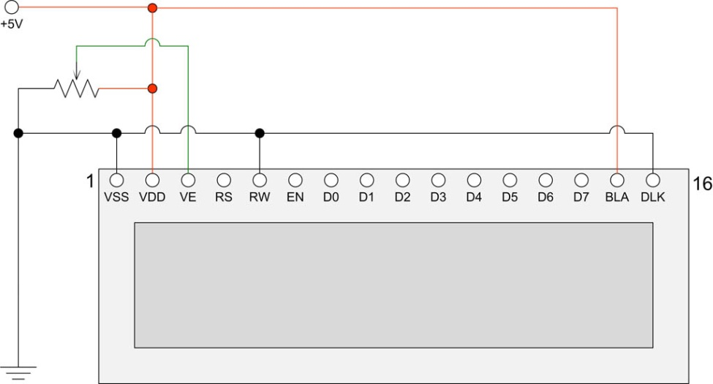

Figure 39 HD44870 LCD electrical circuit

|  |  |  |
| --- | --- | --- |
| note_icon.png | The standard LCD comes with 16 pins. Adafruit supply an RGB backlit LCD with two extra pins namely pins 17 and 18. These are non-standard. These must be wired to ground (GND 0 Volts) to work. For more information see the section *Using the Adafruit* backlit RGB LCD display on page 53. | |
| Wire pin 1 and 5 together  Figure 40 Wire LCD pin 1 (GND) and 5 (RW) together | | The Read/Write (RW) pin 5 must be connected to pin 1 (0V). It is very important that this pin is grnote_icon.pngounded!  If pin 5 is not grounded it will damage the Raspberry PI. Always wire LCD pin 5 and 1 directly together. Do not rely on grounding pin 5 with a GND wire on the connector. If this wire drops off then the LCD data lines will be put into write mode putting +5V on the GPIO pins which will probably cause irreparable damage to the Raspberry Pi. If using an I2C backpack this step is not necessary as it is already done in the backpack. |
| note_icon.pngnote_icon.pngnote_icon.pngnote_icon.png | Warning – Some LCD displays such as Midas have a different voltage arrangement for Pin 15 and Pin 5 (Contrast). Pin 15 is an output which provides a negative voltage ( VEE) which connects to one end of the 10K contrast potentiometer and the other end to +5V (VDD). Connecting +5 Volts to pin 15 will destroy the LCD device.  DO NOT USE THESE DEVICES UNLESS YOU KNOW WHAT YOU ARE DOING.  If using a 16x4 LCD although not directly supported then set the **lcd\_width** statement in **/etc/radiod.conf** to 16 (lcd\_width=16).  Note: All settings in the **/etc/radiod.conf** file use GPIO numbers and NOT physical pin numbers. So in the above example **lcd\_width** is GPIO 16 (Physical pin 36).  From version 5.9 onwards there is a new program called wiring.py which will display physical the wiring required for the settings found in **/etc/radiod.conf**. See page 174. | |

## Power supply considerations

The Raspberry Pi uses a standard Micro USB (type B) power connector, which runs at +5V. In general the Raspberry PI can draw up to 700mA. Many telephone adapters deliver less than that and can lead to problems. You also need to consider the LCD screen which can also need up to 20mA but depends on the type of backlight. However due to the extra current that can be drawn by connected USB or other devices, a 2.5A supply will be needed.

Try to find a power adapter that delivers at least 1.5 Ampere. As mentioned above a 2.5A supply may be required if USB are used. See the following article. The newer RPi models can draw up to 1.5 Amps if USB peripherals or sound cards are attached.

<http://elinux.org/RPi_VerifiedPeripherals#Power_adapters>

The Raspberry PI can be powered either the USB port or via the GPIO header (Pin 2 or 4). Some prototyping boards such as the Ciseco Humble PI can provide power in this way.

Visit <https://www.modmypi.com>

This interface board can be ordered with an optional 5-volt regulator. If using the Humble PI try with regulator use 6v to 7v as the power input to the Humble PI 5v regulator (Not the Raspberry PI). Trying to use 9v or more will mean that the 5-volt regulator will get far too hot.

If using an adaptor or separate 5-volt Power Supply try to use a switched-mode power supply adaptor. This take less current and generate less heat that a power dissipation device. If a power supply is designed to be earthed then use a 3-core cable with live, neutral and earth wires.

Things not to do:

* Do not try to tap off power from the Power supply or transformer used by the speaker’s amplifier. This won’t work (earth loops) and can cause damage to the PI and peripherals.
* Do not tap off (cascade) from the amplifier DC supply (12 volts for example) with another 5V voltage regulator. This will most likely cause interference.
* Do not feed power to the PI from two sources (USB hub and Power adapter). Try to use USB hubs that don’t feed 5 volts back through the USB ports of the Raspberry PI
* Do not connect an untested power supply to the Raspberry PI without checking the voltage first.

Things to do:

* Use double pole mains switches for isolating the mains supply when switched off. A lot of European plugs can be reversed leaving the live wire un-switched if using a single pole switch.
* If using a metal case always earth it and use a three-pin plug with earth pin.
* In general feed the 5-volt supply via the Raspberry Pi rather than via the GPIO header. This is because the Raspberry Pi is fitted with a so-called poly-fuse for protection.

You should try to use a single power supply switch for the radio. Connect the AC power supply of the adaptor to the mains switch. This switch can also provide the mains supply to the speaker amplifier. Also see the section on preventing electrical interference on page 26.

|  |  |
| --- | --- |
| electric_shock.png | **Always consider safety first and make sure that no-one including yourself can receive an electric shock from your project including when the case is open.**  **Also see disclaimer on page 209.** |

## Selecting an audio amplifier

There is a wide range of amplifiers that can be used with the radio which fall into four main categories:

1. A set of PC speakers with amplifier (Logitech or similar) – the simplest option
2. A dedicated AB or Class D stereo amplifier (Velleman or similar)
3. A combined DAC and amplifier from manufacturers such as **IQaudIO**, **HiFiBerry** or **JustBoom**
4. The audio stage of an existing (vintage) radio. Use the PA or record player input (Usually mono only)

|  |  |
| --- | --- |
| http://bpc.h-cdn.co/assets/16/18/480x480/gallery-1462307309-logitech-z150-speakers.jpg  Figure 41 PC speakers | http://www.parts-express.com/Data/Default/Images/Catalog/Original/320-212_HR_0.jpg  Figure 42 Velleman 30W stereo amplifier |
|  |  |
| https://www.raspberrypi.org/wp-content/uploads/2015/07/dac.jpg  Figure 43 IQaudIO DAC and 20W Amplifier | http://askja.se/onewebmedia/Radio/Blaupunkt_Santos/baksida.jpg  Audio Input  Figure 44 Vintage radio PA input |
| note_icon.pngThe above manufacturer’s boards are examples only and do not imply any specific recommendations. | |

## GPIO Hardware Notes

The following shows the pin outs for the GPIO pins on revision 1 and 2 boards. For more information see: <http://elinux.org/RPi_Low-level_peripherals>.

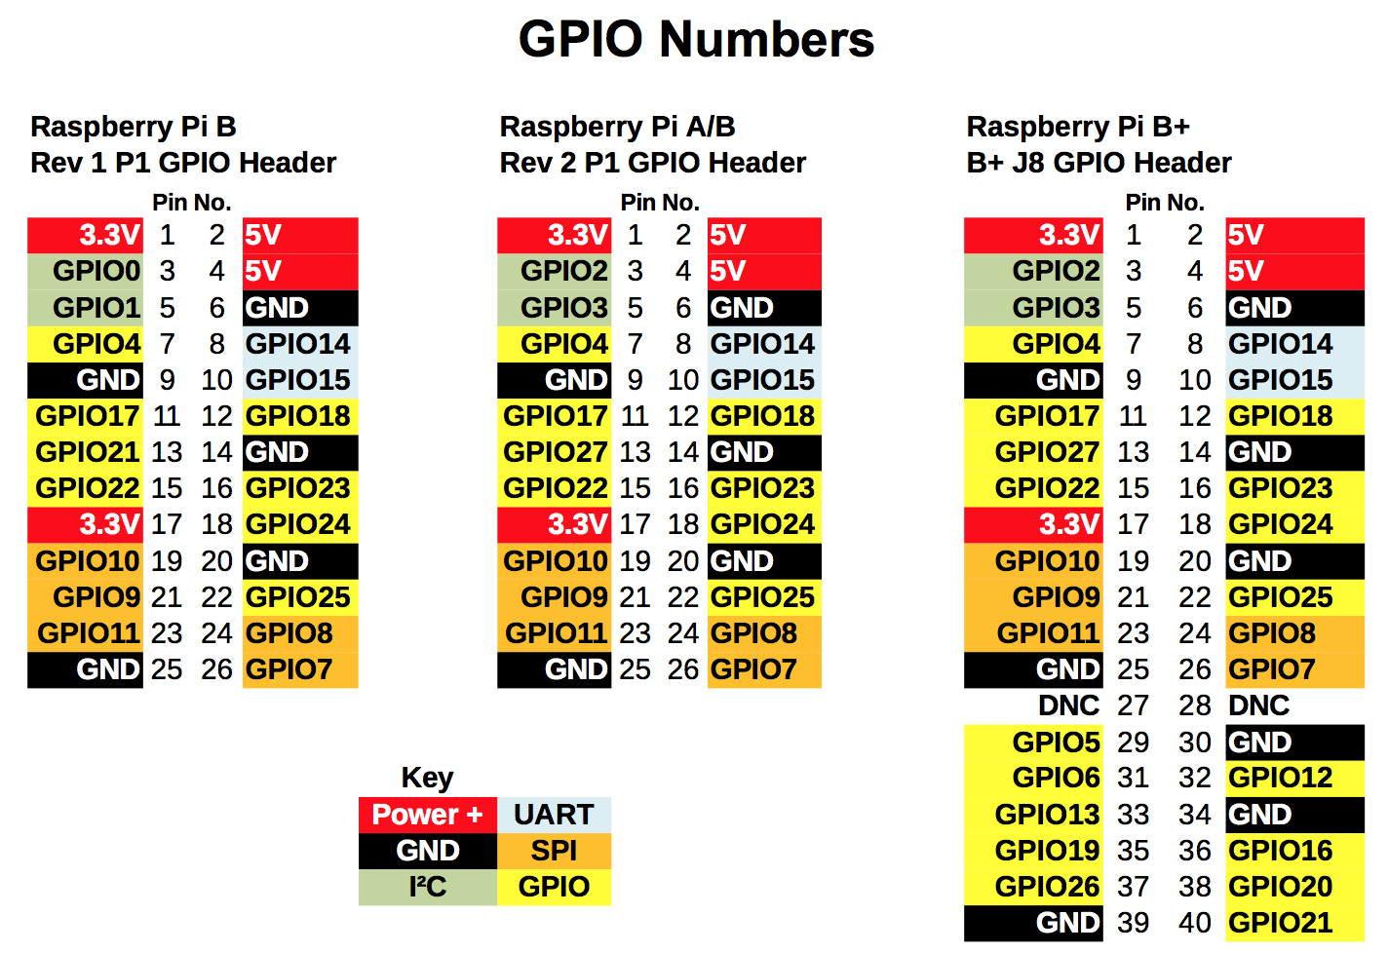

Figure 45 GPIO Numbers

Note: The B+, 2B and 3B have the same pin-outs.

|  |  |  |  |
| --- | --- | --- | --- |
| 26 pin header.jpg  Figure 46 26 pin header extender | |  |  | | --- | --- | | note_icon.png | If connecting any 40 pin interface board via a 26 way ribbon cable it will be necessary to fit a 26 pin header extender and plug the ribbon cable into it. | |

## Parts List

The following table shows the parts list for the Raspberry PI Internet Radio. This list is for the version using the HD44870 LCD directly connected to the GPIO pins. If using the Adafruit five button LCD Plate then don’t order the parts marked with an asterix (\*)

Table 7 Parts list (LCD versions)

|  |  |  |  |  |
| --- | --- | --- | --- | --- |
| Qty |  | Part |  | Supplier |
| 1 |  | Raspberry Pi Computer |  | [Farnell Element 14](http://uk.farnell.com/) |
| 1 |  | Clear Raspberry Case |  | [RS Components](http://www.rs-components.com/index.html) |
| 1 |  | 8GByte SD Card |  | Any PC or Photographic supplier |
| 1 |  | Radio Case |  | See Housing the radio page 16 |
| 1 |  | Raspbian Stretch OS |  | Raspberry Pi foundation downloads |
| 2 |  | Four inch loudspeakers |  | From set of old PC speakers |
| 2 |  | Four inch loudspeaker grills |  | Any electronics shop |
| 1 |  | Stereo Amplifier (3 to 35 watt) |  | Any electronics shop |
| 1 |  | Transformer for amplifier |  | Any electronics shop |
| 1 |  | LCD HD44870 2 x 16 Display \* |  | [Farnell Element 14](http://uk.farnell.com/) |
| 1 |  | Prototype board |  | [Ciseco PLC](http://shop.ciseco.co.uk/) |
| 4 |  | Round push buttons \* |  | Any electronics shop |
| 1 |  | Square push button \* |  | Any electronics shop |
| 2 |  | Rotary encoders if using this option \* \*\* |  | [Sparkfun.com](http://www.sparkfun.com) |
| 1 |  | 26 or 40 way ribbon cable |  | [Tandy](http://www.tandyonline.co.uk/) or [Farnell Element 14](http://uk.farnell.com/) |
| 5 |  | 10KΩ resistors \* (Revision 1 boards only) |  | [Tandy](http://www.tandyonline.co.uk/) or [Farnell Element 14](http://uk.farnell.com/) |
| 5 |  | 1K resistors \* (Revision 1 boards only) |  | [Tandy](http://www.tandyonline.co.uk/) or [Farnell Element 14](http://uk.farnell.com/) |
| 1 |  | Four port USB hub (Revision 1 & 2 boards only) |  | Any PC supplier |
| 1 |  | External power supply for USB hub (1200 mA) |  | Any PC supplier |
| 1 |  | 26 way PCB mount male connector |  | Any electronics shop |
| 1 |  | 26 way GPIO extender (model B+ boards only) |  | [ModMyPi](http://www.modmypi.com) and others |
| 1 |  | Mains cable |  | Hardware shop |
| 1 |  | Double pole mains switch with neon |  | [Farnell Element 14](http://uk.farnell.com/) |
| 5 |  | Male 2 pin PCB mount connectors |  | Any electronics shop |
| 2 |  | Female 4 pin PCB connectors |  | Any electronics shop |
| 1 |  | Female 2 pin PCB connectors |  | Any electronics shop |
| 1 |  | 16 pin male in-line PCB mount connector |  | Any electronics shop |
| 1 |  | Stereo jack plug socket |  | Any electronics shop |
| 1 |  | Panel mount Ethernet socket |  | Any electronics shop |
| 1 |  | Adafruit I2C LCD interface Backpack \*\*\* |  | <http://www.adafruit.com/> |
| 1 |  | TSOP38238 IR Sensor |  | Adafruit industries and others |
| 1 |  | Red or Green LED and 220 Ohm resistor |  | Any electronics shop |
| 1 |  | Optional sound card (DAC) |  | IQaudIO, HifFiBerry or JustBoom |
|  |  | Shrink wrap and thin wire for PCB wiring |  | Any electronics shop |

\* These components are not required if using the Adafruit LCD plate.

\*\* If using rotary encoders.

\*\*\* If using the Adafruit I2C backpack

The above list is not relevant if using a touch screen except when used with rotary encoders or push buttons.

# Chapter 4 - Construction details

## Construction using an interface board

It isn’t necessary to construct the radio connect via an interface board but it does make maintenance easier and is much more reliable and will be needed if you wish to connect to the Raspberry Pi using a ribbon cable. Always bring the ribbon cable into the top of the board as shown in Figure 47 below. If the ribbon cable is connected to the back (underside) of the board the two rows of the 40-pin connector will be swapped over. In the next section how to use breakout boards is covered which may be an easier alternative for many constructors rather than building your own.

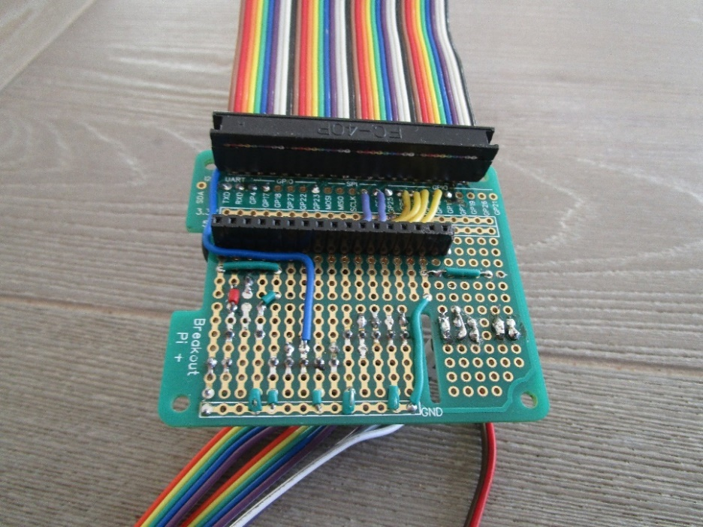

Figure 47 40-pin Interface board with ribbon cable

The figure below shows a 4x20 HD44870 LCD plugged into the interface board.

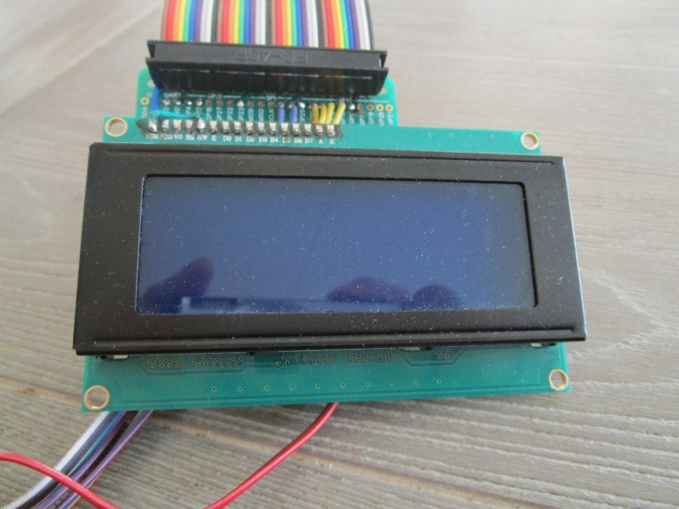

Figure 48 Interface board with LCD screen attached

Below is the other side of the interface board showing the connections to the rotary encoders, an IR sensor the IR activity LED.

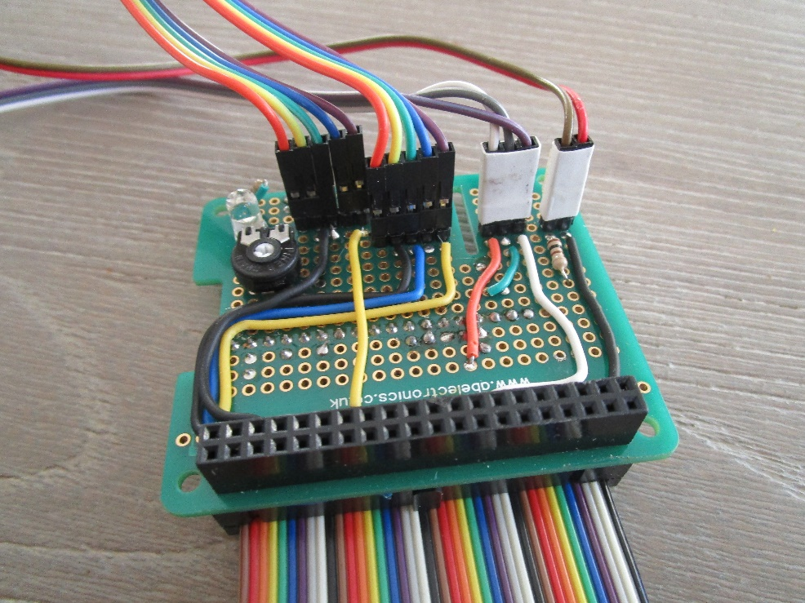

Figure 49 Radio controls connections

Below is the complete overview of the interface card with some test rotary encoders, an IR sensor the IR activity LED.

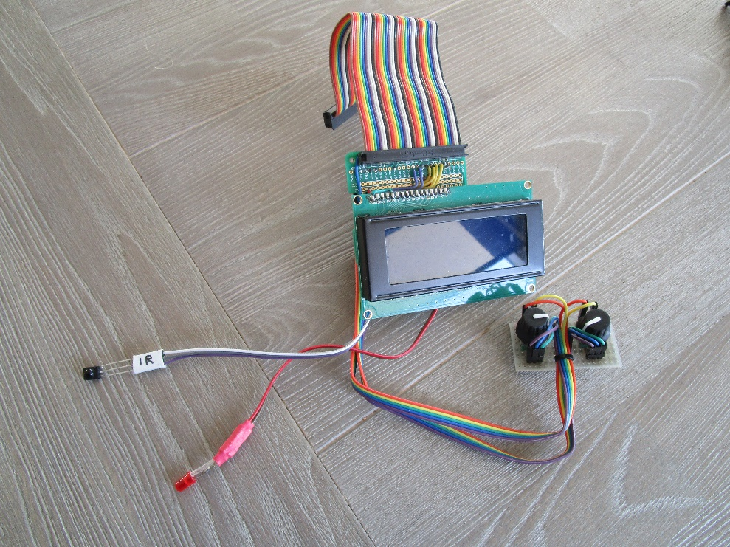

Figure 50 Interface board overview

There are various interface boards available on the market for both 26-pin and 40-pin Raspberry PIs.

## Construction using breakout boards

When this project was begun in the early days of Raspberry Pi there was very little in the way of breakout boards. It was necessary to make connections to button, LCDs and Rotary encoders either direct on the GPIO header or via an especially constructed breakout board. Things became more complex when digital sound cards (DAC) were introduced as these occupied the GPIO header and either did not extend the header pins, or if they did so, only extended a few of them.

This has now changed and there is a wide variety of breakout boards available.

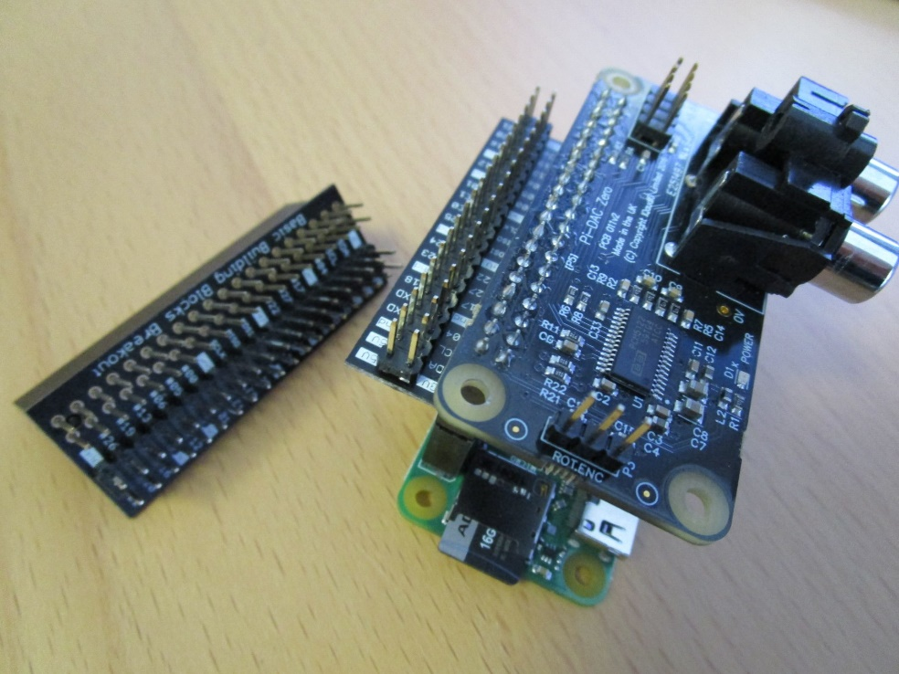

Figure 51 GPIO header breakout board

On the left of the above photo is an example of the 4Tronix GPIO breakout and extender board. On the right of the same photo is the break-out board used with a Raspberry Pi Zero W and an IQaudIO DAC plus. All 40-pins are now made available, except for those used by the DAC, to attach buttons and the like to the GPIO pins.

These boards are available from <http://4tronix.co.uk>

See:

<https://shop.4tronix.co.uk/products/gpio-interceptor-gpio-breakout-for-40-pin-raspberry-pi>

|  |  |
| --- | --- |
| note_icon.png | **Note:** Soldering skills are required to solder the 40-pin header to the breakout board.  The above breakout board is only shown as an example and many more are available on the Internet. |

## Construction using an Adafruit LCD plate

### Introduction

This section is for the radio using an Adafruit RGB-backlit LCD plate for Raspberry PI. The complete instructions for both ordering and building this product are available from the following web site: <http://www.adafruit.com/products/1110> (See tutorials)

**Note:** Don’t confuse this product (which has an I2C interface chip) with the two-line and four-line RGB LCDs which Adafruit also sell.

|  |  |  |
| --- | --- | --- |
| IMG_3677.JPG  Figure 52 Adafruit LCD plate | | The Adafruit LCD plate is designed to directly into the GPIO header on the Raspberry PI. These fit into a female 26 way header. If you want to connect the Adafruit LCD via a ribbon cable you will need to mount a 26 way male header instead of the female header and you will also need to construct a reversing board (Shown on the left of the picture on the left). Because ribbon cable swaps the two rows of pins over the reversing card is required to swap the two rows of pins back to their correct orientation. |
|  | |  |
| IMG_3679.JPG  Figure 53 Adafruit LCD plate with ribbon cable adapter | | Back view of the reversing board plugged into the Adafruit LCD plate.  The GPIO pins used are:   1. 3.3 Volts 2. 5.0 volts 3. SDA0 4. - 5. SCL0 6. Ground |
| note_icon.png | **Note 1:** If you are going to plug the Adafruit LCD plate directly into the GPIO header on the Raspberry PI then you don’t need the above reversing plate. Just follow the construction instructions on the tutorial on the Adafruit site. | |
| note_icon.png | **Note 2:** The “Select” button on the Adafruit plate is the “Menu” button for the radio. | |

### Using other switches

The Adafruit Plate comes with five 4-pin switches which are mounted on the interface board. You will almost certainly want to use other switches say mounted on a front panel. It doesn’t matter which type of switch you use as long as it is a push to make type. The only reason that a four-connector switch is used is for mechanical strength. If you look closely you will see push button symbol between pins 2 and 4 and 1 or 3 on the component side for four of the switches. Either 2 and 4 and 1 or 3 should be connected to the switches.

It is advisable to solder two posts (male pins) for each switch on the reverse side of the board (The non-component side). Don’t solder wires directly into the board. It is better to use push-on jumper wires connected to the switches to connect to the posts on the card.

**Note:** Rotary encoders cannot be used with the Adafruit Plate as these require three connections and the Adafruit routines to utilise them are not supplied by Adafruit.

### Using the Adafruit LCD plate with the model B+, 2B and 3B

The plate is designed for revisions of the Raspberry Pi. It uses the I2C (SDA/SCL) pins. Adafruit supply a special extra tall 26-pin header so the plate sits above the USB and Ethernet jacks. For Pi Model B+, the resistors sit right above the new set of USB ports. To keep them from shorting against the metal, a piece of electrical tape must be placed on the top of the USB ports.

### Using alternatives to the Adafruit display

Caution is advised. There are a number RGB boards which are compatible with the software provided by Adafruit Industries. Below is such an example of a Chinese 1602 I2C LCD. When originally tried the backlight wasn’t lit and it was necessary to wire Pin 1 (GND 0V) and Pin 16 (Backlight). This is no longer necessary from version 5.10 onwards as the backlight is software controlled.

|  |  |  |
| --- | --- | --- |
| Figure 54 Chinese 1602 I2C LCD  Note that the RGB part is a RGB LED that you see shining very brightly in the above picture. It is not actually lighting up the LCD backlight unlike the Adafruit RGB plate. |  | **220 or 330 Ohm resistor**  Figure 55 Enabling the backlight.  If running the radio version 5.9 or earlier then solder a 220 or 330 Ohm resister between pin 1 (0V GND) and pin 16 (Backlight). Version 5.10 or above this is no longer necessary. |

To switch off the very bright RGB light switch off the colour definitions in **/etc/radiod.conf.**

For example: **bg\_color=OFF**

## Construction using an I2C LCD backpack

Skip this section if you are not using an I2C backpack. There are two versions of the backpack supported:

1. Adafruit I2C backpack using an MCP23017 port expander – Hex address 0x20
2. Arduino I2C backpack using a PCF8574 port expander – Hex address 0x27 or 0x37

The I2C interface only requires two signals namely the I2C Data and Clock. This saves six GPIO pins when compared with the directly wired LCD interface. See <https://www.adafruit.com/product/292>.

The radio software also supports the more common PCF8574 chip based backpack popular with the Arduino hobby computer may also be used. See <http://www.play-zone.ch/en/i2c-backpack-pcf8574t-fur-1602-lcds-5v.html> for example.

This is configurable in the **/etc/radiod.conf** file.

# The i2cbackpack is either ADAFRUIT or PCF8574

# i2c\_backpack=PCF8574

i2c\_backpack=ADAFRUIT

**Note:** In previous versions the **i2c\_backpack** parameter was incorrectly shown as PCF8475 instead of PCF8574. Check the **/etc/radiod.conf** file.

### Adafruit I2C Backpack

|  |  |
| --- | --- |
| LCD_I2C_BackPlate_1.jpg  Figure 56 Adafruit I2C Backpack | The Adafruit I2C/SPI backpack interface is shipped as shown in the diagram opposite. There are no connectors shipped to connect to the LCD itself to this interface. These must be ordered separately.  Order a 16 in-line connector. |
|  |  |
| LCD_I2C_BackPlate_2.jpg  Figure 57 LCD connected to an Adafruit I2C backpack | The diagram shown on the left shows a 2x16 character LCD connected to the I2C backpack.  The wiring right to left is:   1. LAT (Unused) 2. Blue: I2C Data – GPIO pin 3 3. Yellow: I2C Clock – GPIO pin 5 4. Red: +5 volts – GPIO pin 2 5. Black: GND (0 volts) – GND pin 6   The I2C Data (DAT) connects to pin 3 on the Raspberry Pi GPIO header and the I2C Clock (CLK) to pin 5 on the GPIO header. |

### Arduino PCF8574 I2C backpacks

These types of backpack are popular with Arduino users. The device address is usually hex 0x27. Another manufacture may use hex 0x37. This is configurable in the radio configuration program.

|  |  |
| --- | --- |
| Figure 58 Arduino I2C backpack  i2c\_backpack=PCF8574  #i2c\_backpack=ADAFRUIT | The wiring From top to bottom is:   1. GND (0 volts) – GPIO pin 6 2. VCC +5 volts – GPIO pin 2 3. SDA I2C Data – GPIO pin 3 4. SCL I2C Clock – GPIO pin 5   The blue potentiometer on the right is the contrast adjustment.  To use this device either amend the **i2c\_backpack** parameter in **/etc/radiod.conf** (Comment out the ADAFRUIT line) or run the configure\_radio.sh program. |

### Creating the interface board for the I2C back pack

An interface board is recommended to connect the I2C backpack and rotary encoders etc. to the GPIO interface. Any number of Raspberry Pi prototyping boards are available for all versions of the Rasberry Pi. The Ciseco Humble Pi prototype board shown in Figure 59 has been discontinued.

|  |  |
| --- | --- |
| DSC00831.JPG  Figure 59 Ciseco Humble PI I2C interface board | DSC00829.JPG  Figure 60 The I2C backpack interface board |
| The above figure shows the I2C interface board using the Ciseco Humble PI (Discontinued). The header pins in the centre from left to right are, I2C interface connector (4 pins), Volume rotary encoder (5 pins), Channel rotary encoder (5 pins), IR sensor (3 pins) and front panel LED (2 pins). In this version there are two rows of 18 pins (male and female) to allow different I2C backpack to be connected. You will normally only need one or the other. | The above diagram shows the Adafruit I2C backpack connected to the interface board along with the rotary encoders. The 26-pin male header connects to the GPIO ribbon cable on the Raspberry PI. On the left is a 6V to 9V power input feeding a 5 Volt regulator. |

## Construction using the Adafruit 3.5 inch TFT

**Note:** There are two types of TFT touch-screen available screen available from Adafruit namely Capacitive or Resistive. The one used in this project was the 3.5-inch Resistive type.

The installation instructions can be found on the Adafruit web site:

<https://cdn-learn.adafruit.com/downloads/pdf/adafruit-pitft-3-dot-5-touch-screen-for-raspberry-pi.pdf>

Or from the Bob Rathbone web site:

<http://bobrathbone.com/raspberrypi/documents/Adafruit/adafruit-pitft-3-dot-5-touch-screen-for-raspberry-pi.pdf>

Software installation is also covered in the above manual. Below is the easy installation script from the manual. The supported resolution is 720 x 480 pixels. Smaller resolutions are not supported.

$ wget https://raw.githubusercontent.com/adafruit/Raspberry-Pi-Installer-Scripts/master/adafruit-pitft.sh

$ chmod +x adafruit-pitft.sh

$ sudo ./adafruit-pitft.sh

The TFT screen should be calibrated using the **evtest** program

$ sudo apt-get install evtest tslib libts-bin

$ sudo evtest /dev/input/touchscreen

See the Adafruit manual for the full procedure.

## Fitting a wake-up button

One of the features of this radio’s design is that the menu button (LCD versions) or a special key (Touchscreen version) can do an orderly system shutdown. This is more desirable, and certainly safer and more convenient than pulling the power plug out. The system when properly shutdown goes into a so-called halt state. If the power is left connected the Raspberry Pi, it can be woken up by a button connected between pins 5(GPIO3) and 6(GND).

|  |  |
| --- | --- |
| Figure 61 Wake-up button | On the left is the Raspberry Pi unit which is running the radio on a TV with HDMI inputs as shown in Figure 2 on page 4. A small black wake-up button is fitted to the case and connects to physical pins 5 and 6. When pressed with the Raspberry Pi in a halt state but power still applied it will start its boot-up sequence. It should be noted that pin 5 (GPIO3) is also used as the I2C data line. Although the button could still be fitted it is probably not a good idea as it will disrupt the I2C signal if the wake-up button is pressed. |

## Installing an IR sensor and remote control

**Note:**  This installation procedure is only for LCD versions of the radio. If using a HDMI or Touchscreen display see *Installing the FLIRC USB remote* control on page 42.

### IR Sensor

If you wish to use an IR remote control with other variants of the radio then purchase an IR sensor TSOP38238 or similar. The output in this case will be connected to GPIO 11 (Pin 23) or GPIO 26 (pin 37) for LCD or Adafruit Plate respectively.

|  |  |  |  |  |  |  |  |  |  |  |  |  |  |
| --- | --- | --- | --- | --- | --- | --- | --- | --- | --- | --- | --- | --- | --- |
| IR sensor TSOP38238.png  Figure 62 TSOP38238 IR sensor | The TSOP38xxx series works from 2.5 to 5.5 volts and is ideal for use the Raspberry PI.   |  |  |  | | --- | --- | --- | | IR sensor | Description | RPi | | Pin 1 | Signal Out | GPIO in \* | | Pin 2 | Ground | Pin 6 | | Pin 3 \*\* | Vs 3.3 Volts | Pin 1 |   \* See Table 11 IR Sensor Pin outs on page 91.  \*\* Caution; Do not accidently connect to 5 volts |

There are equivalent devices on the market such as the TSOP4838 which operate on 3.3 volts only.

See <http://www.vishay.com/docs/82491/tsop382.pdf> for more information on these IR sensors.

 **Tip:** These IR sensors are very prone to damage by heat when soldering them. It is a good idea to use a 3-pin female connector and push the legs of the IR detector into them. If you solder the IR detector directly into a circuit then take precautions by connecting a crocodile clip across each pin in turn whilst soldering it. See figure below:

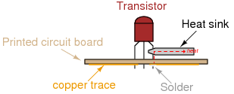

Figure 63 Soldering precautions

### Remote control

|  |  |
| --- | --- |
| Remote control.jpg | Almost any surplus IR remote control can be used with this project. Later on it is explained how to set up the remote control with the radio software. You will need to install the software for IR sensor.  See the section called *Installing the Infra Red sensor software* on page 90. |

### Remote Control Activity LED

If wanted an activity LED can be connected to GPIO 11 or 13 depending on the type of radio. This flashes every remote control activity is detected. It is a good idea to include this.

|  |  |
| --- | --- |
| Led_polarity.png  Figure 64 LED polarity | LEDs have polarity and must be wired correctly to work. The diagram shows the polarity of a typical LED. The longer lead is the positive (+) connection and connects to the Anode (The smaller terminal inside the LED)  Also the LED must be wired in series with a resistor to limit the current, typically 100 Ohms is OK. Failure to do this may cause the LED to burn brightly for a while then burn out.  Connect the cathode to GND (RPi Pin 6) and the Anode (+) to the GPIO pin shown in the following table via a 100 Ohm resistor. |

The following table shows the GPIO pin used for the LED connections.

Table 8 Remote Control Activity LED

|  |  |  |  |
| --- | --- | --- | --- |
| Radio Type | Pin | GPIO | Type of Raspberry PI |
| Activity LED not fitted | none | n/a | Not applicable |
| Two or Four line LCD with Push Buttons | 23 | **11** | 26 or 40 Pin version |
| Two or Four line LCD with Rotary encoders | 23 | **11** | 26 or 40 Pin version |
| Two or Four line LCD with I2C backpack | 23 | **11** | 26 or 40 Pin version |
| Adafruit RGB plate with push buttons | 33 | **13** | 40 pin version only |
| Vintage radio with no LCD display | 16 | **23** | 26 or 40 Pin version |
| Designs using IQaudIO etc. sound boards | 36 | **16** | 40 pin version only |
| PiFace CAD with IR sensor | 16 | **23** | 26 or 40 Pin version |

How to configure the LED is shown on in the section called *Configuring the remote control activity LED* on page 109.

|  |  |
| --- | --- |
| DSC00492.JPG  Figure 65 Adafruit plate with IR sensor and activity LED. | The illustration on the left shows an Adafruit RGB plate with IR sensor and activity LED.  The IR sensor picks up 3.3 volts from the reversing plate and connects the signal output to Pin 40 (GPIO 21) and GND (pin 39).  The LED connects to pin 33 (GPIO 13) and ground (pin 34). |

## Construction using an IQaudIO Cosmic Controller

IQaudIO manufacture a comprehensive range of sound devices and controller boards. See their web site at: <http://www.iqaudio.co.uk/>

From version 6.6 onwards the radio software provides support for the IQaudIO Cosmic controller.

The IQaudIO Cosmic controller consists of the following:

* A three push-button interface (Channel UP/DOWN and Menu)
* A rotary encoder (Used as volume control)
* Three status LEDs (Normal, Busy and Error)
* A 128 by 64 pixel OLED display (I2C interface)
* Optional IR detector (Ordered separately)

[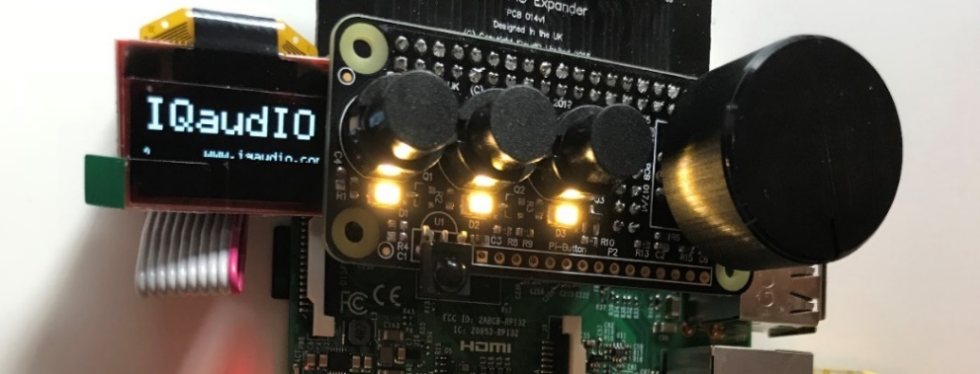](https://www.google.com/url?sa=i&rct=j&q=&esrc=s&source=images&cd=&cad=rja&uact=8&ved=2ahUKEwih34jBr8jaAhXPyKQKHfOmCecQjRx6BAgAEAU&url=https://iqaudio.co.uk/blog/new-product-the-cosmic-controller-n22&psig=AOvVaw1nWIMWHxqQk3MvsT45xisG&ust=1524297128455134)

Figure 66 IQaudIO Cosmic controller and OLED display

The main advantage of this hardware, is that it contains everything required by the radio software.

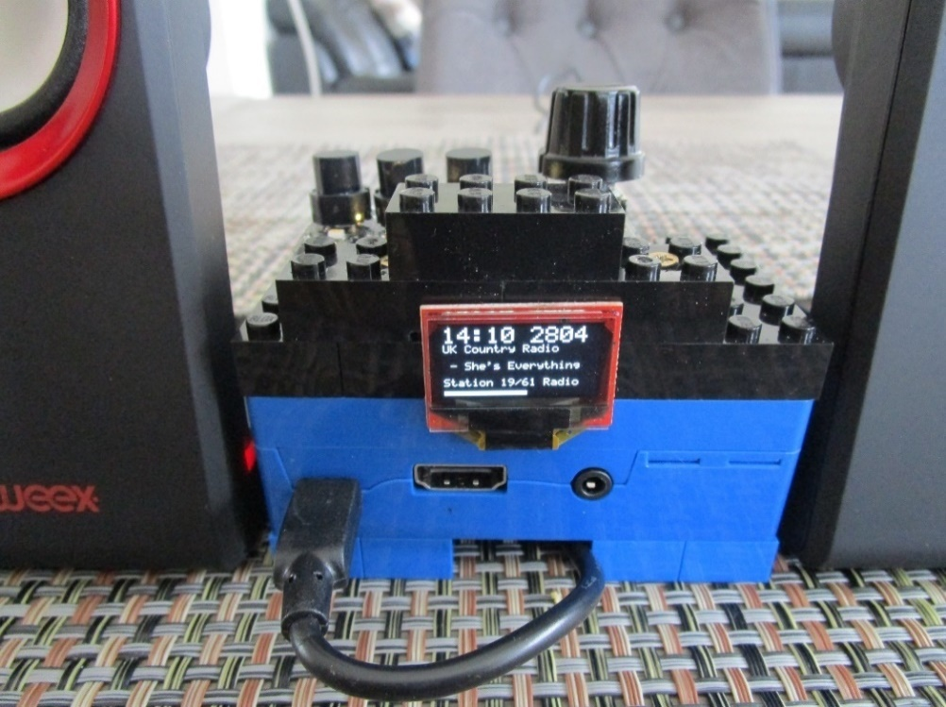

Figure 67 Lego radio with IQaudIO Cosmic controller and OLED

If using the IQaudIO Cosmic controller it is necessary to configure it as shown in the section *Configuring the IQaudIO* Cosmic controller and *OLED* on page 110.

## Construction using the Pimoroni Pirate radio

A full set of instruction for building the Pimoroni Pirate radio with pHat BEAT can be found here:

<https://learn.pimoroni.com/tutorial/sandyj/assembling-pirate-radio>

Soldering skills are required.

## Construction using the PiFace CAD

Fortunately, no soldering or construction is required with the PiFace CAD. Just plug it in and install and run the software. The PiFace CAD also has an IR sensor which means that it can be used with a remote control. It is however more sluggish in its operation when compared to other variants of the radio as the SPI interface on the Raspberry Pi is fairly slow. It also has the disadvantage that the push buttons are on the bottom of the unit.

|  |  |
| --- | --- |
| PiFace CAD.png | PiFace CAD case.png |
| Figure 68 PiFace CAD and Rasberry PI | Figure 69 PiFace CAD in a case |

Various ready-made cases are available from various suppliers. Warning: not all fit properly and might require some modification.

The PiFace CAD uses the SPI interface (from Motorola)

See <http://en.wikipedia.org/wiki/Serial_Peripheral_Interface_Bus> and the section called *Installing PiFace CAD software* on page 81 for further information on SPI.

## Installing the FLIRC USB remote control

**Note:**  This installation procedure is only for the HDMI or Touchscreen display of the radio. If using an LCD display see *Installing an IR sensor and remote control* on page 38.

### FLIRC USB Remote Control dongle

|  |  |
| --- | --- |
|  | The FLIRC USB dongle allows the use of any remote control with your Raspberry Pi. In this design it is intended for use with the graphical version of the radio. It allows button presses on a remote control to be mapped to the keyboard input of the Raspberry Pi. For example, pressing the volume up button on the remote control will act just like pressing the + key on keyboard (If so mapped). The graphical version of the radio accepts key presses. The LCD versions of the program don’t so FLIRC will not work with the LCD versions. This may however change in a later version. |

More can be found at the FLIRC website: <https://flirc.tv>

Documentation can be found at: <https://flirc.gitbooks.io/flirc-instructions/content/title-page.html>

## Using DAC Sound Cards

The sound output of the on-board audio jack on the Raspberry Pi is known to be limited. Using a DAC (Digital Audio Card) will give much better quality and output. Several are available.

### HiFiBerry DAC

This version supports the HiFiBerry DAC (Digital Analogue Converter) from HiFiBerry. See <https://www.hifiberry.com>. There are a lot of versions of the HiFiBerry DAC.

They split down into two main types:

1. The HiFi Berry DAC using the P5 connector (Older boards but not all)
2. The HiFi Berry DAC PLUS using the 40-pin connector (A+, B+ and Pi2 boards)

Choose the correct HiFiBerry DAC for your Raspberry PI.

#### HiFiBerry DAC using the P5 connector

The following example is using the version with a normal audio jack plug and a Raspberry B2. Solder an eight-pin header into the Raspberry B. Connect the eight-pin socket on the HiFiBerry to the eight pin P5 header on the Raspberry Pi.

See <https://www.hifiberry.com/soldering-hifiberry/>

|  |  |  |
| --- | --- | --- |
| C:\Users\Bob\AppData\Local\Microsoft\Windows\INetCache\Content.Word\imagesDZW35CP4.jpg  Figure 70 Raspberry PI P5 connector |  | Pin layout of the P5 Connector:  1 - +5V 2 - +3V3 3 - GPIO28 PCM\_CLK 4 - GPIO29 PCM\_FS 5 - GPIO30 PCM\_DIN 6 - GPIO31 PCM\_DOUT 7 - Ground 8 - Ground  These GPIOs are not available on the A+/B+/Pi2 |
| C:\Users\Bob\AppData\Local\Microsoft\Windows\INetCache\Content.Word\DSC01052.jpg  Figure 71 HiFiBerry DAC plus Connector |  | C:\Users\Bob\AppData\Local\Microsoft\Windows\INetCache\Content.Word\DSC01055.jpg  Figure 72 Pi Radio with HiFiBerry DAC |

Create your own P5 connector using an eight Male/Female patch wires as shown in the above left figure. Although not essential it is a good idea to use shrink wrap to keep the patch pins neatly together.

#### The HifBerry DAC Plus using the 40 Pin Connector

The HiFiBery DAC PLUS uses the 40 pin connector and has an unpopulated 40 pin header to extend the GPIO pins on the HiFiBerry DAC to use with other cards.

|  |  |  |
| --- | --- | --- |
| Figure 73 HiFiBerry DAC Plus |  | The DAC plus uses the 40 pin connector on new Raspberry PIs. A 40 pin dual in line male header is required (purchase separately).  Solder the 40 pin male header into the component side of the HiFiBerry DAC as shown Figure 74 below. The Radio interface card is then mounted on this header. |
|  |  |  |
| Figure 74 HiFiBerry mounted on the Rasberry Pi |  | The A+/B+/Pi2 uses the following pins supporting PCM.  Pin 12 GPIO18 PCM\_CLK (Conflict!)  Pin 35 GPIO19 PCM\_FS  Pin 38 GPIO20 PCM\_DIN  Pin 40 GPIO21 PCM\_DOUT  (All set to mode ALT0)  Pin 12 (GPIO) conflicts with the down switch on the radio. Wire the down switch to GPIO 10 (Pin 19) and configure the **down\_switch=10** parameter in **/etc/radiod.conf**. |

|  |  |
| --- | --- |
| note_icon.png | Note: All settings in the **/etc/radiod.conf** file use GPIO numbers and NOT physical pin numbers. So in the above example **down\_switch** is GPIO 10 (Physical pin 19). |
| note_icon.png | The Pimoroni pHat is compatable with HiFiBerry DAC (Not DAC+) and uses the same Device Tree (DT) overlay. |

|  |  |
| --- | --- |
|  |  |

## IQaudIO DAC sound products

The **IQaudIO DAC** products use several GPIOs currently used by the 26-pin version of radio software. The radio must be wired as shown in *Table 5 Radio and DAC* devices 40 pin wiring and NOT the 26-pin wiring version shown in Table 4. The **/etc/radiod.conf** configuration file must also be configured to support these devices.

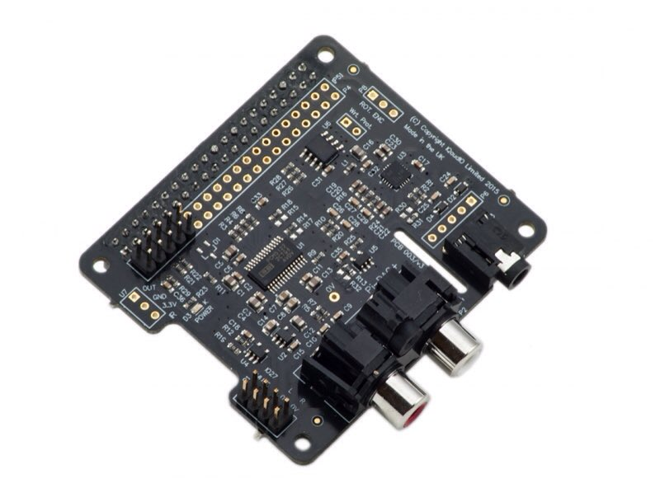

Figure 75 IQaudIO DAC plus

The switch and LCD GPIO configuration in **/etc/radiod.conf** must also be changed to match the wiring shown in *Table 5 Radio and DAC devices 40 pin* wiring. This can be done with the **configure\_radio.sh** program.

# Other switch settings

menu\_switch=17

mute\_switch=4

up\_switch=15

down\_switch=14

left\_switch=23

right\_switch=24

# LCD GPIO connections

lcd\_select=7

lcd\_enable=8

lcd\_data4=5

lcd\_data5=6

lcd\_data6=12

lcd\_data7=13

The radio installation program will allow selection of either the 26 pin or 40 pin wiring scheme.

**Note:** The above configuration is set-up using the **configure\_audio.sh** program to amend the **/etc/radiod.conf** during installation.

## JustBoom DAC products

The construction using **JustBoom** products is similar to other sound cards. The radio must be wired as shown in *Table 5 Radio and DAC* devices 40 pin wiring and NOT the 26 pin wiring version shown in Table 4. The **/etc/radiod.conf** configuration file must also be configured to support these devices.

|  |  |
| --- | --- |
| Figure 76 JustBoom Amp HAT | Figure 77 JustBoom Amp Zero pHAT |

|  |  |
| --- | --- |
| https://www.justboom.co/wp-content/uploads/2016/06/Header-Size-1.jpg  Figure 78 JustBoom Zero stacker requirements | The **JustBoom** Zero boards are used with stackers or installed directly on the Raspberry Pi Zero. Some stackers and some 2x20 male headers on the market though are too thin or too short to provide good contact with the board. Use stackers that the pins are squared and are at least 0.6mm in width. If you are soldering the 2x20 male header on the Raspberry Pi Zero make sure that the pins are 0.6mm in width and 6mm in usable height. |
| Figure 79 Using the 40-pin stacker | Plug a suitable stacker onto the Raspberry Pi Zero. Plug the JustBoom Zero board on top of the stacker so that the pins protrude through the JustBoom Zero board.  Plug the radio interface card or ribbon cable (not shown) on top of these protruding pins. |

## Pimoroni pHat DAC

The Pimoroni pHAT DAC provides an affordable high-quality DAC for the Raspberry Pi. The 3.5mm stereo jack comes soldered onto the board already. Though designed to match the format of the Raspberry Pi Zero it is compatible with all 40-pin GPIO Raspberry Pi variants.

Features:

•24-bit audio at 192KHz

•Line out stereo jack

•pHAT format board

•Uses the PCM5102A DAC to work with the Raspberry Pi I2S interface

[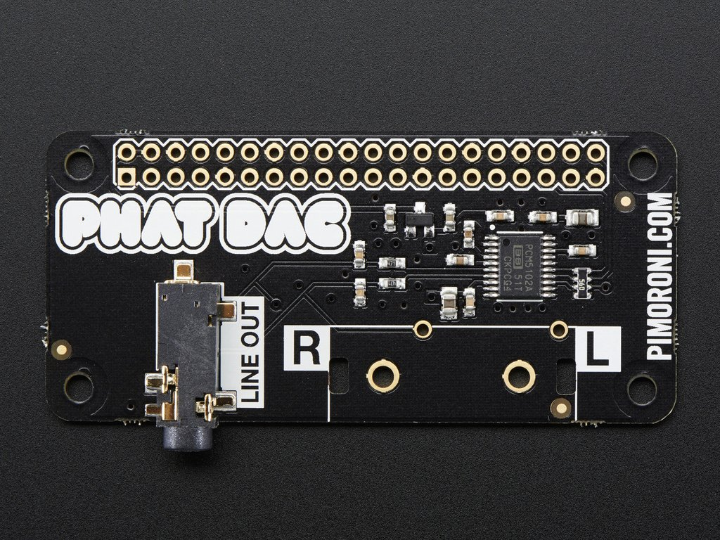](https://www.google.com/url?sa=i&source=images&cd=&cad=rja&uact=8&ved=2ahUKEwii3_aeuILbAhULfFAKHQunBPsQjRx6BAgBEAU&url=https://www.pakronics.com.au/products/pimoroni-phat-dac-for-raspberry-pi-zero-ada3016&psig=AOvVaw31U9I2MuiKG95s3ur4CCSE&ust=1526292242162987)

Figure 80 Pimoroni pHat DAC

**Note 1:** Do not use the 40 female header that comes with the board but use a 40-pin extender so that other cards can be used on top of it.

**Note 2:** The Pimoroni pHat is not completely compatible with the HiFiberry DAC although it uses the same software driver. In particular to use the Alsa sound mixer a package called **pulseaudio** is required. However **pulseaudio** is not compatible with several of the features of this package such as the **espeak** speech package. Normally the pulseaudio package must be removed as shown in the section called *Installing pulseaudio* on page 68. The Pimoroni pHat DAC will run fine without any mixer controls.

## Construction Tips and Tricks

This section contains some construction tips which may be useful. It goes without saying that having the correct tools such as a good fine tipped soldering iron, wire strippers and the like will greatly help constructing the radio.

### Wiring up rotary encoders and switches

|  |  |
| --- | --- |
| Figure 81 Rotary encoder wiring components | Purchase prototype board jumper wires with at least one end fitted with female connectors. The best type is the ribbon type particularly in the case of rotary encoders. Strip off five wires for the rotary encoder or two for push buttons. Also it is better to use shrink wrap to cover the wires after they have been soldered onto the switch or rotary encoder. This improves both insulation and strength. |
|  |  |
| Figure 82 Using wire strippers | Cut the plugs off the end that is to be soldered to the rotary encoder or switch. Leave the other end with *female* connectors. Using good wire strippers, strip a few millimetres off the wires. Separate the wires for about 30 centimetres. |
|  |  |
| Figure 83 Tinning the wires with solder | Twist the copper strands together as tightly as possible and tin the wires with a little solder. A so called “Extra pair of hands” is very useful for gripping the wires using crocodile clips. |

|  |  |
| --- | --- |
| Figure 84 Soldering up the switch | Tin the switch connections with solder. Cut a few millimetres of shrink wrap and slide onto the wires to be soldered. Make sure that the shrink wrap sleeves are well away from the heat of soldering iron as these will shrink easily with the slightest bit of heat. Tack the wire onto the top of the switch connector. Don’t attempt to twist the wire around the connector. Just tack it on top with a little bit of heat from the soldering iron. |
|  |  |
| Figure 85 Shrink shrink-wrap with a hair dryer | After soldering on all wires push the shrink wrap over the newly soldered wires. Using a hair dryer heat the shrink wrap until it has completely shrunk tightly over the wires.  The finished switch can either be connected directly to the Raspberry Pi or to an interface board. |
|  |  |
| Figure 86 Connecting the rotary encoder an interface board | If using an interface board, the female connectors can be bound together to form a plug using a larger piece of shrink-wrap. Slip the shrink wrap over the female pins and heat with a hair dryer. This can then be labelled up using Dymo tape machine or a CD marker pen. Push the newly created plug onto the male pins on the interface board. |

### Preventing electrical interference

One of the most irritating faults that one can have is the LCD screen occasionally either going blank or displaying hieroglyphics especially when switching on and off other apparatus or lights on the same circuit. This is due to Electromagnetic Interference (EMI).

See <https://en.wikipedia.org/wiki/Electromagnetic_interference> for more information.

EMI can be caused by any number of sources such as fluorescent lighting, switching on and off equipment on the same circuit as the radio or even electrical storms. If you are using a standard Raspberry PI USB power supply then you will probably not experience this problem as nearly all are fitted with a ferrite core (This is the big lump in the cable or may be built in). If you do experience this problem then try the following solutions one at a time in the order shown below. They can all be used together if required.

#### Using a clip on ferrite core on the +5 volt cable

|  |  |  |
| --- | --- | --- |
| [http://www.lindy.co.uk/images/13mm-ferrite-core-black-p8085-5513_image.jpg](http://www.google.nl/url?sa=i&rct=j&q=&esrc=s&source=images&cd=&cad=rja&uact=8&ved=0CAcQjRw&url=http://www.lindy.co.uk/cables-adapters-c1/audio-video-c107/analogue-audio-c118/13mm-ferrite-core-black-p8085&ei=fl-OVc6sIMPyUtHlmLgI&psig=AFQjCNG9pV-IWxiJ3UeIhLWBJpkz80E7rQ&ust=1435480292988157)  Figure 87 Clip on ferrite core | One of the most effective solutions is to put a clip on ferrite core on the +5V cable going to both the Raspberry Pi and USB hub. Loop the wire through at least once. Even a single loop seems to be enough. Try this first! | [https://images-na.ssl-images-amazon.com/images/I/61o7Pw9-umL._SL256_.jpg](http://www.google.nl/url?sa=i&rct=j&q=&esrc=s&source=images&cd=&cad=rja&uact=8&ved=0CAcQjRw&url=http://www.amazon.com/Ferrite-Core-Cord-Noise-Suppressor/dp/B0002MQGEK&ei=sF-OVe3PKYG5UarribgE&psig=AFQjCNG9pV-IWxiJ3UeIhLWBJpkz80E7rQ&ust=1435480292988157)  Figure 88 Loop +5V supply around the core |
| Fit a mains filter | | |
| [http://eliteemc.com/images/YunpenChassisWebcomp.jpg](http://www.google.nl/url?sa=i&rct=j&q=&esrc=s&source=images&cd=&cad=rja&uact=8&ved=0CAcQjRw&url=http://eliteemc.com/Single-Phase-EMI--and--RFI-Mains-Filters.php&ei=d3SOVe-vG8jmUp6TjLgI&psig=AFQjCNFTAC3qOdvolm61Nam3r7apcQjIZg&ust=1435485671482528)  Figure 89 Various mains filters | Try using a mains filter. This has the advantage that it can prevent spikes coming in from the mains and protect against electrical storms. The picture on the right shows an integrated filter and panel mount mains socket. | [http://www.schaffner.com/typo3temp/pics/ffe6120f64.jpg](http://www.google.nl/url?sa=i&rct=j&q=&esrc=s&source=images&cd=&cad=rja&uact=8&ved=0CAcQjRw&url=http://www.schaffner.com/en/products/emcemi.html&ei=0nSOVeKQJ8usUciOgogG&psig=AFQjCNFTAC3qOdvolm61Nam3r7apcQjIZg&ust=1435485671482528)  Figure 90 Integrated mains socket and filter |
|  |  |  |
|  |  |  |

#### Use an I2C LCD backback

If all else fails replace the directly wired LCD wiring with an I2C backpack. See the section called *Construction using an I2C LCD backpack* on page 34 for further information.

#### Preventing ground loops

|  |  |
| --- | --- |
| [3.5mm Stereo Ground Loop Isolator Female to Male Earthing for Audio](https://www.kenable.co.uk/images/201087_1.jpg)  Figure 91 3.5mm Jack Ground Loop Isolator | Avoid creating ground loops in the first place during construction. Ground loop issues usually cause a humming noise. Trying to tap off the Raspberry power supply from the power supply for the amplifier (if used) is one sure way to create a ground loop. If you experience such a problem then a 3.5mm Jack Ground Loop Isolator available from suppliers such as Kenable (<http://www.kenable.co.uk> ) can prevent unwanted hum on the audio system. Place the isolator between the Audio output of the Rasberry Pi or sound card and the amplifier input.  For further information on ground loops:  <https://en.wikipedia.org/wiki/Ground_loop_(electricity)> |

## Connecting up a USB power adapter

|  |  |
| --- | --- |
| Figure 92 Connecting up a USB power adapter | It is convenient to connect all power supply components for the Raspberry Pi, amplifier and USB hub etc via a single mains switch. USB 240V AC to +5V power adapters are designed to connect directly to the mains and not via a mains switch. One idea is to purchase a European round pin adapter and use standard electrical connector blocks to connect the incoming AC power cable to the two pins of the power adapter. AC cables to other components such as the amplifier can also be connected to the connector blocks. Use electrical tape or shrink-wrap to isolate the connector blocks. |

## Cooling the Raspberry Pi

The Raspberry Pi is built from commercial chips which are qualified to different temperature ranges; the LAN9512 is specified by the manufacturers being qualified from 0°C to 70°C, while the Application Processor (AP) is qualified from -40°C to 85°C. Operation outside these temperatures is not guaranteed. The temperature of the CPU should not really go above 80°C. If it does the CPU will throttle back its processor clock speed to reduce the temperature. The official line from the Raspberry Pi is that does not require cooling even though you can get temperature warnings when using the Raspberry Pi 7-inch touch screen.

The **vcgencmd** command can be used to check the CPU temperature.

$ /opt/vc/bin/vcgencmd measure\_temp

temp=67.1'C

For most of the radio designs in this document no specific cooling is required. If you need to cool the Raspberry Pi (Those with touchscreens in particular) then a variety of heat sinks and cooling fans are available as shown in Figure 93 below. Even with a heat sink good ventilation is necessary.

|  |  |  |
| --- | --- | --- |
| Koellichaamset voor Raspberry Pi A/B/B+, Banana PI, Cubie Board en pcDuino  Figure 93 Heat sink kit | A variety of heat sink and cooling fan kits are available for the Raspberry Pi. Fans are a less good idea as they will produce a background hum. Also as the CPU gets hot and the RPi is mounted vertically the adhesive softens and the fan and its heat sink tend to fall off unless secured in some way. Try to using a heat sink first. | [Raspberry Pi - ventilator, dual SERTRONICS RPI-DFAN](https://cdn-reichelt.de/bilder/web/xxl_ws/A300/RPI-DFAN_1.png)  Figure 94 Cooling fans |

## Miscellaneous

### Simple tone regulator

It may be that you wish to fit a tone regulator to the radio. Below is one option.

The following diagram and modified text came from Jack Orman at:

<http://www.muzique.com/lab/swtc.htm>

|  |  |  |  |  |
| --- | --- | --- | --- | --- |
| http://www.muzique.com/images/swtc3.gif  Figure 95 Simple tone control circuit | | | This tone control circuit that has a response that can be altered from high cut to high boost as the knob is turned. The output resistance is constant so the volume does not vary as the tone control is adjusted.  Suggested values for beginning experimentation with are R1=10k, R2=47k, C1=0.022uF and 100k for the tone and volume pots. | |
| note_icon.png | Note that the above circuit has a lot of attenuation of the audio output so using the onboard audio output of the Raspberry Pi might result in a disappointing level of volume. It is recommended to use a sound output DAC or USB sound dongle. | | |
| tone_regulator  Figure 96 Tone control board | | The illustration on the left shows a simple passive tone regulator board using the above circuit.  The audio output from the Raspberry Pi or DAC is fed into the board via a standard Audio socket.  Below the input are the connections to the tone regulator potentiometer mounted on the front panel of the radio.  Below the potentiometer connections are the two 100K presets for adjusting the output level to the Audio Amplifier.  Below these the Left and Right audio outputs connect to the Amplifier. | | |

### Using the Adafruit backlit RGB LCD display

The Adafruit backlit RGB LCD has three LED backlights (Red, Blue and Green) which can either be switched on individually or in various combinations together as shown in the table below:

Table 9 Adafruit backlit RGB display wiring

|  |  |  |  |  |  |
| --- | --- | --- | --- | --- | --- |
| Switch  pin | Red  (Pin 16) | Green  (Pin 17) | Blue  (Pin 18) | Colour | Diodes  required |
| 1 | 0 | 0 | 0 | Off | 0 |
| 2 | 0 | 0 | 1 | Blue | 0 |
| 3 | 0 | 1 | 0 | Green | 0 |
| 4 | 0 | 1 | 1 | Light Blue | 2 |
| 5 | 1 | 0 | 0 | Red | 0 |
| 6 | 1 | 0 | 1 | Purple | 2 |
| 7 | 1 | 1 | 0 | Yellow | 2 |
| 8 | 1 | 1 | 1 | White | 3 |
| Common | GND |  |  | Total diodes | 9 |

|  |  |
| --- | --- |
| http://d1gsvnjtkwr6dd.cloudfront.net/large/SC-DI-1N4148_LRG.jpg  Figure 97 IN4148 diode | The diodes used are any low voltage low current diodes such as the IN4148. So to use all of the above combinations would require a single pole 8 way rotary switch and logic and nine diodes. The first switch position is off. |

* Do not wire anything to position 1.
* Wire pin 16 (Blue) of the LCD backlight to switch position 2.
* Wire pin 17 (Green) of the LCD to switch position 3
* Wire pin 18 (Red) of the LCD to switch position 5
* Wire pin 17 and 18 via two diodes to pin 4 to give the colour light blue
* Do the same for the other two colour combinations
* Wire pin 16, 17 and 18 to pin 8 via three diodes to give the colour white
* Wire the centre pin of the switch to 0v (GND)

# Chapter 5 – System Software Installation

## Conventions used in this tutorial

Installation of the radio program requires you to enter lines at the command line prompt. This requires you to log into the Raspberry PI as user ‘**pi**’. The default password is **raspberry**.

**Note:** Don’t carry out any of the following commands just yet. They are just examples.

Raspberrypi login: **pi**

Password: **raspberry**

pi@raspberrypi:~$ Last login: Sun Apr 6 10:18:18 2014 from 192.168.2.100

pi@raspberrypi:~$

The prompt line is displayed ending with a **$** sign. The **pi@raspberrypi:~** string means user ‘pi’ on host machine called ‘raspberrypi’. The ~character means the user ‘pi’ home directory **/home/pi**. In this tutorial if you are required to do something as user **pi** then only the $ sign will be shown followed by the command as shown in the example below:

$ **mpc status**

Some of the commands need to be carried out as user ‘root’.

To become root user type in the ‘**sudo** **bash**’ command:

$ **sudo bash**

root@raspberrypi:/home/pi#

Again, the prompt shows the username, hostname and current working directory. However only the # followed by the required command will be shown in this tutorial. For example:

# **apt-get install mpd mpc python-mpd**

Some commands produce output which does not need to be shown. In such a case a ‘:’ is used to indicate that some output has been omitted.

$ **aplay -l**

\*\*\*\* List of PLAYBACK Hardware Devices \*\*\*\*

: {Omitted output}

card 0: ALSA [bcm2835 ALSA], device 1: bcm2835 ALSA [bcm2835 IEC958/HDMI]

Subdevices: 1/1

Subdevice #0: subdevice #0

card 1: Device [USB PnP Sound Device], device 0: USB Audio [USB Audio]

Subdevices: 0/1

Subdevice #0: subdevice #0

END OF EXAMPLE COMMANDS.

## Entering system commands

If you are new to Linux there are a couple of things that may cause confusion.

1. Entering program names on the command line
2. File path names
3. File permissions

Take the following examples:

$ raspi-config

The following command fails

$ **configure\_radio.sh**

$ -bash: configure\_radio.sh: command not found

The following two commands both work.

$ cd /usr/share/radio

$ ./configure\_radio.sh

$ /usr/share/radio/configure\_radio.sh

The third command has a **./** in front of it, the first one doesn’t. Why?

The reason is that the **raspi-config** program is in the **/usr/bin** directory which is in the **PATH** environment directive. This can be seen with the following command.

$ **echo $PATH**

/usr/local/sbin:/usr/local/bin:/usr/sbin:/usr/bin:/sbin:/bin:/usr/local/games:/usr/games

The second program is located in the **/usr/share/radio** directory which is not in the PATH directive. The **./** in front of the command means that the program or script will be found the current directory.

So, this means for programs not in directories specified in the **PATH** environment directive, you must either specify the full path name to the command or change to its directory and then enter the command with a **./** in front of it.

In the system prompt for user pi you will see a **~** character. The **~** character means the home directory for the current user, this case pi. So **~** is the same as **/home/pi**.

pi@raspberry3:~ $

For information on file permissions see the following link:

<https://wiki.archlinux.org/index.php/File_permissions_and_attributes>

## Editing configuration files

At various points during the installation procedures in this manual you will be asked to edit certain configuration files such as **/etc/radiod.conf** (The radio configuration file) or **/boot/config.txt** (The boot configuration file). There are various text editors that can be used but the main ones in the case of the Raspberry Pi are:

1. Nano - **nano** is a small, free and friendly editor particularly suited for use by beginners.
2. Vi – **vi** is usually the professional user’s choice of editor. It is very powerful but a lot harder to use for someone unfamiliar with it.

Usage:

**nano <filename>**

or

**vi <filename>**

Where *<filename>* is the name of the file to be edited.

See <https://www.raspberrypi.org/documentation/linux/usage/text-editors.md> for an overview of available text editors.

It is important to know that most configuration files are owned by root so you may be able to read them but not write them. For example:

$ nano /etc/radiod.conf

This will allow you to read the file but not change it. To give user **pi** temporary root user permissions so that you can save changes to the file use the **sudo** command in front of the editor command:

$ sudo nano /etc/radiod.conf

Or

$ sudo vi /etc/radiod.conf

## Using the Vi editor

This is too big a subject to cover here. Type “Using vi” into a search engine such as Google or Bing to display various tutorials on how to use **vi**.

## Using Nano

When **nano** is started it will display the contents of the file being edited. For example, **/etc/radiod.conf**. In this example the following screen will be displayed.

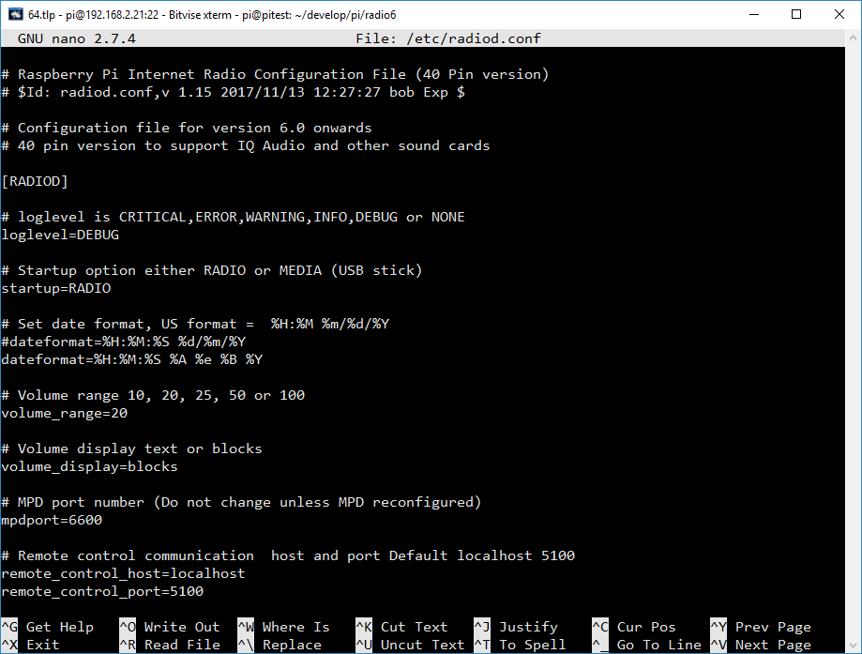

Figure 98 The nano file editor

Hold down the Ctrl key and press the letter G on the keyboard to display the help text. The following screen will be displayed:

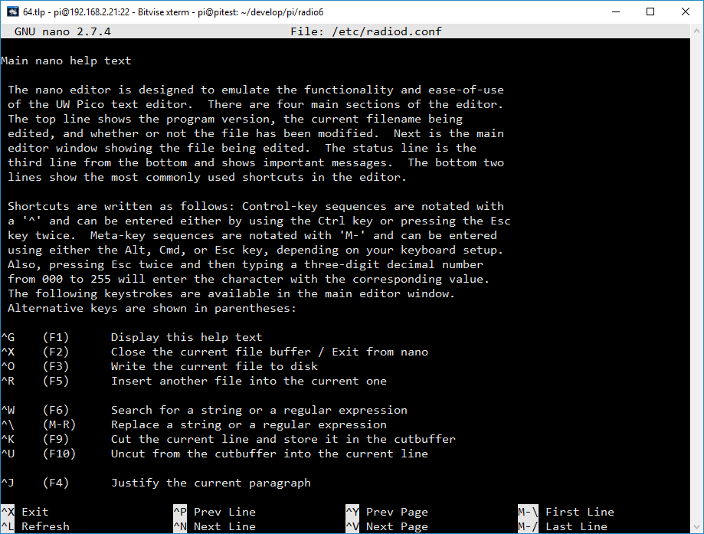

Figure 99 The nano editor help screen

The ^ character means the Control-key (Ctrl). So for example ^O above is Ctrl + O. For more information on **nano** see <https://www.nano-editor.org/dist/v2.0/nano.html>

## System Software installation

There is a cheat sheet in *Appendix B – Cheat sheet* which contains a list of installation instructions.

A lot of very useful Raspberry Pi documentation will be found at: <https://www.raspberrypi.org/documentation>

The latest version of the operating system is called **Raspbian Stretch** (Raspbian Linux 9). Create a new SD card with **Stretch**.

|  |  |
| --- | --- |
| **note_icon.png** | **Note:** The touch-screen version of the software requires a desktop version of the operating system so use **Rasbian Stretch** and not the **Lite** version. Although it is possible to upgrade Lite to use a desktop, it is beyond the scope of this manual. Only use **Lite** for LCD versions of the radio. |
| **note_icon.png** | **Note:** The Raspberry Pi 3B+ released in March 2018 needs Raspbian Stretch from March 2018 or later. The Pi 3B+ will not boot with earlier versions of the operating system. |

**Raspbian Stretch download** (recommended)

<http://www.raspberrypi.org/downloads>

### SD card creation

Use at least an 8 Gigabyte Card. Create an SD card running the latest version of **Raspbian Stretch** or **Stretch Lite**. See the *Image Installation Guides* on the above site for instructions on how to install the **Raspbian** operating system software.

### Upgrading from Raspbian Jessie to Stretch

You are strongly advised not to upgrade Raspbian Jessie to Raspbian Stretch. The reasons are:

1. The upgrade takes nearly two hours. It is quicker to create a Stretch SD card from scratch.
2. The operating system keeps locking the root account when powering off and on.
3. The **wpa\_suplicant** system used by WiFi does not start up.
4. This version of the radio will work fine with Raspbian Jessie

If you want to use Stretch the create a new SD card from an image downloaded from the Raspberry Pi Foundation web site.

### Log into the system

Boot up the Raspberry Pi with the new SD card with the **Debian Stretch** operating system. If you have used **Stretch** desktop then a graphical desktop will be displayed. Start a terminal session by clicking on the black terminal icon on the top left of the screen. With **Stretch Lite** only a log in prompt will be displayed. In such a case log into the Raspberry Pi as user **pi** andusing the password **raspberry**. Alternatively log in using SSH (See following section).

### Using SSH to log into the Raspberry PI

If using a PC or MAC it is possible to use SSH (Secure Shell) to log into the Raspberry Pi. You will need to install either **Putty** or **Bitvise** on a PC to provide an SSH client. However, the latest version of **Stretch** requires SSH to be enabled first. Due to increasing security concerns SSH is disabled by default on Raspbian images. See <https://www.raspberrypi.org/blog/a-security-update-for-raspbian-pixel/>. There are two ways to enable SSH:

1. Add a file called **ssh** to the boot sector of the SD card
2. Use the **raspi-config** program to enable SSH.

#### Add a file called ssh to boot sector

The boot partition on a Pi should be accessible from any machine with an SD card reader, on Windows, Mac, or Linux. If you want to enable SSH, all you need to do is to put a file called **ssh** in the **/boot** directory. The contents of the file don’t matter: it can contain any text you like, or even nothing at all. When the Pi boots, it looks for this file; if it finds it, it enables SSH and then deletes the file. Insert the SD card into the SD card reader. On a Windows PC run the **cmd** program by typing “cmd” in the Windows search box. Now change to the drive letter where the SD card is. In the following example this is D: Type “D:” then type “echo 0 > ssh”.

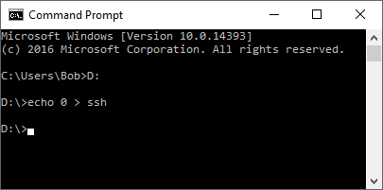

Figure 100 Enabling SSH on the boot sector

Boot the Raspberry Pi with this SD card.

### Enabling ssh in raspi-config

Using a keyboard and HDMI screen connected to the Raspberry Pi log into the system as user pi.

After logging in run **raspi-config**. Select “Advanced options” and select option A4 to enable SSH.

$ **sudo raspi-config**



Figure 101 Enabling SSH

Reboot the Raspberry Pi after which it will be possible to log into the Raspberry Pi using SSH.

$ **sudo reboot**

After logging back in the following message is displayed.

SSH is enabled and the default password for the 'pi' user has not been changed. This is a security risk - please login as the 'pi' user and type 'passwd' to set a new password.

**Note:** Security is becoming more and more of an issue for devices connected to the internet. If SSH has been enabled then please change the user password at the first opportunity. See the section called *Chapter 13* - Internet Security page 196 for further information on security issues.

## Preparing the Operating System for software installation

### Update to the latest the packages

Run the following command to update the library list.

$ sudo apt-get update

Run the following command to upgrade to the latest packages for this release.

$ sudo apt-get upgrade

The above command will take some time!

If you have an older version of the Raspberry Pi then update the firmware.

$ sudo rpi-update

Reboot the Raspberry Pi.

$ sudo reboot

**Important:** After upgrading the system the repository locations may no longer be valid. Re-run **apt-get update** to refresh the package list. Failing to do this may result in packages failing to install.

Re-run the update command to update the library list.

$ sudo apt-get update

Once you have updated the operating system login to the system and run **raspi-config**.

$ **sudo raspi-config**

**Warning:** If you are intending to run the touch-screen/HDMI version of the radio, do not be tempted to start removing components of the **pygame** software such as games as this may unfortunately remove graphic libraries used by the radio software.

### Disable booting to the desktop environment

If you are planning to use a touch-screen or HDMI display skip this section.

The desktop environment is not required for the LCD versions of the Radio and takes a lot of processing power. It is enabled by default in **Stretch** but is not installed with **Stretch Lite**. If you are not planning to use the touch-screen or HDMI version of the radio then disable it. Select option **3 Boot options**



Figure 102 Disabling the graphical desktop



Figure 103 Desktop enable/disable selection

Select option **B1** Desktop/CLI.

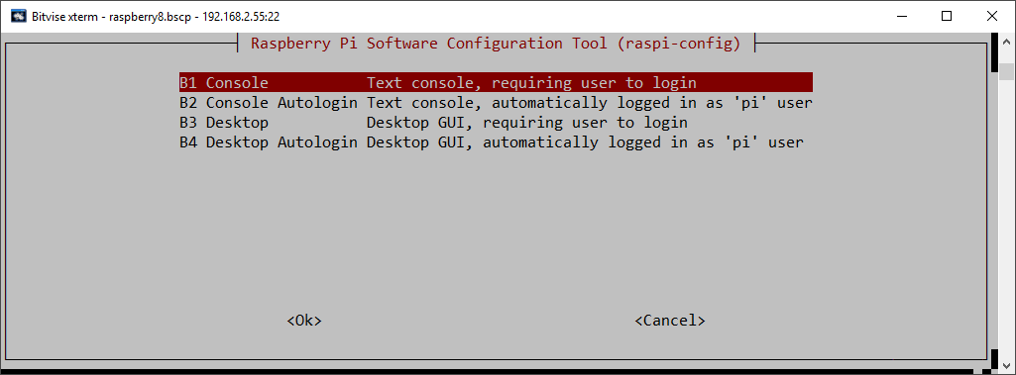

Figure 104 Console login selection

Select option **B1** or **B2** to disable the desktop and select OK

### Setting the time zone

The **Raspian Stretch** operating system is usually set to UK time. The easiest way to set the time zone for your country if you are in a different time zone is to use the **raspi-config** program and select “Localisation Options”:



Figure 105 Setting the time zone

Select option 4 “Localisation Options”, Use the tab key to move to <Select> and press enter.

The above screen is using the Bitvise SSH client program (See Putty on the web).



Figure 106 Selecting the time zone

Select the “Change Timezone” option. Again, use the tab key to move to <Select> and press enter.



Figure 107 Saving the timezone

Select the region your country is in, Europe for example. Use the tab key to move to <OK> and press enter. The program will then display a list of time zones for the selected region.



Figure 108 Time zone country selection

Select the correct one and save it by tabbing to <ok> and pressing the enter key. The time zone will be updated. Exit the program once finished.

### Changing the system hostname and password

It is a good idea to change the system password for security reasons especially if your raspberry PI is connected to a network with a wireless (WIFI) network. Changing the hostname is also a good idea as it makes identifying your radio on the network much easier. If you wish to do this, change the default hostname from ‘raspberrypi’ to something like ‘piradio’ or ‘myradio’.

Both the password and hostname can be changed using the **raspi-config** program.



Figure 109 Changing the Raspberry PI password

Option 1 is used to change the password. Make sure you record your new password somewhere safe (It is easy to forget it).

The hostname is changed in option 2 Network Options:



Figure 110 Changing the hostname

Enter new UNIX password:

Retype new UNIX password:

As the password is entered nothing is displayed. This is normal. You will be asked if you wish to reboot the system. After you reboot the system you will see the new hostname at the login prompt.

pi@piradio:~$

In the above example the new hostname is **piradio**. Once the hostname has been changed the program will ask if you wish to reboot. Answer “yes” to reboot.

### Configuring the Wi-fi Connection

This is a new option in Stretch and may not be available in earlier versions of Stretch. On later versions of the Operating system you may be asked to select the country you are in for legal WiFi channel selection. Select option N2:



Figure 111 Setting up the Wi-Fi in raspi-config

Now enter the SSID and passphrase for your network. Save the settings and reboot the Raspberry PI. If this option is not available then use the procedure *Configuring a wireless adaptor* on page 95.





Figure 112 Entering Wi-Fi credentials

Reboot the system. After reboot it is possible that you may see the following message:

Wi-Fi is disabled because the country is not set.

Use raspi-config to set the country before use.

In such a case re-run **rasp-config**. Select localisation options and select I4 to set Wi-Fi country:



Figure 113 Setting up the Wi-fi country

Select your country from the dropdown menu and exit the **raspi-config** to save the setting.

### Setting up the locale

As default the language used by Raspbian is English. To change this in Advanced options select option I1 Change Locale.



Figure 114 Selecting change locale

Select a locale beginning with the two-letter international code for your country and language.

Usually this will be a locale containing the string ISO or UTF-8.

  fi\_FI.ISO-8859-1 (Try this one first)

[fi\_FI.ISO-8859-15@euro](mailto:fi_FI.ISO-8859-15@euro)

fi\_FI.UTF-8

In the following example for the Netherlands the locale is this **nl\_AW UTF-8** for the Netherlands (nl).



Figure 115 Generating the locale.

Warning: Do not be tempted to generate “All locales” as this is not necessary and will take a very long time.

Press OK to continue. The program will now generate the selected locales.

Generating locales (this might take a while)...

en\_GB.UTF-8... done

nl\_AW.UTF-8... done

Generation complete.

The following screen is displayed:



Figure 116 Selecting the locale

Select the required locale **nl\_AW** in this example and press OK to save. The new locale will become active after the next reboot.

### Install other required packages

#### Install the ffmpeg video converter

This section is only applicable if the HDMI/Touchscreen version of the radio is to be used. If using an LCD version of the radio then skip this section. The **ffmpeg** video converter is required to extract artwork (if included) from music files mpeg files. Install **ffmpeg** video converter with the following command:

$ sudo apt-get install ffmpeg

Reading package lists... Done

:

The following packages have unmet dependencies:

ffmpeg : Depends: libavdevice57 (>= 7:3.2.10) but it is not going to be installed

Depends: libsdl2-2.0-0 (>= 2.0.4) but it is not installable

E: Unable to correct problems, you have held broken packages.

If the installation fails with the above message re-run the **apt-get update** command to update the library list and retry installing **ffmpeg**.

$ sudo apt-get update

Run the following for further information about **ffmpeg**.

$ man ffmpeg

#### Install python-requests

If you are running **Stretch Lite** it is necessary to install **python-requests** for the Shoutcast program as this is not loaded by default. This step should not be necessary if using the **Stretch** desktop operating system.

$ sudo apt-get install python-requests

#### Install libraries for the Olimex OLED

If using the IQaudIO Cosmic controller and OLED is also necessary to install **libffi-dev** plus other necessary libraries. If you are not using the IQaudIO controller then skip this section. Carry out the following instructions.

$ sudo apt-get install libffi-dev

$ sudo apt-get install build-essential libi2c-dev i2c-tools python-dev

If using **Raspbian Lite** also install the **python-pil** package:

$ sudo apt-get install python-pil

# Chapter 6 - Installing the radio Software

## Music Player Daemon Installation

If you haven’t already done so upgrade the system packages as shown in *Update to the latest the packages* on page 60.

After reboot install the [Music Player Daemon](http://en.wikipedia.org/wiki/Music_Player_Daemon) (mpd) and its client (mpc) along with the Python MPD library.

$ **sudo apt-get install mpd mpc python-mpd**

Answer yes ‘y’ when asked to continue.

If the installation says it cannot find the above packages then re-run the update command to update the library list and retry installing.

$ sudo apt-get update

Note: If installing on **Stretch Lite** this will take quite a long time as there are a lot of software libraries to be installed.

**Note:** At this stage there are no playlists configured so the music daemon won’t play anything. The play lists are created when the **radiod** Debian Package is installed in the next section.

## Installing pulseaudio

The **pulseaudio** package may or may not be installed. This has been different between various releases of the operating system. Currently the **pulseaudio** package causes a lot of problems with the radio software, in particular **espeak**. If you do not intend to use espeak and need pulseaudio, for example, for blue-tooth devices or pHat BEAT then install it. The following table shows the options:

Table 10 PulseAudio installation options

|  |  |
| --- | --- |
| Type of radio installation | Install pulseaudio |
| Using speak | No |
| Pimoroni Pirate Radio with pHat BEAT | Yes |
| LCD display radio | No |
| HDMI or touch-screen displays | No |
| Bluetooth sound devices | Yes |

The radio installation program will configure the Music Player Daemon to use **pulseaudio** instead of alsa. Note: The Pimoroni installation software for Pirate Radio installs pulseaudio.

To install **pulseaudio**:

$ sudo apt-get install pulseaudio

To remove **pulseaudio**:

$ sudo apt-get remove pulseaudio

Also remove unwanted libraries.

$ sudo apt autoremove

## Install the Radio Daemon

Note: If you are installing the software for a Pimoroni Pirate radio with pHat beat it is necessary to first install the Pimoroni software as show in the section *called Installing Pimoroni Pirate Radio (pHat BEAT)* on page 82.

The Raspberry PI Internet Radio software is distributed as a Debian package. This can be downloaded from <http://www.bobrathbone.com/raspberrypi/pi_internet_radio.html>

Either download it to your PC or Macintosh and copy it to the **/home/pi** directory or get it directly using the **wget** facility.

To use the **wget** facility first copy the download link from the above page (Right click on the link). Log into the Raspberry PI. Now use **wget** to the software package:

$ **wget http://www.bobrathbone.com/raspberrypi/packages/radiod\_6.9\_armhf.deb**

Run **dpkg** to install the package.

$ **sudo dpkg -i radiod\_6.9\_armhf.deb**

The **dpkg** program will install the files.

(Reading database ... 131542 files and directories currently installed.Preparing to unpack radiod\_6.9\_armhf.deb ...

Raspberry PI internet radio installation

Stopping radiod service

Unpacking radiod (6.9)

## Configuring the radio

Once that is done the installation will run the **configure\_radio.sh** script. This update the configuration settings in **/etc/radiod.conf**.

**Note:** This configuration program does the basic configuration to get the radio going with the hardware you are using. More complex configuration options are explained in *Chapter 7 – Configuration* on page 107.

The configuration program is automatically run when installing the radio package but can safely be run at any time using the following commands:

$ cd /usr/share/radio

$ sudo ./configure\_radio.sh

The installation script detects if this is a software upgrade and if that is the case displays the following screen. Normally select option 2 if upgrading the software. This means that the configuration will not be changed.



Figure 117 Configure radio – Upgrade

If you selected option 1 above and you are upgrading the software from a previous version, the program will ask if you wish to overwrite the existing configuration. Unless you have a heavily modified configuration you may safely overwrite the configuration file:



Figure 118 Replace configuration file

If option 1 is selected the existing configuration will be replaced. A backup copy of the original configuration is written to **/etc/radiod.conf.save**. The following screen will then be displayed:



Figure 119 Configure radio - User interface selection

Even if you are using a touch screen or HDMI display you still can select option 1 or 2. Only select option 3 if you are only going to use a HDMI or touch screen display with no buttons or rotary encoders and with or without a mouse. pHat BEAT and PiFace CAD come with their own push-buttons so select option 5 or 6 respectively.

**Note:** This configuration program can be re-run at any time in the future. Change directory to **/usr/share/radio** and run **configure\_radio.sh**. To do this run the following:

$ cd /usr/share/radio

$ sudo ./configure\_radio.sh

Select option 1 if push buttons are being used or option 2 if using rotary encoders. This screen and all following screens have the option to not change the configuration. The program will then ask you



Figure 120 Configure radio - Confirmation screen

If the push-button interface is selected, the program will ask how they have been wired. As from version 6.9 push-buttons can be wired to either +3.3V(The original scheme) or GND(0V).



Figure 121 Push-button voltage selection

Select the correct voltage that the push-buttons have been wired to, either GND(0V) or +3.3V.

The program will now ask which version of the wiring has been used during construction:



Figure 122 Configure radio - wiring selection

Normally select the 40-pin option unless you have used the 26-pin wiring scheme. See *Table 4 Controls and LCD wiring 26 pin version* and *Table 5 Radio and DAC devices 40 pin wiring.*

Confirm selection and continue to the next screen:



Figure 123 Configure radio - Display interface selection

Select the correct option for the display interface and confirm selection. Again, it is possible leave the configuration unchanged.

If option 5 – ‘HDMI or touch screen display’ was selected the go to the section called *Installing the HDMI or* touch screen on page 77.

If option 2, 3, 4 or 6 was selected then this will require the hex address to be configured. Otherwise the program will skip the screens in the next section and go to the section called *Select the type of LCD* display on page 76.

If option 6 (Olimex OLED) was selected then the following will be displayed:



Figure 124 Olimex OLED flip display

This option sets the **flip\_display\_vertically** parameter in **/etc/radiod.conf** to **yes** or **no** and allows the Olimex OLED display to be flipped vertically.

## Configure SPI Kernel Module

Skip this section unless installing PiFace CAD.

If installing the radio on PiFace CAD it is necessary to enable the SPI interface. If PiFace CAD was selected the following message will be seen:

The PiFace CAD display requires the

SPI kernel module to be loaded at boot time.

The program will call the raspi-config program

Select the following options on the next screens:

5 Interfacing options

P4 Enable/Disable automatic loading of SPI kernel module

Press enter to continue:

Press enter and select option 1:



Figure 125 Enable SPI Kernel Module



Figure 126 Enable SPI kernel module option

Select the option P4 SPI. The following screen is displayed:



Select Yes to enable the SPI kernel module. Select “Finish” to exit.

## Configure the I2C interface

Skip this section unless using a device which uses the I2C interface. If the OLED display or one of the I2C backpacks or Adafruit RGB plate was selected then the following screen will be seen:



Figure 127 Configure radio - I2C interface hex address

At this stage you may not know what the Hex address for PCF8574 devices is so simply select option 1 or 2 depending upon whether you are using an Adafruit or Arduino backpack. These use different I2C integrated circuits namely MCP23017 (Adafruit) or PCF8574 (Arduino). For the OLED display select option 4. Once you have installed the I2C libraries (described later) you can run the **configure\_radio.sh** program again to change to the correct hex address.

The following text will be displayed if I2C libraries are required

The selected display interface type requires the

I2C kernel libraries to be loaded at boot time.

The program will call the raspi-config program

Select the following options on the next screens:

5 Interfacing options

P5 Enable/Disable automatic loading of I2C kernel module

Press enter to continue:



Figure 128 Configure radio - Enable I2C libraries

The **raspi-config** program now runs. Select 5 “Interfacing options” then option P5:



Figure 129 Selecting interfacing options in raspi-config



Figure 130 Select I2C libraries in raspi-config

Select - P5 I2C Enable/Disable automatic loading of I2C kernel module. The following screen will be displayed. Select yes to enable the ARM I2C interface.



## Select the type of LCD display

Skip this section if you are not using an LCD display directly connected to the GPIO pins. Confirm the selection and continue to the next screen to select the type of LCD display. This section is not relevant for a HDMI or touch screen.



Figure 131 Configure radio - Display type selection

Select the type of display to be used and confirm the selection. The installation script asks if you wish to configure the audio device:



Figure 132 Configure radio audio output option

You should select option 1 to run the audio device configuration program.

If you selected option 1 then go to the section *Configuring the audio output* on page 78.

## Installing the HDMI or touch screen software

This section is only relevant if configuring an HDMI or touchscreen interface. If using an LCD display then skip this section. The following screen is displayed:



Figure 133 Touchscreen selection

Select the type of screen that is connected to the Raspberry Pi.



Figure 134 Selecting the type of radio display

Select which radio program to start-up. . See *Figure 1 Raspberry pi 7-inch touchscreen radio* and *Figure 3 Vintage tuning touch-screen radio* on page 4.



Figure 135 Configuring the HDMI or touch screen display startup

Normally select option 1 to automatically start the gradio.py program when the Graphical Desktop is loaded. This copies a desktop configuration to the file **/home/pi/Desktop/gradio.desktop** file.

[Desktop Entry]

Name=Radio

Comment=Internet radio

Icon=/usr/share/radio/images/radio.png

Exec=sudo /usr/share/radio/gradio.py

Type=Application

Encoding=UTF-8

Terminal=false

Categories=None;

There is also a similar file created called **gradio.desktop** for the vintage graphical radio.

The installation script also copies the graphic screen configuration to **/etc/radiod.conf**. It also disables start-up of the **radiod** service which is only used for the LCD versions of the radio.

Now select the option to display the radio full screen (7-inch touchscreen) or in a desktop window (Large HDMI monitor or TV).



Figure 136 Configuring the graphical radio full screen

Configuration of the HDMI/Touch screen is shown in the section *Configuring the HDMI or Touch Screen* on page 107.

Operation of the HDMI/Touch screen is shown in the section called *Operation of HDMI and touch screen displays* on page 126.

Now go to the section *Configuring the audio output* on page 78.

## Configuring the audio output

If building a new radio start by using the Raspberry Pi on-board audio output jack. Leave configuring a digital audio card such as HiFiberry or IQaudIO until later.

The installation will run the **configure\_audio.sh** script.



Figure 137 Selecting the audio output device

**Note:** This configuration program can be re-run at any time in the future. Change directory to **/usr/share/radio** and run **configure\_audio.sh**. To do this run the following:

$ cd /usr/share/radio

$ sudo ./configure\_audio.sh

## Installing the Python I2C libraries

This needs to be carried out for all displays which use I2C (OLED and Adafruit RGB plate) or backpacks (Arduino or Adafruit). Enter the following commands to add SMBus support required for Python I2C support:

$ sudo apt-get install python-smbus

Note: **python-smbus** may already be installed on **Raspian Stretch** but not the **Lite** version

If you are using a revision 2 Raspberry Pi (Newer boards) carry out the following:

$ **sudo i2cdetect -y 1**

If you are using a revision 1 Raspberry Pi (Old boards) carry out the following:

$ **sudo i2cdetect -y 0**

This will search **/dev/i2c-0** (Old RPIs) or **/dev/i2c-1** (Later versions) for all address, and if correctly connected, it should show up at **0x20** for the Adafruit LCD Plate or normally **0x27** for the Arduino PCF8574 backpack but might be another address such as **0x3F.** The OLED 128x64 pixel display uses address **0x3C**. See Figure 138 *The I2C bus display using the i2cdetect program*.



Figure 138 The I2C bus display using the i2cdetect program

If the following is seen instead then it is necessary to run enable the I2C module at boot time using **raspi-config**.

Error: Could not open file `/dev/i2c-1' or `/dev/i2c/1': No such file or directory

If problems with **i2cdetect** are still encountered, then edit the **/boot/config.txt** file using **sudo nano** and change the following line:

#dtparam=i2c\_arm=on

Change to:

dtparam=i2c\_arm=on

Reboot and retry the i2cdetect program.

|  |  |
| --- | --- |
| note_icon.png | **Note:** If the Arduino PCF8574 backpack is using another address other than **0x27** then you must modify the **i2c\_address** parameter in **/etc/radiod.conf**. For example, if the backpack is using the address **0x3F** then modify the **i2c\_address** parameter to match this as shown in the example below: |

# The i2c\_address parameter overides the default i2c address. 0x00 = use default

# Some backpacks use other addresses such as 0x3F, then set i2c\_address=0x3F

**i2c\_address=0x3F**

Once both of these packages have been installed, you have everything you need to get started accessing I2C and SMBus devices in Python. Now reboot the Raspberry PI.

$ **sudo reboot**

The Radio should start automatically. If not then go to the section called *Chapter* 9 -Troubleshooting on page 159.

## Installation log

A log of the changes made by the configuration program will be written to the **/usr/share/radio/install.log** file.

### Reboot to enable the software

The software is installed in the **/usr/share/radio** directory. Now reboot the Raspberry PI.

**$ sudo reboot**

Once rebooted the software should run and music should be heard out of the on-board audio jack. If not go to the section called *Chapter* 9 -Troubleshooting on page 159.

The radio daemon (LCD versions only) can be started and stopped with the **service** command:

$ sudo service radiod start

$ sudo service radiod stop

This will also stop and start the MPD daemon.

To prevent automatic start-up of the radio at boot time run the following command:

$ sudo systemctl disable radiod

To re-enable it:

$ sudo systemctl enable radiod

## Installing PiFace CAD software

Before running the radio on the PiFace CAD it is necessary to install the PiFace CAD Python library. Run the following command:

$ sudo apt-get install python-pifacecad

The SPI maximum frequency has changed to 125000000 after kernel 4.9.43, however the pifacecad software can't support the default frequency. You can read about this at the following link: <https://github.com/raspberrypi/linux/issues/2165>

To correct this problem it is necessary to modify **/usr/lib/python2.7/dist-packages/pifacecommon/spi.py** to limit the SPI frequency.

$ sudo vi /usr/lib/python2.7/dist-packages/pifacecommon/spi.py

It is very likely that this problem my be fixed in a later release of the kernel and that the following patch will not be necessary.

Edit the “spi transfer struct” from

# create the spi transfer struct

transfer = spi\_ioc\_transfer(

tx\_buf=ctypes.addressof(wbuffer),

rx\_buf=ctypes.addressof(rbuffer),

len=ctypes.sizeof(wbuffer)

)

To:

# create the spi transfer struct

transfer = spi\_ioc\_transfer(

tx\_buf=ctypes.addressof(wbuffer),

rx\_buf=ctypes.addressof(rbuffer),

len=ctypes.sizeof(wbuffer),

speed\_hz=ctypes.c\_uint32(100000)

)

Warning. Do not forget to add the comma (,) to the end of the previous line. Restart the **PiFace CAD** radio. Also run update the Raspberry Pi firmware to the latest version.

$ sudor pi-update

## Installing Pimoroni Pirate Radio (pHat BEAT)

### Install Pimoroni software

To use the Pimoroni Pirate radio with **pHat BEAT** it is necessary to install the Pimoroni software and test the radio using the Pimoroni software first. Do this before installing the Rathbone radio software. The Pimoroni software uses the **VLC** media player and not **MPD**.

Once the Pimoroni software is installed and tested it is then necessary to disable the Pimoroni radio software and install the Rathbone radio software as shown in *Chapter 6 - Installing the radio Software* on page 68. Only the VU meter software is used by the Rathbone software.

To install the Pimoroni software carry out the following:

The following instructions are based on the following link:

<https://github.com/pimoroni/phat-beat/blob/master/projects/vlc-radio/README.md>

Run the following command:

$ curl https://get.pimoroni.com/vlcradio | bash

The following will be displayed.

:

If you want to see what this script does before running it,

you should run: 'curl https://get.pimoroni.com/vlcradio'

:

Do you wish to continue? [y/N] **y**

Enter **y** to continue. The installation script will take some time to install and build the software.

Reboot the Raspberry Pi and test the Pirate radio.

$ sudo reboot

|  |  |
| --- | --- |
| note_icon.png | **Note:** This author does not provide any support for the Pimoroni software or VLC media player. If you have problems getting the Pimoroni software to run then contact <https://forums.pimoroni.com/c/support> |

### Disable Pimoroni software

To install To disable the Pimoroni software run the following commands:

$ sudo systemctl disable vlcd

$ sudo systemctl disable phatbeatd

$ sudo reboot

### Install the Rathbone Internet radio software

Do the following:

1. Now carry out the instructions shown in *Chapter 6 - Installing the radio Software* on page 68.
2. Since the Pirate Radio does not have a screen it is necessary to install **espeak** as shown in the section called *Installing the speech facility* on page 103 to hear choices when using the menu button.

## Configuring HDMI or Touchscreen

If using a touch-screen or HDM TV/Monitor add the following lines to **/boot/config.txt**.

hdmi\_group=2

hdmi\_mode=4

hdmi\_cvt 800 480 60 6 0 0 0

max\_usb\_current=1

If the screen upside-down then add the following line.

# Rotate screen 180

lcd\_rotate=2

## Apply patches to the radio software

Patches will be announced on Twitter at: <https://twitter.com/bob_rathbone>. Follow this Twitter feed for announcements about new patches.

Patches can be viewed at <http://www.bobrathbone.com/raspberrypi/pi_internet_radio.html>

Patches take the form:

**radiod-patch-<version>-<patch-number>.tar.gz**

Where; **<version>** is the package version number, 6.9 in this case.

**<patch-number>** is the patch number from 1 onwards.

For example:

radiod-patch-6.9-1.tar.gz

To apply this patch (if it exists) run the following:

$ cd /usr/share/radio

$ wget http://www.bobrathbone.com/raspberrypi/packages/radiod-patch-6.9-1.tar.gz

$ tar -xvf radiod-patch-6.9-1.tar.gz

## Setting the mixer volume

All sound output goes through a mixer. After rebooting the Raspberry Pi run the **alsamixer** program without any additional parameters:

$ alsamixer

The following screen is displayed:

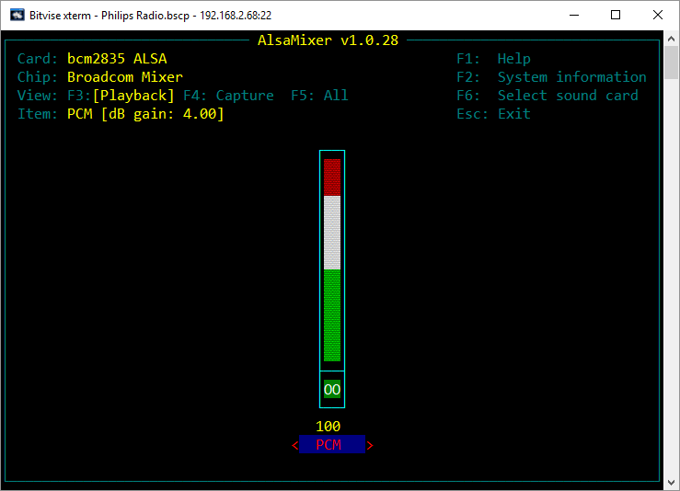

Figure 139 Basic Alsa sound mixer

The above illustration shows the **bcm2835** Alsa Mixer. There is only one mixer control called PCM (Pulse Code Modulated). Adjust the volume to 100% if not already set by using the Up and Down keys on the keyboard. Press the **Esc** key or **Ctl-Z** to exit the program.

It is also possible to set the volume for the on-board mixer volume with the **amixer** program.

$ **amixer cset numid=1 100%**

numid=1,iface=MIXER,name='PCM Playback Volume'

; type=INTEGER,access=rw---R--,values=1,min=-10239,max=400,step=0

: values=400

| dBscale-min=-102.39dB,step=0.01dB,mute=1

## Configuring other sound devices

Other sound devices can be used with the radio. Currently supported are the following devices:

* CMedia USB speakers or devices (See page 85)
* Sound cards such as **HiFiBerry**, **IQaudIO**, **JustBoom** and **Pimoroni pHat** DAC and DAC+ products (See page 86)

To check if the audio device is present run the **aplay** command.

$ **aplay -l**

\*\*\*\* List of PLAYBACK Hardware Devices \*\*\*\*

card 0: ALSA [bcm2835 ALSA], device 0: bcm2835 ALSA [bcm2835 ALSA]

Subdevices: 8/8

Subdevice #0: subdevice #0

Subdevice #1: subdevice #1

Subdevice #2: subdevice #2

Subdevice #3: subdevice #3

Subdevice #4: subdevice #4

Subdevice #5: subdevice #5

Subdevice #6: subdevice #6

Subdevice #7: subdevice #7

card 0: ALSA [bcm2835 ALSA], device 1: bcm2835 ALSA [bcm2835 IEC958/HDMI]

Subdevices: 1/1

Subdevice #0: subdevice #0

card 1: Device [USB PnP Sound Device], device 0: USB Audio [USB Audio]

Subdevices: 0/1

Subdevice #0: subdevice #0

In the above example **Card 0** is the on-board devices namely the audio output jack and HDMI. **Card 1** is a USB PnP sound device.

To configure other sound devices run the **configure\_audio.sh** utility.

$ cd /usr/share/radio

$ ./configure\_audio.sh

### Configuring a USB sound device

To configure a USB DAC sound devices such as CMedia speakers or sound dongles run the **configure\_audio.sh** utility.

To configure USB audio devices run the Run the **configure\_audio.sh** utility.

$ cd /usr/share/radio

$ ./configure\_audio.sh



Figure 140 Configure USB DAC

Reboot when prompted. After rebooting the Raspberry Pi run the **alsamixer** program.

$ alsamixer

The following screen is displayed:

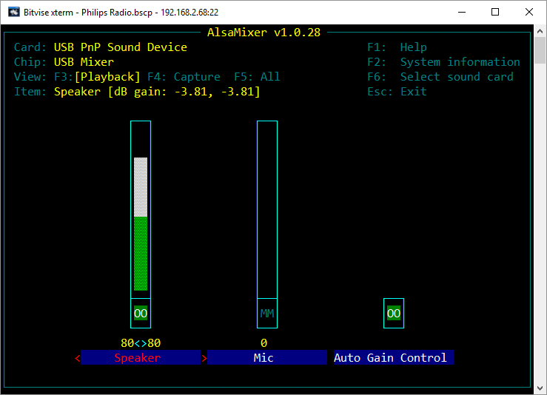

Figure 141 The USB PnP Alsa Mixer

Use the Left and Right keys to position on the ‘Speaker field’. Adjust the sound level using the Up and Down keys (80% in the above example). Pres **Esc key** or **Ctl Z** key to exit.

### Configuring a Sound Card

This section covers configuration of add on DAC boards such as **HiFiBerry**, **IQaudIO** and **JustBoom** **DAC**, **DAC+** and Amplifier products. Older versions of the **HiFiBerry DAC** that used the 26 pin GPIO header are not supported.

To configure add on audio cards run the Run the **configure\_audio.sh** utility:

$ **cd /usr/share/radio**

$ **./configure\_audio.sh**



Figure 142 Configuring add-on DAC sound cards

Select option 4, 5, 6 or 7 depending upon the HiFiBerry device being used an press OK.

Reboot when prompted by the next screen.

The Pimoroni pHat is compatable with HiFiBerry DAC (Not DAC+) and uses the same Device Tree (DT) overlay so select HiFiBerry DAC if using the pHat.

After rebooting run the **alsamixer** program.

$ alsamixer

Use the left and right keys to select the mixer control (Analogue) and use the up down keys to change the volume to 100%.

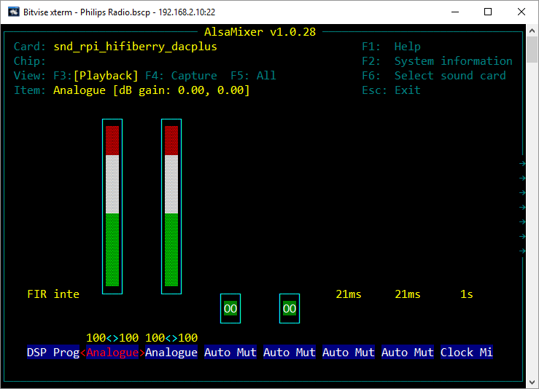

Figure 143 Set mixer analogue volume

Next use the right key to position on the “Digital” mixer control and use the up down keys to change the mixer volume:

**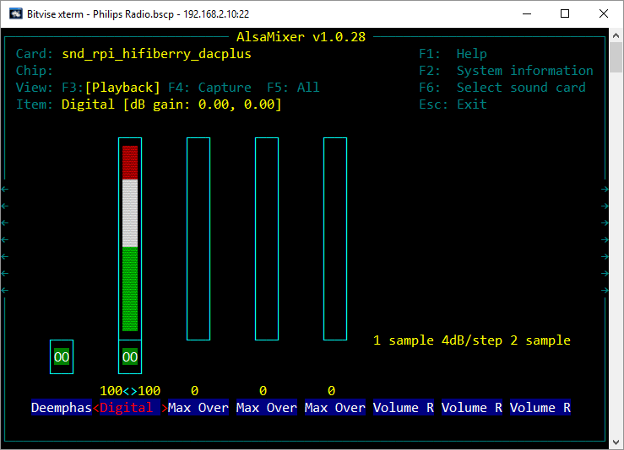**

Figure 144 Set mixer digital volume

## Testing the Music Player Daemon MPD

This section provides useful information on the operation of the Music Player Daemon (MPD) and its client (MPC) or diagnostics if no music is heard when the Radio is started.

If no music is being heard check the status of MPD:

$ **sudo service mpd status**

mpd is running.

If the following is seen:

$ **sudo service mpd status**

mpd is not running ... failed!

Start the MPD daemon.

$ **sudo service mpd start**

Starting Music Player Daemon: mpd.

If no music is heard check that there are playlists configured using the music player client **mpc playlist** command (sudo isn’t necessary):

$ **mpc playlist**

Nashville FM

RAI Radio Uno

RAI Radio Duo

Prima Radio Napoli

Radio 1 Nederland

:

If no playlists are shown run the **create\_stations.py** program as shown in the section called Creating new playlists on page 140.

## Manually configuring sound cards

Unless you have a need to manually configure some other sound card or need to troubleshoot a non-working card you can skip this section. Configuring a HiFiBerry DAC is shown in this example Edit the **/boot/config.txt** and add the following line to the end of the file depending upon the version you are using.

dtoverlay=hifiberry-dacplus

See <https://www.hifiberry.com/guides/configuring-linux-3-18-x/> for other devices.

Modify the **audio\_output** section in **/etc/mpd.conf** to support the HiFiBerry DAC and software mixer.

audio\_output {

type "alsa"

name "HiFiBerry DAC"

device "hw:0,0"

# mixer\_type "hardware"

mixer\_type "software"

:

Reboot the Raspberry PI.

$ sudo reboot

If no music is heard run the **alsamixer** program and set the volume to at least 80% as shown in the previous section on **HiFiBerry** devices.

## Configuring MPD to use pulseaudio

In this version **pulseaudio** is removed due to the fact that for some unknown reason MPD has problems if **pulseaudio is** installed and MPD is configured to use the default ALSA system. However, more and more people want to use the Pi as Bluetooth speakers which requires **pulseaudio**

MPD can be configured to use either the default Alsa sound system or the Pulse audio server. If you want to use **pulseaudio**, stop the radio and install **pulseaudio**:

$ sudo systemctl stop radiod

$ sudo apt-get install pulseaudio

Either re-run the **configure\_radio.sh** program or manually change the **audio\_output** type statement in /etc/mpd.conf to **pulse**.

audio\_output {

# type "alsa"

type "pulse"

name "IQAudio DAC+"

device "hw:0,0"

mixer\_type "software"

:

}

Reboot the Raspberry Pi to restart the radio.

$ sudo reboot

## Installing the Infra Red sensor software

If installing version 6.3 download and install the patches shown in the section *Apply patches to the radio software* on page 83.

If you haven’t already done so update the operating system first.

$ **sudo apt-get update**

$ **sudo apt-get upgrade**

Install **lirc** with the following command:

$ **sudo apt-get -y install lirc**

Now you must create an /etc/lirc/lircd.conf for your remote control.

Either download one from here:

http://lirc.sourceforge.net/remotes/

Or generate one yourself with the following command:

sudo irrecord -f -d /dev/lirc0 /etc/lirc/lircd.conf

It is necessary to install the **python-lirc** package.

**Note:** Earlier versions of **Raspbian Stretch** do not have the **python-lirc** package in its repository which means it must be downloaded from the author Tom Preston at GitHub.

Normally python-lirc it can be installed using apt-get as shown below.

Try using installing **python-lirc** with the following command:

$ **sudo apt-get -y install python-lirc**

If the package isn’t foundsee<https://github.com/tompreston/python-lirc/releases>

At the time of writing the latest release of the package was 1.2.1. To download this package run the following command:

$ wget https://github.com/tompreston/python-lirc/releases/download/v1.2.1/python-lirc\_1.2.1-1\_armhf.deb

Note: The above command is all one line. Now install the software:

$ sudo dpkg -i python-lirc\_1.2.1-1\_armhf.deb

If you carried out the above command then edit **/etc/lirc/lirc\_options.conf** and change the driver name in the [lircd] section from ‘devinput’ to ‘default’.

[lircd]

Nodaemon = False

driver = default

The following step requires configuration of the **lirc-rpi dtoverlay** in **/boot/config.txt** file using the following table:

Table 11 IR Sensor Pin outs

|  |  |  |  |
| --- | --- | --- | --- |
| Radio Type | Pin | GPIO | Type of Raspberry PI |
| Two or Four line LCD with Push Buttons | 21 | 9 | Any (No DAC) |
| Two or Four line LCD with Rotary encoders | 21 | 9 | Any (No DAC) |
| Two or Four line LCD with I2C backpack | 21 | 9 | Any (No DAC) |
| Adafruit RGB plate with push buttons | 36 | 16 | 40 pin version only |
| All versions using DAC sound cards | 22 | 25 | 40 pin version only |
| IQaudIO Cosmic Controller and OLED display | 22 | 25 | 40 pin version only |

If using the separate IR sensor and activity LED configure lirc-rpi in the **/boot/config.txt** file with the lirc-rpi device details. Edit the **/boot/config.txt** file and add the correct **dtoverlay** statement to the end of the file:

For all radio versions except the Adafruit plate:

dtoverlay=lirc-rpi,gpio\_in\_pin=9,gpio\_in\_pull=high

Do this for the AdaFruit plate.

dtoverlay=lirc-rpi,gpio\_in\_pin=16,gpio\_in\_pull=high

For 40 pin versions using IQaudIO products or other DAC cards.

dtoverlay=lirc-rpi,gpio\_in\_pin=25,gpio\_in\_pull=high

Save the **/boot/config.txt**.

Now copy the **lircrc.dist** file to **/etc/lirc/lircrc**

$ **cd /usr/share/radio**

$ **sudo cp lircrc.dist /etc/lirc/lircrc**

Reboot the Raspberry Pi

$ **sudo reboot**

Now test your remote control with the mode2 command. You should see lots of codes when you press buttons on the remote control.

$ **sudo mode2 -d /dev/lirc0**

space 5358604

pulse 4591

space 4459

pulse 651

If you see the following output then edit **/etc/lirc/lirc\_options.conf** and change the driver name in the [lircd] section from ‘devinput’ to ‘default’ as previously shown.

Using driver devinput on device /dev/lirc0

Trying device: /dev/lirc0

Using device: /dev/lirc0

Running as regular user pi

Partial read 4 bytes on /dev/lirc0

Check that the **lirc0** device exists. If it doesn’t exist you cannot continue. Check that the /**boot/config.txt** file has been correctly configured as shown above.

$ **ls -la /dev/lirc0**

crw-rw---T 1 root video 246, 0 Jan 1 1970 /dev/lirc0

It is now necessary generate a configuration for the remote control then first move the distributed **/etc/lirc/lircd.conf** file out of the way.

$ **sudo mv /etc/lirc/lircd.conf /etc/lirc/lircd.conf.org**

Now run the configuration program.

$ **sudo irrecord -f -d /dev/lirc0 /etc/lirc/lircd.conf**

If you see the following

irrecord: could not open /dev/lirc0

irrecord: default\_init(): Device or resource busy

irrecord: could not init hardware (lircd running ? --> close it, check permissions)

Run the following command:

$ sudo service lircd stop

If the problem persists, make sure the **/boot/config.txt** file has been correctly set up as previously shown and that a reboot was carried out.

Follow the instructions in the **irrecord** program exactly!

The **irrecord** program will ask you for the names of the buttons that you want to configure. You may not make your own names up. You must use the names shown in the first column of the following table and which are defined in **/etc/lirc/lircrc.**

It is a good idea to just start with the basic keys for volume up and channel change and when you have the remote control working re-configure with all of the keys shown in *Table 12 Remote Control Key names and functions*.

Table 12 Remote Control Key names and functions

|  |  |  |  |  |
| --- | --- | --- | --- | --- |
| Key Names | Normal | Search | Source | Options |
| KEY\_VOLUMEUP | Volume up | Volume up | Volume up | Volume up |
| KEY\_VOLUMEDOWN | Volume down | Volume down | Volume down | Volume down |
| KEY\_CHANNELUP | Channel up | Channel up | Channel up | Channel up |
| KEY\_CHANNELDOWN | Channel down | Channel down | Channel down | Channel down |
| KEY\_MUTE | Mute sound | Mute sound | Mute sound | Mute sound |
| KEY\_MENU | Step menu | Play selected | Load tracks/stations | Next menu |
| KEY\_UP | Not used | Previous artist | Toggle source | Previous option |
| KEY\_DOWN | Not used | Next artist | Toggle source | Next option |
| KEY\_LEFT | Not used | Track up | Not used | Toggle option |
| KEY\_RIGHT | Not used | Track down | Not used | Toggle option |
| KEY\_OK | Step menu | Play selected | Load tracks/stations | Next menu |
| KEY\_LANGUAGE\* | Voice on/off | Voice on/off | Voice on/off | Voice on/off |
| KEY\_INFO\* | Speak info | Speak info | Speak info | Speak info |

\* Only used if speech (espeak) is implemented for visually impaired persons.

**Note:** The **KEY\_OK** and **KEY\_MENU** do the same thing.

The actual list of available names that may be used can be displayed with the following command:

$ **sudo irrecord --list-namespace**

There are more than 440 key names but only use the ones defined in the list above.

Start the radio software if not already running.

$ **sudo service radiod start**

Configure the **irradiod** daemon to start at boot time and start it

$ sudo systemctl enable irradiod

$ sudo service irradiod start

The activity LED will flash a few times however it is necessary to reboot the system to enable the new IR remote configuration.

$ **sudo reboot**

Now test the remote control with your newly configured remote control.

## Testing the remote control

If there are problems with the remote control you can test using **ircat** which will display the key codes that have been programmed. Stop the **irradiod** daemon first and restart service **lircd**.

|  |
| --- |
| The service name to start lirc has changed between releases. In older releases it is called **lirc** and the newer release it is called **lircd**. Use the correct name in the following commands: |

$ **sudo service irradiod stop**

$ **sudo service lircd start**

{ or service **lirc** start }

Loading LIRC modules:.

Starting remote control daemon(s) : LIRC :.

Starting execution daemon: irexec:.

Now run **ircat** and press each key on the remote control in turn:

$ **ircat piradio**

KEY\_VOLUMEUP

KEY\_VOLUMEDOWN

KEY\_CHANNELUP

KEY\_CHANNELDOWN

KEY\_MENU

KEY\_MUTE

KEY\_UP

KEY\_RIGHT

KEY\_LEFT

KEY\_DOWN

KEY\_LANGUAGE

KEY\_INFO

Use Ctrl-C to exit. If keys are not responding repeat the previous Remote-Control installation procedure.

Check that the radio is listening on UDP port 5100 (or as configured in **/etc/radiod.conf**).

$ **sudo netstat -an | grep 5100**

udp 0 0 127.0.0.1:5100 0.0.0.0:\*

## Disabling the repeat on the volume control

If you wish to disable the repeat on the volume control the edit the **/etc/lirc/lircrc** file,

set **repeat = 0**, for KEY\_VOLUMEUP and KEY\_VOLUMEDOWN definitions.

begin

prog = piradio

button = KEY\_VOLUMEUP

config = KEY\_VOLUMEUP

repeat = 0

end

begin

prog = piradio

button = KEY\_VOLUMEDOWN

config = KEY\_VOLUMEDOWN

repeat = 0

end

## Configuring a wireless adaptor

This section is only needed for earlier versions of the operating system. The wireless adaptor is now configured using raspi-config. See section *Configuring the Wi-fi Connection* on page 64.

If you need to manually configure a wireless adaptor for the radio then follow this procedure. Choose a wireless adapter that has been approved for the Raspberry PI or use the model 3B with in-built WiFi adapter. See the following link for approved Raspberry PI peripherals: <http://elinux.org/RPi_VerifiedPeripherals>

### Install the wireless adapter

Switch off the Raspberry PI and plug in the adaptor into one of the USB ports. Power the PI back on and log in. Check to see if your wireless adapter has been recognised by running the **lsusb** command.

pi@raspberrypi:~$ **lsusb**

Bus 001 Device 002: ID 0424:9512 Standard Microsystems Corp.

Bus 001 Device 001: ID 1d6b:0002 Linux Foundation 2.0 root hub

Bus 001 Device 003: ID 0424:ec00 Standard Microsystems Corp.

Bus 001 Device 004: ID 148f:5370 Ralink Technology, Corp. RT5370 Wireless Adapter

The above shows a Ralink (Tenda) wireless adaptor but this will vary depending on the adapter that has been installed.

### Configure the adaptor

The configuration is contained in the **/etc/network/interfaces** file as shown below

$ **cat /etc/network/interfaces**

# interfaces(5) file used by ifup(8) and ifdown(8)

# Please note that this file is written to be used with dhcpcd

# For static IP, consult /etc/dhcpcd.conf and 'man dhcpcd.conf'

# Include files from /etc/network/interfaces.d:

source-directory /etc/network/interfaces.d

You do not need to change this file. To configure a static IP address, see *Configuring a static IP address* on page 98). The file to be amended is shown on the line beginning with wpa-roam and is **/etc/wpa\_supplicant/wpa\_supplicant.conf**. Edit this file.

It will only contain a couple of lines.

ctrl\_interface=DIR=/var/run/wpa\_supplicant GROUP=netdev

update\_config=1

Add the following after the above lines:

network={

ssid="YOUR\_SSID"

scan\_ssid=1

psk="YOUR\_KEY"

proto=RSN

key\_mgmt=WPA-PSK

pairwise=CCMP

auth\_alg=OPEN

}

Substitute YOUR\_SSID and YOUR\_KEY with the actual SSID and key for your wireless router. The above configuration is for a router using WPA encryption. If your router is using the older WEP encryption then you will need to adapt the configuration to use WEP. See next section.

### Explanation of the network fields

Table 13 WiFi network configuration

|  |  |  |
| --- | --- | --- |
| Field |  | Description |
| ssid |  | your WIFI (SSID) name |
| scan\_ssid |  | A value of 1 means broadcast and value of 2 means a hidden SSID (Normally enter a value of 1) |
| psk |  | Your WIFI password |
| proto |  | Your choice of RSN or WPA. RSN is WP2 and WPA is WPA1. (most configurations are RSN) |
| key\_mgmt |  | Either WPA-PSK or WPA-EAP (pre-shared or enterprise respectively) |
| pairwise |  | Either CCMP or TKIP ( WPA2 or WPA1 respectively) |
| auth\_alg |  | OPEN option is required for WPA and WPA2 (other option, SHARED & LEAP) |

The only problem with the above configuration is that the **psk** key is in plain text and can be read by anyone who has access to the Raspberry PI. It is possible to increase security by generating a so-called passphrase with the **wpa\_passphrase** command. For example if your **ssid** is *mywlan* and the WIFI password is *abcdef1234* then use the following command to generate the passphrase.

# **wpa\_passphrase mywlan abcdef1234**

network={

ssid="mywlan"

#psk="abcdef1234"

psk=53a566e0ccf03ec40b46e6ef4fc48b836e428fb0fd5e0df95187ba96e60ce7ce

}

Copy and paste the passphrase into the psk parameter into the **/etc/wpa\_supplicant/wpa\_supplicant.conf** file. Do not include any quotes around it. Remove the comment line which shows the original key (#psk=”abcdef1234”)

### Operating the wireless interface

If configured correctly the wireless adapter will start up when the Raspberry PI is rebooted.

The adaptor can be started and stopped with the following commands:

root@raspberrypi:/home/pi# **ifup wlan0**

and

root@raspberrypi:/home/pi# **ifdown wlan0**

To see what **SSIDs** are available run the **iwlist** command as shown in the following example:

root@raspberrypi:/home/pi# **iwlist wlan0 scanning | grep ESSID**

ESSID:"mywlan"

ESSID:"VGV751926F4B9"

ESSID:"prime"

ESSID:"Sitecom6A212C"

### Troubleshooting the wireless adapter

Problem – Starting the wireless adapter gives the following message:

# **ifup wlan0**

wpa\_supplicant: /sbin/wpa\_supplicant daemon failed to start

run-parts: /etc/network/if-pre-up.d/wpasupplicant exited with return code 1

Failed to connect to wpa\_supplicant - wpa\_ctrl\_open: No such file or directory

wpa\_supplicant: /sbin/wpa\_cli daemon failed to start

run-parts: /etc/network/if-up.d/wpasupplicant exited with return code 1

This is due to an incorrect **/etc/wpa\_supplicant/wpa\_supplicant.conf** file. The problem is due to an incorrect configuration. For example, a space after the **ssid=** directive as shown below.

network={

ssid= "homelan"

scan\_ssid=1

psk="d762c954df"

proto=RSN

key\_mgmt=WPA-PSK

pairwise=CCMP

auth\_alg=OPEN

}

**Solution:** Correct the error and run the **ifup wlan0** command.

**Problem:** The following is seen:

root@raspberrypi:/home/pi# ifup wlan0

ifup: interface wlan0 already configured

**Solution:** This isn’t actually an error. Just run the **ifdown wlan0** command and retry the **ifup wlan0** command. It should then work.

### Configuring a static IP address

The Raspberry PI Ethernet network interface comes configured out of the box to use DHCP (Dynamic Host Configuration Protocol) when using Raspbian Stretch or a similar operating system. This means it is given an IP address by the (home) router for a particular lease period. This also means that if the Raspberry PI is switched off for any length of time it may get a different IP address from the one it had previously. This may not be very convenient especially if you are using the web interface or a mobile app to control the radio. There are two possible choices here:

1. Configure the home router so that DHCP delivers a fixed address based upon the Raspberry Pi’s MAC address. This is called DHCP IP address reservation.
2. Configure the Raspberry Pi with a static IP address.

### Configuring DHCP in a router

It is beyond the scope of this manual to show how to reserve DHCP IP addresses and will vary anyway between routers. Also, it isn’t always possible configure the router. Take a look at the following link for a good example of how to do this: <http://lifehacker.com/5822605/how-to-set-up-dhcp-reservations-so-you-never-have-to-check-an-ip-address-again>

Alternatively search the internet with the name of your router and the term “DHCP IP address reservation”.

If DHCP IP address reservation isn’t an option then it is possible to configure a so-called static IP address which will not change between reboots. To do this you must find out the IP address of your router (gateway) and netmask for your network. Do this with the **netstat** command as shown below:

$ **netstat –r -n**

Kernel IP routing table

Destination Gateway Genmask Flags MSS Window irtt Iface

0.0.0.0 192.168.1.254 0.0.0.0 UG 0 0 0 eth0

192.168.1.0 0.0.0.0 255.255.255.0 U 0 0 0 eth0

In the above example the IP address of the gateway is 192.168.1.254. Your router’s IP address will almost certainly be different. Take a note of the gateway IP address and the subnet (Genmask) of your network. In this case that is 255.255.255.0. You will need to use these values to configure the interface. The next thing you need is a free IP address in your network. There will be lots of them but approximately 50 to 100 of them will be claimed for the DHCP pool. The only way to know what DHCP is using is to log into your router and look at the configuration. If this isn’t possible or you are unsure of what to do then pick one somewhere in the middle of the network range. For example, in the above network you could choose 192.168.1.125. Check that it isn’t already in use somewhere else in your network. Check it with the **ping** command. If you see 100% packet loss then the IP address you have chosen isn’t in use in your system so you can use it.

$ **ping -c 4 192.168.1.125**

PING 192.168.1.125 (192.168.1.125) 56(84) bytes of data.

From 192.168.1.8 icmp\_seq=1 Destination Host Unreachable

From 192.168.1.8 icmp\_seq=2 Destination Host Unreachable

From 192.168.1.8 icmp\_seq=3 Destination Host Unreachable

From 192.168.1.8 icmp\_seq=4 Destination Host Unreachable

--- 192.168.1.125 ping statistics ---

4 packets transmitted, 0 received, +4 errors, 100% packet loss, time 3012ms

### Ethernet static IP configuration

Edit the **/etc/dhcpcd.conf** file using **sudo nano** or **sudo vi**. Go to the bottom of the file to see an example of a static IP address (commented out).

# Example static IP configuration:

#interface eth0

#static ip\_address=192.168.0.10/24

#static routers=192.168.0.1

#static domain\_name\_servers=192.168.0.1 8.8.8.8

Remove the # character from the interface definitions and modify the IP addresses as required. However, use an IP address which is clear of the DHCP pool. An IP address 150 or higher will probably be safe.

interface eth0

static ip\_address=192.168.0.150/24

static routers=192.168.0.1

static domain\_name\_servers=192.168.0.1 8.8.8.8

Note IP 8.8.8.8 is the IP address of Googles public DNS (Domain Name System) servers.

Save the file and reboot the system. After reboot; log into the Raspberry PI using the new IP address. If unable to log in connect a keyboard and screen and reboot. Log in and troubleshoot the problem.

## Installing the Web interface

MPD has several web clients. See the following link: <https://www.musicpd.org/clients/> The one used in this example is called *Snoopy* (No longer listed) is used in this version the radio software.

### Install Apache

Install Apache the web server. Make sure that the system is up to date with the following commands otherwise installation of Apache may fail.

$ **sudo apt-get update**

$ **sudo apt-get upgrade**

Now install Apache and the PHP libraries for Apache as user root.

Run the following command:

$ **sudo apt-get install apache2 php libapache2-mod-php**

This will take some time. If the above fails run the following command and re-run the installation:

$ **sudo** **apt-get -f install**

#### Test the Apache web browser

Point your web browser at the IP address of the Raspberry PI. For example: http://192.168.2.51. You should see the following display.

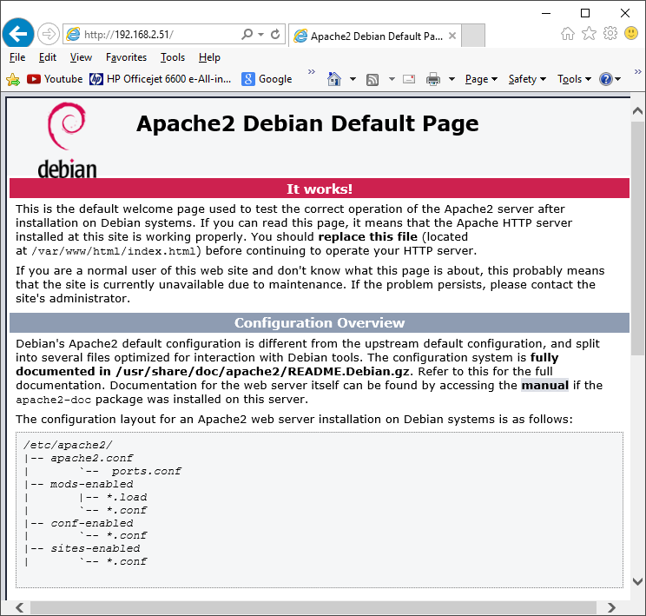

### Install the Web Browser server pages

It is now necessary to install the web pages for the Radio. Download the correct radio web pages Debian package from the Bob Rathbone web site.

For **Raspbian Stretch** run the following:

$ wget http://www.bobrathbone.com/raspberrypi/packages/radiodweb\_1.7\_armhf.deb

Now run:

$ **sudo dpkg -i radiodweb\_1.7\_armhf.deb**

This package will install the radio web pages in the **/var/www/html** directory and the CGI scripts in /**usr/lib/cgi-bin** directory. It will also enable the CGI scripts module.

The following error message may appear:

apache2: Could not reliably determine the server's fully qualified domain name, using 127.0.1.1. Set the 'ServerName' directive globally to suppress this message

The message may be ignored or it can be suppressed by editing the **/etc/apache2/apache2.conf** file and adding a **ServerName** directive.

Edit **/etc/apache2/apache2.conf** file.

Add the following line anywhere in the **apache2.conf** file.

ServerName localhost

### Start the radio web interface

Point your web browser at the IP address of the Raspberry PI. For example: <http://192.168.2.11> . You should see the following display:

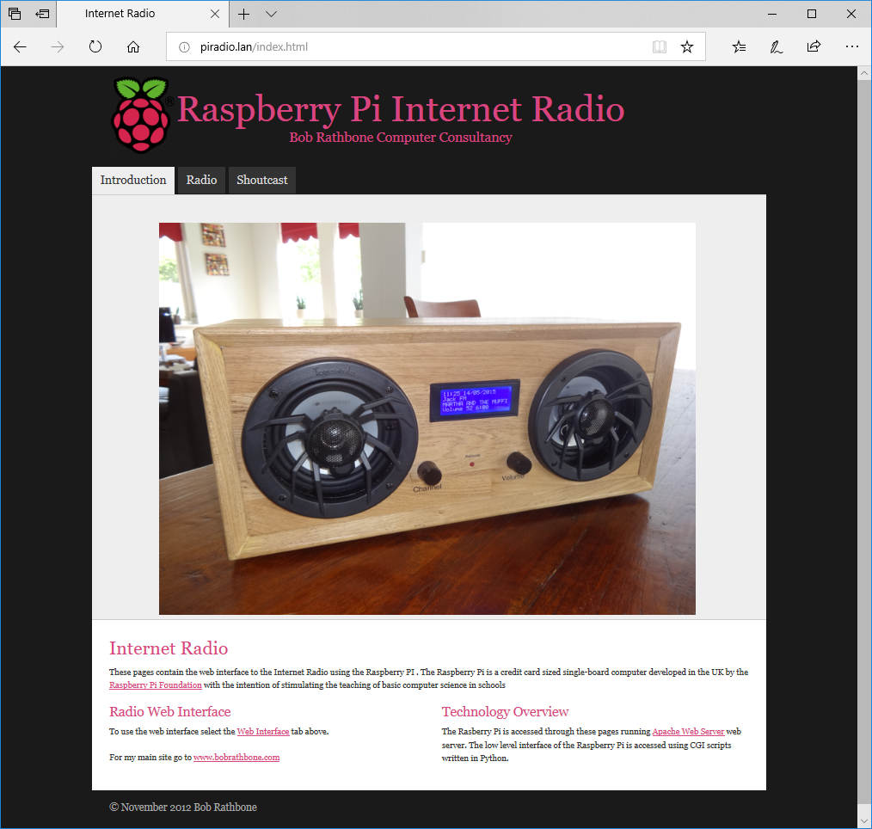

Figure 145 Radio web interface

Now click on the ‘Radio’ tab. If the radio software is running you will see the following:

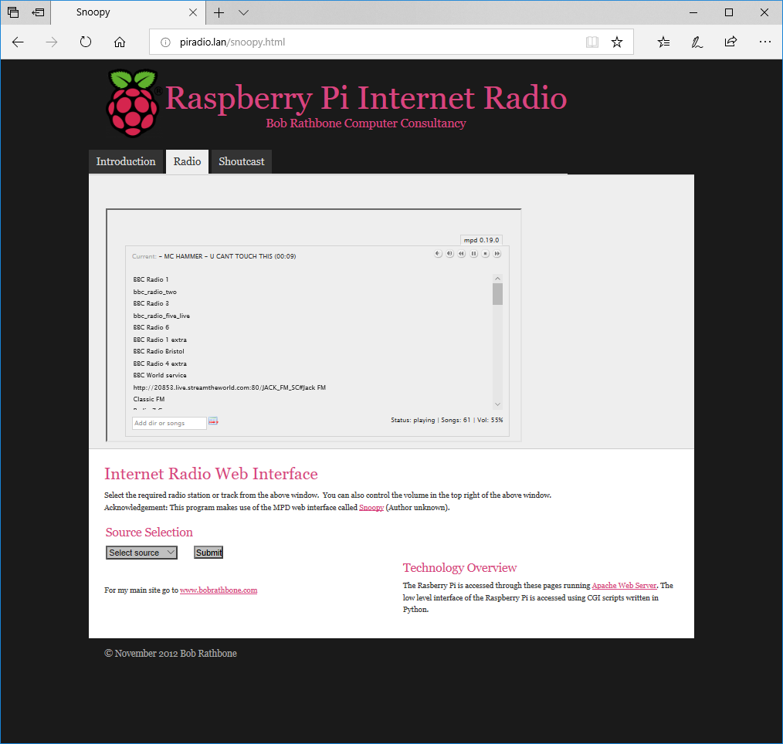

Figure 146 Snoopy web interface

Click on any station in the list to select a station. After a short pause the station should start playing if it is online.

|  |  |
| --- | --- |
|  | Currently there are four music sources that can be selected namely Radio, Media, Airplay and Spotify.  The desired source can be selected from the source drop-down selection box. Click on the required source then click on ‘Submit’ button to load the selected source in the radio. |

The Shoutcast tab is explained in *Using the Shoutcast Web Interface* on page 146.

**Note:** The radio tab only displays radio stations or media tracks from MPD. It is not currently capable of displaying Spotify or Airplay details which can only be seen on the radio itself.

### Changing the Web Interface Radio photo

If you want to change the photo displayed by the web interface, then replace the **jpeg** photo file at **/var/www/html/images/radio.jpg**. Try to adjust the size on disk to about 50K using a suitable photo editor such as Photo Shop. Copy the new jpeg photo to the pi home directory with any ftp program.

Now copy it to the web pages image directory using sudo.

$ sudo cp radio.jpg /var/www/html/images/.

If the new image looks stretched then it may also be necessary to change image proportions in the <img..> statement in **/var/www/html/index.html** file. Find the following line in the index file and adjust the width/height values to display the photo with the correct proportions.

<img border="0" src="images/radio.jpg" width="780" height="580"></td>

## Installing the speech facility

It is possible to configure speech for visually impaired and blind persons who cannot read the display. As channels are changed or stepping through the menu the radio will “speak” to you. This excellent idea came from one of the project contributors, see *Acknowledgements* on page 210). This facility requires installation of the **espeak** package.

See <http://elinux.org/RPi_Text_to_Speech_(Speech_Synthesis)>

The speech facility makes use of the **/var/lib/radio/language** file as already described in the section called *Creating a new language file* on page 113

Install the **espeak** package:

$ sudo apt-get install espeak

Enable the speech facility in **/etc/radiod.conf** and restart the radio.

# Speech for visually impaired or blind listeners, yes or no

speech=yes

The verbose setting speaks the station or track details every time it is changed. However it can take a long time to move through the tracks or stations whilst speaking. Usually set this to no.

verbose = no

To get the right balance between speech volume and the normal radio volume adjust the **speech\_volume** parameter percentage (10-100%)

speech\_volume=30

### The /var/lib/radiod/voice file

The **/var/lib/radiod/voice** file contains the **espeak** command (or part of it).

$ espeak -ven+f2 -k5 -s130 –a

Where -v is the voice (en+f2 = English female voice 2), -k is capitals emphasis, -s is the voice speed and -a is amplitude (0-200), the -a parameter is filled in by the radio program.

### Testing espeak

You can test **espeak** with the following command (Stop the radio first).

$ espeak -ven+f2 -k5 -s130 -a20 "Hello Bob" --stdout | aplay

To see the capabilities of **espeak** see the website <http://espeak.sourceforge.net/> or run:

$ espeak –h

If no sound is heard then then test using the **aplay** program. The **espeak** system will not work if **aplay** is not working. Test with **aplay** and a suitable wav file.

$ sudo mpc pause

$ aplay /usr/share/scratch/Media/Sounds/Vocals/Singer2.wav

If still no sound check what devices are configured using aplay.

# **aplay -l**

\*\*\*\* List of PLAYBACK Hardware Devices \*\*\*\*

card 0: ALSA [bcm2835 ALSA], device 0: bcm2835 ALSA [bcm2835 ALSA]

Subdevices: 8/8

Subdevice #0: subdevice #0

Subdevice #1: subdevice #1

Subdevice #2: subdevice #2

Subdevice #3: subdevice #3

Subdevice #4: subdevice #4

Subdevice #5: subdevice #5

Subdevice #6: subdevice #6

Subdevice #7: subdevice #7

card 0: ALSA [bcm2835 ALSA], device 1: bcm2835 ALSA [bcm2835 IEC958/HDMI]

Subdevices: 1/1

Subdevice #0: subdevice #0

card 1: Device [Generic USB Audio Device], device 0: USB Audio [USB Audio]

Subdevices: 0/1

Subdevice #0: subdevice #0

In the above example there are two devices namely *bcm2835 ALSA* (normal audio jack output)and *Generic USB Audio Device*. If using either a HiFiBerry DAC or IQaudIO device then create the **/etc/asound.conf** file using nano:

$ sudo nano /etc/asound.conf

Add the following lines:

ctl.!default {

type hw

card 1

}

pcm.!default {

type plug

slave {

pcm "plughw:0,0"

format S32\_LE

}

}

The format S16\_LE is an alternative format but does not work with HiFiBerry DAC. The above statements set up the default mixer and PCM sound device respectively to use card 1.

If using the USB (Card 2 device 1) then change the device definition in the above file.

pcm "plughw:1,0"

Retest with **aplay** (No need to reboot).

Note: This author does not provide support for **espeak**.

### Speech Operation

At the moment the speech function is highly experimental and will be developed further if there is the demand. The best use is with the remote control which includes a button for toggling sound on and off and another button to speak information about the station or track as well as speaking the time. These buttons are set up in the section called *Installing the Infra Red sensor software* on page 90.

The Rotary encoder version of the radio is the best implemented. The MUTE switch is now the “Speak information” switch. To mute the radio, hold the button in for two seconds and release.

### Suppressing an individual message

It is possible to suppress speech of an individual message by adding an exclamation mark (!) to the beginning of the message string in the language file. For example if you do not wish to hear the time when speaking information then change **the\_time** parameter by adding an ! character to the beginning of the text to be spoken as shown in the example below:

the\_time: !The time is

The exclamation message is removed if the message is displayed on a display. Only speech is affected.

## Keeping the radio software up-to-date

|  |  |
| --- | --- |
| Afbeeldingsresultaat voor twitter logo | The Radio software may be updated from time to time especially if a new version of the operating system is released or a new feature is added to the software. To keep up to date follow the author on Twitter at: <https://twitter.com/bob_rathbone> (https://twitter.com/bob**\_**rathbone) |

## Backing up the SD card

Having spent a lot of time and effort installing and configuring the Radio software it is a very good idea to create a backup of the SD card should it ever become corrupted. There are various ways of doing this. For backing up under Linux see:

<https://www.raspberrypi.org/documentation/linux/filesystem/backup.md>

One of the easiest ways of backing up the SD card on a Windows machine using Windows Disk Imager (Win32DiskImager) described in the following link.

<https://www.raspberrypi.org/forums/viewtopic.php?t=26463>

This allows you to create a copy of the SD card in ann image (.img) file. This can then be compressed using **winzip/Zzip** or any other zip utility to reduce the space on disk.

# Chapter 7 – Configuration

This section covers manual configuration of the radio. A number of programs are provided to help with configuration. These are:

1. **configure\_radio.sh** – Configure the basic radio interfaces.
2. **configure\_audio.sh** – Configure the audio output.
3. **set\_mixer\_id.sh** – Configure the Alsa mixer volume control ID (normally called by the radio program)

The above programs are found in the **/usr/share/radio** directory and are normally used to configure the radio and audio output. The following descriptions cover manual configuration and those configuration parameters not set by the above programs.

## Configuring the HDMI or Touch Screen

In the **/etc/radiod.conf** file there is a section called [SCREEN] as shown below. This is the HDMI/Touch Screen default configuration.

# Graphics (touch screen) screen settings

[SCREEN]

# Size is in pixels. Supported is 800x480 (7" screen) or 720x480(3.5" screen)

# or 480x320 (2.8" or 3.5" screen) or 1024x600 (Maximum)

# Also see framebuffer\_width and framebuffer\_height parameters in /boot/config.txt

screen\_size=800x480

fullscreen=yes

# Screen save time in minutes, 0 is no screen saver

screen\_saver=0

# Title %V = version %H = hostname

window\_title=Bob Rathbone Internet Radio Version %V - %H

window\_color=turquoise

banner\_color=white

labels\_color=white

display\_window\_color=lightblue

display\_window\_labels\_color=black

slider\_color=darkgreen

display\_mouse=yes

# Wallpaper backgrounds. See /usr/share/scratch/Media/Backgrounds

wallpaper=/usr/share/scratch/Media/Backgrounds/Nature/beach-malibu.jpg

# Set date format for graphic screen

dateformat=%H:%M:%S %A %e %B %Y

# Allow switching between vgradio and gradio

switch\_programs=yes

# The following is specific to the vintage graphical radio

scale\_labels\_color=white

stations\_per\_page=40

display\_date=yes

display\_title=yes

**Parameter Explanation**

**fullscreen** Set to **yes** or **no**. If using a large HDMI monitor or TV set to **no**.

**window\_title** Title to display in the desktop window if **fullscreen=no**

**window\_color** Window background colour if **wallpaper** (See below) not specified.

**banner\_color** This is the colour of the time and date banner.

**labels\_color** This is the colour of the radio and MPD option labels.

**display\_window\_color** This is the background colour of the station/track display window.

**display\_window\_labels\_color** Colour of the display window text.

**slider\_color** The color of the slider in the slider window next to the search window.

**display\_mouse** Future use – hide mouse **yes/no**.

**wallpaper** Background wall paper. Any jpeg or gif file can be specified.

See directory =/usr/share/scratch/Media/Backgrounds.

**dateformat** The format for displaying the time and date banner.

The following settings are specific to the vintage graphical radio:

**scale\_labels\_color** This sets the color of the station names on the tuning scale

**stations\_per\_page** This is the maximum number of stations that will be displayed on each page.

**display\_date** Display the date at the top of the screen yes/no

**display\_title** Display the station title at the bottom of the screen yes/no

****All parameters use the American spelling for color and not the British spelling.

The **wallpaper** parameter overrides the **window\_color** parameter.

The parameters allow any theme to be configured for the HDMI or Touch Screen window.

## Configuring GPIO outputs

Apart from changing the **down\_switch** GPIO setting to be compatible with the **HiFiBerry DAC** it is not normally necessary to change the GPIO settings for the switches, rotary encoders or LCD display connections. The default settings match the wiring configuration shown in Table 4 on page 19. Unless here is a need to change the GPIO configuration skip this section.

All switches, rotary encoders and LCD display settings are configurable in the **/etc/radiod.conf** file.

|  |  |
| --- | --- |
| note_icon.png | If the GPIO assignments are changed in the **/etc/radiod.conf** file then these must match the actual physical wiring for your radio project. |

### Switches and rotary encoders GPIO assignments

The default switch settings including the rotary encoders are shown below. Normally there is no need to change these as they are set by the **configure\_radio.sh** program.

# Switch settings for 40 pin version (support for IQaudIO)

menu\_switch=17

mute\_switch=4

up\_switch=24

down\_switch=23

left\_switch=14

right\_switch=15

### Disabling button or rotary encoder GPIOs

From version 6.8 onwards it is possible to disable a button or rotary encoder GPIO configuration. For example, if you are building a radio with an amplifier with its own volume control you may not need the music player daemon volume control as well. In this case set these to 0 to disable them.

menu\_switch=17

up\_switch=24

down\_switch=23

mute\_switch=0

left\_switch=0

right\_switch=0

This will free the GPIOs originally configured for the volume control for other uses (14, 15 and 23 in this example).

### LCD display GPIO assignments

The default LCD settings for a 40 pin Raspberry Pi are shown below. Again, there is no need to change these unless your wiring is different. Again, setting these to 0 disables the outputs.

# LCD GPIO connections for 40 pin version of the radio

lcd\_select=7

lcd\_enable=8

lcd\_data4=5

lcd\_data5=6

lcd\_data6=12

lcd\_data7=13

### Configuring button interface with pull up resistors

This applies to the radio with push buttons only. The original design of the radio wires the push buttons from low to high (GND 0V to 3.3V). It is now more usual to configure the buttons to operate from high to low (3.3V to GND 0V). This is the case for rotary encoders. It may be easier to wire up the buttons to GND 0V. In such a case it is necessary to configure the **pull\_up\_down** parameter in **/etc/radiod.conf** to ‘up’ as shown below.

# Pull GPIO up/down internal resistors (Applies button interface only).

# Default:down

pull\_up\_down=up

## Configuring the remote control activity LED

It is useful to have an activity LED which flashes every time the remote control is pressed. How to wire the activity LED is shown on page 39. Which pins you connect to will depend on the type of radio you are building. Table 8 on page 39 shows the required LED connections. Boards such as the the **AdaFruit RGB plate** will need a 40 pin Raspberry PI as all the first 26 pins are occupied but the plug in card.

Configure the LED in **/etc/radiod.conf** for to pin 11 GPIO 23 for all versions except AdaFruit plate or Vintage radio. For Adafruit RGB plate configure either **remote\_led=0** (No LED) or GPIO 13 (pin 33). For the vintage radio use GPIO 23 (Pin 16). See the section called *Remote* Control Activity LED on page 39.

# Output LED for remote control, default GPIO 11 (pin 23) or

# GPIO 13 (pin 33) for AdaFruit plate

# remote\_led=0 is no output LED

remote\_led=11

### Testing the remote control activity LED

It is possible to test the activity LED with the **remote\_control.py** program.

$ cd /usr/share/radio/

$ sudo ./remote\_control.py flash

Or use the service command:

$ sudo service irradiod flash

The **irradiod** script calls the **remote\_control.py** program. The activity LED should flash about six times. If not then check that the **remote\_led** parameter in the **/etc/radiod.conf** configuration file is correctly set and that the activity LED is correctly wired (See LED wiring on page 39).

## Changing the date format

The date is configured in the **/etc/radiod.conf** file using the **dateformat** parameter:

dateformat=%H:%M %d/%m/%Y

The default configuration is: **%H:%M %d/%m/%Y**

Where: %H = Hours, %M=Minutes, %d= Day of the month, %m=month, %Y=Year

It is possible to change the date format (for example for the United States) by changing the format.

Some valid formats are:

%H:%M %m/%d/%Y US format

%H:%M %d-%m-%Y Minus sign as date separator

%d/%m/%Y %H:%M Reverse date and time

%H:%M %m%d Short date display for Olimex OLED

Seconds can also be displayed:

%H:%M:%S %d/%m/%Y Display seconds (%S) on 20 character displays only

## Configuring the IQaudIO Cosmic controller and OLED

The **configure\_radio.sh** program can be used to set the configuration to use the 128 by 64 pixel OLED supplied with the Cosmic controller. This sets the **display\_type** parameter to **OLED\_128x64**.

display\_type=OLED\_128x64

When running with the Cosmic controller OLED screen there are two relevant settings in the **/etc/radiod.conf** file which are not set by the **configure\_radio.sh** program.

The OLED display can be flipped vertically by setting the **flip\_display\_vertically** parameter to yes.

flip\_display\_vertically=yes

Note: If upgrading you will need to add this parameter to the **[RADIO]** section of the **/etc/radiod.conf** file.

The three LEDs on the Cosmic Controller board are driven by the *status\_led\_class.py* program. This class was originally written for the Vintage radio but is now also used with this board. Configure the following parameters in **/etc/radiod.conf** as shown below:

rgb\_red=14

rgb\_green=15

rgb\_blue=16

The left LED means an ERROR, the middle LED means NORMAL operation and the right-most is BUSY.

If you want to switch off the status LEDs then set them to 0. However, GPIO 15 is switched on automatically at boot time. To switch it off add the following two lines to **/etc/rc.local**.

gpio -g mode 15 out

gpio -g write 15 0

Set the date format so that it displays fits the display.

dateformat=%H:%M %d%m

## Configuring the Adafruit LCD backlight colours

Some Adafruit displays such as the **rgb-negative Adafruit LCD** allow changing the colour of the backlight. This is configurable in the **/etc/radiod.conf** file. The colours that can be used are RED, GREEN, BLUE, YELLOW, TEAL, VIOLET and WHITE or OFF (No backlight).

The colour settings in the /etc/radiod.conf file

# Background colours (If supported) See Adafruit RGB plate

# options OFF, RED, GREEN, BLUE, YELLOW, TEAL, VIOLET, WHITE

bg\_color=WHITE

mute\_color=VIOLET

shutdown\_color=TEAL

error\_color=RED

search\_color=GREEN

info\_color=BLUE

menu\_color=YELLOW

source\_color=TEAL

sleep\_color=OFF

**Note:** Always use the American spelling ‘color’ in all commands and not the British spelling ‘colour’.

## Configuring startup mode for Radio or Media player

The radio can be configured to start in **RADIO**, **MEDIA**, **LAST** modes or a **playlist** name. The default is **RADIO**. To change this, edit **/etc/radiod.conf** and change the **startup=RADIO** parameter to **MEDIA** or **LAST** to start the radio with the last playlist used in the previous run.

# Startup option either RADIO,MEDIA or LAST a playlist name

startup=RADIO

#startup=\_Radio

Alternatively, the radio can be configured to load a specific playlist. To display the available playlists run the following command:

$ **mpc lsplaylists**

USB\_Stick

\_UK\_stations

Beatles

\_Radio

:

To configure the radio to start with a specific playlist change the **startup=** statement.

#startup=RADIO

startup=\_Radio

## Configuring the volume display

The volume can be displayed as either text or as a series of blocks. This is configured in **/etc/radiod.conf** using the **volume\_display** parameter. The default is text.

# Volume display text or blocks

volume\_display=text

|  |
| --- |
| 12:01 30/08/2017  WPJR Country  Lonestar – Mr. Mom  Volume 75 |

To display the volume as a series of blocks change this to ‘blocks’:

volume\_display=blocks

|  |
| --- |
| 12:01 30/08/2017  WPJR Country  Lonestar – Mr. Mom   |

|  |  |
| --- | --- |
| note_icon.png | If the timer or alarm functions are being used then the volume display reverts back to text display so as to allow display of the alarm or timer values. |

## Configuring the volume range

This setting affects the volume control sensitivity.

The MPD daemon has a volume range from 0 to 100. The volume is incremented or decremented by one each time the volume button is pressed or rotary encoder is turned a notch. This means a lot of turns of the knob or pushes of the button to change the volume the full range. Also, different devices are more sensitive than others.

For example, the Adafruit plate version allows very rapid change of the volume and the default range of 0 to 100 is not a problem. The rotary encoder version of the radio requires a lot of twisting of the volume knob to get from 0 to 100.

This **volume\_range** parameter allows you to set the volume range to increase the sensitivity of the volume control as shown below. For example, if the volume range is set to 20 you will see the volume displayed from 0 to 20 however the MPD volume is incremented by 5.

Increment = 100 / Volume range. For example, 100/20 = 5

So, if the volume displayed on the LCD is 10 and the range is 20, then the MPD volume is 10 x 5 = 50%.

The volume range is configured in **/etc/radiod.conf** configuration file using the **volume\_range** parameter:

# Volume range 10, 20, 25, 50 or 100

volume\_range=20

Ideally you should choose a volume range number that divides into 100 equally as shown above however other values will work.

## Changing the display language

The language file is stored in **/home/pi/radio/language** directory. This contains the text that will be either displayed or spoken. The default language is English. The **language.en** file is copied to **/var/lib/radiod/language**. The language file (if present) file is loaded during start-up of the radio. If not present the default English text is used.

The format of each entry in the language file is:

<label>:<text>

For example:

select\_source: Select source

It is possible to display all the labels and text by running **language\_class.py**.

$ **cd /usr/share/radio**

$ **./language\_class.py**

airplay: Airplay

alarm: Alarm

alarmhours: Alarm hours

alarmminutes: Alarm minutes

colour: Colour

consume: Consume

current\_station: Current station

information: Information display

loading: Loading

loading\_media: Loading media library

loading\_radio: Loading radio stations

main\_display: Main

media\_library: Media library

menu\_find: Find

menu\_option: Menu option:

menu\_search: Search

:

### Creating a new language file

To create a new language file by running the **language\_class.py** program and redirecting the output to a file called **language.<new>** where **<new>** is the country code. For example, to create a language file in Dutch, the country code is **nl**.

$ cd /usr/share/radio

$ sudo ./language\_class.py > language/language.nl

Now edit the text (Not the labels) in the language/language.nl file. It isn’t necessary to change every message. Lines beginning with # are for any comments.

# Nederlands text for uitspraak

main\_display: Hoofd menu

search\_menu: Zoek menu

select\_source: Media selecteren

options\_menu: Opties menu

rss\_display: RSS beeld

information: Informatie beeld

the\_time: De tijd is

loading\_radio: Radio zenders laden

loading\_media: Media laden

search: Zoek

source\_radio: Internet Radio

source\_media: Muziek selectie

sleeping: Slaapen

Finally copy the new language file to **/var/lib/radiod/language** (Omit the country code) and restart the radio.

$ sudo cp language/language.nl /var/lib/radiod/language

$ sudo service radiod restart

## Configuring an RSS feed

To display an RSS feed it is necessary to create the **/var/lib/radiod/rss** file with a valid RSS URL. For example:

http://feeds.bbci.co.uk/news/uk/rss.xml?edition=int

The above is the RSS for the BBC news feed however any valid RSS feed may be used. If the **/var/lib/radiod/rss** is missing or contains an invalid RSS URL then this mode is skipped when stepping through the menu. The software comes with a valid BBC RSS feed file in the **/var/lib/radio/rss** file. You can test the feed first by pasting it into your PC’s web browser URL and pressing enter.

If configured, the RSS feed will be automatically displayed by stepping through the menus.

## Configuring the Alsa Equaliser

**Note:** The author of the radio software does not currently have a configuration that is compatible with either **Pulseaudio** or **Airplay**. If you wish to use either **Pulseaudio** or **Airplay** you cannot currently use the Alsa equalizer. This may change in a future release.

Install the Alsa equalizer plugin with **apt-get**:

$ sudo apt-get install -y libasound2-plugin-equal

Amend the “device” parameter in the **audio\_output** block in **/etc/mpd.conf** configuration file.

audio\_output {

type "alsa"

name "IQAudio DAC+"

#device "hw:0,0"

device "plug:plugequal"

mixer\_type "software"

}

In the above example we are using an IQaudIO card but may be any sound card.

Save the existing **asound.conf** file just in case you need to restore the original file

$ sudo cp /etc/asound.conf /etc/asound.conf.save

Edit the **/etc/asound.conf** file as shown below:

pcm.!default {

type plug

slave.pcm plugequal;

}

ctl.!default {

type hw card 0

}

ctl.equal {

type equal;

}

pcm.plugequal {

type equal;

slave.pcm "plughw:0,0";

}

pcm.equal {

type plug;

slave.pcm plugequal;

}

If your sound system is using card 1 (for example a USB audio device) then change the hardware settings in the above configuration to use card 1.

:

type hw card 1

:

slave.pcm "plughw:1,0";

Reboot the Raspberry Pi.

$ sudo reboot

After reboot run the Alsa Equaliser as user **mpd**. It will not work if called as either user pi or root (sudo).

$ sudo -H -u mpd alsamixer -c 0 -D equal

If using card 1 change the -c 0 parameter above to -c 1.

The following screen will be displayed:

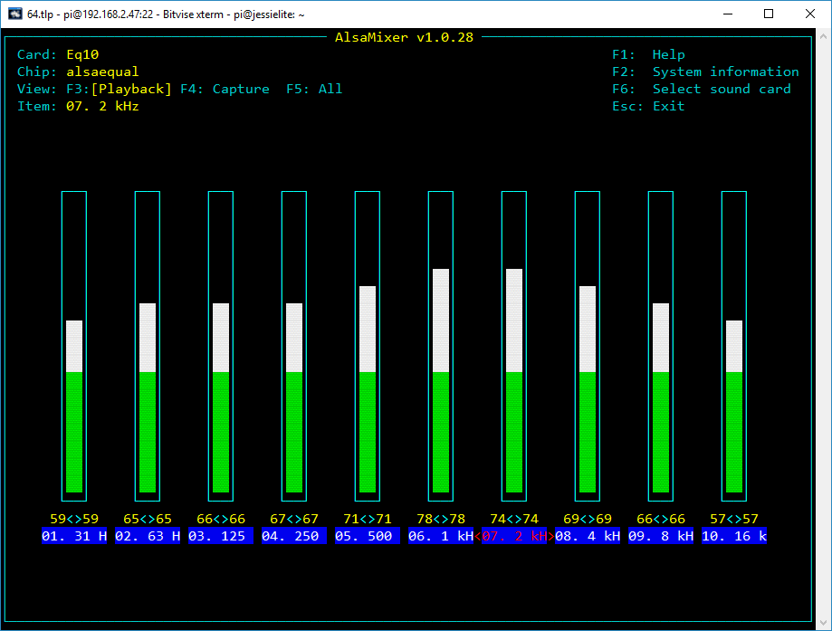

Figure 147 The Alsa Equalizer

Use the Tab key to move along to the desired equalizer frequency to be changed. In this example, it is the <2KHz> block. Use the up and down arrows to adjust the level. The settings are saved in the **/var/lib/mpd/.alsaequal.bin** file. Changes to the sound should be heard.

**Note:** If you set a particular frequency value too high you will cause unpleasant distortion to the sound output.

### Disabling the Alsa equalizer

Restore the original asound.conf file:

$ sudo cp /etc/asound.conf.save /etc/asound.conf

Restore the original “device” parameter in the **audio\_output** block in **/etc/mpd.conf** configuration file.

audio\_output {

type "alsa"

name "IQAudio DAC+"

device "hw:0,0"

#device "plug:plugequal"

mixer\_type "software"

}

Reboot the Raspberry Pi to restore the original sound configuration.

## Configuration of the FLIRC USB dongle

**Note:**  This installation procedure is only for the HDMI or Touchscreen display of the radio. If using an LCD display see *Installing the Infra Red sensor software* on page 90.

It is first necessary to install FLIRC. First install the necessary libraries.

$ sudo apt-get install libhidapi-hidraw0 libqt5xmlpatterns5

Add the FLIRC repository by running the following:

$ curl -s https://packagecloud.io/install/repositories/Flirc/repo/script.deb.sh | sudo bash

Install the flirc package

$ sudo apt-get install flirc

Reboot the Raspberry pi in Desktop mode.

Click on the left-hand program icon (A Raspberry) and select Accessories. In Accessories select **Flirc**.

The following screen will be displayed. However, on a 7-inch touchscreen you may not be able to see the whole FLIRC window. In this case use the procedure called Configuring FLIRC from the command line on page 118. The first time you run this program it may ask you if you want to upgrade the firmware (Version v4.4.2 at the time of writing).



Figure 148 FLIRC setup program

On the **Controllers** drop down menu select the **Full Keyboard** controller.

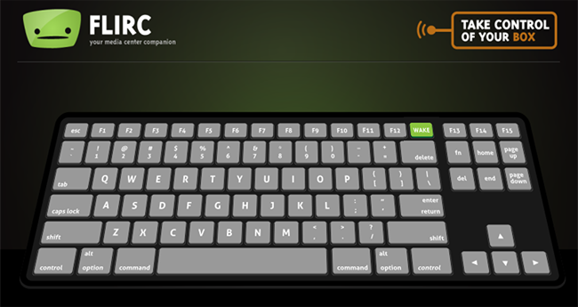

Figure 149 FLIRC keyboard controller

Now map the buttons on the remote control to the keys shown in Table 16 Graphic screen keyboard command on page 132. For example, press the letter **m** on the above keyboard and then press the Mute button on the Remote Control. For volume control up press Shift key followed by the + key on the keyboard, then press the volume up button on the remote control. Do the same with the – key for volume down. Full instructions for configuring FLIRC are to be found at: <https://flirc.gitbooks.io/flirc-instructions/>

## Configuring FLIRC from the command line

If using a small touchscreen there may not be enough room to see the Flirc screen. If so do the following:

1. Amend the **fullscreen=yes** parameter to **fullscreen=no** in **/etc/radiod.conf**
2. Reboot the Raspberry PI
3. When rebooted open a terminal session on the desktop (Don’t use remote SSH).
4. In the terminal window on the command line run the following:

$ flirc\_util format

Now record the buttons:

$ flirc\_util record up

Press any button on the remote to link it with ‘+‘

‘up’ is the name of the key. Now press the Channel Up key. The following will be displayed:

Successfully recorded button.

Repeat the command for each key name.

They are:

pageup, pagedown,

+, -,

left, right,

up, down,

return,

l(small letter L), p, a,

r, t, c, s, m and d.

In the case of the + and – keys press shift first, followed by the + or – key.

Test and if necessary repeat key-mapping. If configuring on an HDMI Television do not configure volume (+-) or mute (m) keys as the TV will provide these functions.

The configured keys can be displayed with the **flirc\_util keys** command.

$ flirc\_util keys

Recorded Keys:

Index hash key

----- --------- ---

0 7D14E297 down

1 ED385097 up

2 58C86297 right

3 41787497 left

4 BF8F6297 return

5 AB616762 r

6 2676D097 t

7 B6536297 c

8 9206E297 s

9 590C3E97 l

10 E8E8D097 p

11 C49C5097 a

12 F1EFD097 e

13 B9F03963 escape

14 D1F15097 pageup

15 53DA6297 pagedown

16 9F5BE297 escape

17 A8DDF497 left\_ctrl Q

18 66FFBE97 d

Saving the configuration:

flirc\_util saveconfig my\_flirc\_config

Saving Configuration File 'my\_flirc\_config.fcfg' to Disk

[========================================>] 100%

Configuration File saved

There is also a **loadconfig** command.

What if a key does not work after configuring it.

First delete the key by its index. In this example the key d (Display Window) command isn’t working.

$ flirc\_util delete\_index 18

Re-record the key

$ flirc\_util record d

Press any button on the remote to link it with ‘+‘

Successfully recorded button.

Re-test and repeat until a reliable ‘hash’ is received from the remote control.

If a key is multiply defined delete the first one you see by its index.

13 B9F03963 escape

14 D1F15097 pageup

15 53DA6297 pagedown

16 9F5BE297 escape

$ flirc\_util delete\_index 13

Re-test and if necessary re-record.

There is a help facility for the flirc\_utility.

$ flirc\_util help

# Chapter 8 - Operation

## Operation of LCD versions

This section assumes that the LCD screen is working correctly, the MPD daemon is installed and tested and that there is an Internet connection available. This section is for LCD versions only. For graphical radios see *Operation of HDMI and touch screen displays* on page 126.

### Starting the program

The program must either be run as root user or using sudo.

The basic operation of the program is:

$ sudo service radiod start|stop|restart|status|info|version

Where start: Start the radio program.

stop: Stop the radio program.

restart: Restart the radio program.

status: Show the status of the radio daemon.

info: Show program information

version: Show the version number of the program

To start the radio:

$ **sudo systemctl start radiod**

To stop the radio:

$ **sudo systemctl start radiod**

The following System V commands will also work:

$ sudo service radiod start

$ sudo service radiod stop

To display the status either use the program directly or use the **sudo service radiod status** command:

$ **sudo service radiod status**

● radiod.service - Radio daemon

Loaded: loaded (/lib/systemd/system/radiod.service; enabled; vendor preset: enabled)

Active: active (running) since Wed 2017-11-08 10:06:19 CET; 3h 55min ago

Main PID: 1619 (python)

CGroup: /system.slice/radiod.service

└─1619 python /usr/share/radio/radiod.py nodaemon

:

{The last relevant log entries will be displyed here}

To see what version of the software you are running:

$ **sudo service radiod version**

Version 6.9

To display information about the running program:

$ **sudo service radiod info**

radiod.py Running PID 1877

Music Player Daemon 0.19.21

Raspbian GNU/Linux 9 (stretch)

Linux stretch 4.9.41-v7+ #1023 SMP Tue Aug 8 16:00:15 BST 2017 armv7l GNU/Linux

The above shows the process ID of the radio, the Music Player Daemon version and operating system details.

### Radios with push buttons operation

The original radio has five buttons, four function buttons and one menu button. However, the new design can also support a sixth button which is the mute button. The Menu button changes the display mode and the functions of the left and right-hand buttons as shown in the following table. If using rotary encoders please see Table 15 on page 124.

|  |
| --- |
| **Menu button** - Changes the display mode and the functions of the buttons. |

Table 14 Push Button Operation

|  |  |  |  |  |
| --- | --- | --- | --- | --- |
|  | Volume buttons | | Channel buttons | |
| LCD Display Mode | Right button | Left button | Up button | Down button |
| Mode = TIME  Line 1: Time Line 2: Station or Track | Volume Up | Volume Down | Station/Track up | Station/Track down |
| Mode = SEARCH  If source = RADIO Line 1: Search: Line2: Radio Station | Volume Up | Volume Down | Scroll up radio station | Scroll down radio station |
| Mode = SEARCH  If source = MEDIA Line 1: Search Line2: MusicTrack/Artist | Scroll up through artists | Scroll down through artists | Scroll up through track | Scroll down through track |
| Mode = SOURCE  Line 1: Input Source: Line2: Radio or Media playlist or Airplay | Volume Up  Mute | Volume Down  Mute | Cycle up through Airplay, Radio and Media playlists | Cycle down through Airplay, Radio and Media playlists |
| Mode = OPTIONS  Line 1: Menu Selection  Line 2: <option>  Options are Random, Consume, Repeat, Reload Music, Timer, Alarm ,Alarm Time Set (Hours), Alarm Set (Minutes), Streaming: | Toggle selected mode on or off. Set timer and Alarm | Toggle selected mode on or off. Set timer and Alarm | Cycle through Random, Consume, Repeat, Reload Music, Timer, Alarm , Alarm Time Set and Streaming | Cycle through Random, Consume, Repeat, Reload Music, Timer, Alarm Time Set and Streaming: |
| Mode = RSS (1)  Line 1: Time Line 2: RSS feed | Volume Up  Mute | Volume Down  Mute | Station/Track up | Station/Track down |
| MODE = IP address  Line 1: IP address Line 2: Station or Track | Volume Up  Mute | Volume Down  Mute | Scroll up through track or radio station | Scroll down through track or radio station |

Note: If the **/var/lib/radiod/rss** file is missing then the RSS mode is skipped.

If it contains an invalid RSS URL, this will be displayed on the LCD.

### Radios with rotary encoders operation

This option is for a radio with rotary encoders with push buttons. The volume knob when pushed in is the **Mute** sound function. Likewise, the tuner knob when pushed in is the **Menu** switch.

The Menu button (Tuner knob depressed) changes the display mode and the functions of the clockwise and anti-clockwise operation of the knobs as shown in the following table.

|  |
| --- |
| **Menu button** - Changes the display mode and the functions of the buttons. |

Table 15 Rotary Encoder Knob Operation

|  |  |  |  |  |
| --- | --- | --- | --- | --- |
|  | Volume knob | | Tuner knob | |
| LCD Display Mode | Clockwise | Anti-clockwise | Clockwise | Anti-clockwise |
| Mode = TIME  Line 1: Time Line 2: Station or Track | Volume Up | Volume Down | Station/Track up | Station/Track down |
| Mode = SEARCH  If source = RADIO Line 1: Search: Line2: Radio Station | Volume Up | Volume Down | Scroll up radio station | Scroll down radio station |
| Mode = SEARCH  If source = MUSIC LIBRARY Line 1: Search Line2: MusicTrack/Artist | Scroll up through artists | Scroll down through artists | Scroll up through track | Scroll down through track |
| Mode = SOURCE  Line 1: Input Source: Line2: Radio or Media playlist or Airplay | Volume Up  Mute | Volume Down  Mute | Cycle up through Airplay, Radio and Media playlists | Cycle down through Airplay, Radio and Media playlists |
| Mode = OPTIONS  Line 1: Menu Selection  Line 2: <option>  Options are Random, Consume, Repeat, Reload Music, Timer, Alarm and Alarm Time(Hours), Alarm Time(Minutes) set and Change colour(1), Streaming on/off. | Toggle selected mode on or off. Set timer and Alarm | Toggle selected mode on or off. Set timer and Alarm | Cycle through Random, Consume, Repeat, Reload Music, Timer, Alarm Time Set, Streaming and Background colour(1) | Cycle through Random, Consume, Repeat, Reload Music, Timer, Alarm , Alarm Time Set, Streaming and Background colour(1) |
| Mode = RSS (2)  Line 1: Time Line 2: RSS feed | Volume Up | Volume Down | Station/Track up | Station/Track down |
| MODE = IP address  Line 1: IP address Line 2: Station or Track | Volume Up | Volume Down | Scroll up through track or radio station | Scroll down through track or radio station |

|  |  |
| --- | --- |
| note_icon.png | Note 1: The colour change option is only available for the AdaFruit RGB plate (ada\_radio.py). Note 2: If the **/var/lib/radiod/rss** file is missing or contains an invalid RSS URL then the RSS mode is skipped. |

### Mute function

Pressing both volume buttons together or in the case of a rotary encoder with a push button (Volume) will mute the radio. If voice is enabled then then operation is slightly different (See section on espeak). Press either the volume up or down switch to un-mute the radio. If you change channel or use the menu switch the radio will also be un-muted. If the alarm is set then the radio will go into sleep mode.

## Operation of HDMI and touch screen displays

### The graphical screen

The HDMI and Touch Screen versions of the program can be started in three separate ways.

1. Automatically when starting the desktop
2. By clicking on the radio icon on the desktop
3. By manually starting the program from the command line

To start the radio from command line run the gradio.py program:

$ cd /usr/share/radio

$ sudo ./gradio.py &

|  |  |
| --- | --- |
| Starting the radio from the desktop. Click the icon shown here on the desktop. |  |

In all cases a screen similar to the following will be displayed. In this example **fullscreen=no**.

Figure 150 HDMI and Touch Screen Display

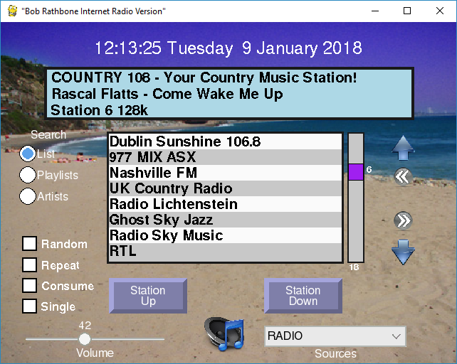

Search window

Last page

Search slider

First page

Search Down

Date Banner

MPD Options

Search Up

Display window

SearchOptions

Channel button

Volume Slider

Source selection

Mute button

Clicking the mouse on a control such as station Up/Down or touching it do the same thing. In the following description we will only refer to “clicking”. By this, also touching a control is also meant.

### The display window

The display window normally displays the Radio station or Media rack that is currently playing. Clicking in the display window changes the third line to display the RSS feed if configured. A second click in the same window displays version details, IP address and hostname.



Figure 151 Graphical scree information display

In this example the hostname is ‘stretch’. The version number will be different for later releases. Two IP addresses are displayed (Wireless and Ethernet).

### The search window

The search window normally displays the contents of the currently selected playlist.



Figure 152 Graphical radio search window

Click on a station in the list selects it. Clicking in the slider window or dragging the slider re-positions the list. The current position, 16 in this example, is displayed next to the slider. The length of the current playlist, 28 for this playlist, is displayed at the bottom of the slider window.

Clicking on the Up and Down arrows travels up and down the list. Clicking on the left double arrow goes to the first page in the list. Clicking on the right double arrow goes to the last page in the list.



Figure 153 Graphical radio search functions

Clicking on the Playlists radio button selects the available playlists. This shows the playlists for radio or media such as the USB stick or Network share. It also shows ‘airplay’ which is not really a playlist but is a source, but can be selected here. Click on the desired playlist in the search window.



Figure 154 Display playlists

In the following example the USB stick playlist was selected. Once a playlist selected the list is displayed.



Figure 155 Display of media tracks

Clicking the Artists radio button displays the list of artists in the search window. Once clicked the search window positions on the first song of that artist’s tracks.



Figure 156 Displaying artists

Note that if you click on the ‘Artists’ radio button when displaying Radio stations, it will always be forced back to the ‘List’ display as Artist selection is not relevant for Radio stations.

### Smaller TFT screens

Screens with a resolution equal to or less than 420 x 320 pixels will display slightly different than previously shown. Only one line will be displayed in the search window. There are no options for Random, Repeat or Consume due to lack of space.

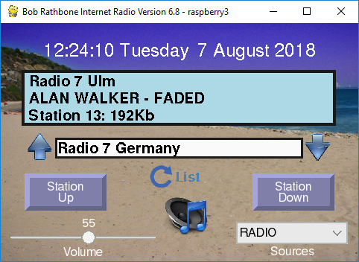

Search list type

The search list type (Playlist, Station/Track list or Artist) is cycled through by clicking on the Search list type button. All other controls work the same as shown in Figure 150 on page 126.

### Artwork display

If the music track has artwork and the **ffmpeg** (See *Setting up the locale* on page 65) package has been installed then the artwork will be displayed. Clicking on any of the radio search buttons will re-display the search window. The artwork cannot be displayed until the track is re-selected.

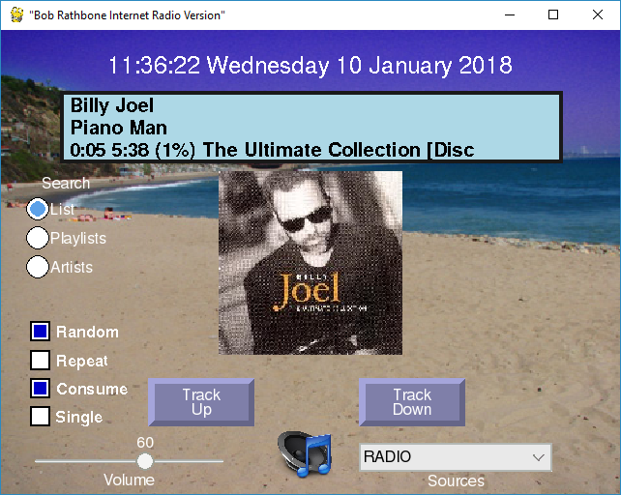

Figure 157 Track artwork display

Note that the two grey push buttons now display ‘Track Up/Down’ instead of ‘Station Up/Down’.

### Volume and Mute controls

|  |  |
| --- | --- |
|  | The volume is controlled by a slider at the bottom left of the window. Clicking on the loud-speaker at the bottom of the screen mutes the sound and displays the mute icon as shown on the left. Any volume control change un-mutes the radio. |

### Source selection

|  |  |
| --- | --- |
|  | Click on the down arrow on the right of the Source selection to select the Source namely Radio, Media, Airplay or Spotify. The radio will select the first playlist in that source. Re-selecting the same source will select the next playlist for that Source. |

### Other graphic window controls

Music Player Daemon(MPD) options Random, Repeat, Consume and Single are selected using the square push buttons on the bottom left of the window. Only the Random option is stored for the next time.

#### Running Airplay on the HDMI touchscreen

Airplay must first of all be installed on the Raspberry Pi. See *Chapter 12 -* Setting up Airplay on page 190 for instructions how to do this. To select Airplay either select it from the Sources drop-down box or from the playlists in the search window.

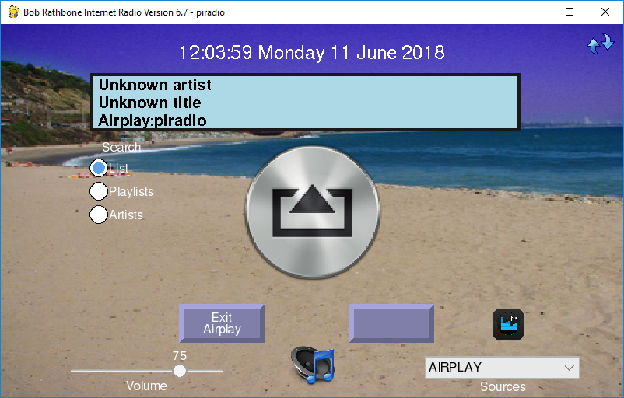

Figure 158 Airplay running on a Graphical screen

Connect to the Raspberry Pi from an Airplay compatible mobile device or run an App such as **CloudBreak**. The hostname to connect to is displayed when Airplay is first opened in the Display Window as shown below:



In this case the hostname is ‘piradio’. To exit Airplay, press the left button at the bottom of the screen. The other button on the right has no label and doesn’t do anything in Airplay mode.

#### Changing the graphical radio theme

The colour scheme and background are largely configurable in the [SCREEN] section of the **/etc/radiod.conf** configuration file. Button colours cannot be configured.

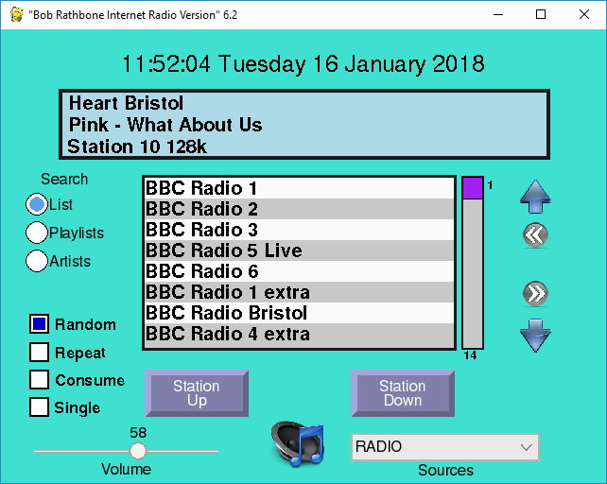

Figure 159 Changing the graphical screen theme

One good personalisation is to use your own favourite holiday picture as the background.

wallpaper=<path to your photograph>

Window and label colours can be changed to your own preferences. In the above screen the wallpaper option has been disabled, so the **window\_color** option is used.

# Graphics (touch screen) screen settings

[SCREEN]

fullscreen=yes

window\_title="Bob Rathbone Internet Radio Version"

window\_color=turquoise

banner\_color=black

labels\_color=black

display\_window\_color=lightblue

display\_window\_labels\_color=black

slider\_color=purple

display\_mouse=yes

switch\_programs=yes

screen\_saver=0

# Wallpaper backgrounds. See /usr/share/scratch/Media/Backgrounds

#wallpaper=/usr/share/scratch/Media/Backgrounds/Nature/beach-malibu.jpg

# Set date format for graphic screen

dateformat=%H:%M:%S %A %e %B %Y

# The following is specific to the vintage graphical radio

scale\_labels\_color=white

stations\_per\_page=40

display\_date=yes

display\_title=yes

### Python pygame colour constants

See <https://www.webucator.com/blog/2015/03/python-color-constants-module/>

However, be aware that not all colours are supported on the Raspberry Pi version of pygame.

### Graphic screen keyboard controls

The HDMI/Touchscreen version accepts input from the keyboard. It is limited and is only included as a keyboard may be connected to the Raspberry Pi when using an HDMI screen. The normal interface is either touch screen or mouse and not the keyboard.

Table 16 Graphic screen keyboard command

|  |  |  |  |
| --- | --- | --- | --- |
| Key | Description | Key | Description |
| Page Up (PgUp) | Channel/Track Up | **Up Arrow** | Search Up |
| Page Down (PgDn) | Channel/Track Down | **Down Arrow** | Search Down |
| + Key | Volume increase | **Left arrow** | Go to first search page |
| - Key | Volume decrease | **Right arrow** | Go to last search page |
| R | Toggle Random | **L** | Select Search List |
| T | Toggle Repeat | **P** | Select Search Playlists |
| C | Toggle Consume | **A** | Select Search Artists |
| S | Toggle Single | **M** | Toggle Mute on/off |
| D | Cycle display window | **ESC** | Exit program |
| X | Switch between **vgradio** and **gradio** |  |  |

You may be interested how the screen-shots in this section were created. A Windows based server called **XMing** was run on the Windows PC. X-Forwarding is then enabled in the SSH program (Putty or Bitvise etc). A SSH terminal session was started and the gradio.py program started which is then displayed on the PC desktop. Then clicking on the graphic radio window at pressing **Alt** and **PrtScn** keys together copies the window to the system clip-board where it can be pasted into a document. Operation is however very sluggish so the method is not recommended for normal use.

## The Vintage Graphic Radio

As an alternative to the **gradio.py** program there is a touch-screen version of the radio called **vgradio.py**. This radio program only can play radio stations and not other Media (USB stick for example) or Airplay.

**Note:**  This radio program can only play radio stations and not other Media such as a USB stick or Airplay, nor are there currently any plans to change this. If you want to play media you will need the full feature **gradio.py** program previously described.

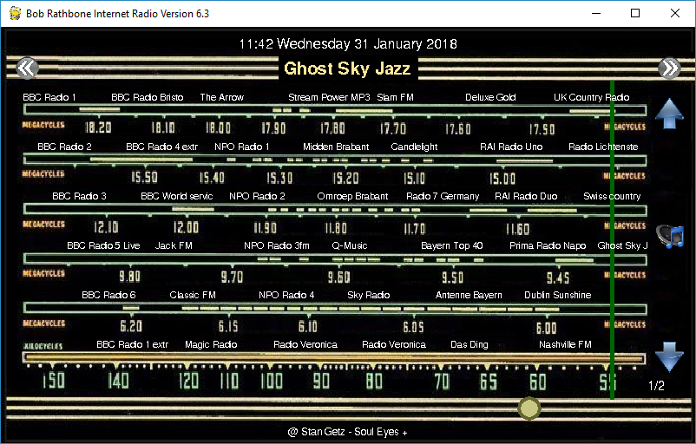

Figure 160 The vintage graphic radio on a touch-screen

This allows a radio to be constructed to look like a vintage radio with a sliding tuning dial.

The pages scroll through the stations so hundreds of stations can be added.

When you touch the name of a station on the tuner dial the green slider jumps to that location and plays the selected station.

The double arrows at the top of the of the screen allow you to page through the stations.

At the bottom is the round volume slider. Under that is the title of the currently playing song.

The blue arrows are used to step through the stations one at a time.

The mute button is on the right-hand side of the screen. This design can also be combined with rotary encoders or switches.

To run this radio, either run the **configure\_radio.sh** program or amend the **/home/pi/.config/lxsession/LXDE-pi/autostart** configuration file to run **vgradio.py** instead of gradio.py.

@lxpanel --profile LXDE-pi

@pcmanfm --desktop --profile LXDE-pi

@xscreensaver -no-splash

@point-rpi

@sudo /usr/share/radio/vgradio.py

This radio is designed to work with a single radio playlist. This is normally the **\_Radio** playlist. You should configure the radio to start with this playlist by amending the **startup** parameter in **/etc/radiod.conf**.

startup=\_Radio

However, this does not mean that you cannot have multiple radio playlists. If you have more than one radio playlist then by using the page up button (Double right arrow) it is possible to scroll through to the current playlist to the end and then onto the next playlist. In this case the new playlist name will be displayed in the very top-left of the screen.

You cannot currently scroll back to the previous playlist but must continue scrolling through the pages until you reached the desired playlist.

If using the FLIRC remote control dongle then it is only necessary to program the following keys:

**pageup, pagedown, left, right, up, down**.

### Switching between graphics programs

From version 6.4 onwards it is possible to switch between the full feature graphical radio (**gradio.py**) and the vintage graphical radio (**vgradio.py**). First configure the **switch\_programs** parameter in the [SCREEN] section of **/etc/radiod.conf**.

switch\_programs=yes

|  |  |
| --- | --- |
|  | Restart the program. The switch icon on the left will appear towards the top of the right-hand side of the screen. By clicking on it the program will switch between the two versions of the desktop radio programs. There will be a very short pause in the music stream whilst it is doing the switch-over. |

### Configuring a screen saver

**Note:**  The **xscreensaver** program described here does not appear to work if the radio program is in full screen mode. This will probably be addressed in a later release.

Modern LCD displays are not as susceptible to screen burnout as the old cathode ray tubes of old. However continuous static screen displays will eventually cause shadowing. It is therefore a good idea to install a screen saver. The standard one for **Raspian** is called **xscreensaver**. To install it run the following:

$ sudo apt-get install xscreensaver

After installation of the screen saver it can be configured in the desktop preferences menu. This allows configuration of time, screen saver or a blank screen. Choose a not too busy screen saver or the blank screen option.

There is also a program called **xscreensaver-command** for command line manipulation of the screen saver. However, the advice is not to use it as, at the time of writing, it causes severe problems with both the console and desktop display.

## Playing Media

### Playing MP3 and WMA files

The radio software also allows you to play music from the following sources:

1. From a USB stick
2. From a music directory on the SD card (Create this yourself)
3. From a Network Attached Storage (NAS)

Playlists for all of the above can be created using the the **create\_playlist.sh** program.

$ cd /usr/share/radio

$ sudo ./create\_playlist.sh

See the section on Creating Media playlists on page 142 for a detailed description of this program.

### Playing music from a USB stick

Put your music tracks on a USB stick (MP3 and WMA files only) and insert it into the USB port of the Raspberry PI. Reboot the PI. Once the Radio program is running, push the Menu button until "Input source" is displayed. Press either the left or right button to change the source to "Music Library". Now press the Menu button again. The music on the USB stick will now be loaded.

### Playing music from the SD card

With large (32GB) SD cards now available music can be stored on in one or more directories on the SD card. It is necessary to first create a directory in **/home/pi** as user **pi** and then link it in the **/var/lib/mpd/music/** directory. Carry out the following instructions as user **pi** to create **mymusic** for example:

$ mkdir /home/pi/mymusic

Using FTP, copy the music from a PC to the **/home/pi/mymusic** directory and reload the library via the options menu. Now run the **create\_playlist.sh** program.Select option 3 (SD card).

### Playing music from a Network Attached Storage (NAS)

This is a bit more involved to set up. See the section called *Mounting a network drive* on page *154*.

### Organising the music files

For the search routines to work properly the music must be organised in a certain way. The files must be placed in the top-level directory of USB stick. The search routines use the first directory as the artist’s name and the music files themselves as the track name. For example:

**Elvis Presley/The 50 Greatest Hits Disc 1/01 That's All Right.mp3**

In the above example the first directory is set up with the artist name and this will appear in the search. The next directory “The 50 Greatest Hits Disc 1” is not used by the search routines. The file name “That's All Right.mp3” without the mp3 extension becomes the track name in this example.

## MPD Logging

All logging for the MPD daemon is to the **/var/log/mpd/mpd.log** file by default.

Radio program logging  
The Radio program logs to a file called **/var/log/radio**.**log.** See example log below:

2018-05-25 15:46:27,094 INFO IP 192.168.2.64

2018-05-25 15:46:28,731 INFO Board revision 2

2018-05-25 15:46:28,785 INFO OS release: Raspbian GNU/Linux 9 (stretch)

2018-05-25 15:46:28,806 INFO Linux smallpi 4.14.30+ #1102 Mon Mar 26 16:20:05 BST 2018 armv6l GNU/Linux

2018-05-25 15:46:35,028 INFO Connected to MPD port 6600

2018-05-25 15:46:38,294 INFO UDP Server listening on localhost port 5100

2018-05-25 15:46:38,321 INFO UDP listen:remote 0.0.0.0 port 5100

2018-05-25 15:46:39,185 INFO Radio running pid 5774

2018-05-25 15:46:39,190 INFO Radio ['/usr/share/radio/radiod.py', 'nodaemon'] Version 6.9

There are six levels of logging namely CRITICAL, ERROR, WARNING, INFO, DEBUG or NONE.

This is configured in the **/etc/radiod.conf** file.

# loglevel is CRITICAL,ERROR,WARNING,INFO,DEBUG or NONE

loglevel=INFO

## Configuration and status files

The main configuration file is **/etc/radiod.conf**. See section *A.1 Files added to the system* on page 215. This file is normally maintained by the **configure\_radio.sh** program. This is run at installation time but can be safely run at any time.

There are some other configuration and status files in the **/var/lib/radiod** directory. These are:

alarm Alarm setting in t:hh:mm where t is the alarm type (t=0=off)

current\_station The current radio station

current\_track The current music track

language Espeak language definition file

mixer\_volume Used by Airplay to set mixer volume (See page 192)

mixer\_volume\_id Mixer volume ID (Used primarily for Airplay volume control)

rss RSS feed URL

share The NAS share instruction

stationlist The user list of radio station URLs

streaming Icecast2 streaming on or off

timer Timer (Snooze) value in minutes

voice The espeak voice file

volume The volume setting

It isn’t normally necessary to change most of these files. However, the **stationlist**, **share, language** and **rss** file will need to be edited as required. The other files are maintained by the radio or configuration programs. When the radio program starts up the it uses the last settings, for example, the volume setting.

## Using the Timer and Alarm functions

Note: The Rasbian operating system synchronizes time over the Internet. It does this using the **timesync** service. This service is a light-weight, client only, time synchronisation service, using the Network Time Protocol (NTP).

There is a timer (Snooze) and alarm function (LCD and OLED versions only). The timer and alarm can operate individually or together. The timer when set will put the radio into Sleep Mode when the timer expires. The Alarm can be set to either On, Repeat or “Weekdays only”.

### Setting the Timer (Snooze)

Press the Menu button until the “Menu Selection” is displayed. Press either the channel UP or DOWN control until “Timer off” is displayed on line 2 of the LCD screen. Now push the volume UP button to set the timer. Use volume UP and DOWN to adjust the timer which will be displayed as “Timer hh:mm:ss” wher hh=hours, mm=minutes and ss=seconds. The Timer can be set up to 24 hours in increments of one minute. Once the timer is set, press the Menu button; the display will return to TIME mode.

On a four line LCD display the timer will be seen counting down after the Volume display on line 4. On a two line LCD display the timer count down will be displayed on line 1 after the time display.

When the timer expires (reaches zero) the radio will enter SLEEP mode. Sleep mode can only be exited by pressing the menu button.

To switch the timer off go back to the timer menu as described above and reduce the timer to 0 using the volume DOWN control. This will switch off the timer.

The timer function uses the **/var/lib/radiod/timer** file which will contain the value of the timer in minutes when it was successfully fired. You do not need to change the contents of this file.

### Setting the Alarm

The Alarm menu has three settings:

* The alarm type (On, off, repeat etc)
* The Alarm Hours time ( Pressing menu in this mode puts the radio into Sleep mode)
* The Alarm Minutes time ( Pressing menu in this mode puts the radio into Sleep mode)

Press the Menu button until the “Menu Selection” is displayed. Press either the channel UP or DOWN (Or rotate rotary encoder) until “Alarm off” is displayed on line 2 of the LCD screen. Using the volume UP control cycle through the options which are

* Alarm off - The Alarm is switched off
* Alarm on – The Alarm is on for one time only. Once the alarm is fired it will return to off.
* Alarm repeat – The Alarm will be repeated every day and not switched off.
* Alarm weekdays only – The Alarm will only fire Monday through Friday. It is not reset.

Now move to “Set alarm time:” using the channel UP control. The current alarm time will be displayed on line 2 of the display. Using the volume UP and DOWN control adjust the alarm time (Hours or Minutes) to the required setting. If you do not wish to put the radio into sleep mode at this stage then use the channel UP/DOWN control to move away from the “Set alarm time:” option and press the Menu button. If you press the Menu button whilst in the “Set alarm time:” option and the Alarm is set to anything except off then the radio will enter Sleep mode and display the alarm on line 2 for a two-line LCD or on line 4 for a four-line LCD.

Note: Sleep mode can only be exited by pressing the Menu button.

The alarm function uses the **/var/lib/radiod/alarm** file which will contain the current alarm type and time. The format is **t:hh:mm** where t is type (0=off, 1=on, 2=repeat, 3=weekdays only) and hh:mm is hours and minutes (24 hour clock). You do not need to change the contents of this file.

PLEASE NOTE THAT THE ALARM RELIES UPON THE SELECTED RADIO STREAM TO BE AVAILABLE WHEN THE ALARM WAKES UP. THIS CANNOT BE GUARANTEED AS THE STATION FEED MAY BE OFF AIR OR THERE IS A PROBLEM WITH THE INTERNET CONNECTION. YOU SHOULD NOT THERFORE RELY SOLEY ON THIS ALARM FUNCTION IF YOU HAVE AN IMPORTANT APPOINTMENT OR A PLANE OR TRAIN TO CATCH FOR EXAMPLE. ALSO SEE DISCLAIMER ON PAGE 209.

### Using the Alarm and Timer functions together

The Alarm and Timer functions can be used together. For example you want to set your radio to a 30 minute snooze time before going to sleep and to sound the alarm in the morning. Simple set the Timer to the required elapse time and then set the alarm as described in the previous section. Press the Menu button and the timer will be seen counting down followed by the alarm time on line 4 or line 1 for the four-line and two-line LCD respectively.

## Music Player Clients

MPD is designed around a client/server architecture, where the clients and server (MPD is the server) interact over a network. A large number of graphical and web based clients are available for MPD and are to numerous to mention here. Please see the following link for further information on MPD clients: <http://mpd.wikia.com/wiki/Clients>. The main client used in this project is MPC.

### Using the MPC client

Everything you should normally wish to do can be done using the radio. However there may be occasions that you wish to test or control music selection, volume etc. using MPC. It is also useful for diagnosing Music Player Daemon problems.

Log into the Raspberry PI using the console or SSH login. To start playing music run:

$ mpc play

To see a list of all available commands, run:

$ mpc help

Here are some frequently used **mpc** commands:

|  |  |
| --- | --- |
| MPC command | Description |
| mpc | Displays status (**mpc status** also does the same) |
| mpc current | Displays currently playing station or track |
| mpc next | Play next song |
| mpc prev | Play previous song |
| mpc play n | Play station or track where n is the track or station number |
| mpc volume 75 | Set volume to 75% |
| mpc stop | Stop playing |
| mpc random <on|off> | Toggle shuffling of songs on or off |
| mpc repeat <on|off> | Toggle repeating of the playlist |
| mpc clear | Clear the playlist |
| mpc consume <on|off> | When playing tracks remove from the playlist once played |
| mpc playlist | List loaded radio stations or streams |
| mpc listall | List all songs in the music directory |

### Adafruit RGB Plate changing colours

This section is only relevant for the Adafruit RGB plate. The **ada\_radio.py** program has an option to change the colour of the display. Push the menu button until “Menu selection”. Push the channel button until “Select color” is displayed. Now push the volume button to cycle through the colours. The available colours are red, green, blue, yellow, teal, violet, white or Off (No backlight).

### Shutting down the radio

You can simply switch the power off. This doesn’t normally harm the PI at all. However if you want a more orderly shutdown then press the menu button for at least three seconds. This will stop the MPD daemon and issue a shutdown request to the Raspberry PI. Wait at least another ten seconds and then power off the Radio.

## Creating and Maintaining Playlist files

Note: The creation of playlists has completely changed from earlier 5.x versions of the program. Read the following carefully for an understanding of the new playlists structure.

To use existing play-lists, see the section called *Using old 5.x Radio playlists* on page 143.

Previous versions of the radio only allowed three playlists namely Radio, USB stick or Network share. This has completely changed in version 6.0 onwards. It is now possible to define as many playlists as you wish. For example:

Table 17 Example playlists

|  |  |  |  |  |
| --- | --- | --- | --- | --- |
| Playlist Name | Type | File name | Description |  |
| Radio | Radio | \_Radio.m3u | Playlist with radio stations |  |
| BBC stations | Radio | \_BBC\_stations.m3u | Playlist with only BBC radio stations |  |
| German stations | Radio | \_German\_stations.m3u | Playlist with only German radio stations |  |
| USB stick | Media | USB\_Stick.m3u | Playlist with the contents of the USB stick |  |
| Network | Media | Network.m3u | Playlist with the contents from a network share |  |
| Country | Media | Country.m3u | Playlist with just country music |  |
| Rock and Roll | Media | Rock\_and\_Roll.m3u | Playlist with just Rock and Roll music |  |

You may have as many or few playlists as you like. All playlists are stored in **/var/lib/mpd/playlists** and must have a **.m3u** file extension. All radio stations begin with an underscore “\_”. The reason for this is that the radio program has to handle and display Radio and Media playlists differently. The “\_” at the beginning of the playlist file name identifies the playlist as a Radio playlist. It also has the added advantage that it puts all the Radio playlists at the beginning of the list of available playlists.

### Creating new playlists

There are four ways to create playlists:

1. Create Radio station playlists with the **create\_stations.py** program
2. Create Media playlists from either USB stick or Network share using **create\_playlist.sh**
3. Use the Shoutcast (get\_shoutcast.py) program or web interface
4. Manual creation of your own Media playlists

#### The create stations program

The *create\_stations.py* program is used to create playlists in the **/var/lib/mpd/playlists** directory. If you wish to understand more about playlist files see the section called *Overview of media stream URLs* on page 149.

The directories and files used by the *create\_stations.py* program are shown in the following table:

Table 18 Playlist files and directories

|  |  |  |  |
| --- | --- | --- | --- |
| Name | Type | Description |  |
| /usr/share/radio/station.urls | File | Initial distribution file containing sample stations |  |
| /var/lib/radiod/stationlist | File | The file containing the users list of radio stations |  |
| /usr/share/radio/station.urls | File | Initial distribution Radio playlist. This is copied to /var/lib/radiod/stationlist during program installation. |  |
| /var/lib/mpd/playlists | Directory | Location of MPD playlists |  |
| /var/lib/mpd/music | Directory | Location of media files for either a USB stick or a Network share |  |

The **/var/lib/radiod/stationlist** file is the file that should be maintained by you to create Radio playlists. When this *create\_stations.py* program is first run it copies the distribution file **station.urls** to the **/var/lib/radiod/stationlist** file. You may then modify the **/var/lib/radiod/stationlist** file.

The format is: **(<playlist name>)**

Example: **(Radio)**

The above will create a playlist called **\_Radio.m3u** and will contain the title and URLs for each station. Now add or remove radio station definitions in the **stationlist** file. The first statement in the station definition is the name of the playlist in brackets:

The format is: **[<title>] http://<url>**

Example: **[BBC Radio 4 extra] http://www.bbc.co.uk/radio/listen/live/r4x.asx**

After modifying the **stationlist** file run the *create\_stations.py* program to create the Music Player Daemon playlists.

Below is an example of part of a **stationlist** file stored in **/var/lib/radiod** directory. This file is the source of all radio playlists.

# Radio stations

(Radio)

# United Kingdom

# The following links are iPhone streams (m3u files)

[BBC Radio 1] http://www.radiofeeds.co.uk/bbcradio1.pls

[BBC Radio 2] http://www.radiofeeds.co.uk/bbcradio2.pls

[BBC Radio 3] http://www.radiofeeds.co.uk/bbcradio3.pls

:

# Dutch stations

(Dutch radio)

[NPO Radio 1] http://icecast.omroep.nl/radio1-bb-mp3

[NPO Radio 2] http://icecast.omroep.nl/radio2-bb-mp3

[NPO Radio 3fm] http://icecast.omroep.nl/3fm-bb-mp3

In the above example two Radio playlists are defined by the names in round brackets namely; (Radio) and (Dutch radio).

The *create\_stations.py* program itself is very easy to use. Just run it with **sudo** in the **/usr/share/radio** directory:

$ **cd /usr/share/radio**

$ **sudo ./create\_stations.py**

This will create the playlist files in the **/var/lib/mpd/playlists** directory. Using the example shown above this will produce two files called **\_Radio.m3u** and **\_Dutch\_radio.m3u** in the MPD playlists directory. To create a log file of the program run the following:

$ **sudo ./create\_stations.py | tee playlist.log**

You can examine the playlist.log file to see what actions the *create\_stations.py* program carried out and if there were any errors.

The program will ask if you wish to delete any old playlists:

Processed 46 station URLs from /var/lib/radiod/stationlist

There are 2 old playlist files in the /var/lib/mpd/playlists/ directory.

Do you wish to remove the old files y/n: **y**

Normally answer ‘y’ unless you don’t wish to remove the old files. Note that old playlists files with the same name as the new ones will always be overwritten.

If you want to avoid the above prompt then there are two other parameters that you may use.

**--delete\_old** Delete old playlist files in the MPD playlist directory

**--no\_delete** Don’t delete old playlist files in the MPD playlist directory

Example:

$ **sudo ./create\_stations.py --no\_delete**

Finally there is a help parameter:

$ **sudo ./create\_stations.py --help**

### Creating Media playlists

The radio program comes with a program called create\_playlist.sh. This creates a single playlist for a USB stick, SD card location or a network share.

$ **cd /usr/share/radio**

$ **sudo ./create\_playlist.sh**

The following screen is displayed.



Select option 1 initially.



Answer “Yes” to create the playlist from the USB stick.



Enter a filter name or enter for no filter.



Select Yes to continue.



The program will suggest a name for the playlist but you may choose any name (But do not make it too long).

The program continues by creating a playlist called **USB\_stick.m3u** in **/var/lib/mpd/playlists**.

sudo service radio stop

sudo service mpd stop

Mounted /dev/sda1 on /media

cd /var/lib/mpd/music/

/var/lib/mpd/music

sudo find -L media -type f -name \*.mp3 -or -name \*.ogg -or -name \*.flac > /tmp/list29073

sudo mv /tmp/list29073 /tmp/USB\_Stick

===========================================================

58 tracks found in directory media (No filter)

mv /tmp/USB\_Stick.m3u /var/lib/mpd/playlists/USB\_Stick.m3u

sudo service mpd start

mpc stop

volume: 58% repeat: off random: off single: off consume: off

mpc update media

Updating DB (#1) ...

volume: 58% repeat: off random: off single: off consume: off

#### Specifying a playlist filter



The program will then suggest the playlist name The\_Beatles.



You will note that spaces in the playlist name have been replaced with underscores(\_).

This is just for the file name. When the playlist is displayed in the radio program the underscores will be converted back to spaces. The program will now create a playlist with the name **The\_Beatles.m3u** (or whatever name was given).

sudo service radio stop

:

29 tracks found in directory share matching "The Beatles"

mv /tmp/The\_Beatles.m3u /var/lib/mpd/playlists/The\_Beatles.m3u

:

Updating DB (#1) ...

volume: 58% repeat: off random: off single: off consume: off

#### Specifying multiple filters

More than one string may be specified in a filter. To do this specify the filter strings with a pipe character (|) seperating them,for example:



This will filter all songs from ZZ Top, The Beatles and Elvis or any other titles that contain these names. However this may not be want is wanted. Maybe songs by Elvis are wanted and not songs with ‘Elvis’ in the title. For example *Dire Straits – Calling Elvis*. In such a case use the **/** character to only look for directory names beginning with ‘Elvis’ . The above filter becomes:

**ZZ Top|Beatles|/Elvis**

Restart the radio to reload all new playlists. Using the / character gives a more accurate playlist.

Please note that filters are not case sensitive. Filter ‘Elvis’ and ‘elvis’ will return the same result.

If you selected option 3 (SD card) you will be prompted for the location where you have installed you music files. This location must pre-exist and have music files.



## Accessing Shoutcast

From version 6.5 onwards it is possible to create playlists from the Shoutcast database. See <http://www.shoutcast.com>. Shoutcast provide what can best be described as “fringe” radio stations. They do have a few stations by country but not many. If you are hoping, for example, to get all the United Kingdom BBC radio stations you will be disapointed. However their support for radio stations by genre is very good, for example: rock, jazz, country or classical. This version of software provides two methods of creating playlists from the Shoutcast database:

1. Using the get\_shoutcast.py program
2. Using the shoutcast tab in the radio web interface.

### Using the get\_shoutcast.py program

Running the program with no parameters will produce the following usage message:

$ **cd /usr/share/radio**

$ **./get\_shoutcast.py**

This program must be run with sudo or root permissions!

Usage: sudo ./get\_shoutcast.py id=<id> limit=<limit> search="<string>"|genre="<genre>" install

Where: <id> is a valid shoutcast ID.

<limit> is the maximum stations that will be returned (default 100).

<string> is the string to search the shoutcast database.

<genre> is the genre search string.

install - Install playlist to MPD without prompting.

See http://www.shoutcast.com for availble genres.

If you see the following message then install python-requests as shown in the section called *Install python-requests* on page 67.

Traceback (most recent call last):

File "./get\_shoutcast.py", line 19, in <module>

import requests

ImportError: No module named requests

The program must be run with sudo. In the following example we want to get fifty jazz stations.

$ **sudo ./get\_shoutcast.py genre="jazz" limit=50**

Extracting shoutcast stations: genresearch

Processing URL: http://api.shoutcast.com/legacy/genresearch?k=anCLSEDQODrElkxl&limit=50&genre=jazz

Abc Lounge

Smoothjazz.com Global

:

:

Created 50 records in /usr/share/radio/playlists/\_jazz.m3u

Do you wish to copy this playlist to /var/lib/mpd/playlists [y/n]: **y**

Answer ‘y’ to install the new playlist.

Copied /usr/share/radio/playlists/\_jazz.m3u to /var/lib/mpd/playlists

Reload playlists: OK

This will copy the new **\_jazz.m3u** playlist to the **/var/lib/mpd/playlists** directory. The program will also signal the radio program to reload its playlists so that the new playlist can be accessed straight away.

If you answer ‘n’ to the above question your new playlist will be saved in **/usr/share/radio/playlists** repository. You can copy it later, if so wished, to the MPD playlists directory.

$ **cd /usr/share/radio/playlists**

$ **sudo cp \_jazz.m3u to /var/lib/mpd/playlists**

You must use **sudo** to do this.

The program requires an authorisation key. This is embedded in the program and it is not necessary to specify it. If it ever changes or expires a new authorisation key must be configured in **/etc/radiod.conf**.

shoutcast\_key=anCLSEDQODrElkxl

You need to get this key directly from <http://www.shoutcast.com>.

Note: Access to the Shoutcast is a free service made available through the goodwill of the folks at Shoutcast. It can be withdrawn at any time if over-used or abused so please do not set up any facility, such as scripting, which will stress their servers.

### Using the Shoutcast Web Interface

The radio web interface now has a Shoutcast tab. Click on Shoutcast tab to open the interface. Fill in the search form and press the Submit button once and wait until the summary page is displayed.

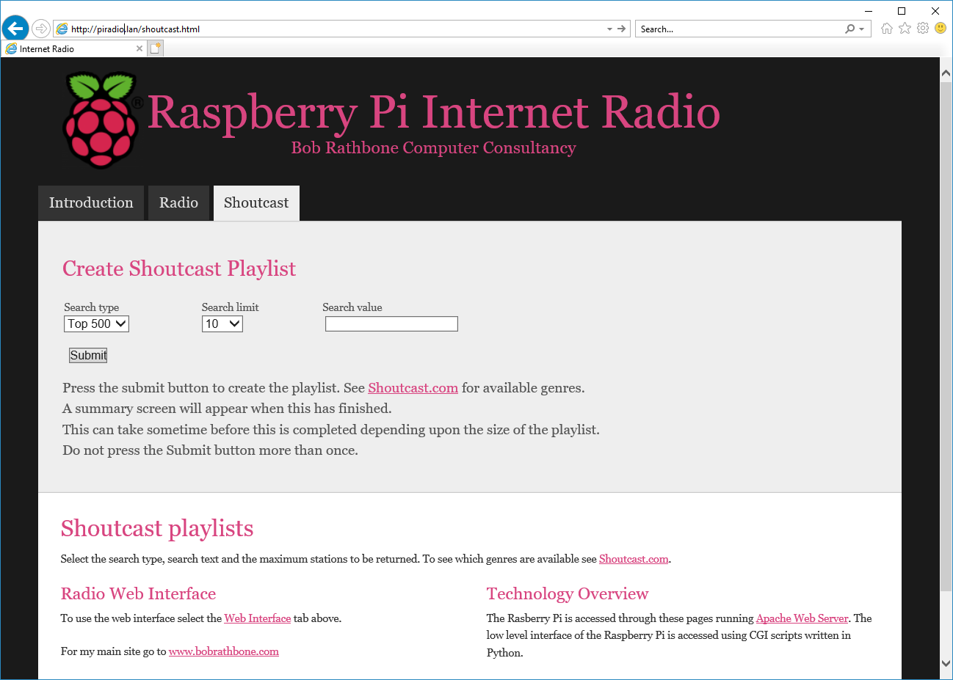

Figure 161 Shoutcast playlist web page

The summary page will be displayed. You should see the **Reload playlists: OK** message which means that the new playlist is available in the radio.

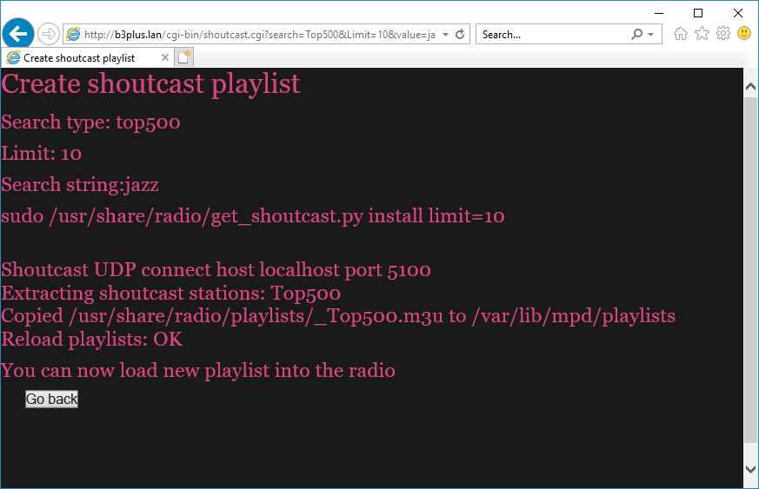

Figure 162 Shoutcast playlist summary

### Using old 5.x Radio playlists

Old 5.x playlists are not compatible with this version of the radio. However, the **/var/lib/radiod/stationlist** file can still be used. Do the following:

1. Stop the radio
2. Copy the old **stationlist** file to **/var/lib/radiod/stationlist**
3. Remove most of the (title) statements from the **/var/lib/radiod/stationlist** file
4. Remove all old playlists from **/var/lib/mpd/playlists** directory

$ sudo rm /var/lib/mpd/playlists/\*

1. Run the **create\_stations.py** program as previously described.

If you find upon running the Radio that you have a lot of radio playlists. Reduce the number by removing title statements in the **stationlist** file as previously mentioned. These are the names in brackets – for example (BBC Radio). Re-run the **create\_stations.py** program.

### Radio stream resources on the Internet

There are a lot of resources on the Internet how to find PLS and M3U files so simply search for “PLS or M3U files” through the search machine of your choice. Below are some good sources of radio streams around the world.

|  |  |
| --- | --- |
| <http://www.listenlive.eu> | <http://www.publicradiofan.com> |
| <http://www.radio-locator.com> | For UK and Irish listeners |
| <http://bbcstreams.com/> | <http://www.radiofeeds.co.uk/> |

### Getting a radio stream from a web browser

|  |  |
| --- | --- |
|  | To copy a URL open the web page in any browser on a PC and right click on the URL. Select properties from the drop-down list. For internet explorer will show a window similar to the illustration on the left will be displayed: |

Copy and paste the URL into the **/var/lib/radiod/stationlist** file. Add the title in square brackets as shown in the previous section. Other browsers may provide options such as ‘copy link’or ‘save link as’. This is browser dependant.

## Overview of media stream URLs

A deep understanding of this section is not necessary but can be useful when creating playlists. This section is provided for background information only. At first the whole business of how music streams are provided can be quite confusing. The URLs on a radio station web page can be of different types, for example:

1. A URL pointing to a M3U playlist file (MPEG3 URL). This format is used by MPD.
2. A URL pointing to a PLS playlist file (Shoutcast Play List)
3. A URL pointing to an ASX playlist file (Advanced Stream Redirector)
4. A URL which is an actual stream such as MP3 (MPEG 3) or AAC (Advanced Audio Coding)

1, 2 and 3 are so called redirector URLs and point to a playlist file containing one or more URLs to the radio stream(s) itself. The *create\_stations.py* program tries to figure out what type of URL that it is and create a playlist from it. This is the facility you should use rather than trying to create your own playlists which can be quite time consuming.

### M3U Files

M3U stands for MPEG3 URL. This is the format that MPD itself uses. The following Wikipedia article explains the M3U file format:

<http://en.wikipedia.org/wiki/M3U>

The Music Player Daemon uses m3u files. An example [M3U](http://en.wikipedia.org/wiki/M3U) file is shown below:

radio10.m3u playlist file

#EXTM3U

#EXTINF:-1, Radio 10 Gold NL

http://icecast.streaming.castor.nl:80/radio10

These playlist files have the m3u file extension. i.e. **<filename>.m3u**. The first line is the header and must be #EXTM3U. The second line is #EXTINF: and is information about the radio stream. The -1 means unlimited play length. This is followed by a comma and then the name of the radio station (*Radio 10 Gold* in this case). The third line is the URL (icecast in this case) for the radio stream. More than one radio stream may be defined in the m3u file. You do not need to create this type of file yourself. Modify the **stationlist** file and run **create\_stations.py**.

M3U files may also contain a simple list of file paths to media files. For example:

media/Steve Miller Band/Album onbekend/0726 Steve Miller Band - The Joker.mp3

media/Stories/Album onbekend/Stories - Brother Louie.mp3

:

In this version of the radio the program knows that these are media files as opposed to radio playlists because they do not start with an underscore ‘\_ ‘ which is the convention that the radio program uses for a radio playlist (It is not a general convention).

Note that in the above example **media** is a directory (or a link to it) in the **/var/lib/mpd/music** directory and that the ‘/’ character is omitted.

### PLS file format

A good place to start is the following Wikipedia article:

<http://en.wikipedia.org/wiki/PLS_(file_format)>

A PLS playlist file does not contain any music files itself, but rather points to music files stored elsewhere. The PLS file format is often used to play Internet radio streams, for example, if you want to play a radio stream from Shoutcast, you can copy the PLS file URL of the station from the site and play it in a desktop media player like Winamp. A PLS file will be similar to below

[playlist]  
NumberOfEntries=2

Version=2  
File1=http://206.217.213.16:8430  
Title1=Blues Radio UK  
Length1=-1

File2=http://205.164.62.13:8030

Title2=Absolute Blues Hits

Length2=-1

The PLS file always starts with the **[playlist]** statement. The **NumberOfEntries** statement must match the number of streams defined in the PLS file (Two in the above example). Set the **Version** number always to 2. There is a File*n*, Title*n* and Length*n* where *n* is the entry number.

### ASX file

The Advanced Stream Redirector (ASX) format is a type of XML metafile designed to store a playlist of Windows Media files for a multimedia presentation. An example ASX file is shown below.

<ASX version="3.0">

<ABSTRACT>http://www.bbc.co.uk/iplayer/radio/bbc\_radio\_bristol/</ABSTRACT>

<TITLE>BBC Bristol</TITLE>

<AUTHOR>BBC</AUTHOR>

<COPYRIGHT>(c) British Broadcasting Corporation</COPYRIGHT>

<MOREINFO HREF="http://www.bbc.co.uk/iplayer/radio/bbc\_radio\_bristol/" />

<PARAM NAME="HTMLView" VALUE="http://www.bbc.co.uk/iplayer/radio/bbc\_radio\_bristol/" />

<Entry>

<ref href="mms://wmlive-nonacl.bbc.net.uk/wms/england/lrbristol?BBC-UID=1523a2f20f858eb0ba0a4385918e6433df886bb650e021b4446ff486f8204e3a&amp;SSO2-UID=" />

</Entry>

</ASX>

### Direct stream URLs

These URLs tend to end with .mp3 or \_SC or AAC etc. However, there are others. For example:

http://mp3.streampower.be/radio1-high.mp3

http://7639.live.streamtheworld.com:80/977\_MIX\_SC

You can determine if a URL is a direct radio stream by using the **wget** program.

# **cd /tmp**

# **wget http://mp3.streampower.be/radio1-high.mp3**

--2014-03-14 13:08:10-- http://mp3.streampower.be/radio1-high.mp3

Resolving mp3.streampower.be (mp3.streampower.be)... 80.200.255.61

Connecting to mp3.streampower.be (mp3.streampower.be)|80.200.255.61|:80... connected.

HTTP request sent, awaiting response... 200 OK

Length: unspecified [audio/mpeg]

Saving to: `radio1-high.mp3'

[ <=> ] 365,281 15.8K/s

If **wget** doesn’t exit and you see the <=> characters moving backwards and forwards then it is a URL to the radio stream itself. You will also see *Length: unspecified* in the output. Press control -C to exit **wget**. Remove the file that **wget** created (/tmp/radio-high.mp3 in this case).

## Listening to live Air Traffic Control (ATC)

For those interested in aviation this is a fascinating use of the radio. Live ATC net provide streaming of live ATC transmissions from airports the world over. Their web site is <http://www.liveatc.net/>

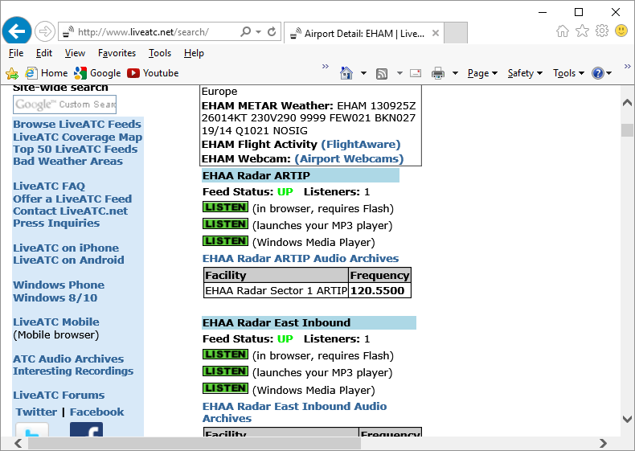

Figure 163 Live ATC web page

Not only do these streams provide the live ATC conversations but also the in the station information ATIS (Aerodrome Terminal Information Service). This consists of coded weather information which all pilots can understand.

One way to add these stations to a radio playlist is to install **WinAmp** on a PC. Enter either the **ICAO** or **IATA** code of the station in the search box on the Live **ATC** web site, for example **EHAM** or **AMS** (Schiphol, Amsterdam, the Netherlands) .

Click on the MP3 player **LISTEN** option. The station will be loaded and shortly **WinAmp** will start playing the stream.

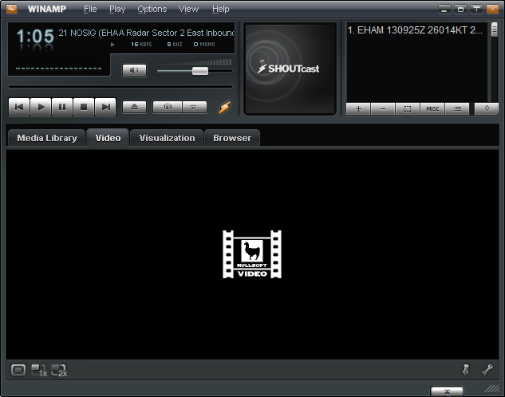

Figure 164 WinAmp playing ATC live feed

Right click in the top left box (Display elapsed time of 1:05 in this example). The station information will be displayed.

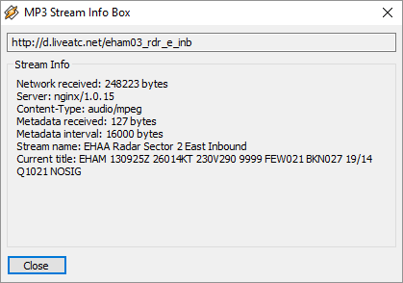

Figure 165 WinAmp station information

The URL for the stream is shown in the top box. **http://d.liveatc.net/eham03\_rdr\_e\_inb**

The stream name is: EHAA Radar Sector 2 East Inbound

The station Title shows the ATIS information.

EHAM 130955Z 25016KT 9999 FEW020 BKN024 19/14 Q1021 NOSIG

Using the URL shown create a playlist to **/var/lib/radiod/stationlist** for the live traffic ATC as shown in the following example.

(Air traffic)

[EHAA Approach Departures] http://d.liveatc.net/eham4

[EHAA Radar Sector 2 East Inbound] http://d.liveatc.net/eham03\_rdr\_e\_inb

[EHAA Radar SW] http://d.liveatc.net/eham02\_rdr\_sw

[EHAA Radar 3 South] http://d.liveatc.net/eham02\_rdr\_s

[EHEH Approach] http://d.liveatc.net/eheh2\_app

[CYYT] http://d.liveatc.net/cyyt

[KJFK Gnd Tower] http://d.liveatc.net/kjfk\_gnd\_twr

[CYYZ Tower] http://d.liveatc.net/cyyz7

Now run the **create\_stations.py** program to create the playlists.

$ cd /usr/share/radio

$ sudo ./create\_stations.py

Now restart the radio or use the menu to reload the radio stations (Select source option):

$ sudo service radiod restart

Finally select the new ATC station(s).

Finding out ICAO and IATA airport codes

Try sites such as <https://en.wikipedia.org/wiki/List_of_airports_by_ICAO_code:_A>

Decoding ATIS information

See site <http://www.met.tamu.edu/class/metar/quick-metar.html> or search for ATIS decode.

In the following example:

EHAM 130955Z 25016KT 9999 FEW020 BKN024 19/14 Q1021 NOSIG

EHAM Amsterdam Schiphol, the Netherlands

130955Z 13th of the current month. Time 09:55 Zulu (UTC)

25016KT Wind 250 degrees at 16 Knots

9999 Visibility 10 Kilometres or greater

FEW020 Few clouds at 2000 feet

BKN024 Broken cloud at 2400 feet

19/14 Temperature 19 degrees Celsius. Dew point 14 degrees Celsius

Q1021 Barometric pressure 1021 Millibars (Will be given in Inches Mg in US airports)

NOSIG No significant weather.

## Mounting a network drive

It is very likely that you may have your music on a shared network drive and want to play the music through the radio. There are two main types of network drive protocols used by Raspbian Stretch on the Raspberry Pi namely:

* CIFS – Common Internet File System
* NFS – Network File System

The protocol used for CIFs is SMB (Server Message Block – Microsoft). Previously connections to SMB was via a product called SAMBA but has been largely replaced by the mount using the CIFS option in the Linux. The steps to mount the network drive are as follows:

1. Find out the IP address of your network drive.
2. Create and test the mount command using either NFS or CIFS.
3. Copy the mount command to **/var/lib/radiod/share** file.
4. In the Radio menu select “Music Library” as the source and press “Menu” again to load
5. Update the playlists to include the files on the new share (Network drive).

This procedure assumes that you already have your Network Drive configured and working with your PC and can play music via the PC. In the examples below a Synology Network Drive was used with a volume called Volume1 with a directory called “music”. The IP address for the Synology Network drive used was 192.168.2.6.

First stop the Radio software when creating and testing the mount command.

Don’t configure **/etc/fstab** to do the mount of the network drive. Although this is the usual way of mounting shares however the radio program needs total control of the mount and un-mount process.

The general syntax for the mount command is as follows:

mount -t <type> -o option1,option2,… <remote IP address and directory> <mount point>

Where: <type> is either **nfs** or **cifs**.

-o option1,option2 are the mount options.

<remote IP address and directory> Is the IP address and music directory path

<mount point> This will always be /share for this program

### Finding the IP address of the network drive

Only general guidance can be given here. Nearly all network drives have a web interface. The IP address was almost certainly provided from DHCP in your home router. The IP address will be the IP address of the Web Interface. Look at your network drive documentation for further information.

### The CIFS mount command

The following example mount command assumes that you have a guest user configured with password ‘guest’. Adapt the command as required.

mount -t cifs -o username=guest,password=guest,uid=pi,gid=pi,vers=1.0 //192.168.2.6/music /share

The above command is all on one line. The **uid** and **gid** parameters set the ownership of the music files to user **pi**. The **vers** statement is the CIFS version and can be 1.0, 2.0 or 3.0 depending upon the NAS storage. The share directory is created when you first run the Radio program so there is no need to create it. If the command was successful you should be able to display the music from the network drive. Go to section called *Display the share directory* on page155.

### Older NAS drives sec security option

Older NAS drives may also require the **sec=ntlm** option to the **-o** line. The **sec** option is the authentication protocol and determines how passwords are encrypted between the server and client. Security mode **ntlm** used to be the default authentication method but that is now become **ntlmssp**. If you are accessing a network drive which doesn't support **ntlmssp** you have to add **sec=ntlm** to the options as shown below:

-o username=guest,password=guest,uid=pi,gid=pi,sec=ntlm

Many NAS devices use older technology so they often only use **ntlm** authentication. There are other authentication methods such as **ntlmv2** but most are not currently supported with the Raspberry Pi OS.

### The NFS mount command

The following NFS mount example assumes the NFS protocol has been configured for the music directory.

mount -t nfs -o ro,nolock 192.168.2.6:/volume1/music /share

A few things to note here; the NFS mount command uses the volume name (volume1 – can vary), The CIFS mount command doesn’t. The second thing is that the IP address and remote directory are separated by a colon (:). If the command was successful you should be able to display the music from the network drive.

### Display the share directory

If the mount was successful using either CIFS or NFS you should be able to display the **/share** directory with the ls command.

# **ls -la /share**

total 4

drwxrwxrwx 85 pi pi 0 May 10 14:18 .

drwxr-xr-x 23 root root 4096 Jul 15 17:57 ..

drwxrwxrwx 4 pi pi 0 May 10 14:16 Albert Hammond

drwxrwxrwx 3 pi pi 0 May 10 14:16 Alexander Curly

drwxrwxrwx 3 pi pi 0 May 10 14:16 Allen Price & Georgie Fame

drwxrwxrwx 3 pi pi 0 May 10 14:16 Al Martino

drwxrwxrwx 3 pi pi 0 May 10 14:16 Animals

drwxrwxrwx 4 pi pi 0 May 10 14:16 Aretha Franklin

drwxrwxrwx 3 pi pi 0 May 10 14:16 Armand

The important thing apart from seeing the files is that you should see that the files are owned by pi and group pi.

### Un-mounting the /share directory

To un-mount the share directory use the **umount** command (not unmount).

# **umount /share**

### Copy the mount command to the configuration

Once the mount command is working copy it to the **/var/lib/radiod/share** file.

For example for the CIFS mount command:

# **echo “mount -t cifs -o username=guest,password=guest,uid=pi,gid=pi //192.168.2.6/music /share” > /var/lib/radiod/share**

The above command is all on one line.

**Note:** If you decide to directly edit the **/var/lib/radiod/share** file instead of using the above command then do not include quotations marks around the command.

### Load the music library

Now run the radio program. The radio stations will be loaded. Cycle through the menu until **Input Source**: is displayed. Press the channel up or down buttons to select **Music Library**.

Now press the **Menu** button. The program loads whatever playlists it has in its database, and will most likely be only those from the USB stick if installed. However the *playlist* for the new share files are not yet in the MPD database. The playlist needs to be updated in the following section.

### Update the playlists for the new share

Select Music Library Now cycle through the menu until **Menu Selection:** is displayed. Press the channel up or down buttons until the **Update list:No** is displayed. Use the Volume buttons to toggle the display to **Update list:Yes**.

Now press the Menu button. This will cause the MPD database to be cleared and updated from all the files loaded in the **/var/lib/mpd/music** directory including the new share. This can take some time ( Several minutes) if the Network Drive contains a large amount of music files. During this process the Radio program will ignore any button depressions and you will see the first **Initialising** (Library) and then **Updating** (Library).

### Disabling the share

To disable the share simply put a hash character (#) at the beginning of the line in the **/var/lib/radiod/share** file as shown in the example below. Alternatively remove the share file altogether.

# mount -t cifs -o username=guest,password=guest,vers=1.0 //192.168.2.6/music /share

### Further information

#### Mount points

For your information if you display the **/var/lib/mpd/music** directory you will see two soft links to the **/share** and **/media** directories for the network drive and USB stick respectively. You may also see a link called **sdcard** to the location of the music library on the SD card.

$ **ls -la /var/lib/mpd/music/**total 8

drwxr-xr-x 2 root root 4096 Jul 7 12:37 .

drwxr-xr-x 4 mpd audio 4096 Apr 7 11:02 ..

lrwxrwxrwx 1 root root 6 Jul 7 12:17 media -> /media

lrwxrwxrwx 1 root root 16 Jul 7 12:37 sdcard -> /home/pi/mymusic

lrwxrwxrwx 1 root root 6 Jul 7 12:17 share -> /share

These links are created automatically by the Radio program. If these are missing they can be re-created with the ln -s command.

$ cd /var/lib/mpd/music

$ sudo ln -s /media

$ sudo ln -s /share

$ sudo ln -s /home/pi/mymusic sdcard

This shouldn’t normally be necessary as the links are created by the program when it creates the media and share mount points.

### Troubleshooting mount problems

See section called *Cannot mount remote network drive* on 166.

## Controlling the Music Player daemon from Mobile devices

### Android devices

There are a number of Android Apps capable controlling the Music Player Daemon from an Android such as a smart-phone or tablet. One of the most popular seems to be **MPDdroid** See the following link: <https://github.com/abarisain/dmix/releases> or download from the Android Play Store.

MPDdroid allows you to control a MPD server (Music Player Daemon) and stream from it. It is a fork from an earlier program called **Pmix** and adds various new features and streaming support. The radio daemon is completely integrated with MPD clients such as **mpc** and **MPDdroid**

|  |  |  |
| --- | --- | --- |
| Load the MPDdroid App use the Google Play Store on your device. Go to the settings menu and select **WLAN based connection**. Select **Host**and fill in the IP address of the radio and press OK. Set up the **Streaming url suffix** to **mpd.mp3**.  All other settings can be left at their defaults. | Keep pressing the back button to exit and then re-start the MPDdroid App. The play screen should be displayed as shown below. Volume, pause, fast forward/back can all be controlled from this screen. | To switch to the play list drag the play screen to the left. The current station list or play list will be displayed. Tap on the desired station or track to play it. Drag the play screen to the right to return to the play screen. |
| mpDroid-setup.png  Figure 166 MPDdroid set-up screen | MPDroid playing.jpg  Figure 167 MPDdroid play screen | MPDroid play.jpg  Figure 168 MPDdroid play queue |

**Note:** **MPDdroid** is third party software and no support can be provided by bobrathbone.com.

### Apple devices

Download **mPod – MPD Remote Control Software** from the Apple store or at following link: <http://antipodesaudio.com/mpd.html> . Run **mPod**, it will automatically find the Raspberry Pi running the Music Player daemon.

# Chapter 9 -Troubleshooting

Also see the section called *Using the diagnostic programs* on page 172. If you need to create a log file in DEBUG mode see the procedure for doing this on page 176.

## Installation problems

### The Raspberry Pi will not boot

This is always worrying if this happens but doesn’t always mean that the situation is irrecoverable. It often indicates a SD card corruption problem. Connect the HDMI output of the Raspberry Pi to the HDMI input of a TV set and attach a USB keyboard. Reboot the Pi. If you see the following:

[....] An automatic file system check (fsck) of the root filesystem failed. A manual fsck must be performed, then the system restarted. The fsck should be performed in maintenance mode with the root filesystem mounted in read-on

[FAIL] ... failed!

[warn] The root filesystem is currently mounted in read-only mode. A maintenance shell will now be started. After performing system maintenance, please CONTROL-D to terminate the maintenance shell and restart the system. ... (warning).

sulogin: root account is locked, starting shell

root@raspberrypi:~#

With Raspbian Stretch you may are asked to press enter which brings up the dollar $ prompt

Cannot access console, press enter to continue

$

Enter a root password that you can remember.

$ **sudo passwd root**

Enter new UNIX password:

Retype new UNIX password:

Password successfully changed

$ sudo reboot

When reboot has finished you will be asked to enter the root password you just entered which will take you to the # prompt.

Then run the following commands:

# **umount /**

**# fsck -y /dev/mmcblk0p2**

This will, with luck, correct the file system. When **fsck** has finished reboot the system. Once rebooted use **vi** or **nano** to modify **/etc/default/rcS**. Add the following line to **/etc/default/rcS**.

# automatically repair filesystems with inconsistencies during boot

**FSCKFIX=yes**

Finally reboot the Raspberry Pi.

$ sudo reboot

### Missing package dependency problems

If an attempt is made to install the radio software without first installing **mpd** and **mpd-python** the following will be seen:

dpkg: dependency problems prevent configuration of radiod:

radiod depends on python-mpd; however:

Package python-mpd is not installed.

radiod depends on mpc; however:

Package mpc is not installed.

radiod depends on mpd; however:

Package mpc is not installed.

To correct this first install the missing packages as shown in the section *Music Player Daemon Installation* on page 68. Now run the following:

$ sudo apt --fix-broken install

Now re-run the radio software package installation.

### Confused or unsure of wiring

All wiring is configurable in **/etc/radiod.conf**. The physical wiring must match the configuration in the configuration file. Run the **wiring.py** program (See page 174). Adapt either the configuration or wiring to match each other. The configuration in **/etc/radiod.conf** uses GPIO numbers and not physical pin numbers.

### Unexpected message during an upgrade

It is possible one of the files has been changed in a new package. For example:

Configuration file `/etc/logrotate.d/radiod'

==> Deleted (by you or by a script) since installation.

==> Package distributor has shipped an updated version.

What would you like to do about it ? Your options are:

Y or I : install the package maintainer's version

N or O : keep your currently-installed version

D : show the differences between the versions

Z : start a shell to examine the situation

The default action is to keep your current version.

\*\*\* radiod (Y/I/N/O/D/Z) [default=N] ? **Y**

Installing new version of config file /etc/logrotate.d/radiod ...

Executing post install script /var/lib/dpkg/info/radiod.postinst

update-rc.d: using dependency based boot sequencing

If you see this enter a Y to install the new file unless you have a good reason not to do so.

## HDMI/Touchscreen problems

### HDMI/Touchscreen does not start

Is it already running but not displaying? Stop it with the following command:

$ sudo /usr/share/radio/gradio.py stop

If it is not starting on reboot then re-run the **configure\_radio.sh** program as shown in the section *Configuring the radio* on page 69. Select the option to start the program at boot time.

### HDMI/Touchscreen is displaying upside-down

The standard orientation is with the connectors for power and HDMI at the bottom of the screen. However, with the official Raspberry case, it has the cables at the top. If the screen is displaying upside-down then edit the **/boot/config.txt** configuration file and add the following line.

lcd\_rotate=2

Reboot the Raspberry Pi for the changes to take effect.

See the following guide:

<https://www.modmypi.com/blog/raspberry-pi-7-touch-screen-assembly-guide>

### The touch screen displays a lightning symbol

This is an under-voltage warning. See:

<https://www.raspberrypi.org/documentation/configuration/warning-icons.md>

Use at least a 1.5 ampere (1500 mA) power supply.

### The touch screen displays a thermometer symbol

The Raspberry Pi is getting too hot. Improve airflow to the Raspberry Pi. Do not ignore this waring.

### Sound is heard but the graphical radio program will not start

This is almost certainly due to the fact that the **radiod** service is running. Either re-run the **configure\_radio.sh** program to reconfigure or run the following commands.

$ sudo systemctl stop radiod

$ sudo systemctl disable radiod

## Trouble shooting problems with MPD

Most problems are due to the following:

* Incompatibility with the **pulseaudio** package
* Sound mixer volume set to zero or very low volume
* Incorrect setup of the **/etc/mpd/mpd.conf** file
* If using a sound card, no driver loaded in **/boot/config.txt**
* The Raspberry Pi audio is configured to use the **HDMI** output instead of the output jack or sound card.

Check the audio jack cable first before doing anything else.

The /var/log/mpd/mpd.log file is the place to look first if all other things seem normal.

Remove the **pulseaudio** package unless required for Bluetooth audio devices.

$ sudo apt-get remove pulseaudio

Re-run the **configure\_audio.sh** program as shown in the section *Configuring the audio output* on page 78. You must do this to configure MPD to work with pulseaudio.

If using the onboard audio output there should not be a problem. The standard **/etc/mpd.conf** settings should be OK. Only if pulse audio is not removed or the Alsa mixer volume is not set can it lead to lack of sound. See *Music Player Daemon Installation* on page 68.

If using a USB or HiFiBerry DAC:

1. Check to see if the DAC is visible using **aplay -l** command
2. Check that the **/etc/mpd.conf** is correctly configured.
3. Check that the mixer volume is correctly set.
4. For HiFiBerry DAC ensure **/boot/config.txt** contains the correct **dtoverlay** statement.

See *Configuring other sound devices* on page 85.

### MPD fails to install

During installation of MPD some files return a 404 error (Not found) the following message is seen.

Unable to fetch some archives, maybe run apt-get update or try with –fix-missing?

This is due to that an update was not previously carried out as shown in the section called *SD card creation* on page 58. Perform the update and upgrade as shown and re-install MPD and MPC.

### Music Player Daemon won’t start

The MPD daemon logs to the **/var/log/mpd/mpd.log** file. Examine this file for errors. The MPD daemon is dependent on good M3U files so check that these are correct as described in the section called *Creating and Maintaining* Playlist files on page 140.

### The MPD program may display a socket error

When starting the MPD daemon the following message is seen:

Starting Music Player Daemon: mpdlisten: bind to '[::1]:6600' failed: Failed to create socket: Address family not supported by protocol (continuing anyway, because binding to '127.0.0.1:6600' succeeded)

If this message is seen in the MPD log file this is simply because IP version 6 (IPv6) isn’t installed so the message doesn’t affect operation of the MPD.

To prevent it from happening configure the *bind\_to\_address* parameter in the **/etc/mpd.conf** file to “any”. The installation procedure should normally set this anyhow.

### The MPD daemon complains about the avahi daemon

The following message is seen in the **/var/log/mpd/mpd.log** file

Apr 10 15:37 : avahi: Failed to create client: Daemon not running.

Change the *zeroconf\_enabled* parameter in the **/etc/mpd.conf** file to “no” . This is normally set in the radio package installation procedure. The *avahi* daemon is used to configure systems without a network connection but is not enabled by default. It is not required for this design.

## LCD Problems

### LCD screen not showing anything

Check that the wiring conforms to the *wiring list* on page 15. Make sure that pin 3 is grounded (0V) to give maximum contrast or if a contrast potentiometer is fitted then make sure it is at the maximum setting. Make sure the correct Radio variant has been selected. Re-run the **configure\_radio.sh** program as shown in the section *Configuring the radio* on page 69.

Run the **test\_lcd.py**program to see if the LCD displays anything. This runs independently of any other software and can be used stand alone. Run the **wiring.py** program (See page 174).

### The LCD only displays hieroglyphics

This can be caused by incorrect wiring of the LCD. This problem has also been experienced with faulty LCD hardware particularly when re-booting the Raspberry PI.

Check the wiring conforms to the *wiring list* on page 15. In particular check the data lines to pins 11, 12, 13 and 14 (See LCD wiring on page 22). Retest the LCD using the **test\_lcd.py**program.

If the wiring is correct run the **configure\_radio.sh** script to select the correct revision of the board and restart the program. Run the **wiring.py** program (See page 174).

### The LCD displays hieroglyphics or goes blank occasionally

If the LCD is normally working OK but goes wrong when switching on and off lights this is due to Electromagnetic Interference (EMI). See the section *Preventing electrical interference* on page 50.

### LCD backlight not working

Check that pins 15 and 16 of the LCD display have +5V and 0V (GND) respectively.

See on LCD Module Wiring on page 23.

### LCD only displays dark blocks on the first line

This is normal when the raspberry PI starts up. The display should work with the **test\_lcd.py**program. If the **test\_lcd.py**program still doesn’t display anything then check that the wiring conforms to the *wiring list* on page 19. If you are using the Adafruit LCD plate the make sure that you are running the **ada\_radio.py** program and not one of the other programs (See Table 1 on page 15). **configure\_radio.sh** script to select the correct radio daemon. Run the **wiring.py** program (See page 174).

### The LCD displays the message “No playlists”

Cause: There are no playlists found in **/var/lib/mpd/playlists**. Check to see if there are any playlists in **/var/lib/mpd/playlists.** You should see files with the **m3u** extension.

$ **ls /var/lib/mpd/playlists/**

\_Air\_traffic.m3u Network.m3u \_Radio.m3u USB\_Stick.m3u

If no m3u playlist files are present then run the **create\_stations.py** program.

$ **sudo ./create\_stations.py –delete\_old**

:

:

New radio playlist files will be found in /var/lib/mpd/playlists/

Restart the radio.

### Constant alternate display of Station Name and Volume

Problem: The LCD screen continually switches between displaying station name and volume. Also the radio log file displays "ERROR radio.\_setVolume error vol=nn” where nn is the volume level. This is due an incompatibility with the **pulseaudio** package.

Solution: Remove the **pulseaudio** package.

$ sudo apt-get remove pulseaudio

### Adafruit LCD backlight problems

When using an AdaFruit Blue/White 2x16 character display, if stepping through the menus the backlight goes off and on. This is because with this type of display the backlight is only using one of the RGB inputs. To solve this problem, set all backlight colours except sleep\_color to WHITE.

bg\_color=WHITE

mute\_color=WHITE

shutdown\_color=WHITE

error\_color=WHITE

search\_color=WHITE

info\_color=WHITE

menu\_color=WHITE

source\_color=WHITE

sleep\_color=OFF

## I2C and SMBUS problems

### Import errors

The following is seen:

$ sudo ./radiod.py nodaemon

Radio running pid 825

:

ImportError: No module named smbus

The cause is that the **python-smbus** package has not been installed as shown in the section *Installing the Python I2C libraries* on page 79.

The following is seen:

$ sudo ./radiod.py nodaemon

Radio running pid 825

:

ImportError: No module named PIL

The **python-pil** package has not been installed as shown in the section *Install libraries for the Olimex OLED* on page 67.

## PiFace CAD and SPI problems

### PiFace CAD not detected

When running the radio configured for PiFace CAD the following is seen when running the radio in nodaemon mode.

pifacecad.core.NoPiFaceCADDetectedError: No PiFace Control and Display board detected (hardware\_addr=0, bus=0, chip\_select=1).

This is due to the Raspberry Pi being unable to operate with the default speed of the SPI bus. Edit **spi.py** program file as shown in the section *Installing PiFace CAD software* on page 81. Also update the RPi firmware by running **rpi-update**.

## Olimex OLED problems

### Radio does not start with Olimex screen

Run the program in no daemon mode as shown in the section called *Running the radio program in nodaemon mode* on page 176.

Traceback (most recent call last):

:

ImportError: No module named PIL

If the above is seen then the libraries for the Olimex display have not been installed. Carry out the instructions as shown in the section called *Install libraries for the Olimex OLED* on page 67.

If the problem is not missing libraries check wiring and connections to the OLED as these can be easily damaged.

### OLED Screen is displaying upside down

This can be changed by setting the **flip\_vertical** setting in **/etc/radiod.conf** to yes or no.

flip\_display\_vertically=yes

## Rotary encoder problems

Run the test programs shown in the section called Testing rotary encoders on page 173.

These programs display the configuration found in **/etc/radiod.conf**. Does this match the actual wiring? If not, either correct the wiring or amend the switch settings in **/etc/radiod.conf**.

Check wiring in particular the common pin must be connected to ground (and not 3.3 volts).

## Button problems

This section applies to push button radios only.

### Buttons seem to be pressing themselves

Version 1 boards only. The symptoms are that it looks like buttons are generating their own signals i.e. they appear to being continually pressed although they are not being operated. In particular the MENU button displays this problem. This is because the inputs are “floating”. All inputs for the button operated radios (Not Adafruit plate) need to be pulled down to ground using a 10K resistor for version 1 boards. Newer version 2.0 or later boards have inbuilt pull-up/pull-down resistors. The radio software enables the internal pull-down resistors so doesn’t require external resistors.

## Stream decode problems

The radio may display a message similar to the following:

ERROR: problems decoding http://173.244.194.212:8078

This is due to an invalid URL (In the above example this is <http://173.244.194.212:8078>) in one of the M3U files. Locate the offending URL in the play list file in the **/var/lib/radiod/stationlist** file. Either correct the radio stream URL or remove it all together. Re-run the **create\_stations.py** program. Also check that the file URL is not the pointer to the playlist file (See section Creating and Maintaining Playlist files on page 140.

## Cannot mount remote network drive

There are just too many possibilities to cover all of these here. However a few common problems are covered here:

**Error:** mount error(112): Host is down

**Cause:** Missing or incorrect **vers** statement.

The vers parameter can be 1.0, 2.0 or 3.0. The mount.cifs man page incorrectly states that version 1.0 is the default. This is correct for the Stretch OS. Try adding **vers=1.0** to the mount statement in **/var/lib/radiod/share**.

...uid=pi,gid=pi,vers=1.0 ...

**Error:** mount error(115): Operation now in progress

**Cause:** Most likely an incorrect IP address

**Error:** NFS mount hangs

**Cause:** Most likely an incorrect IP address

**Error:** mount.nfs: access denied by server while mounting <ip address>:/music

**Cause:** The volume name is missing – for example /volume1/music

**Error:** mount error(16): Device or resource busy

**Cause:** The share mount directory is in use because a mount has already been done. Run the umount command.

**Error:** mount error(2): No such file or directory

**Cause:** The path specified in the mount doesn’t exist

**Error:**

mount.nfs: rpc.statd is not running but is required for remote locking.

mount.nfs: Either use '-o nolock' to keep locks local, or start statd.

mount.nfs: an incorrect mount option was specified

**Cause:**

You need to include the “–o noclock” option.

If the error isn’t in the above list then search the web for suggestions.

## Sound problems

### Noisy interference on the radio

If there is noise interference when playing the radio and this is still present even when the radio is muted this can be for several reasons. This can happen with a wired Ethernet connection and a Wi-Fi dongle are connected to the Raspberry Pi and the Ethernet activity is being picked up by the Wi-Fi dongle. This can be cured by using either a wireless adapter or the Ethernet connection and not both. Another common cause can be an inadequate power supply. See on Power supply considerations on page 25. Unfortunately, the later 40 pin versions of the Raspberry Pi seem to be more prone to interference. The recommendation is to use a USB DAC or a suitable DAC card.

### Humming sound on the radio

This is usually due to a ground loop somewhere in the design. See the section called Preventing ground loopson page 51.

### Music is first heard at boot time then stops and restarts

This only happens if the MPD daemon has been enabled to start at boot time. The reason that music is initially and then stops is because the MPD daemon is started at boot time and restarted when the radio software starts. To disable this behaviour, use the following:

$ sudo systemctl disable mpd

This will stop MPD starting at boot time. Starting of the MPD daemon is completely controlled by the radio software. The radio package installation procedure now automatically disables the Music Player Daemon at boot time.

### USB sound device won’t play

The **/var/log/mpd/mpd.log** file shows the following message:

<date> : mixer: Failed to set mixer for 'My ALSA Device': failed to set ALSA volume: Invalid argument

This can happen with certain USB devices. The radio may start but stops almost immediately and displays the “Radio stopped” message on the LCD screen. The MPD daemon if run on its own plays OK but the volume can’t be changed using the **mpc volume** command.

If problems are experienced with your USB device (Tenx Technology for example) then add the **mixer\_type “software”** parameter to the /**etc/mpd.conf** file.

audio\_output {

type "alsa"

name "MyUSB DAC"

device "hw:0,0" # optional

format "44100:16:2" # optional

#mixer\_device "default" # optional

#mixer\_control "PCM" # optional

#mixer\_index "0" # optional

mixer\_type "software" # Add this line for USB devices

}

### HiFBerry or other types of DAC no sound

Check first if the card is visible using the **aplay** command. The DAC card should be visible.

$ **aplay -l**

\*\*\*\* List of PLAYBACK Hardware Devices \*\*\*\*

card 0: sndrpihifiberry [snd\_rpi\_hifiberry\_dacplus], device 0: HiFiBerry DAC+ HiFi pcm512x-hifi-0 []

Subdevices: 0/1

Subdevice #0: subdevice #0

If using version 5.6 or earlier the onboard devices will be seen as shown below.

# **aplay -l**

\*\*\*\* List of PLAYBACK Hardware Devices \*\*\*\*

card 0: ALSA [bcm2835 ALSA], device 0: bcm2835 ALSA [bcm2835 ALSA]

:

card 0: ALSA [bcm2835 ALSA], device 1: bcm2835 ALSA [bcm2835 IEC958/HDMI]

Subdevices: 1/1

Subdevice #0: subdevice #0

card 1: sndrpihifiberry [snd\_rpi\_hifiberry\_dacplus], device 0: HiFiBerry DAC+ HiFi pcm512x-hifi-0 []

Subdevices: 0/1

Subdevice #0: subdevice #0

The reason is that the **configure\_audio.sh** in version 5.8 onwards disables the on-board devices by changing the **dtparam** in **/boot/config.txt** to off:

dtparam=audio=off

Re-run the configure\_audio.sh program as shown in the section Configuring the audio output on page 78.

If the **DAC** card is still not visible check the following:

Check that the B output of the channel rotary encoder is wired to GPIO 10 (pin 19) and not GPIO 18 (pin 12). GPIO18 is used by the DAC plus. Also check that the **down\_switch** parameter in **/etc/radiod.conf** is set to 10 (Comment out down\_switch=18) to reflect the actual wiring.

#down\_switch=18

down\_switch=10

Make sure that the /boot/config.txt file contains the following line.

dtoverlay=hifiberry-dacplus

Finally modify the **audio\_output** section in **/etc/mpd.conf**.

The Device parameter should point to the correct card.

audio\_output {

type "alsa"

name "DAC"

device "hw:0,0"

#format "44100:16:2" # optional

mixer\_device "PCM"

mixer\_control "PCM"

mixer\_type "software"

}

If your card is configured as card 1 (Run **aplay -l** to determine this) then amend the device statement to 1 as shown below. This is most likely if using a USB sound dongle.

device "hw:1,0"

Reboot the Raspberry Pi and retest.

## Cannot change volume when running Airplay

This is most likely caused by the wrong mixer volume ID. In normal radio operation is controlled by MPD. As Airplay is nothing to do with MPD, the volume when using Airplay is controlled through the Alsa mixer. Run the following **amixer controls** command to identify the mixer volume ID.

The mixer volume ID can be identified as shown in the following command example.

$ **amixer controls | grep -i volume**

:

numid=4,iface=MIXER,name='Mic Playback Volume'

numid=8,iface=MIXER,name='Mic Capture Volume'

numid=6,iface=MIXER,name='Speaker Playback Volume'

Run the set\_mixer\_id.sh program to set the mixer volume id in **/var/lib/radiod/mixer\_volume\_id** file.

$ cd /usr/share/radio

$ sudo ./set\_mixer\_id.sh

### Volume control errors

The following error or similar is seen in the log file:

ERROR volume.\_setVolume error vol=50: [52@0] {setvol} problems setting volume

Set the **mixer\_type** to “software” in **/etc/mpd.conf.**

audio\_output {

:

mixer\_type "software"

:

}

## Operational problems

### Radio daemon doesn’t start or hangs

This is almost certainly a problem with either the MPD daemon or failed internet connection. Check the network connection and run installation tests on the MPD daemon. Occasionally a bad playlist file can also cause this problem. You can check that your Raspberry PI has an internet connection with the *ip addr* command. The example below shows interface *eth0* connected as IP 192.168.2.22.

# **ip addr**

1: lo: <LOOPBACK,UP,LOWER\_UP> mtu 16436 qdisc noqueue state UNKNOWN

link/loopback 00:00:00:00:00:00 brd 00:00:00:00:00:00

inet 127.0.0.1/8 scope host lo

2: eth0: <BROADCAST,MULTICAST,UP,LOWER\_UP> mtu 1500 qdisc pfifo\_fast state UP qlen 1000

link/ether b8:27:eb:fc:46:15 brd ff:ff:ff:ff:ff:ff

inet 192.168.2.22/24 brd 192.168.2.255 scope global eth0

### Volume control not working with DAC or USB speakers

This is hardware dependant. Not all USB hardware and drivers work with mixer type “hardware”.

If this problem is being experienced try setting the **mixer\_type** parameter to “software”. Edit the **/etc/mpd.conf** file and change the mixer type to software.

mixer\_type "software"

Remove the # at the beginning of the line to enable software mixing and save the file. Restart the radio software.

Note: This solution was provided by one of the constructors and is untested by the author.

### The radio keeps skipping radio stations

**MPD** will automatically skip bad stations. Remove any bad URLs from /bvar/lib/radiod/stationlist and re-run create\_stations.py.

## IR remote control problems

### The irrecord program complains that lircd.conf already exists

When running the following command:

$ sudo irrecord -f -d /dev/lirc0 /etc/lirc/lircd.conf

The following message is displayed:

irrecord: file "/etc/lirc/lircd.conf" already exists

irrecord: you cannot use the --force option together with a template file

This is because the existing /etc/lirc/lircd.conf has not been moved out the way. Run the following command:

$ sudo mv /etc/lirc/lircd.conf /etc/lirc/lircd.conf.org

See the instructions in the section called *Installing the Infra Red sensor software* on page 90.

### The irrecord cannot open /dev/lirc0

If the following is seen when running the **irrecord** program:

irrecord: could not open /dev/lirc0

irrecord: default\_init(): Device or resource busy

irrecord: could not init hardware (lircd running ? --> close it, check permissions)

Run the following command and retry the command:

$ sudo service lircd stop

### Remote control software does not start up

Check that there are no problems with the remote\_contol.py program (Called by service **irradiod**)

$ **cd /usr/share/radio/**

$ **sudo** **./remote\_control.py nodaemon**

remote control running pid 13299

Make a note of the pid (in this example it is 13299). Operate the volume up and down. The following should be displayed:

KEY\_VOLUMEUP

KEY\_VOLUMEDOWN

To stop the program run using the previously noted pid (13299).

$ sudo kill -9 13299

If the **remote\_control.py** program is working OK make sure that the **irradiod** service is enabled to start at boot time. Enable using **systemctl**.

$ sudo systemctl enable irradiod

Reboot the Raspberry Pi

$ sudo reboot

## Using the diagnostic programs

The diagnostic code for testing various components of the radio is contained in the various class code files themselves. For example **lcd\_class.py** (Test LCD display). First stop the radio and then run the relevant class code.

The classes that contain diagnostic code are as follows:

* **lcd\_class.py** Test the LCD screen (Directly wired to the GPIO)
* **lcd\_adafruit\_class.py** Test the Adafruit LCD plate and buttons
* **lcd\_i2c\_adafruit.py** Test the Adafruit I2C backpack
* **lcd\_i2c\_pcf8574.py** Test LCD with a PCF8574 I2C backpack
* **lcd\_piface\_class.py** Test PiFace CAD display and buttons
* **button\_class.py** Test push button switches (Directly wired to the GPIO)
* **rotary\_class.py** Test rotary encoders (Directly wired to the GPIO)
* **rotary\_class\_alternative.py** Test rotary encoders using alternative driver

A number of other programs are supplied and can also be used for diagnostics.

* **display\_model.py** Display Raspberry Pi model information
* **display\_current.py** Display current station or track details
* **wiring.py** Display wiring as configured in **/etc/radiod.conf**

All diagnostic programs are supplied in the **/usr/share/radio** directory. Change to this directory first!

$ **cd /usr/share/radio**

All programs require the **./** characters in front of the name to execute unless called by their full pathname. All of those using the GPIO interface also require to be called with **sudo**.

### Running the radio program in diagnostic mode

This is one of the first things you should learn to do. Running the **radiod.py** program in **nodaemon** mode will display any errors it encounters. Use Ctrl-C to exit the program.

$ **sudo ./radiod.py nodaemon**

### Using the LCD test code

$ **sudo ./lcd\_class.py**

The above program will display the following text on the LCD:

|  |
| --- |
| Bob Rathbone  Line 2: abcdefghi |

Line 2 scrolls the alphabet followed by 0 through 9.

The **lcd\_adafruit\_lcd.py** program does the same except it also prints a message on the console screen when a button is pressed.

### Testing push buttons program

Test push buttons directly wired to the GPIO pins.

$ **sudo ./button\_class.py**

down\_switch

up\_switch

right\_switch

left\_switch

menu\_switch

Pull Up/Down resistors DOWN

Button pressed on GPIO 17

:

Pressing the switches should show on the screen as shown in the above example.

### Testing rotary encoders

This program does a simple test of the rotary encoders.

$ **sudo ./rotary\_class.py**

Test rotary encoder Class

Left switch GPIO 14

Right switch GPIO 15

Up switch GPIO 24

Down switch GPIO 23

Mute switch GPIO 4

Menu switch GPIO 17

Tuner event 1 CLOCKWISE

Tuner event 2 ANTICLOCKWISE

Volume event 1 CLOCKWISE

Volume event 2 ANTICLOCKWISE

Tuner event 4 BUTTON UP

Tuner event 3 BUTTON\_DOWN

Volume event 4 BUTTON UP

Volume event 3 BUTTON\_DOWN

Volume event 1 CLOCKWISE

Volume event 2 ANTICLOCKWISE

You can also try

$ **sudo ./rotary\_class\_alternative.py**

### The remote\_control program

The **remote\_control.py** program listens on the IR interface for commands from the Remote Control. The **remote\_control.py** program is started from the **irradiod** service. It then passes commands to the radio program. The **remote control** program provides complete control of the radio and can change menu options, do searches etc. just as the same as the knobs or buttons. It normally communicates with the radio program using UDP port 5100 on the local network interface.

### The display\_model program

This program displays the Raspberry PI model details.

$ **./display\_model.py**

000e: Model B, Revision 2.0, RAM: 512 MB, Maker: Sony

In this example 000e=Manufacturers revision, B=Model, 2.0=Revision, 512MB RAM, Maker=Sony.

If you are unsure of the model or revision of the Raspberry PI use this program to find this out.

### The display\_current program

This is a useful diagnostic that prints out the raw information available from the MPD daemon. The radio daemon uses the same libraries as this test program.

$ **./display\_current.py**

id: 32

pos: 7

name: Blues Radio UK

file: http://206.217.213.16:8430

title: 04 Billy Jones Blues - I'm A Bluesman

current\_id 8

Status

songid: 32

playlistlength: 25

playlist: 31

repeat: 0

consume: 0

mixrampdb: 0.000000

random: 0

state: play

xfade: 0

volume: 75

single: 0

mixrampdelay: nan

nextsong: 8

time: 22:0

song: 7

elapsed: 22.400

bitrate: 96

nextsongid: 33

audio: 32000:24:2

uptime: 28

db\_update: 1400354144

artists: 228

playtime: 23

albums: 132

db\_playtime: 302046

songs: 1297

To find out the exact meaning of all these fields please refer to the standard **python-mpd** documentation at <https://pypi.python.org/pypi/python-mpd/> or <http://pythonhosted.org/python-mpd2/topics/getting-started.html>.

### The wiring program

The **wiring.py** program displays a wiring list based upon the configuration that it finds in **/etc/radiod.conf**. In the following example the 40-pin wiring (See Table 5 on page 20) has been selected during installation. The first column shows the GPIO setting in **/etc/radiod.conf**. The second column (Pin) shows the physical pin for that GPIO. For example, in the **left\_switch** parameter in **/etc/radiod.conf** has been set to GPIO 23 which is physical pin 16 on the 40 pin GPIO header.

The program displays three wiring sections namely:

1. SWITCHES – Rotary encoder and push button wiring
2. LCD – Directly connected LCD wiring
3. OTHER – Remote control and activity LED, I2C backpacks

$ **cd /usr/share/radio**

$ **sudo ./wiring.py**

Radio wiring scheme based upon configuration in /etc/radiod.conf

--------------- SWITCHES ----------------

GPIO Pin Switch Rotary

==== === ====== ======

23 16 <------> Left switch A

24 18 <------> Right switch B

6 <------> Gnd 0v C

4 7 <------> Mute switch < GND 0V

14 8 <------> Down switch A

15 10 <------> Up switch B

6 <------> Gnd 0v C

17 11 <------> Menu switch < GND 0V

Pull Up/Down resistors DOWN

Push button switches must be wired to +3.3V

Rotary push switches must always be wired to GND 0V

----------------- LCD ------------------

GPIO Pin Function LCD pin

==== === ======== =======

5 29 <------> Lcd data4 11

6 31 <------> Lcd data5 12

12 32 <------> Lcd data6 13

13 33 <------> Lcd data7 14

8 24 <------> Lcd enable 6

7 26 <------> Lcd select 4

2 <------> VCC +5V 2,15

6 <------> GND 0V 1,16

10K Pot <------> Contrast 3

----------- OTHER ------------

GPIO Pin Function

==== === ========

16 36 <------> Remote led

3 5 <------> I2C Data

2 3 <------> I2C Clock

25 22 <------> IR Remote (See /boot/config.txt)

Currently the wiring for the vintage radio RGB Led and Menu switch are not shown.

In the above output the connections are descriptive. The parameters found in **/etc/radiod.conf** can be displayed with the -p option:

$ **./wiring.py -p**

Radio wiring scheme based upon configuration in /etc/radiod.conf

--------------- SWITCHES ----------------

GPIO Pin Switch Rotary

==== === ====== ======

23 16 <------> left\_switch A

24 18 <------> right\_switch B

6 <------> GND\_0V C

4 7 <------> mute\_switch < GND 0V

14 8 <------> down\_switch A

15 10 <------> up\_switch B

6 <------> GND\_0V C

17 11 <------> menu\_switch < GND 0V

:

In the above display the **left\_switch** label is the parameter found in **/etc/radiod.conf**.

If the wiring shown in the **wiring.py** program then either amend the wiring to match the wiring list shown in the output of the wiring program or amend **/etc/radiod.conf** to match the actual wiring.

The program also has a help function (-h option).

$ **./wiring.py -h**

Usage: ./wiring.py -p -h

Where -p print parameters, -h this help text

### Running the radio program in nodaemon mode

If for some reason the radio program stops or crashes without explanation (particularly if you have modified the code), it can be extremely difficult to see what is happening as the radio software runs as a so-called system daemon.

There is a way to run the software in foreground mode. In this case stop the radio and change to **/usr/share/radio** directory and run the radio program with the **nodaemon** option.

$ cd /usr/share/radio

$ sudo ./radiod.py nodaemon

If the program crashes it will display a stack trace which will give the file name and line numbers where the program crashed. Use **Control-C** to exit **nodaemon** mode (This will also display a stack trace which is normal and is not an error).

In the case of **gradio.py** and **vgradio.py**, these are not daemons and can be run as shown in the example for gradio.py below:

$ sudo ./gradio.py

### Creating a log file in DEBUG mode

You may be asked to supply a log file in DEBUG mode for support purposes.

Stop the radio and remote control if running:

$ sudo service radiod stop

$ sudo service irradiod stop

Edit the **/etc/radiod.conf** file and switch on DEBUG mode as shown below.

# loglevel is CRITICAL,ERROR,WARNING,INFO,DEBUG or NONE

loglevel=DEBUG

Remove the old log file:

$ sudo rm /var/log/radio.log

Start the radio and remote control if required:

$ sudo service radiod start

$ sudo service irradiod start

Operate the radio including the operation you are having with.

Send the **/var/log/radio.log** file to [bob@bobrathbone.com](mailto:bob@bobrathbone.com)

Switch off DEBUG mode by editing the **/etc/radiod.conf** file and as shown below.

loglevel=INFO

## Displaying information about the Raspberry Pi

There are a number of standard facilities to provide information about the Raspberry Pi which may be useful when diagnosing a problem.

### Displaying information about the Operating system

Display **/etc/os.release** using the **cat** command

$ **cat** **/etc/os-release**

PRETTY\_NAME="Raspbian GNU/Linux 9 (stretch)"

NAME="Raspbian GNU/Linux"

VERSION\_ID="9"

VERSION="9 (stretch)"

ID=raspbian

ID\_LIKE=debian

HOME\_URL="http://www.raspbian.org/"

SUPPORT\_URL="http://www.raspbian.org/RaspbianForums"

BUG\_REPORT\_URL="http://www.raspbian.org/RaspbianBugs"

### Display the kernel details

Display the kernel version using **uname**.

$ **uname -a**

Linux stretchpi 4.9.41-v7+ #1023 SMP Tue Aug 8 16:00:15 BST 2017 armv7l GNU/Linux

### Displaying the GPIO information

The **gpio readall** command can be used to display the GPIO configuration.

+-----+-----+---------+------+---+-Model B2-+---+------+---------+-----+-----+

| BCM | wPi | Name | Mode | V | Physical | V | Mode | Name | wPi | BCM | Switch

+-----+-----+---------+------+---+----++----+---+------+---------+-----+-----+

| | | 3.3v | | | 1 || 2 | | | 5v | | |

| 2 | 8 | SDA.1 | IN | 1 | 3 || 4 | | | 5V | | |

| 3 | 9 | SCL.1 | IN | 1 | 5 || 6 | | | 0v | | |

| 4 | 7 | GPIO. 7 | IN | 1 | 7 || 8 | 0 | IN | TxD | 15 | 14 | Left

| | | 0v | | | 9 || 10 | 0 | IN | RxD | 16 | 15 | Right

| 17 | 0 | GPIO. 0 | IN | 0 | 11 || 12 | 0 | IN | GPIO. 1 | 1 | 18 |Up/Down

| 27 | 2 | GPIO. 2 | OUT | 0 | 13 || 14 | | | 0v | | |

| 22 | 3 | GPIO. 3 | OUT | 0 | 15 || 16 | 0 | OUT | GPIO. 4 | 4 | 23 |

| | | 3.3v | | | 17 || 18 | 0 | OUT | GPIO. 5 | 5 | 24 |

| 10 | 12 | MOSI | IN | 0 | 19 || 20 | | | 0v | | | Down\*

| 9 | 13 | MISO | IN | 0 | 21 || 22 | 0 | IN | GPIO. 6 | 6 | 25 | Menu

| 11 | 14 | SCLK | IN | 0 | 23 || 24 | 0 | OUT | CE0 | 10 | 8 |

| | | 0v | | | 25 || 26 | 1 | OUT | CE1 | 11 | 7 |

+-----+-----+---------+------+---+----++----+---+------+---------+-----+-----+

| 28 | 17 | GPIO.17 | ALT2 | 0 | 51 || 52 | 0 | ALT2 | GPIO.18 | 18 | 29 |

| 30 | 19 | GPIO.19 | ALT2 | 0 | 53 || 54 | 0 | ALT2 | GPIO.20 | 20 | 31 |

+-----+-----+---------+------+---+----++----+---+------+---------+-----+-----+

| BCM | wPi | Name | Mode | V | Physical | V | Mode | Name | wPi | BCM |

+-----+-----+---------+------+---+-Model B2-+---+------+---------+-----+-----+

\* Alternative down switch for HiFiBerry DAC+ compatibility.

The physical pins are shown in the center numbered 1 to 26 and 51 through 54 (for a model B2) in this example. The above output is for a radio using a directly wired LCD and push buttons. For example:

Physical pin 8 is BCM GPIO 14 and mode is configured as an input for the left switch and is currently low (V column is 0).

# Chapter 10 - Streaming to other devices using Icecast2

## Inbuilt MPD HTTP streamer

The MPD daemon can be configured to use its own inbuilt streamer. However this requires a special MPD client such as **gmpc** on the PC. It cannot be easily accessed from a web browser. If you wish to use the inbuilt streamer see the following URL:

<http://mpd.wikia.com/wiki/Built-in_HTTP_streaming_part_2>

## Introduction to Icecast

You may wish to play the output of the Radio through your PC speakers or a mobile device such as a tablet or telephone. This is possible to do this using **Icecast**. For more information on **Icecast** see the following Wikipedia article: <http://en.wikipedia.org/wiki/Icecast> .

Please also refer to *Intellectual Property, Copyright, and Streaming Media* on page 208.

## Installing Icecast

Install **icecast2** using the **install\_streaming.sh** script.

$ **cd /usr/share/radio**

$ **sudo ./install\_streaming.sh**

Starting Icecast2 integration with the Music Player Daemon

The Icecast2 installation progra will ask if you wish to configure Icecast2.

Answer 'yes' to this. Configure Icecast as follows:

Icecast2 hostname: localhost

Icecast2 source password: mympd

Icecast2 relay password: mympd

Icecast2 administration password: mympd

Continue y/n: **y**

Enter ‘y’ to continue. The Icecast2 installation program will ask if you wish to configure Icecast2:



Figure 169 Configuring Icecast2

Answer ‘**yes**’ to this. Configure Icecast as follows:

Icecast2 hostname: **localhost**

Icecast2 source password: **mympd**

Icecast2 relay password: **mympd**

Icecast2 administration password: **mympd**

It is important that you replace the default password ‘hackme’ with ‘mympd’ and that you leave the Icecast2 hostname as ‘localhost’. The installation program continues configuration. The icecast2 server will be started:

Done Configuring icecast2..

Processing triggers for libc-bin (2.19-18+deb8u6) ...

Processing triggers for systemd (215-17+deb8u5) ...

Configuring Icecast2

Copying /etc/icecast2/icecast.xml to /etc/icecast2/icecast.xml.orig

Check that the PI Radio stream (Output 2) is enabled

$ **mpc outputs**

Output 1 (My ALSA Device) is enabled

Output 2 (PI Radio MPD Stream) is enabled

Check that MPD has established a connection with the icecast2 server

$ **netstat -tn | grep :8000**

tcp 0 0 127.0.0.1:59096 127.0.0.1:8000 ESTABLISHED

tcp 0 0 127.0.0.1:8000 127.0.0.1:59096 ESTABLISHED

This completes the installation of Icecast2 however you may need to configure the clock speed.

## Overclocking older Raspberry PI’s

With older versions of the Raspberry Pi it will almost certainly be necessary to over-clock to handle Icecast2 streaming using the **raspi-config** program. Medium over-clocking seems to be sufficient. Note that the later versions of the Raspberry Pi cannot be overclocked and are fast enough anyhow.

Run **raspi-config**. Select option ‘Overclock’. After a warning screen about over-clocking has been displayed, the following screen will be displayed:

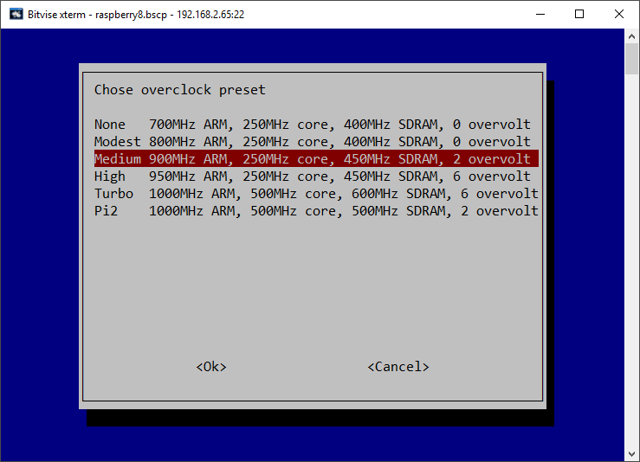

Figure 170 Over-clocking the Raspberry PI

Select ‘Medium’ to start with. Reboot the Raspberry PI when prompted. Re-test the radio with streaming switched on.

## Icecast2 Operation

The radiod daemon has full control over the Icecast2 service and stops and starts it as required. When the radio is first switched on the Icecast2 streaming service will not normally be enabled unless it was enabled as shown below by an earlier run of the radio software.

### Switching on streaming

Before you can listen to the streaming on the PC or mobile device it is necessary to start the Icecast2 streaming daemon. It must be switched on first.

Use the options menu (Press menu button three times). Step through the menu option using the Channel up/down buttons until “**Streaming off**” is displayed in the LCD display (assuming Icecast is installed). Press either Volume button and after a short delay the text should change to “Streaming on” in the LCD display. Press the menu button again to exit the options menu.

This starts the Icecast2 service. It also writes the word “on” or “off” to a file called /**var/lib/radiod/streaming**. This is file is used to enable or disable the Icecast streaming function at boot time.

#### Starting Icecast2 manually

Use the following command:

$ sudo service icecast2 start

To stop it again:

$ sudo service icecast2 stop

#### Enabling Icecast2 at reboot time

It isn’t necessary to enable the Icecast2 service at boot time as the radio program will start it depending on the contents of the /**var/lib/radiod/streaming** file. Should you wish to enable streaming at boot time then enable it with the following command:

$ sudo update-rc.d icecast2 enable

Or

$ sudo systemctl enable icecast2

### Playing the Icecast stream on Windows

To play the Icecast2 radio stream on a PC point your web browser at the IP address of the radio on port 8000 and the **mpd** mount point. In the following example the IP address of the radio is 192.168.2.8. So, this would be:

**http://192.168.2.8:8000/mpd**

This will normally open the default media player.

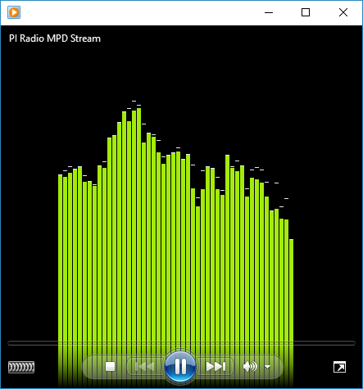

Figure 171 Windows media player

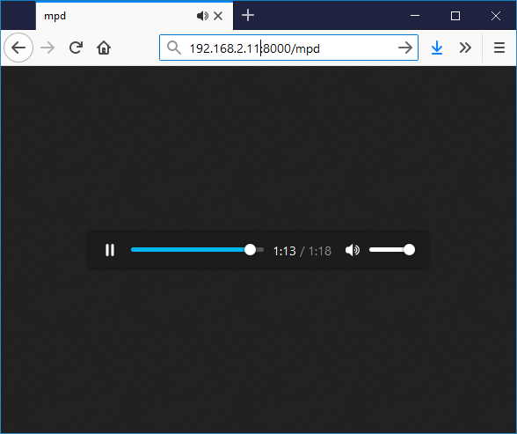

Figure 172 Firefox embedded media player

You will be prompted if you wish to save or open the radio stream. Always select open using the configured media player. The selected radio station or music track should be heard through the PC speakers. At this point you may wish to mute the sound from the radio itself. Simply reduce the volume to almost zero.

|  |  |
| --- | --- |
| note_icon.png | Note: It is probably possible to configure Windows 10 Edge or Internet Explorer 11 to use Windows Media player instead of TWINUI. Note: If the mute function is used it will stop the **Icecast** stream. |

### Running the Icecast Adminstration web pages

Using the same IP address as shown in the previous example but without the mount point will bring up the administrator window:

**http://192.168.2.8:8000**

The following screen should be displayed. If not continue to the troubleshooting guide at the end of this chapter:

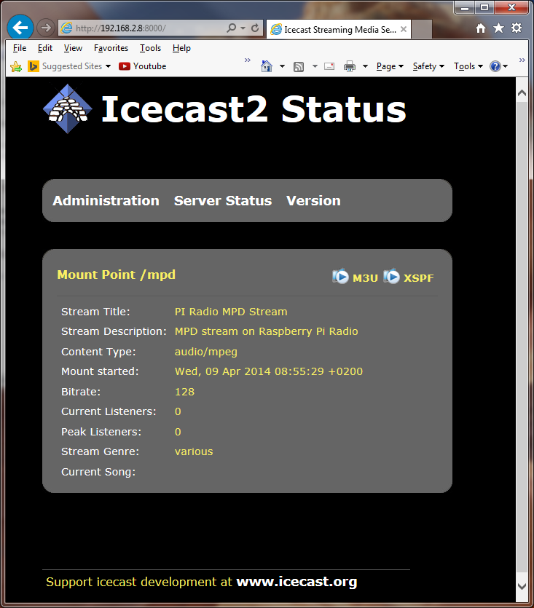

Figure 173 Icecast2 Status

Initially the server status screen is displayed. If you click on the **Administration** tab the you will be prompted for the login credentials.

Log in as admin with user *admin* password *mympd*.

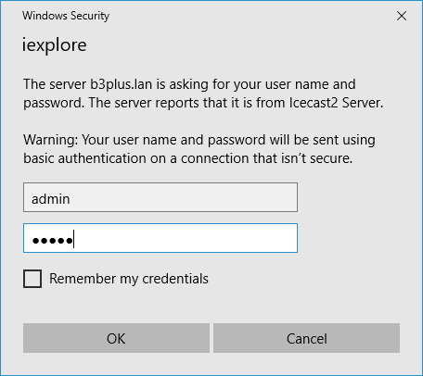

### Playing the Icecast2 stream on an Apple IPad

This is exactly the same as playing the Icecast2 stream on a Windows PC.

1. Open the Safari browser.
2. Type in the Icecast2 URL. For example **http://192.168.2.11:8000/mpd**
3. Click the M3U button

This should open the iTunes Player and after a short time should start playing the radio stream.

### Playing the Icecast2 stream on an Android device

1. Open your web browser
2. Type in the Icecast2 URL. For example **http://192.168.2.11:8000/mpd** (don’t include .m3u)
3. When asked to “Complete action with” select your *Android System* then *Music player*

The Icecast stream should start playing. It is important not to key in **mpd.m3u** at the end of the URL. It must be **mpd** only.

### Visual streaming indicator

When streaming is switched on an asterix ‘\*’ character is displayed as a visual streaming indicator in the LCD display on the Raspberry PI radio. When the ‘\*’ character is displayed this indicates that the Icecast2 streaming is switched on.

For the four line 20 character display the visual indicator is displayed after the time on the first line.

09:26 02/05/2014 \*

For the two line by 16 character display there isn’t the room to do this so it is displayed after the Volume or Mute message on the second line.

Volume 75 \* or Sound muted \*

## Troubleshooting Icecast2

Help for general problems with icecast2 can be found on the forums at <http://www.icecast.org/>

Icecast2 has two log files in the **/var/log/icecast2** directory namely **access.log** and **error.log**. The error log may give a clue as to the problem.

Below is a simulated error caused by mis-configuring the shoutcast entry in /etc/mpd.conf file. Here the hostname ‘piradio’ has been configured in the **/etc/mpd.conf** shoutcast entry instead of ‘localhost’.

$ **tail -f /var/log/mpd/mpd.log**

Apr 07 10:43 : output: Failed to open "PI Radio MPD Stream" [shout]: problem opening connection to shout server piradio:8000: Couldn't connect

### Problem - Icecast streaming page says it can’t be displayed.

Possible causes:

* The icecast service is not running on the radio.
  + Start it either from the Radio options menu (Streaming on) or run **sudo service icecast2 start** on the Rasperry PI and retry.
* Incorrect IP address or missing port number in the URL.
  + See Icecast2 Operation on page 181

### Problem – No Mount Point displayed

Possible causes:

* This is mostly due to a mis-match in the MPD configuration and the Icecast2 configuration.
  + The icecast configuration is file is **/etc/icecast2/icecast.xml** . Make sure that all of the passwords are set to ‘mympd’. The password ‘hackme’ will not work.
* There is no /mpd directory or the permissions are incorrect.
  + Check that the **/mpd** directory exists and that the permissions are set to 777. See Installing *Icecast* on page 179.

### Problem - Cannot play the stream on my Android device

There are a number of Icecast players which can be downloaded onto Android and play Icecast2 streams across the network without problem. However, the usual Android System Music player should work. The most likely cause of this problem is keying in an incorrect URL (Maybe adding .m3u to the end). See *Playing the Icecast2* stream on an Android deviceon page 184.

### Problem – Music keeps stopping or is intermittent

This is difficult to give a definitive answer to this problem. It must be remembered that running MPD and Icecast2 together on a Raspberry PI is pushing the Raspberry PI to its limits. It can also depend on your network or the PC you are using. Personal experience showed no problem playing a stream on PC with a wired network connection however a Laptop connected over a wireless network did not work well. Trying to play two or more devices on the MPD/Icast2 stream is also likely to result in poor results.

Try over-clocking the Raspberry PI using the **raspi-config** program. Medium over-clocking seems to be sufficient. See Overclocking older Raspberry PI on page 180. The icecast streaming facility is a fun thing to try out but if it doesn’t work properly or is causing you stress; switch the streaming facility off.

# Chapter 11 - Setting up Spotify

|  |  |
| --- | --- |
|  | The radio can also be set up as a Spotify receiver. You will still need a Spotify App on your telephone, PC or Tablet. You will also need a Premium Spotify account and not just a free or trial version.  More information at <https://www.spotify.com> |

## Spotify installation

As from version 6.7 onwards you can install **Raspotify** from Dave Cooper.

First carry a system update and upgrade as shown in *Update to the latest the packages* on page 60

Now download the **Raspotify** software with the **curl** command.

$ curl -sL https://dtcooper.github.io/raspotify/install.sh | sh

This will both download and install **Raspotify**. In the **/etc/default/raspotify** configuration file you will see the OPTIONS line for Spotify account details. It is not necessary to configure your account details as these will be picked up from the connecting **Spotify** App on your PC or Mobile.

#OPTIONS="--username <USERNAME> --password <PASSWORD>"

Edit **/lib/systemd/system/raspotify.service** and disable the restart options.

#Restart=always

#RestartSec=10

The radio will automatically stop and start Raspotify but it may be started and with the following commands:

$ sudo systemctl start raspotify

$ sudo systemctl stop raspotify

You can also check the status with **systemctl**.

$ **sudo systemctl status raspotify**

● raspotify.service - Raspotify

Loaded: loaded (/lib/systemd/system/raspotify.service; enabled; vendor preset: enabled)

Active: active (running) since Wed 2018-05-30 11:41:20 CEST; 1h 0min ago

Process: 4072 ExecStartPre=/bin/chown raspotify:raspotify

:

Disable Raspotify from starting at boot time. Starting and stopping Raspotify is done by the radio.

$ sudo systemctl disable raspotify

## Spotify operation

To start the Radio as a Spotify receiver either select Spotify from the Playlists (LCD or OLED versions) or from the Sources window in the touchscreen version:

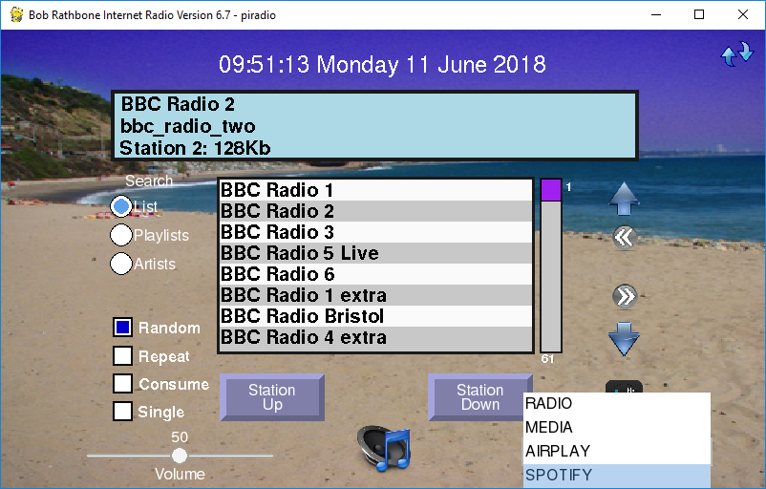

Figure 174 Starting the Spotify Receiver

The following window will appear however a different message may appear on the second line of the display window:

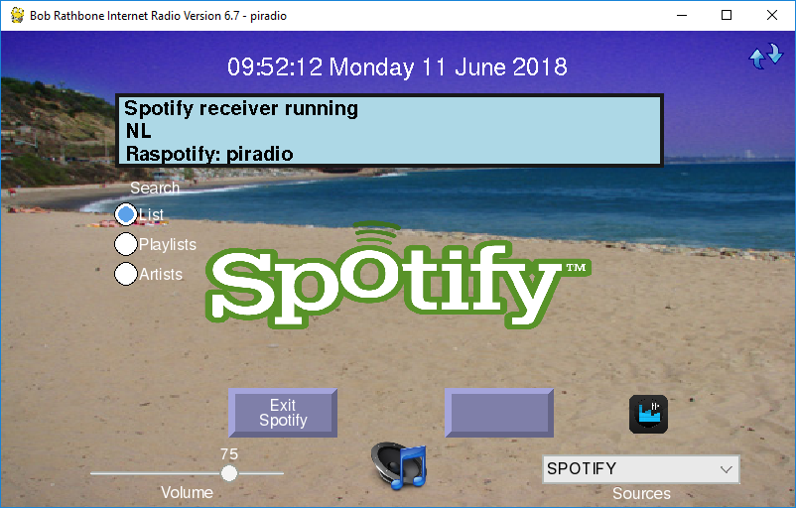

Figure 175 The radio in Spotify mode

|  |  |
| --- | --- |
| Figure 176 Spotify connecting to the radio | To use Spotify you will need a Spotify App on your telephone, PC or Tablet.  As previously mentioned you will need a Premium Spotify account and not just a free or trial version.  On the radio, press the Menu button until you come to the sources selection. Press channel Up or Down until you see Spotify displayed.  Press the Menu button again and the radio will stop the MPD player and start raspotify.  Now click on *Connect to a device* in the Spotify application. You should see an entry called Spotify Connect with the hostname of your radio. |
| Figure 177 Listening to Spotify on the radio | Click on the *Spotify Connect* device for the radio (*piradio* in this example).  The Spotify application will switch from the current device (PC, mobile phone or tablet) to the Raspberry Pi radio.  You can control the volume either from the Spotify Application or using the volume control on the radio.  To exit Raspotify on the Raspberry Pi press the Menu button and then select another source such as the radio. |

The Spotify application will connect the Raspotify application on the Radio.

In the case of the touchscreen version of the program the following screen will be displayed:

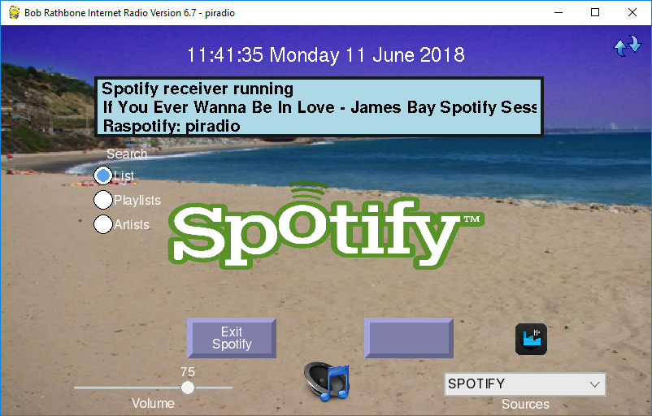

Figure 178 Spotify playing a music track

In the case of the LCD or OLED version of the radio the title line above will be displayed on the second line of LCD or OLED screen.

**Note:** Raspotify unfortunately does not supply the Artist information. Only the track name is supplied by librespot which is used by Raspotify. There is currently no solution for this.

## Exiting Spotify

For the LCD and OLED versions press the Menu button until the Select source: window is displayed. Select any other source (playlist) to exit.

In the case of the touchscreen version of the radio, press the “Exit Spotify”button at the bottom of the screen.

## Troubleshooting Raspotify

### Installation problems

If the curl command to install the Raspotify software fails then carry out a system update and upgrade as shown in *Update to the latest the packages* on page 60.

Retry the curl command.

### Raspotify exits with a 101 error code

This is almost certainly an authentication fault. Check your user name and password are correctly set up in **/etc/default/raspotify** and retry.

**Note:** The author does not directly support Raspotify.

Report Raspotify issues to <https://github.com/dtcooper/raspotify/issues>

Raspotify comes with an MIT licence. See <https://opensource.org/licenses/MIT>

# Chapter 12 - Setting up Airplay

If you have not already done so, carry out a system and firmware upgrade, as shown in *Preparing the Operating System* on page 60. **Airplay** uses a program called **shairport-sync** from Mike Brady.

Airplay is based upon the procedure in the following link:

<http://www.redsilico.com/multiroom-audio-raspberry-pi>

|  |  |
| --- | --- |
| note_icon.png | Do not use the procedure in the above link. Use the procedure described below as it has been greatly modified to work with the radio software. |

## Installation script

From version 6.5 onwards there is an installation script called **install\_airplay.sh.**

$ cd /usr/share/radio

$ ./install\_airplay.sh

This will install both **shairport-sync** and configure the radio to use it.

If the script fails with a dependency error for PHP. Run the following:

$ sudo apt-get -f install

Re-run **install\_airplay.sh.**

Only if this script fails try the manual procedure below. Otherwise skip the next section.

## Manual procedure

Install the necessary build library modules and the git program:

$ sudo apt-get install build-essential git xmltoman

Install other build libraries:

$ sudo apt-get install autoconf automake libtool libdaemon-dev libasound2-dev libpopt-dev libconfig-dev libssl-dev

The above instruction is all on one line.

If running on Stretch it will be necessary to install the following libraries:

$ sudo apt-get install libdaemon-dev libpopt-dev pkgconf libconfig-dev

Install the Avahi daemon required for Airplay network discovery.

$ sudo apt-get install avahi-daemon libavahi-client-dev

Edit the **/usr/share/alsa/alsa.conf** file (use **sudo nano**). Scroll down a few pages until you see the following line:

pcm.front cards.pcm.front

Change this line to:

pcm.front cards.pcm.default

Create a development directory and change to it:

$ mkdir -p projects/airplay

$ cd projects/airplay

### Build and install shairport-sync:

Get the source from github and configure the build.

$ git clone https://github.com/mikebrady/shairport-sync.git

$ cd shairport-sync

$ autoreconf -i -f

If **autoreconf** is missing for any reason install it with the following command:

$ sudo apt-get install dh-autoreconf

|  |  |
| --- | --- |
| note_icon.png | There is a problem with **autoreconf** which causes it to fail unpredictably. At the moment, it seems very unreliable. Below are some suggestions if it exits with an error. |

If **autoreconf** does fail with the following message then make sure that the latest packages are installed. The **autoreconf** program can take several minutes.

autoreconf: 'configure.ac' or 'configure.in' is required

Carry out the procedure in section *Update to the latest the packages* on page 60 and retry.

If autoreconf still fails run the **following** command and then retry the above **autoreconf** command:

$ autoreconf -m

Note that the above command will fail but somehow it seems to (sometimes) cure the problem. Re-run the **autoreconf -vif** command.

Now configure the package build files (It is the configure script which is created by autoreconf)

$ ./configure --sysconfdir=/etc --with-alsa --with-avahi --with-ssl=openssl --with-metadata --with-systemd

Now build and install shairport-sync:

$ make

$ sudo make install

The last command installs the **shairport-sync-metadata** program inthe **/usr/local/bin** directory and the distribution configuration file in **/etc/shairport-sync.conf**.

Change back up one directory

$ cd ..

Test Airplay (shairport-sync) – Stop the Music Player Daemon first:

$ **mpc stop**

$ **shairport-sync**

Successful Startup

Now run Airplay on an Airplay mobile phone or tablet. Search for connected devices which should include the raspberry pi. Play a music track which should be heard on the radio. Use **control-C** to exit. Use **Control-C** to exit **shairport-sync**.

### Install the shairport metadata reader

To display the track metadata (Artist, Title and Album) on the display screen, it is necessary to install the **shairport-sync-metadata-reader** from Mike Brady.

$ git clone https://github.com/mikebrady/shairport-sync-metadata-reader

$ cd shairport-sync-metadata-reader

$ autoreconf -vif

$ ./configure

$ make

$ sudo make install

The last command installs the **shairport-sync-metadata-**reader program inthe **/usr/local/bin** directory.

### Configuring the Airplay feature

Below are the configuration parameters found the Airplay section of **/etc/radiod.conf** affecting the Airplay (shairport-sync) function in the radio.

[AIRPLAY]

# Airplay activation yes or no

airplay=no

# Mixer preset volume for radio and media player if using sound card

# Set to 0 if using onboard audio or USB sound dongle.

# If using a sound card set to 100% initially and adjust as neccessary

mixer\_volume=0

# Mixer volume ID (Airplay) Use command 'amixer controls | grep -i volume'

# to identify mixer volume control ID

mixer\_volume\_id=1

|  |  |
| --- | --- |
| note_icon.png | If upgrading from an earlier version of the radio and you selected “Do not update existing configuration” during installation then the [AIRPLAY] section will be missing from **/etc/radiod.conf**. If this is the case then copy the above lines to the end of the file. |

Enable Airplay in **/etc/radiod.conf**

airplay=yes

Set the mixer output volume ID (Volume control for Airplay). Run

$ amixer controls | grep -i volume

Identify the ID (numid) for the playback volume for your device.

For sound cards or HDMI using digital volume control this is likely to be similar to the following.

numid=1,iface=MIXER,name='Digital Playback Volume'

For onboard jack sound output

numid=6,iface=MIXER,name='Speaker Playback Volume'cd

Modify or add the **mixer\_volume\_id** for your device in **/etc/radiod.conf. For example:**

mixer\_volume\_id=6

The **mixer\_volume** parameter has a very special use and is used to preset the mixer volume (alsamixer) if using a DAC sound card or HDMI output. It is not relevant if using the onboard audio jack as output and must be set to 0. The reason it is needed is that Airplay can only be controlled by the mixer level unlike the radio which uses Music Player Daemon volume commands.

For on-board audio changing the mixer volume is not relevant as it is controlled by MPD. In this case set it to 0:

mixer\_volume=0

For sound cards or HDMI set it to somewhere between 80 and 100.

mixer\_volume=90

### Airplay service check

Check that all is well with D-Bus. The following

$ **sudo** **systemctl start shairport-sync**

Failed to get D-Bus connection: Unknown error -1

If the above error message is seen install **systemd-sysv**:

$ sudo apt-get install systemd-sysv

Reboot the Raspberry Pi.

$ sudo reboot

See the following section on how to use Airplay.

## Using Airplay on the radio

Using Airplay on a HDMI/Touchscreen is described in the section called *Running* Airplay on the HDMI touchscreen on page 130. LCD versions of the radio are described here.

|  |  |  |
| --- | --- | --- |
| Figure 179 Airplay source selection |  | Press the menu button until **Input Source:** is displayed.  Turn the channel button (or Up/Down switches on a push-button radio) until **Airplay receiver** appears.  Press the menu button one more time. The word Airplay will be displayed on the bottom line along with ‘Unknown artist’ and ‘Unknown title’. |

Now use the Airplay device to connect to the raspberry PI (varies according to device software). Start playing the music tracks and this should start being heard on the radio which also displays the Artist, Track and Album on the LCD display. The volume is adjustable if correctly set-up. The mute also works in the normal way but does not pause or stop the Airplay stream as this can only be done from the device running Airplay.



Figure 180 Running an Airplay device on the radio with Cloudbreak

The above example is using an evaluation copy of CloudBreak running on an Android mobile telephone. See: <https://play.google.com/store/apps/details?id=com.nav.aoaplayer>

# Chapter 13 - Internet Security

|  |  |
| --- | --- |
| <http://2.bp.blogspot.com/-HjmDs7Xh350/VLF-nMgrREI/AAAAAAAAAgs/l_nCq0frA9Y/s1600/internet-security-identity-theft-prevention.jpg> | This is a section that probably will not concern most people as their Raspberry Pi is not exposed to the internet. However, with more and more cases of such devices such as web cams and other Internet connected devices being hack by unscrupulous hackers, Internet Security is an aspect of home computing that must be taken seriously. These incursions can be used to mount Phishing (harvesting bank details etc.) or Distributed Denial of Service attacks (**DDOS**) on the wider community as a whole. More and more Internet providers are choosing to block compromised user’s systems from access to the Internet until the infection is removed. |

## Some golden Internet Security rules

|  |  |
| --- | --- |
| [Forgot Password Icon image #18346](http://www.freeiconspng.com/free-images/forgot-password-icon-18346) | Always change the user **pi** password from the system installation default. When installed the password for user **pi** is ‘raspberry’. It will be the first password that will be attempted by a hacker. The password can easily be changed using the **raspi-config** program (See *Changing the system hostname and password* on page 63). The user **pi** is very dangerous if hacked as with the command **sudo bash** the hacker then has user root privileges and can do anything they want including installing **Phishing** or **DDOS** software. Don’t give them the chance! |
|  |  |
| <http://2.bp.blogspot.com/-FiTqThXstks/VSEAt1qoLII/AAAAAAAAJT0/eM1DQ5RRQAs/s1600/telnet.png> | Never ever use insecure protocols/programs such as **Telnet** , **Rexec** or **FTP** across the Internet**.** The problem with all such programs is that the login username and password are un-encrypted and can be discovered by a hacker using eavesdropping software. The use of such software to access the Raspberry Pi will attract hackers like flies around a honey-pot. |
|  |  |
|  | If access to the Raspberry Pi across a network is required (for example a headless RPi) then use Secure Shell (**SSH**) for terminal access and Secure Copy (**SCP**) for file transfer. On the latest releases of Raspbian Stretch **SSH** is disabled for security reasons. How to enable this is shown in *Using SSH to log into the Raspberry PI* on page 58. For extra security use **SSH keys** (explained later) |
|  |  |
|  | Install **firewall** software such as **fail2ban**. The **Raspbian Stretch** operating system has a firewall called **iptables** which can be configured to block or allow access to specific ports from a specific **IP** address or range. The **fail2ban** software is an enhancement to **iptables** which monitors certain ports for hacking attempts and adds a blocking rule to the **iptables** configuration. More on this later. The fail2ban software is a good defence against so-called brute-force dictionary attacks. |

## SSH keys installation

### Raspberry Pi ssh keys

If using **SSH** across the Internet, changing the password for user **pi** will afford some limited protection. However a hacker can still access the system with SSH and try to log in as user **pi**. They can still try (often using software) to try and guess the software. By using SSH keys a greater level of protection is afforded as person logging in must be in possession of the SSH keys.

Log in as user **pi** and then run the **ssh-keygen** program. Just press enter when asked any questions.

$ **ssh-keygen -t rsa -C “raspberrypi”**

Generating public/private rsa key pair.

Enter file in which to save the key (/home/pi/.ssh/id\_rsa):

Created directory '/home/pi/.ssh'.

Enter passphrase (empty for no passphrase):

Enter same passphrase again:

Your identification has been saved in /home/pi/.ssh/id\_rsa.

Your public key has been saved in /home/pi/.ssh/id\_rsa.pub.

The key fingerprint is:

c0:54:96:d9:2d:a5:d0:d0:7c:68:91:8a:5f:e2:a5:9d pi@pixelpi

The key's randomart image is:

+---[RSA 2048]----+

| ..=O.\*. |

| o .o.X.o |

| o. o.o |

| ..o o |

| oS\* . |

| + E |

| |

| |

| |

+-----------------+

Two keys are generated, one public and one private in the **.ssh** directory. The key i**d\_rsa.pub** is the public key. The **id\_rsa** file is the private key.

$ **ls -la .ssh/**

total 16

drwx------ 2 pi pi 4096 Feb 16 12:40 .

drwxr-xr-x 19 pi pi 4096 Feb 16 12:40 ..

-rw------- 1 pi pi 1675 Feb 16 12:40 id\_rsa

-rw-r--r-- 1 pi pi 392 Feb 16 12:40 id\_rsa.pub

## Generate a client key

It is also necessary to generate SSH keys on Typically **Putty** and **Bitvise** are a very popular choice for **SSH** clients. There is already so much documentation on the Internet on how to generate SSH keys for both **Putty** and **Bitvise** that it is not repeated here. Search the Internet for instructions.

## Add client public key to Raspberry Pi authorised keys

On the Raspberry Pi create or edit the **/home/pi/.ssh/authorized\_keys**.

$ cd /home/pi/.ssh/

$ vi authorized\_keys

Paste or copy the Public key created on the PC to the  **authorized\_keys** file. (Some output in the following text omitted).

ssh-rsa AAAAB3NzaC1yc2EAAAABJQAAAQEAuX+NEQoQECPN2d+Lu+qL2exMT/ICYbrNax6DVWBtKGzTxFOb:

LeiaFbI3tWyi+ZPXg8Swhr1OaPN6l2E/fnAQPbGl2S+YMtcIXknNiwVGL8RB3D8N/Q== rsa-key-20170216

Finally connect to the Raspberry Pi from the PC client using the **publickey** method. If this works OK disable password login method. Edit vi /etc/ssh/sshd\_config and disable PAM and Password authentication.

PasswordAuthentication no

:

UsePAM no

## Firewall set-up

Linux has a firewall facility built-in to the kernel called **iptables**. Rules may be added to **iptables** to allow or deny access to system services as required. However, **iptables** is static and has to be configured with any new rules. The **fail2ban** program enhances **iptables** by dynamically adding rules as required. For example, if a hacker attempts five unsuccessful logins using SSH then **fail2ban** blocks that IP address from connecting to the SSH port by adding a blocking rule to **iptables**. The following commands install and enable **fail2ban**.

$ sudo apt-get install fail2ban

$ sudo systemctl enable fail2ban

Below is an example of a blocked host (195.22.126.242)

$ **sudo iptables -L**

Chain INPUT (policy ACCEPT)

:

Chain FORWARD (policy ACCEPT)

:

Chain OUTPUT (policy ACCEPT)

:

Chain fail2ban-ssh (2 references)

target prot opt source destination

REJECT all -- 195.22.126.242 anywhere reject-with icmp-port-unreachable

However, rules added by fail2ban will be lost if the Raspberry Pi is rebooted. An additional package called iptables**-persistent** can be added so that rules added by fail2ban can be made permanent. The following command allows installation.

$ sudo apt-get install iptables-persistent

The following command can be used to make the **iptables** rules persistent after a reboot. Run the following command before rebooting.

$ iptables-save

Search the internet for more information on **iptables** and **fail2ban**.

# Chapter 14 - Frequently asked questions (FAQs)

## What is the login name and password?

The default login name is: pi

The default password is: raspberry

You should change this at the earliest opportunity. See *Chapter 13* - Internet Security on page 196.

## Why are the radio stations not in the order that they were defined?

Playlists are loaded by the radio daemon in alphabetic order using the playlist name.

When loading an individual playlist, MPD loads the stations in the order that they are defined in each individual playlist. This has been improved by sorting the playlist.

It helps greatly to group stations of the same type into a single playlist. For example group all BBC radio stations into a single playlist.

The only way to get all of the radio stations in the order that you define them is to define a single playlist, for example **myplaylist**:

(myplaylist)

#

# United Kingdom

[BBC Radio 1] <http://bbc.co.uk/radio/listen/live/r1.asx>

[BBC Radio 2] <http://bbc.co.uk/radio/listen/live/r2.asx>

[BBC Radio 3] <http://bbc.co.uk/radio/listen/live/r3.asx>

:

:

[RAIradio3] <http://www.listenlive.eu/rai3.m3u>

This will produce a single playlist called **myplaylist.m3u** with the stations loading in the order that they have been defined in the **/var/lib/radiod/stationlist** file. Make sure there are no blank lines between station definitions otherwise this terminates the playlist. All remaining stations will end up in there own single playlist file.

## Why are some station names not being displayed in the web interface?

The reason for this is that some stations don’t send the name with the stream. If you run the **mpc playlists** command you will see that some radio stations shows only the station URL and not the name:

$ mpc playlist

RAIradio2

:

BBC Radio 4 extra

http://icestreaming.rai.it/1.mp3

BBC Radio 3

BBC Radio 6

BBC Radio 5 live

The only way around this is to complain directly to the radio station to ask them to amend their stream to include the station name and title details. The only way reason that the station name is seen with the radio program is that it picks up the names out of the station list file.

The snoopy web interface can’t do this however.

## Why doesn’t the web interface display URLs until a station is selected?

When the Snoopy web interface is loaded it loads the playlists found in the **/var/lib/mpd/playlists/** directory. Snoopy displays the URLs but doesn’t appear to use any titles defined in the playlists. It only displays the radio station information (if present) once it starts streaming from a particular radio station. Snoopy is third party software over which this author has no control.

## Why are music tracks played randomly when loaded?

This is the default behaviour when the music library is loaded in version 5.2 or earlier. This has changed in version 5.3 onwards. Random always defaults to “off” when the radio is selected. However when the music library is selected the value stored in the **/var/lib/radiod/random** file is used. This value can be changed in the selection menu by selecting “Random off” after loading the music which will store the new value in the **/var/lib/radiod/random** file. So the radio software will remember the desired random setting for the music library when it is restarted.

## Can the volume be displayed as blocks instead of Volume nn?

Yes, it can. Volume is displayed by default as “Volume *nn*” where *nn* is 1 to 100. This can be changed as shown in section *Configuring the volume display* on page 112

## Why do I see a station number on LCD line 3?

For version 3.3 onwards if no song information is available then the station playlist number followed by the stream speed. In the following example Radio 1 is not transmitting any song information. It is number 37 in the play list. The speed from the stream is 96 Kilobit. The displayed stream speed can also continuously change for some radio stations where the stream speed is variable.

|  |
| --- |
| 12:01 23/08/2015  Radio1  Station 37 96K  Volume 75 |

## Is it possible to change the date format?

Yes. Please see the section called *Changing the date format* on page 110.

## Is there a pause & resume function?

Yes, but it is called mute and un-mute. The mute function also stops or pauses the MPD player. If playing a radio station, a “stop” command is carried out. If playing a media track a “pause” is carried out. The reason these are different is that media may be safely paused but in the case of a radio station pausing causes buffering and jumping to the next station when the radio resumes normal playing. See the

|  |  |
| --- | --- |
|  | Note 1: The colour change option is only available for the AdaFruit RGB plate (ada\_radio.py). Note 2: If the **/var/lib/radiod/rss** file is missing or contains an invalid RSS URL then the RSS mode is skipped. |

Mute function on page 124.

## Is there a reboot or shutdown option?

There is only a shutdown option. Hold the menu button in for at least three seconds. The radio will stop and should display “Radio stopped” on the display. Wait ten seconds and then power off the Raspberry Pi. Powering back on achieves the same effect as a reboot. Also see *Fitting a wake-up button* on page 37.

## Why do I see a different station name from the one in the playlist?

The station information displayed comes from the stream itself. The name entered in the playlist definition is only used in the search function. This was a design decision because the station information is only available once a particular radio station is selected so only the playlist name can be initially used. If the station transmits the station title this is used instead.

Run the **display\_current.py** program to see all the information that comes from the stream (It is quite interesting).

## What Rotary Encoder can I use for this project?

The rotary encoders illustrated in this guide are COM-09117 12-step rotary encoders from sparkfun.com. The radio uses so called “Incremental Rotary Encoder”. An incremental rotary encoder provides cyclical outputs (only) when the encoder is rotated. The other type is an absolute rotary encoder and maintains position information even when switched off (See Wikipedia article and my tutorial on rotary encoders).

The cheaper smaller rotary encoders are usually incremental encoders. Absolute rotary encoders are usually bigger and more expensive as they house more electronics. If unfortunately, the seller doesn't provide a specification then there is a small risk that they may not run with this software.

**Note:** Not all manufacturers’ rotary encoders will work with this project. If they work then fine if not regrettably you will need to purchase the recommended rotary encoders. You can also try the alternative rotary class which may just work with your encoders.

## Can this code or documentation be re-used in other projects?

Yes, it can. You can even use it commercially, provided that you do so under the terms of the licence distributed with this package. The software and documentation for this project is released under the GNU General Public Licence and may be re-used it other projects. See Licences on page 208.

You do not need to ask permission to re-use this code or documentation as it is already permitted in the licenses.

## Can I use an Electronic Ink display?

The answer is not at the moment. There are a number of electronic ink displays on the market such as the Pimoroni Inky pHat and the Waveshare. These displays appear to only suitable for static display of information and do not handle dynamically changing screens. However, looking at on-line demo’s the Waveshare device can handle partial screen updates which may make it viable. This is currently being assessed.

# Chapter 15 - Source files

This section is only of interest if you are considering developing your own version of the software or wish to use one of the classes in your own software.

The source consists of several source modules all written in Python using Object Orientated techniques. The source will be visible in the **/usr/share/radio** directory once the Radio package has been installed. The radio Debian package is available at <http://www.bobrathbone.com/pi_radio_source.htm> .

For those who want to develop their own product all source is also available from Github. See *Downloading the source from* github on page 207.

## The Radio program

The radiod.py program is the top level radio program for the LCD versions of the radio and provides the logic for operating the radio. It is called from the **systemd radiod.service** script in the **/lib/systemd/system** directory.

## The Radio Daemon

The radio\_daemon.py code allows the LCD radio program to run as a background daemon. It allows start, stop, restart, version and status commands.

## The Display Class

The *display\_class.py* program is only used by the LCD (including PiFace CAD) and OLED versions of the radio and is responsible for displaying messages on the various types of display. It uses the **display\_type** parameter in the **/etc/radiod.conf** configuration file to load the correct LCD display software. Depending upon the actual device configured it will load one of the following:

Table 19 Display classes

|  |  |  |
| --- | --- | --- |
| Display class file | Description | display\_type |
| lcd\_class.py | LCDs with a directly connected HD44870 interface | LCD |
| lcd\_i2c\_adafruit.py | LCDs with an Adafruit I2C backpack | LCD\_I2C\_ADAFRUIT |
| lcd\_i2c\_pcf8574.py | LCDs with a PCF8574 I2C backpack | LCD\_I2C\_PCF8574 |
| lcd\_adafruit\_class.py | LCDs with an Adafruit RGB plate | LCD\_I2C\_ADAFRUIT |
| lcd\_pifacecad\_class.py | Piface CAD 2x16 LCD with push buttons | PIFACE\_CAD |
| oled\_class.py | Solomon Systech SSD1306 OLED Display (IQaudIO) | OLED\_128x64 |
| no\_display.py | No display attached (vintage radio/Pirate Radio) | NO\_DISPLAY |

The above settings are performed by the **configure\_radio.sh** program.

The Adafruit RGB plate also uses an i2c class courtesy of Adafruit Industries (renamed to i2c\_class.py).

## The Graphical Screen radio programs

The gradio.py and *v*gradio.py programs are the radio programs for the HDMI/Touchscreen version of the radio and is launched on the graphical desktop of the Raspberry Pi. It is optionally called from the **Desktop/gradio.desktop** script in the **/home/pi** directory. The *vgradio.py* program gives a vintage radio look and feel to the radio display.

In the case of both programs the **display\_type** parameter in **/etc/radiod.conf** is set to GRAPHICAL and is set by the **configure\_radio.sh** program.

## The Graphics display class

The *graphic\_display.py* class performs auxiliary display functions such as scrolling and screen mapping for the *gradio.py* and *vgradio.py* programs.

## The Graphics controls class

The gcontrols\_class.py handles the creation of all graphics controls and widgets for the graphic version of the radio. It also uses the SGC widget routines in the **sgc** sub-directory from Sam Bull and Michael Rochester.

## The OLED class

The *cosmic\_class.py* is the display interface for the SSD1306 128x64 pixel OLED display supplied with the IQaudIO Cosmic controller. This class is a wrapper for the routines from **Olimex Limited** in the sub-directory **oled**. It drives the OLED screen although not all functions are used by the radio.

## The button class

The *button\_class.py* detects all button presses from the push button radios (Not the Adafruit RGB nor the PiFace CAD which have their own buttons using I2C and SPI interfaces respectively). It passes button press events up to the event class described later.

## The rotary class

The *rotary\_class.py* and *rotary\_class\_alternative.py* detect all rotary encoder events from the radios fitted with rotary encoders. It passes rotary encoder events up to the event class described later.

## The Cosmic controller Class

The *cosmic\_class.py* is used as the user interface for the IQaudIO Cosmic controller. This provides the interface for three-button and rotary control interface on the controller board.

## The Event class

All user interfaces in the radio software generate a largely common set of events. These are handled by the *event\_class.py*. The *event\_class.py* program accepts events from the following sources:

* The *gradio.py* and *vgradio.py* graphical radio programs
* The *radiod.py* radio program
* The push button interface user interface (*button\_class.py*)
* The rotary encoder user interface (Either *rotary\_class.py* or *rotary\_class\_alternative.py*)
* The IR remote control user interface (*remote\_control.py*)
* The radio web user interface running on an Apache Web server

## The Menu class

The *menu\_class.py* code provides the logic for stepping through the various menus and their options.

## The Message class

All messages are generated from the *message\_class.py* program. This uses message labels to load the correct text to be displayed or spoken. By using labels and the *language\_class.py* software, the radio can be configured to use any language using a Latin character set. It provides messages to display various menu’s, time, station and track information.

## The language class

The *language\_class.py*provides the text for both the radio display or the **espeak** package. It reads the **/var/lib/radiod/language** file (if present) and passes the text to both the message class and if used. It is used by the message class to deliver messages in the users own language.

## The Log class

The *log\_class.py* routine provides logging of events to **/var/log/radio.log** file.

## The Volume class

The volume\_class.py program handles all volume and mixer functions for the radio, Spotify and airplay.

## The Configuration Class

The **config\_class.py** reads and stores the radio configuration from the **/etc/radiod.conf** file

## The RSS class

The *rss\_class.py* routines allow sequential gets from an RSS feed. These feeds are provided from news providers such as the BBC. This class gets the RSS feed defined in the **/var/lib/radiod/rss** file.

## The Translate class

The *translate\_class.py* is used to convert special international character sets (particularly from RSS feeds). It does this by first converting them to escape sequences and then to displayable ascii characters (These will show up in DEBUG logging). These *ascii* characters are then passed to the LCD class where they may are converted again to a valid character in the standard LCD character set.

## The create\_stations program

The *create\_stations.py* program creates playlist files in the **/var/lib/mpd** directory using a list of web links (URLs) with titles as input. This program creates standard playlists for use with with MPD. The operation of the *create\_stations.py* program is covered in detail in the section on managing playlist files on page 140.

## The display\_current program

The *display\_current.py* program is a small diagnostic program which displays the information for the current radio station or track. It is only used for trouble-shooting and it will not normally be used.

## The display\_model script

The *display\_model.py* program displays the revision, cpu, memory and maker (If known) of the board. It is only used for trouble-shooting and it will not normally be used.

## The configure\_radio.sh script

The *configure\_radio.sh* script is normally called during installation of the Radio Debian package but may be run by the user at any time. It selects the correct board revision and radio program variant. It configures the display to be used and the user interface.

The playlist creation program

The create\_playlist.sh script creates playlists from music directories on either a USB stick or a Network drive such as a NAS. It has the ability to accept filters to make a more selective playlist.

## The configure\_audio.sh script

The *configure\_audio.sh* script selects and configures the Audio output. It currently supports selection of the on-board audio jack, HDMI output, USB DAC, HiFiBerry and IQaudIO DACs.

## The set mixer id script

The *set\_mixer\_id.sh* script works out the “Speaker Playback Volume” mixer ID and configures the **mixer\_volume\_id** in **/var/lib/radiod** directory. This information comes from the **amixer controls** command. This mixer ID (integer) is used to set a default mixer volume for MPD and also is used for volume control when using Airplay. The *set\_mixer\_id.sh* script is normally called from the radio program (all versions), usually after a reboot, if the **mixer\_volume\_id** parameter has been removed by the **configure\_audio.sh** program. This script also completes configuration of HDMI audio if selected in the **configure\_audio.sh** program. It is not normally necessary to run this program separately but can be safely run at any time.

## The remote control daemon

The remote control daemon consists of the *remote\_control.py* and the *rc\_daemon.py* program files.

There is a service start stop script called */etc/init.d/irradiod*. This is configured for the correct program by the *configure\_radio.sh* program during installation. The server\_class.py program is used for communication between the remote-control daemon and the radio program.

## The UDP network communications class

The remote control daemon uses the *udp\_server\_class.py* program which communicates over the local TCP/IP network using UDP port 5100 as the default; however, the port is configurable in **/etc/radiod.conf**. When a button is pressed on the remote control this program sends the button identity (See Table 12 Remote Control Key names) to a UDP server running in the radio program. It is also used to send commands from the Web Interface to the radio program.

Button press 🡪 IR remote control daemon 🡪 UDP message over network 🡪 Radio program.

## The Status LED class

The *status\_led\_class.py* is called by the vintage radio software. A Red Blue Green LED is driven to indicate status of the radio as there is no LCD screen. See the Raspberry Pi Vintage Radio supplement.

## The Airplay Class

The *airplay\_class.py* file contains the routines for stopping and starting the **shairport-sync** daemon and for getting artist, title and album of the playing track. It is used when Airplay is selected as the source.

## The Menu Switch class

The *menu\_switch\_class.py* code supports an 8-position rotary switch (Not encoder) as an alternative method of operating a simple menu system. It is meant to be used with the vintage radio software but can be used with any variant.

## The init file

The *\_\_init\_\_.py* file contains a couple of global definitions plus the package version number.

## Downloading the source from github

This is only of interest if you wish develop your own version of the Raspberry PI radio based upon the mainstream source code. Otherwise simply install the Install the Radio Daemon the radio software as shown on page 69. You can view the Raspberry PI source at <https://github.com/bobrathbone/piradio6>

Note: This may be out of date compared to the latest version.

Before you can download the source from **Github** it is necessary to install **git**. For more information on **git** see <http://en.wikipedia.org/wiki/Git_(software)>

Install **git** with the following command:

$ **sudo apt-get install git**

Make a development directory and change to it:

$ **mkdir /home/pi/develop**

$ **cd /home/pi/develop**

Now clone the github piradio repository:

$ **git clone git://github.com/bobrathbone/piradio**

Cloning into 'piradio'...

remote: Counting objects: 71, done.

remote: Compressing objects: 100% (52/52), done.

remote: Total 71 (delta 13), reused 64 (delta 9)

Receiving objects: 100% (71/71), 185.33 KiB | 334 KiB/s, done.

Resolving deltas: 100% (13/13), done.

This will create a sub-directory called ‘piradio’ which will contain the entire source. Also in the **/home/pi/develop/piradio** directory you will also see a directory called **.git** (dot-git). This is the control directory for **git**.

Note: Don’t forget that if you use the **service radiod stop|start** commands that this will start and stop the software in contained in **/usr/share/radio** (If you installed from the package).

You will not necessarily need to use **git** any further unless you wish to save your changes under **git** control. To find out more about **git** and for general support and documentation see:

<http://git-scm.com>

# Licences, acknowledgements and support

## Licences

The software and documentation for this project is released under the GNU General Public Licence.

The GNU General Public License (GNU GPL or GPL) is the most widely used free software license, which guarantees end users (individuals, organizations, companies) the freedoms to use, study, share (copy), and modify the software. Software that ensures that these rights are retained is called free software. The license was originally written by Richard Stallman of the Free Software Foundation (FSF) for the GNU project.

The GPL grants the recipients of a computer program the rights of the Free Software Definition and uses *copyleft* to ensure the freedoms are preserved whenever the work is distributed, even when the work is changed or added to. The GPL is a *copyleft* license, which means that derived works can only be distributed under the same license terms. This is in distinction to permissive free software licenses, of which the BSD licenses are the standard examples. GPL was the first *copyleft* license for general use. This means that you may modify and distribute the software and documentation subject to the conditions of the licences.

See <http://www.gnu.org/licenses> for further information on the GNU General Public License.

The licences for the source and documentation for this project are:

GNU General Public License. See <http://www.gnu.org/licenses/gpl.html>

GNU AFFERO General Public License. See <http://www.gnu.org/licenses/agpl.html>

GNU Free Documentation License. See <http://www.gnu.org/licenses/fdl.html>

## Intellectual Property, Copyright, and Streaming Media

This is an unbelievably complex subject. The author is not a lawyer and cannot offer any legal advice on this subject. If you decide to stream your music content or relay a radio station stream back out to the internet or within a public building or space then you should seek legal advice.

See also: <http://en.wikipedia.org/wiki/Copyright_aspects_of_downloading_and_streaming>

In general Radio stations are providing a stream to promote their radio station. As media providers they should have arrangements in place to make the content that they provide is legally streamed across the Internet but not all do. The question is it legal to listen (or view) such content is a complex one and subject to local and international laws and which vary considerably.

If you implement **Icecast** or any other streaming technology to re-stream content within your own home then provided that this is not streamed back out to the Internet or a public location then one would think that you will not encounter any problems (but you never know).

If you stream music tracks or relay radio stations back out onto the internet or public space then almost certainly you will be infringing a copyright law or intellectual property rights somewhere. The penalties for such an infringement can be severe.

**WARNING: YOU USE THE ICECAST STREAMING IN THIS PROJECT AT YOUR OWN RISK ESPECIALLY IF YOU MAKE THE STREAM CONTENT AVAILABLE ACROSS THE INTERNET OR PUBLIC SPACE, EVEN IF YOU ARE JUST RELAYING AN EXISTING MEDIA STREAM, LEGAL OR OTHERWISE.**

Also see the Disclaimer on page 209.

## Disclaimer

THIS SOFTWARE AND DOCUMENTATION IS PROVIDED BY THE COPYRIGHT HOLDERS AND CONTRIBUTORS 'AS IS' AND ANY EXPRESS OR IMPLIED WARRANTIES, INCLUDING, BUT NOT LIMITED TO, THE IMPLIED WARRANTIES OF MERCHANTABILITY AND FITNESS FOR A PARTICULAR PURPOSE ARE DISCLAIMED. IN NO EVENT SHALL THE COPYRIGHT OWNER OR CONTRIBUTORS BELIABLE FOR ANY DIRECT, INDIRECT, INCIDENTAL, SPECIAL, EXEMPLARY, OR CONSEQUENTIAL DAMAGES (INCLUDING, BUT NOT LIMITED TO, PROCUREMENT OF SUBSTITUTE GOODS OR SERVICES; LOSS OF USE, DATA, OR PROFITS; OR BUSINESS INTERRUPTION) HOWEVER CAUSED AND ON ANY THEORY OF LIABILITY, WHETHER IN CONTRACT, STRICT LIABILITY, OR TORT (INCLUDING NEGLIGENCE OR OTHERWISE) ARISING IN ANY WAY OUT OF THE USE OF THIS SOFTWARE OR DOCUMENTATION, EVEN IF ADVISED OF THE POSSIBILITY OF SUCH DAMAGE.

## Technical support

Technical support is on a voluntary basis by e-mail only at [bob@bobrathbone.com](mailto:bob@bobrathbone.com). If there are any problems with this email address then also CC [r.h.rathbone@gmail.com](mailto:r.h.rathbone@gmail.com). Before asking for support, please first consult the troubleshooting section on page 159. I will always respond to e-mails requesting help and will never ignore them. I only ask that you do the same (i.e. Did my suggestions help or not?). Be sure to provide the following information:

* What have you built (Adafruit or normal LCD variants, sound cards etc)?
* Which program and wiring version are you running?
* A clear description of the fault.
* What you have already done to locate the problem?
* Is anything displayed on the LCD or Graphics screen?
* Did you run the test programs and what was the result?
* Switch on DEBUG logging as described on page 136, run the program and include the **/var/log/radio.log** file. Also run **sudo service radiod info**.
* Did you vary from the procedure in the manual or add any other software?
* Please do not answer my questions with a question. Please supply the information requested.

Please note that support for general Raspberry PI problems is not provided. Only issues relating to the Radio software will be investigated.

For general Raspberry PI support see the following site:

<http://www.raspberrypi.org/forums/>

For support on Music Player Daemon issues see the help pages at the following link:

<http://www.musicpd.org/>

For issues relating to Icecast2 streaming see:

<http://www.icecast.org>

For those of you who want to amend the code to suit your own requirements please note: I am very happy to help people with their projects but my time is limited so I ask that you respect that. Please also appreciate that I cannot engage in long email conversations with every constructor to debug their code or to teach Python.

## Acknowledgements

My thanks to [Matt Hawkins](http://www.raspberrypi-spy.co.uk/) for the original LCD screen driver routines. It made the job of writing the lcd\_class.py much easier.

The original instructions on how to use Rotary Encoders came from an excellent article by [Guy Carpenter](http://guy.carpenter.id.au). See:

<http://guy.carpenter.id.au/gaugette/2013/01/14/rotary-encoder-library-for-the-raspberry-pi/>

To Adafruit Industries for their excellent LCD plate and I2C code. See <http://www.adafruit.com>.

To Steffen Müller for his article on Streaming audio with MPD and Icecast2 on Raspberry Pi.

See <http://www.t3node.com/blog/streaming-audio-with-mpd-and-icecast2-on-raspberry-pi/>

To contributors such as Alan Broad who supplied photos of the Lego example of the radio plus code contribution.

To Mike Whittaker for his contribution on how to drive the USB speaker set. To other contributors such as Jon Jenkins for his excellent implementation using an old Zenith radio.

Thanks to Michael Uhlmann for the work he did testing various Android Apps for MPD. Also, Simon O’Niel who carried out configuration and testing of Cmedia sound dongle.

To Open Electronics Magazine for their excellent article on the Raspberry PI radio using the Adafruit LCD plate. See <http://www.open-electronics.org/internet-radio-with-raspberry-pi/>

To Joaquin Perez, Broadcast Engineer, Leeds for the backlight dimmer and circuit diagram.

To Luboš Ruckl for his work on the Rotary encoder class (adapted from code by Ben Buxton) and the PCF8574 LCD class (adapted from code by an unknown author but believed to be from the Arduino community).

To Béla Mucs from Hungary for his brilliant idea to support speech for visually impaired and blind persons. This facility uses the **espeak** package.

Gordon Henderson <https://projects.drogon.net/> for the GPIO wiring utility.

To <http://www.allaboutcircuits.com> for Figure 63 Soldering precautions.

Jim Downey from Mobile Alabama, the USA for his article on the backlight for Chinese 1602 I2C LCDs. See <http://mbvmc.org/LCD_Backlight.pdf>

Tomás González, Sevilla, Spain for his changes to lcd\_adafruit\_class.py (Previously ada\_lcd\_class.py) to switch on the Chinese 1602 I2C LCD backlight.

To the authors of the SGC Widget routines. Copyright (c) 2010-2012, Sam Bull and Michael Rochester

To ModMyPi (<https://www.modmypi.com>) for their excellent Pi products and setup guides.

Icons used in the graphic versions of the radio. Clipart library <http://clipart-library.com>

and IconSeeker <http://www.iconseeker.com>

Thanks to Olimex Limited for their SSD1306 OLED routines which were used in the oled\_class.py program and for their excellent technical support. See <http://www.olimex.com>. Original source <https://github.com/SelfDestroyer/pyMOD-OLED.git>

Thanks to Gordon Garrity at IQaudIO <http://iqaudio.co.uk> for his help and sponsorship to develop the radio to support the IQaudIO Cosmic Controller and SSD1306 OLED display.

Thanks to Pimoroni for their excellent Pirate radio using pHat BEAT software and hardware. See <http://pimoroni.com> for further information.

Thanks to PiFace UK for their PiFace CAD product. This makes a very easy entry level radio using this software. See <http://www.piface.org.uk/>

To all constructors of this project who have sent in photos of their radio’s and their ideas for improvement and the many appreciative e-mails that I have received from them.

# Glossary

AC Alternating Current - In this context 110V or 220V

AP Application processor (Also see CPU)

DC Direct Current - In this context +5V or +3.3V

AAC Advanced Audio Coding

ALSA Advanced Linux Sound Architecture

ASX Advanced Stream Redirector

ATC Air Traffic Control

CGI Common Gate Interface – Executable Server Side scripts

CAD Control and Display (PiFace) – No longer supported in this version

CD Compact disc - In this context CD marker pen

CIFS Common Internet File System

CPU Central Processor Unit

DAC Digital to Analogue Converter (Digital audio to analogue in this case)

DOS Denial of Service – Attack software aimed at taking down an Internet service (Web etc)

DDOS Distributed Denial of Service – DOS attack from hundreds or thousands of computers

DHCP Dynamic Host Configuration Protocol

DNS Domain Name System. Converts a URL such as google.com to a IP address or addresses

DSP Digital Signal Processing/processor (In this context it is mixer control)

DT Device Tree (Overlay). Device (Sound cards) configuration in /boot/config.txt in Raspbian

EMI Electromagnetic Interference (For example fluorescent lighting etc.)

FLIRC A USB device and software which maps an IR remote control to the keyboard

HDMI High-Definition Multimedia Interface for audio and video plus Ethernet interface.

GPIO General Purpose IO (On the Raspberry PI)

I2C Industry standard serial interface (Philips now NXP) using data and clock signals

IIC Alternative name used by some manufacturers for I2C

I2S Inter-IC Sound (Used in DAC interface) from Philips (Now NXP)

IP Internet Protocol

IPv4 Internet Protocol Version 4

IPv6 Internet Protocol Version 6

IATA International Air Transport Association

ICAO International Civil Aviation Organization

IR Infra-Red (sensor) for use with infra-red devices such as remote controls

LCD Liquid Crystal Display

LE Low Energy – In this context Bluetooth LE (Bluetooth 4.0 core specification)

LIRC Linux Remote Control software

M3U MPEG3 URL

MAC Media Access Control (address)

MMS Microsoft Media Server Internet protocol

MPC Command line client for MPD

MPEG Moving Picture Experts Group

MPEG3 Music encoding standard from MPEG

NAS Network Attached Storage

NFS Network File System

NTP Network Time Protocol

MPD Music Player Daemon

OLED Organic Light Emitting diode

PA Personal Amplifier (Input to audio stage of a vintage radio)

OS Operating system (Raspbian Stretch in this case)

PC Personal Computer

PCM Pulse-Code Modulation is a method used to digitally represent sampled analogue signals

PHP A server-side scripting language designed primarily for web development

PID Process ID

PLS MPEG Playlist File (as used by Winamp)

RSS Really Simple Syndication – Web feed usually containing news items

SD San Disk Memory Card commonly found in cameras and Smartphone’s

SPI Serial Peripheral Interface (Motorola) used by PiFace CAD

SSH Secure Shell – Encrypted terminal

SSID Service Set Identifier. An SSID is the public name of a wireless network.

SVI Standard Volume Indicator. Another name for VU meter/indicator

TCP/IP The common name for network protocols used by the Internet and computer networks.

TFT Thin Film Transistor – Used in display technology and touch-screens

TV Television (In this case with one or more HDMI inputs)

UDP Universal Datagram Protocol. A connectionless network protocol over IP.

URL Universal Resource Locator (A link to a Web page for example)

USB Universal Serial Bus

USB OTG USB On-The-Go, software to support USB devices (Not supported with this radio)

VDD Voltage Drain Supply

VEE Voltage Emitter

VLC Media player used by Pimoroni software (Not used by this radio software)

VSS Voltage Source Supply

VU Volume Unit – Volume meter/indicator also known as SVI (Standard Volume Indicator)

WEP Wired Equivalent Privacy (WEP) is a security algorithm considered less secure than WPA

WIFI Wireless Network using the 802.11 Wireless Network protocol

WPA Wi-Fi Protected Access (WPA) – Also see WPA2

WPA2 Wi-Fi Protected Access version II, an enhanced, more secure version of WPA.

XML Extensible Mark-up Language. A web technology used for transmitting data structures

# Appendix A - System Files used by the Radio Program

## A.1 Files added to the system

### /etc/radiod.conf

This is the main configuration file for the radio program. It is mainly configured by the **configure\_radio.sh** program.

# Raspberry Pi Internet Radio Configuration File

# Configuration file for version 6.0 onwards

# 40 pin version to support IQ Audio and other sound cards

# Also 26 pin version radios use this file

[RADIOD]

# loglevel is CRITICAL,ERROR,WARNING,INFO,DEBUG or NONE

loglevel=INFO

# Startup option either RADIO,MEDIA or LAST a playlist name

#startup=RADIO

startup=\_Radio

# Set date format, US format = %H:%M %m/%d/%Y

dateformat=%H:%M %d/%m/%Y

# Volume range 10, 20, 25, 50 or 100

volume\_range=20

# Volume display text or blocks

volume\_display=blocks

# MPD port number (Do not change unless MPD reconfigured)

mpdport=6600

# Remote control communication host and port Default localhost 5100

remote\_control\_host=localhost

remote\_control\_port=5100

# Remote control UDP server listen host either 0.0.0.0 (All interfaces) or localhost

remote\_listen\_host=localhost

# Output LED for remote control, default GPIO 11 (pin 23) or

# GPIO 13 (pin 33) for AdaFruit plate or PiFace CAD (40 pin RPi needed)

# Use GPIO 16 (pin 36) for designs using IQAudio DAC cards etc.

# remote\_led=0 is no output LED

remote\_led=0

# Display playlist number in brackets yes or no

display\_playlist\_number=no

# Background colours (If supported) See Adafruit RGB plate

# options OFF, RED, GREEN, BLUE, YELLOW, TEAL, VIOLET, WHITE

bg\_color=WHITE

mute\_color=VIOLET

shutdown\_color=TEAL

error\_color=RED

search\_color=GREEN

info\_color=BLUE

menu\_color=YELLOW

source\_color=TEAL

sleep\_color=OFF

# Status LED (Typically for vintage radio) Normally 27,22,23 respectively

rgb\_green=0

rgb\_blue=0

rgb\_red=0

# Menu rotary switch (optional) Normal values are 24,8 and 7 respectively. Value 0 disables

menu\_switch\_value\_1=0

menu\_switch\_value\_2=0

menu\_switch\_value\_4=0

# The i2c\_address overides the default i2c address. 0x00 = use default

# Some backpacks use other addresses such as 0x3F, then set i2c\_address=0x3F

i2c\_address=0x00

# I2C normaly uses bus 1 on the I2C interface. However the very first Raspberry

# used bus 0. If you are using a very old Pi then set i2c\_bus=0

# Run ./display\_model.py to see what model Pi you are running

i2c\_bus=1

# Speech for visually impaired or blind listeners, yes or no

# Needs espeak package - sudo apt-get install espeak

speech=no

# Speech volume as a percentage of the normal MPD volume

speech\_volume=40

# Verbose - yes = each station change is spoken

verbose=no

# Set the user interface to 'buttons' or 'rotary\_encoder'

# These can also be used in conjunction with a graphical/touchscreen display

#user\_interface=rotary\_encoder

#user\_interface=rotary\_encoder

user\_interface=rotary\_encoder

# Switch settings for 40 pin version (support for IQAudio)

menu\_switch=17

mute\_switch=4

up\_switch=24

down\_switch=23

left\_switch=14

right\_switch=15

# Pull GPIO up/down internal resistors (Applies button interface only).

# Default:down

pull\_up\_down=down

# Display types

# NO\_DISPLAY = No display connected

# LCD = directly connected LCD

# LCD\_I2C\_PCF8574 = Arduino (PCF8574) or Adafruit I2C backpack

# LCD\_I2C\_ADAFRUIT = Adafruit I2C backpack

# LCD\_ADAFRUIT\_RGB = LCD I2C RGB plate with buttons

# GRAPHICAL = Graphical or touch screen display

# OLED\_128x64 = 128x64 pixel OLED

display\_type=GRAPHICAL

# Display width, 0 use program default. Usual settings 16 or 20

display\_width=0

display\_lines=0

# LCD GPIO connections for 40 pin version of the radio

lcd\_select=7

lcd\_enable=8

lcd\_data4=5

lcd\_data5=6

lcd\_data6=12

lcd\_data7=13

# Some rotary switches do not work well with the standard rotary class

# Rotary encoder driver. Set to "alternative" to use the alternative rotary encoder class

rotary\_class=standard

#rotary\_class=alternative

# Action on exiting radio. Stop radio only or shutdown the system

# exit\_action=stop\_radio

exit\_action=shutdown

# Shoutcast ID

shoutcast\_key=anCLSEDQODrElkxl

# OLED parameters

# Flip display vertically (yes or no) OLED only at present

flip\_display\_vertically=no

# Splash screen

splash=bitmaps/raspberry-pi-logo.bmp

# Graphics (touch screen) screen settings

[SCREEN]

# Size is in pixels. Supported is 800x480 (7" screen) or 720x480(3.5" screen)

# or 480x320 (2.8" or 3.5" screen)

screen\_size=480x320

fullscreen=no

# Title %V = version %H = hostname

window\_title=Bob Rathbone Internet Radio Version %V - %H

window\_color=turquoise

banner\_color=white

labels\_color=white

display\_window\_color=lightblue

display\_window\_labels\_color=black

slider\_color=darkgreen

display\_mouse=yes

# Wallpaper backgrounds. See /usr/share/scratch/Media/Backgrounds

wallpaper=/usr/share/scratch/Media/Backgrounds/Nature/beach-malibu.jpg

# Set date format for graphic screen

dateformat=%H:%M:%S %A %e %B %Y

# Allow switching between vgradio and gradio

switch\_programs=yes

# The following is specific to the vintage graphical radio

scale\_labels\_color=white

stations\_per\_page=40

display\_date=yes

display\_title=yes

[AIRPLAY]

# Airplay activation yes or no

airplay=no

# Mixer preset volume for radio and media player if using sound card

# Set to 0 if using onboard audio or USB sound dongle.

# If using a sound card set to 100% initially and adjust as neccessary

# Old name was mixer\_volume

mixer\_preset=100

### /etc/logrotate.d/radiod

This file causes the **/var/log/radio.log** to be rotated so that it doesn’t continue to grow and fill the disk.

/var/log/radio.log {

weekly

missingok

rotate 4

compress

notifempty

maxsize 150000

copytruncate

create 600

}

Old log files are compressed and renamed, for example **/var/log/radio.log.1.gz**.

### /etc/init.d/radiod

This is the start stop script for the radio daemon. The NAME parameter must be changed to point to the correct radio program. This is done by the **configure\_radio.sh** shell script which is called during the installation procedure.

# Change NAME parameter this next line to the version of the daemon you are using

# Choices are radiod.py, radio4.py, rradiod.py, rradio4.py, ada\_radio.py,

# rradiobp4.py or rradiobp.py

# No spaces around the = character

NAME=radio4.py

This script is linked to the start stop run levels in the **/etc** directory.

For example:

ls -la /etc/rc2.d/S03radiod

lrwxrwxrwx 1 root root 16 Nov 8 14:28 /etc/rc3.d/S03radiod -> ../init.d/radiod

### /lib/systemd/system/radiod.service

This file is part of the new **systemd** startup services and has been added from version 5.8 onwards to increase compatibility with the new **systemd** start-up and shutdown routines.

# Radio systemd script

:

[Unit]

Description=Radio daemon

After=network.target

[Service]

Type=simple

ExecStart=/usr/share/radio/radiod.py nodaemon

[Install]

WantedBy=multi-user.target

### /etc/init.d/asound.conf

This file is only added if a DAC or USB sound device is added and is needed for **espeak** and **aplay**

# Set default mixer controls

ctl.!default {

type hw

card 0

}

# Set default PCM device

pcm.!default {

type plug

slave {

pcm "plughw:0,0"

format S32\_LE

}

}

### /etc/init.d/irradiod

This is the service start stop script for the remote control daemon. This starts and stops the **/usr/share/radio/remote\_control.py** program which handles the remote control for the IR interface.

### /etc/lirc/lircrc

This file contains the button definitions for the remote control to Pi radio interface.

begin

prog = piradio

button = KEY\_VOLUMEUP

config = KEY\_VOLUMEUP

repeat = 1

end

begin

prog = piradio

button = KEY\_VOLUMEDOWN

config = KEY\_VOLUMEDOWN

repeat = 1

end

begin

prog = piradio

button = KEY\_CHANNELUP

config = KEY\_CHANNELUP

end

begin

prog = piradio

button = KEY\_CHANNELDOWN

config = KEY\_CHANNELDOWN

end

begin

prog = piradio

button = KEY\_MUTE

config = KEY\_MUTE

end

begin

prog = piradio

button = KEY\_MENU

config = KEY\_MENU

end

begin

prog = piradio

button = KEY\_LEFT

config = KEY\_LEFT

end

begin

prog = piradio

button = KEY\_RIGHT

config = KEY\_RIGHT

end

begin

prog = piradio

button = KEY\_UP

config = KEY\_UP

end

begin

prog = piradio

button = KEY\_DOWN

config = KEY\_DOWN

end

begin

prog = piradio

button = KEY\_OK

config = KEY\_OK

end

begin

prog = piradio

button = KEY\_LANGUAGE

config = KEY\_LANGUAGE

end

begin

prog = piradio

button = KEY\_INFO

config = KEY\_INFO

end

# End

### The Desktop file gradio.desktop

[Desktop Entry]

Name=Radio

Comment=Internet radio

Icon=/usr/share/radio/images/radio.png

Exec=sudo /usr/share/radio/gradio.py

Type=Application

Encoding=UTF-8

Terminal=false

Categories=None;

### The Desktop file vgradio.desktop

[Desktop Entry]

Name=Vintage Radio

Comment=Vintage Internet radio

Icon=/usr/share/radio/images/Vintage.png

Exec=sudo /usr/share/radio/vgradio.py

Type=Application

Encoding=UTF-8

Terminal=false

Categories=None;

## A.2 System files modified by the installation

All files to be modified by the installation process are first copied to <filename>.orig.

### /etc/modules

If the i2C interface is installed then the i2c-dev module definition is added to this file. A reboot is required to load the module.

snd-bcm2835

i2c-bcm2708

i2c-dev

# Original file stored as /etc/modules.orig

### /boot/config.txt

This is amended if installing the IR software by adding the lirc-rpi device definition. For example:

dtoverlay=lirc-rpi,gpio\_in\_pin=9

It may also be modified to support **HiFiBerry DAC** and **DAC+**. For example:

dtoverlay=hifiberry-dacplus

For **IQaudIO** devices the relevant overlay will be specified.

dtoverlay=iqaudio-dacplus,unmute\_amp

From version 5.8 onwards the **configure\_audio.sh** program disables the onboard sound devices when configuring a sound card by changing the following line in **/boot/config.txt** from:

dtparam=audio=on

To:

dtparam=audio=off

### The lxsession autostart file for desktop radio

The **/home/pi/.config/lxsession/LXDE-pi/autostart** file is modified to start **gradio.py** or **vgradio.py** if so configured.

@lxpanel --profile LXDE-pi

@pcmanfm --desktop --profile LXDE-pi

@xscreensaver -no-splash

@point-rpi

@sudo /usr/share/radio/gradio.py

# Appendix B – Cheat sheets

The following cheat sheet is a list of the basic commands to install MPD and the radio software.

## B.1 Operating system and configuration

Update OS

$ sudo apt-get update

:

$ sudo apt-get upgrade

$ sudo reboot

Run raspi-config to set up hostname, pi user password and timezone.

$ sudo raspi-config

## B.2 Music Player Daemon and Radio software

Install MPD and MPC

$ sudo apt-get install mpd mpc python-mpd

Download radio package

$ wget http://www.bobrathbone.com/raspberrypi/packages/radiod\_6.9\_armhf.deb

Install radio package

$ sudo dpkg -i radiod\_6.9\_armhf.deb

If using I2C components install python-smbus

$ sudo apt-get install python-smbus

If using PiFace CAD (SPI interface) install python-pifacecad

$ sudo apt-get install python-pifacecad

To install sound cards

$ cd /usr/share/radio

$ sudo ./configure\_audio.sh

IQaudIO Cosmic controller and OLED

$ sudo apt-get install libffi-dev

$ sudo apt-get install build-essential libi2c-dev i2c-tools python-dev

## B.3 Installing the Pimoroni Pirate Radio software

$ curl https://get.pimoroni.com/vlcradio | bash

## B.4 Installing Web Interface

Install Apache and the PHP libraries for Apache.

$ sudo apt-get install apache2 php libapache2-mod-php

Download the web interface package

$ wget http://www.bobrathbone.com/raspberrypi/packages/radiodweb\_1.4\_armhf.deb

Install the web interface package

For Raspbian Stretch:

$ sudo dpkg -i radiodweb\_1.5\_armhf.deb

dpkg -i radiodweb\_1.4\_armhf.deb

## B.5 Installing remote IR software

Install **lirc** and **lirc-python** with the following commands:

$ sudo apt-get -y install lirc

$ sudo apt-get -y install python-lirc

Configure **/boot/config.txt** for **lirc-rpi** overlay to match the wiring for the IR sensor.

dtoverlay=lirc-rpi,gpio\_in\_pin=25,gpio\_in\_pull=high

Copy the button definitions to **/etc/lircrc** and reboot the Raspberry Pi.

$ **cd /usr/share/radio**

$ **sudo cp lircrc.dist /etc/lirc/lircrc**

Generate the **lircd.conf** file using the remote control.

$ mv /etc/lirc/lircd.conf /etc/lirc/lircd.conf.old

$ sudo irrecord -f -d /dev/lirc0 /etc/lirc/lircd.conf

Enable the **irradiod** service to start up at boot time.

$ sudo systemctl enable irradiod

Configure the remote activity LED in **/etc/radiod.conf** to match the wiring for the LED.

remote\_led=16

Test the LED

$ sudo service irradiod flash

## B.6 Enabling speech facility

Install the **espeak** package:

$ sudo apt-get install espeak

Enable the speech facility in **/etc/radiod.conf** and restart the radio.

# Speech for visually impaired or blind listeners, yes or no

speech=yes

## B.7 Installing Spotify

Download the Raspotify software with the curl command.

$ curl -sL https://dtcooper.github.io/raspotify/install.sh | sh

This will both download and install Raspotify.

Edit **/lib/systemd/system/raspotify.service** and disable the restart options.

#Restart=always

#RestartSec=10

# Appendix C – Technical specification and other notes

## C.1 – Technical specification

The specification of the Raspberry PI internet radio is:

* The software runs on **Raspbian Stretch** (Debian 9) on all Raspberry Pi’s except version 1
* Uses the standard Music Player Daemon (MPD)
* The following displays are supported:
  + Raspberry Pi 7-inch touch screen or HDMI screen
  + Most 3.5-inch touch screens
  + 2 x 16-character LCD
  + 2 x 8-character LCD
  + 4 x 16-character LCD
  + 4 x 20-character LCD
  + Adafruit LCD plate with 5 push buttons (I2C interface)
  + Adafruit 3.5-inch TFT touch-screen
  + A 128 by 64-pixel OLED display
  + PiFace CAD with 2x16 LCD
* The LCD can be directly interfaced via GPIO pins or using an I2C backpack interface
* Optional IR sensor and remote control using LIRC or
* Clock display or IP address display
* Five configurable user interfaces are available:
  + Five push button operation (Menu, Volume Up, Down, Channel Up, Down)
  + As alternative to the above rotary encoders may be used
  + Touchscreen with Mouse/Keyboard interface
  + IQaudIO Cosmic controller with three push buttons and rotary encoder
  + Pimoroni Pirate radio using pHat BEAT sound card and VU indicator
  + PiFace CAD with six push-buttons (Only five are used)
* Support for Digital sound cards such as **HiFiBerry, IQaudIO**, **JustBoom or Pimoroni pHat/BEAT**
* Vintage radio conversion to internet radio supported
* Timer (Snooze) and Alarm functions (Not touch screen version)
* Artist and track scrolling search function
* Plays music from a USB stick, SD card or from a Network drive (NAS)
* Menu option to display a single RSS news feed
* Web interface using Snoopy
* Control the radio from either an Android device or **iPhone** and **iPad**
* Plays Radio streams or MP3 and WMA tracks
* Can function as a **Spotify** receiver (Needs a premium Spotify account)
* Optional support for **Apple Airplay** speaker using **shairport-sync**.
* Play output on PC or on a mobile device using ICECAST streaming
* Playlist creation program using a list of URLs (M3U file)
* Playlist creation from the Shoutcast database via command line or Web interface
* Fully integrated with mobile apps such as Android **MPDdroid** or Apple **mPod**
* Speech for visually impaired and blind persons using **espeak**
* Support for European character sets (Limited by LCD capabilities)

|  |  |
| --- | --- |
| note_icon.png | Please note that this is not a consumer product. No claims are made to suitability for all users. It is solely intended as a fun construction project. Please also see **Disclaimer** on page 209. |

## C.2 -Elecrow 7-inch touch-screen notes

Below are some notes on how to set up the Elecrow 7 inch TFT Capacitive touch screen display, with 1024x600 Resolution.

|  |  |
| --- | --- |
| note_icon.png | Please note, much of this information was supplied by a third-party and has not been tested by the author. Therefore, any support by the author is limited. |

Add the following to **/boot/config.txt** file.

hdmi\_force\_hotplug=1

max\_usb\_current=1

hdmi\_group=2

hdmi\_mode=1

hdmi\_mode=87

hdmi\_cvt 1024 600 60 6 0 0 0

hdmi\_drive=1

If when running in full screen mode (**fullscreen=yes** in **/etc/radiod.conf**) you see a small window surrounded by a thick black border then in **/boot/config.txt** file amend the following:

framebuffer\_width=1280

framebuffer\_height=720

To

framebuffer\_width=800

framebuffer\_height=480

Also set the **screen\_size** parameter in **/etc/radiod.conf**.

screen\_size=800x480

Both files must be edited using sudo. For example:

$ sudo nano /boot/config.txt

Further information on the Elecrow touch-screen can be found at:

[https://www.elecrow.com/wiki/index.php?title=7\_Inch\_1024\*600\_HDMI\_LCD\_Display\_with\_Touch\_Screen](https://www.elecrow.com/wiki/index.php?title=7_Inch_1024*600_HDMI_LCD_Display_with_Touch_Screen)

## C.3 Sound card DT Overlays

The following table contains the known Device Tree (DT) overlays for various sound cards. The third column contains the DT overlay statement that needs to be added to the **/boot/config.txt** configuration file. This is either done by running the **configure\_audio.sh** program or by directly editing **/boot/config.txt**.

Table 20 Sound card Device Tree overlays

|  |  |  |
| --- | --- | --- |
| Manufacturer | Sound Card | DT Overlay |
| HiFiBerry | DAC+ Light/DAC Zero/MiniAmp | dtoverlay=hifiberry-dac or Pimoroni pHat |
| HiFiBerry | DAC+ standard/pro | dtoverlay=hifiberry-dacplus |
| HiFiBerry | Digi/Digi+ all models | dtoverlay=hifiberry-digi |
| HiFiBerry | Amp+ | dtoverlay=hifiberry-amp |
| IQaudIO | Pi-DAC+ | dtoverlay=iqaudio-dacplus |
| IQaudIO | Pi-DigiAMP+ | dtoverlay=iqaudio-dacplus,unmute\_amp |
| IQaudIO | Pi-DACZero | dtoverlay=iqaudio-dacplus |
| IQaudIO | Pi-DAC PRO | dtoverlay=iqaudio-dacplus |
| IQaudIO | Pi-Digi+ | dtoverlay=iqaudio-digi-wm8804-audio |
| JustBoom | Amp, Amp Zero, DAC and DAC Zero | dtoverlay=justboom-dac |
| JustBoom | Digi and Digi Zero | dtoverlay=justboom-digi |
| Pimoroni | Pimoroni pHat (HiFiBerry compatable) | dtoverlay=hifiberry-dac |

In all cases, disable the on-board sound system by modifying the **dtparam=audio=on** parameter in the **/boot/config.txt** configuration file to off:

dtparam=audio=off

### Configuring other audio devices

For other audio devices, the DT overlays can be found in the **/boot/overlays/** directory. See the **/boot/overlays/README file**. For example, to enable the Cirrus WM5102 you would add the following line to the end of the **/boot/config.txt** configuration file:

dtoverlay=rpi-cirrus-wm5102

## C.4 UDP messages

This section is only of interest to developers wishing to interface with the radio program.

These are messages (events) sent to the UDP listener in the radio\_class.py program. These are sent from the IR remote control program and from the Shoutcast program & web interface.

Table 21 UDP messages

|  |  |  |
| --- | --- | --- |
| Message | Source | Description |
| MUTE\_BUTTON\_DOWN | Remote control | Mute button held down |
| KEY\_VOLUMEUP | Remote control | Not used, same as KEY\_RIGHT |
| KEY\_RIGHT | Remote control | Volume up or menu up function |
| KEY\_VOLUMEDOWN | Remote control | Not used, same as KEY\_LEFT |
| KEY\_LEFT | Remote control | Volume down or menu down function |
| LEFT\_SWITCH | Radio class | Left switch pressed |
| RIGHT\_SWITCH | Radio class | Right switch pressed |
| KEY\_CHANNELUP | Remote control | Not used, same as KEY\_UP |
| KEY\_UP | Remote control | Channel up or menu up function |
| KEY\_CHANNELDOWN | Remote control | Not used, same as KEY\_DOWN |
| KEY\_DOWN | Remote control | Channel down or menu down function |
| KEY\_MENU | Remote control | Menu function on remote control pressed |
| KEY\_OK | Remote control | OK key on remote pressed |
| KEY\_LANGUAGE | Remote control | Toggle speech facility on/off |
| KEY\_INFO | Remote control | Toggle info on/off |
| MEDIA | select\_source.cgi script | Cycle through Media playlists |
| RADIO | select\_source.cgi script | Cycle through Radio playlists |
| AIRPLAY | select\_source.cgi script | Select Airplay as source |
| SPOTIFY | select\_source.cgi script | Select Spotify as source |
| INTERRUPT | select\_source.cgi script | Not used |
| RELOAD\_PLAYLISTS | shoutcast.cgi script | Reload (new) playlists |

# Appendix D – Wiring diagrams and lists

The following tables shows the wiring for the various versions of the radio. These configurations are normally set up by the **configure\_radio.sh** program with the exception of the Vintage radio.

See *Configuring the radio* on page 69. It is also necessary to set the **pull\_up\_down** parameter in **/etc/radiod.conf** depending on wiring.

## D1 Push Button and Rotary Encoder 40-pin wiring

The following table shows the wiring for the 40-pin push-buttons or rotary encoders.

Table 22 40-PinPush-buttons/Rotary encoder Wiring

|  |  |  |  |  |
| --- | --- | --- | --- | --- |
| Buttons/Encoders | Pin | GPIO | Configuration | Radio function |
| Menu button | 11 | 17 | menu\_switch | Menu |
| Channel down button/Rotary switch A | 16 | 23 | down\_switch | Channel down |
| Channel up button/Rotary switch B | 18 | 24 | up\_switch | Channel up |
| Mute button | 7 | 4 | mute\_switch | Mute sound |
| Volume down button/Rotary switch A | 8 | 14 | left\_switch | Volume Down |
| Volume up button/Rotary switch B | 10 | 15 | right \_switch | Volume Up |

## D.2 Push Button and Rotary Encoder 26-pin wiring

The following table shows the wiring for the 26-pin push-buttons or rotary encoders.

Table 23 26-PinPush-buttons/Rotary encoder Wiring

|  |  |  |  |  |
| --- | --- | --- | --- | --- |
| Buttons/Encoders | Pin | GPIO | Configuration | Radio function |
| Menu button | 22 | 25 | menu\_switch | Menu |
| Channel down button/Rotary switch A | 19 | 10 | down\_switch | Channel down |
| Channel up button/Rotary switch B | 11 | 17 | up\_switch | Channel up |
| Mute button | 7 | 4 | mute\_switch | Mute sound |
| Volume down button/Rotary switch A | 8 | 14 | left\_switch | Volume Down |
| Volume up button/Rotary switch B | 10 | 15 | right \_switch | Volume Up |

Set **pull\_up\_down=up** in **/etc/radiod.conf** depending on wiring.

## D.3 IQaudIO Cosmic Controller wiring

The following table shows the wiring for the IQaudIO Cosmic controller.

Table 24 IQaudIO Cosmic Controller Wiring

|  |  |  |  |  |
| --- | --- | --- | --- | --- |
| Physical control | Pin | GPIO | Configuration | Radio function |
| Left hand push button | 7 | 4 | down\_switch | Channel down |
| Middle push button | 29 | 5 | menu\_switch | Menu |
| Right hand push button | 31 | 6 | up\_switch | Channel up |
| Rotary encoder A input | 16 | 23 | left\_switch | Volume control |
| Rotary encoder B input | 18 | 24 | right\_switch | “ “ |
| Rotary encoder Switch | 13 | 27 | mute\_switch | Mute switch |
| Left status LED | 8 | 14 | rgb\_red | Error status |
| Middle status LED | 10 | 15 | rgb\_blue | Busy status |
| Right status LED | 36 | 16 | rgb\_green | Normal status |
| IR sensor | 22 | 25 | In /boot/config.txt | Remote control |

## D.4 Pimoroni Pirate Radio wiring

The following table shows the wiring for the Pimoroni Pirate radio (pHat BEAT). Orientation is with the basic push buttons on the left-hand side. The menu button is on the top left-hand side.

Table 25 Pimoroni Pirate radio (pHat BEAT) Wiring

|  |  |  |  |  |
| --- | --- | --- | --- | --- |
| Pimoroni buttons | Pin | GPIO | Configuration | Radio function |
| On Off button | 32 | 12 | menu\_switch | Menu |
| Channel Up button | 29 | 5 | up\_switch | Channel up |
| Mute button | 31 | 6 | mute\_switch | Mute sound |
| Channel Down button | 16 | 13 | down\_switch | Channel Up |
| Volume Up button | 36 | 16 | right\_switch | Volume Up |
| Volume Down Button | 37 | 26 | left\_switch | Volume Down |

The On/Off button used in the Pimoroni Radio software re-assigned as the menu switch with the Rathbone radio software. All LCD outputs are set to zero (No display).

Set **pull\_up\_down=up** in **/etc/radiod.conf**

## D.5 Vintage Radio Push-button/Rotary Encoder 40-pin wiring

The following table shows the wiring for the 40-pin push-buttons or rotary encoders. This set-up must be manually configured in **/etc/radiod.conf**. It cannot currently be configured by the **configure\_radio.sh script**.

Table 26 40-PinPush-buttons/Rotary encoder Wiring

|  |  |  |  |  |
| --- | --- | --- | --- | --- |
| Buttons/Encoders | Pin | GPIO | Configuration | Radio function |
| Menu button | 22 | 25 | menu\_switch | Menu |
| Channel down button/Rotary switch A | 19 | 10 | down\_switch | Channel down |
| Channel up button/Rotary switch B | 11 | 17 | up\_switch | Channel up |
| Mute button | 7 | 4 | mute\_switch | Mute sound |
| Volume down button/Rotary switch A | 19 | 10 | left\_switch | Volume Down |
| Volume up button/Rotary switch B | 11 | 17 | right \_switch | Volume Up |

## D.6 Raspberry Pi Rotary Encoder version with backlight dimmer

The following wiring diagram was provided by Joaquin Perez, Broadcast Engineer, Leeds. He also shows the circuitry to dim the backlight using a BS170 Mosfet transistor (Software to support the LED dimmer to follow in a later release).

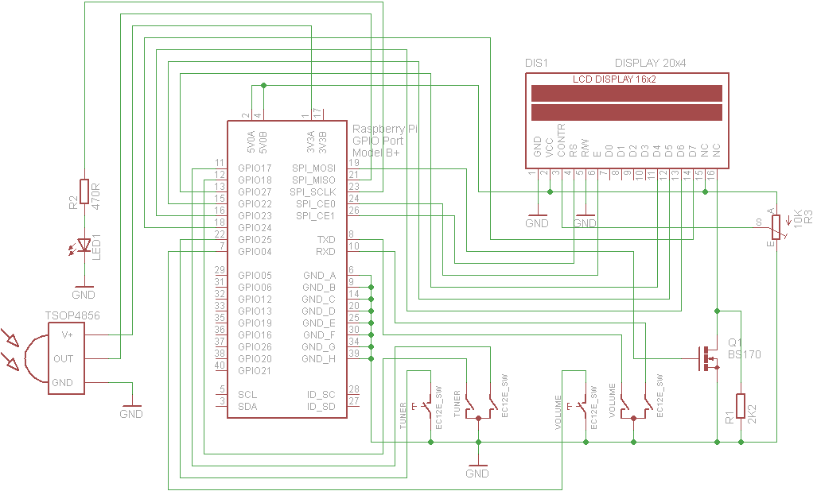

Figure 181 Wiring Raspberry Pi Radio Rotary Encoder version

# Index

1602 I2C LCD, 33

26 way ribbon cable, 27, 28

AAC, 149, 150, 212

activity LED, 7, 17, 39, 91, 94, 109, 110

Adafruit, 5, 6, 17, 23, 24, 28, 32, 33, 34, 35, 36, 38, 39, 53, 79, 91, 109, 111, 112, 139, 163, 165, 172, 203, 209, 210, 226

AdaFruit, 5, 17, 92, 109, 124, 201

AdaFruit industries, 5

AdaFruit RGB plate, 17, 109, 124, 201

airflow, 17

Airplay, 130, 190, 192, 193, 194, 206, 226

Alarm, 123, 124, 136, 137, 138, 226

alsamixer, 84, 86, 87, 89, 116, 193

amplifier, 7, 25, 26, 28, 51

**aplay**, 54, 85, 104, 105, 162, 168, 169, 218

Arduino, 34, 35, 79, 80

**asound.conf**, 104, 115, 116, 218

ASX, 149, 150, 212

audio jack plug, 42

AV, 10, 11

backup, 106

**Bitvise**, 58, 62, 198

Bluetooth speakers, 90

breakout boards, 31

CAD, 8, 41, 109, 212

CGI, 100, 212

CIFS, 154, 155, 156, 212

CloudBreak, 130, 195

colours, 111, 139

COM-09117 12-step rotary encoder, 22

*configure\_radio.sh*, 15, 18, 35, 45, 69, 71, 74, 90, 107, 108, 110, 133, 136, 161, 163, 203, 205, 206, 215, 218, 230

constructor’s gallery, 16

cooling fans, 51

Cosmic controller, 15, 40, 67, 110, 204, 223, 226, 230, 231

Cosmic Controller, 91

**DAC**, 18, 19, 20, 42, 43, 45, 46, 52, 71, 85, 86, 89, 104, 105, 108, 162, 167, 168, 170, 178, 206, 212, 222

daemon, 68, 81, 88, 94, 97, 112, 121, 136, 139, 157, 158, 162, 163, 167, 169, 174, 176, 179, 181, 200, 203, 205, 206, 218, 219

date format, 110, 201

**DDOS**, 196

Device Tree, 228

DHCP, 98, 154, 212

DNS, 99, 212

Domain Name System. *See DNS*

**dpkg**, 69, 100, 160, 223, 224

DSP, 212

DT. *See* Device Tree

Elecrow, 13, 227

Electromagnetic Interference, 50, 163, 212

electronic ink displays, 202

EMI, 50, 163, 212

equalizer, 115, 116

espeak, 9, 93, 103, 104, 105, 125, 136, 205, 210, 218, 225, 226

**fail2ban**, 197, 198

ferrite core, 50

ffmpeg, 67, 129

**firewall**, 197

firmware, 60, 190

**fsck**, 159

**FTP**, 196

GPIO, 6, 17, 19, 20, 21, 22, 25, 27, 28, 32, 34, 35, 36, 38, 39, 43, 44, 86, 91, 109, 172, 173, 212, 226

GPIO header, 25, 32, 35, 86

GPIO pins, 17, 19, 27, 28, 32, 34, 43, 173, 226

Ground Loop Isolator, 51

HD44870, 10, 11, 15, 23, 28, 203

HD44870 LCD, 29

HDMI, 11, 54, 59, 85, 104, 159, 161, 168, 193, 206

heat sink, 51, 52

HiFiBerry, 18, 20, 26, 42, 43, 44, 85, 86, 87, 89, 104, 105, 108, 162, 168, 178, 206, 222, 226

hostname, 63, 64, 185, 223

housing the radio, 16

I2C, 19, 20, 28, 32, 33, 34, 35, 36, 39, 50, 75, 79, 80, 91, 210, 212, 226

I2C interface, 14, 15, 16, 32, 34, 36, 40, 74, 75, 216, 226

Icecast2, 136, 179, 180, 181, 182, 183, 184, 185, 209, 210

interface board, 25, 27, 29, 30, 33, 35, 36, 49

Internet Security, 196

iPad, 226

iPhone, 226

**iPod 4 pole AV**, 11

**iptables**, 197, 198

**iptables-persistent**, 199

iptables-save, 199

IPv4, 213

IPv6, 162, 213

IQaudIO, 230

IQAudio, 11, 15, 18, 20, 21, 23, 26, 28, 39, 40, 45, 67, 78, 85, 86, 90, 91, 92, 104, 108, 110, 115, 117, 204, 206, 222, 226

IR, 7, 8, 17, 19, 20, 28, 36, 38, 39, 41, 42, 91, 94, 173, 206, 213, 219, 222, 226

IR sensor, 38

IR Sensor, 17, 19, 28, 38, 91

Jessie, 28, 58, 61, 62, 68, 98, 154

**Jessie Lite**, 11, 58, 61, 68, 226

**JustBoom**, 18, 26, 46, 86, 226

language file, 105, 113

LCD, 5, 6, 7, 10, 11, 15, 19, 20, 23, 24, 25, 28, 32, 33, 34, 35, 38, 39, 50, 53, 71, 79, 91, 111, 113, 121, 123, 124, 132, 137, 138, 163, 167, 172, 181, 184, 201, 205, 209, 210, 213, 226

LED Backlight, 23

LED dimmer, 232

**lirc**, 90, 91, 92, 93, 94, 95, 170, 171, 219, 222, 224

LIRC, 94, 213

Locale, 65

M3U, 148, 149, 166, 184, 213, 226

MAC, 98, 213

mains filter, 50

micro USB, 11

mixer\_volume, 136, 192, 193

MP3, 135, 149, 226

MPC, 88, 138, 162, 213

**mpd**, 54, 68, 88, 89, 135, 136, 138, 140, 141, 156, 157, 158, 162, 163, 164, 166, 167, 170, 174, 179, 184, 185, 201, 205, 210, 223

MPD, 68, 81, 88, 99, 112, 113, 121, 136, 138, 139, 142, 156, 157, 158, 162, 167, 169, 174, 179, 180, 185, 200, 201, 205, 210, 213, 226

**MPDroid**, 157, 158, 226

mpeg, 67, 150

MPEG, 149, 213

MPEG3, 149, 213

**nano**, 56, 57

NAS, 135, 136, 155, 213, 226

Network Time Protocol, 137, 213

news feed, 114, 226

NFS, 154, 155, 166, 213

NTP, 137, 213

OLED, 11, 15, 40, 67, 74, 79, 110, 204, 211, 213, 226

Olimex Limited, 204, 211

Organic Light Emitting Diode, 11

OS, 28, 155, 213

PC, 5, 16, 28, 69, 114, 135, 148, 154, 179, 181, 182, 184, 185, 213, 226

PC speakers., 182

PCF8574, 34, 35, 210

PCM, 44, 105, 213

pHat BEAT, 8, 14, 41, 68, 69, 82, 231

**Phishing**, 196

Pi Zero, 6, 11

Pi Zero W, 11

PID, 213

PiFace, 8, 41, 212, 219

**PiFace CAD**, 2, 15, 39, 41, 70, 73, 81, 82, 165, 214, 215, 226

PiFace Control and Display, 8

PiJack, 11

Pimoroni, 8, 41, 231

**Pimoroni pHat**, 44, 87, 228

Pimoroni pHAT, 47

Pimoroni Pirate radio, 82

Pirate radio, 8, 14, 41, 231

PLS, 148, 149, 150, 162, 213

potentiometer, 35, 163

power adapter, 25

power supply switch, 25

pulseaudio, 47, 68, 90, 161, 162, 164, 165

**Putty**, 58, 62, 198

**pygame**, 60, 132

**radiod.conf**, 34, 35, 44, 94, 103, 109, 110, 111, 113, 136, 176, 177, 202, 205, 206, 215, 225

Random, 123, 124, 201

Raspberry PI, 1, 4, 5, 6, 7, 10, 17, 25, 28, 32, 36, 38, 39, 42, 43, 50, 54, 69, 80, 81, 89, 91, 95, 96, 97, 98, 99, 100, 101, 109, 135, 138, 139, 163, 170, 173, 180, 181, 184, 185, 207, 209, 210, 212, 226

**Raspbian Jessie**, 58

**Raspotify**, 186

Red Blue Green LED, 206

remote control, 8, 17, 38, 39, 41, 90, 92, 93, 94, 105, 109, 173, 176, 206, 219, 226

Revision 1 board, 22

**Rexec**, 196

rotary encoder, 5, 15, 18, 21, 22, 36, 112, 125, 137, 172, 202, 226

rotary encoders, 5, 6, 7, 15, 17, 22, 23, 28, 35, 36, 123, 124, 202

Rotary encoders, 22, 28, 33, 39, 91

RSS, 114, 123, 124, 136, 201, 205, 214, 226

screen saver, 134

SD, 214

SD card, 106

Secure Shell. *See* SSH

Serial Peripheral Bus interface, 8

**service mpd**, 88

service radiod, 81, 94, 114, 121, 176, 177, 207

shairport-sync, 190, 191, 192, 193, 206, 226

*Shoutcast*, 102, 140, 145, 146, 147, 149, 150

speech, 103, 105

**speech\_volume**, 103

SPI, 8, 34, 41

SPI interface, 15, 41, 73, 223

Spotify, 186, 187, 188, 189, 226

SSD1306, 204, 211

SSH, 58, 62, 138, 196, 214

SSID, 96, 214

**Stretch**, 58, 61, 79, 196, 197, 213

systemd, 218

TCP/IP, 206, 214

**Telnet**, 196

TFT, 5, 13, 15, 36, 37, 214, 226

**timesync**, 137

timezone, 62, 63, 223

tone control, 9, 52

touch screen, 4, 12, 13, 15, 226

TSOP38238, 28, 38

TSOP382xx, 17

type of radio, 15

UDP, 94, 173, 206, 214

URL, 114, 123, 124, 136, 148, 149, 150, 151, 166, 179, 184, 185, 200, 201, 213, 214

USB, 6, 11, 25, 28, 33, 50, 95, 135, 156, 157, 167, 170, 210, 214, 226

USB adaptor, 6

USB stick, 135, 156, 157, 226

USB to Ethernet adapter, 6, 11

USB-OTG, 13

version 1.0 boards, 21

**vi**, 56

vintage radio, 9, 16, 109, 206

Vintage radio, 26, 39, 109, 226

**VLC**, 82

wake-up button, 37

web interface, 98, 101, 102, 103, 154, 200, 201

Web interface, 99, 101, 226

WEP, 96, 214

**wget**, 69, 100, 150, 151, 223, 224

WiFi, 95

WIFI, 63, 96, 214

Win32DiskImager, 106

wiring, 18, 19, 22, 23, 28, 35, 53, 110, 163, 165

wiring diagram, 232

WMA, 135, 226

WPA, 96, 97, 214

WPA2, 96, 214

XML, 150, 214

**xscreensaver**, 133, 134

**xscreensaver-command**, 134